Operating the Sputter Ion Gun Power Supply (SIGPS)

1) Move the manipulator to the sputter gun position

- x = 1.200”

- y = 1.500“

- Z = 7.24 cm

-Theta = 288.0 Degrees

2) Prep the Argon gas line to the sputter gun

Open all the gas line connections aside from the one that goes to the MC and the one at the Argon gas to the gas line.

Turn on the mechanical pump to pump out most of the left over air/water vapor.

Close the NuPro valve from the mechanical pump. (Righty tighty)

Then fill the line with Argon/sputter gas.

Next close the Argon gas from the gas line.

Then open the Nupro valve with the mechicalical pump to pump out the Argon gas.

This step helps dump out any left over air/water vapor that may have gotten stuck.

Then close the Nupro valve and turn off the mechanical pump.

3) Turn off ion pumps/close gate valves for ion pump on MC and S2 from MC

4) Plug in 5 multimeters to read

a. anode voltage

i. technically it would be both anode and beam voltage because we are floating the supply for the beam voltage

ii. need to measure with a high voltage probe

b. anode current

c. filament current

d. Lens 1 Voltage

e. Lens 2 Voltage

5) Then we will let Argon gas into the chamber.

a. The sputter guns gas knob.

i. (0/0) is the initial location of the knob when the sputter gun gas flow is closed by turning the knob all the way clockwise (to the right) and aligns with the same label below the knob.

ii. (1/2) sticker represents a half turn on the knob. These are displayed in figure 1.

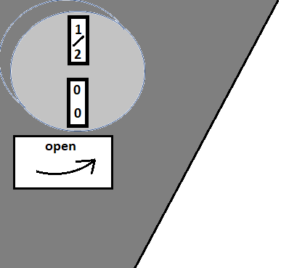  
Figure 1: This displays the gas knob with the full turn and the half turn stickers.

` iii. When we tested this on Feb 20th; 2020 the pressure in the Main Chamber was 2:6 e - 9 torr prior to releasing Argon. Turning the valve for 4:5 rotations we saw a rise in pressure to 5:0 e – 6 torr.

6) Turn on the SIGPS.

a. Set anode to max (check should be around 250 V with no beam voltage)

b. slowly ramp up filament current.

i. When you get close to the max of the filament current (3.8 A) you’ll see a few milliamps of anode current coming out. (0.6-1.43 mA)

c. set the beam voltage.(500 V)

- Voltage max 750 V (due to lens supplies max limit)

\***going past 1.2 kV** will cause BNC to banana adapter to **spark**\*

d. adjust the lens voltages until you have maximum current on sample. (350 V)

i. measure the current on your sample. (0.5 micro Ampsish)

e. to really clean off the sample run this for about 30 mins.

**Shutting down procedures**

1. Close the gas knob.
2. Ramp down the filament current, anode voltage, beam voltages and the lenses.
3. Then turn off the SIGPS and the external power supplies.
4. Open the gate valve in the MC for the ion pump and open the shut valve from S2 to MC