Notes for summer researcher
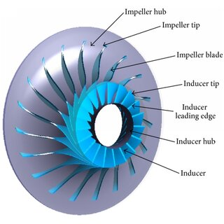
Main references:
- Fortran code from NASA (https://software.nasa.gov/software/LEW-17450-1 & https://ntrs.nasa.gov/citations/19740001912) that is translated to Python by Mitchell Lowe
- Lowe, Mitchell (2016). Design of a load dissipation device for a 100 kW supercritical CO2 turbine, https://doi.org/10.14264/uql.2017.244
  - Code optimizes geometry and then predicts compressor performance based on enthalpy rise in the compressor. Obtaining the net enthalpy rise involves calculating different loss functions (e.g. enthalpy loss associated with blading loading loss and disk friction loss).
Other references:
- Preliminary design of centrifugal compressor using multidisciplinary optimization method (https://doi.org/10.1051/meca/2019071)
- A method to select loss correlations for centrifugal compressor performance prediction (https://doi.org/10.1016/j.ast.2019.105335)

TO-DO:
- Draw and understand all variables in the code
- Empirical values are used and results may be sensitive to those. OK?
- Include several stages and intercooling
- Search for MSG in the files, I have included some questions and suggestions to changes in the code.
- Add main function such that each file can be imported to other files but not run at the same time.
- Make file(s) with fluid parameters and compressor variables. At the moment, these variables have to be adjusted in each individual file.
- Include Thermopack? Now only ideal gas.
- Will be important to assess the limitations of this code (see ex. Section "Concluding remarks" in https://ntrs.nasa.gov/citations/19740001912 and "4.2 Off-Design Code" in https://doi.org/10.14264/uql.2017.244)
- Study sensitivity to different input parameters? Can we also optimize these?
  - Concern: Many input parameters. This will be an optimization problem with several variables
- Use Ansys Baldemodeler (BladeGen) to visualize blade geometry? Free student licence?

