SPY3 – Whitepaper
Denis Keller, dk@sintro.eu
Marian Mashayekhi, marian.mashayekhi@sintro.eu
www.sintro.eu
Abstract— In this paper, we present evidence against the prevailing theory about financial markets. In academic research, questions revolve around the assumption that asset prices reflect all available information and exhibit a random walk. The direct implication of this hypothesis is that no market participant can consistently earn excess returns on a risk-adjusted basis, except by luck or by using non-public information. This paper examines whether the assumption that historical information cannot be enough to consistently outperform the market holds. Empirical data has shown that asset returns are negatively skewed with a so-called “fat-tail distribution”. The systematic model outlined in this paper provides an easily replicable approach which more than doubles the Sharpe ratio relative to a buy-and-hold strategy for the S&P500. The SPY3 model invests based on three quantitative factors – risk, momentum and mean reversion – and determines whether to invest in risky assets or not.

Key words: Asset Management, Financial Markets, Portfolio Allocation and Analysis, Systematic Investing

Introduction
Over the past decades, systematic investment strategies have grown to be a force in the portfolio selection process of institutional investors (Harvey, 2021). With the rise of technology, new quantitative strategies are gaining popularity among investors due to their cost efficiencies, lack of behavioural biases, rigorous risk management and data-driven decision-making processes (Richardson, 2022). The purpose of this paper is to present a systematic approach to investing, with the objective of maximizing the Sharpe ratio. Previous research in the field of quantitative finance has lagged in providing an easily replicable investment approach to investors. Additionally, research has not fully explored how to capitalize on the momentum puzzle while limiting downside risks. Our algorithmic approach leverages the benefits of dynamic risk management and empirical insights derived from the return distribution function of public assets.

A Perfect World

Efficient Market Hypothesis
According to the Efficient-Market Hypothesis (EMH), a market is efficient, when prices of securities always accurately represent all currently available information and consistent outperformance is impossible (Fama, 1969). These outlines are not favorable for our systematic approach and therefore, a passive investment strategy that is implemented with index funds (ETFs) should be the better option. Already the weak-form of the EMH implies that no profits can be made by any historical price-based strategies such as the one presented in chapter V. However, if markets were not fully efficient, then such systematic strategies can be profitable after all.

Modern Portfolio Theory
In the 1950s, Harry Markowitz introduced a mathematical framework for portfolio optimization within a mean-variance

setting based on the benefits of diversification, known as modern portfolio theory (MPT). His pioneering analysis demonstrated that although the expected portfolio return is the weighted average of the expected returns of the individual assets, the variance of portfolio returns is typically lower than the weighted average of the asset variances because overall risk depends on the correlation among individual assets (Markowitz, 1959). The less correlation there is between assets, the greater the diversification benefits.

Capital Asset Pricing Model (CAPM)
Sharpe (1964), Lintner (1965) and Mossin (1966) further developed the MPT by including two key assumptions for choosing mean-variance efficient portfolios. The first assumption states that all investors can borrow and lend at the same risk-free rate which is unaffected by the amount borrowed or lent. Therefore, unlike the MPT model, only the portfolio with the highest Sharpe ratio on the efficient frontier really matters to investors, which is typically represented by the market portfolio (Bodie et al., 2014). Investors optimize their portfolios in a mean-variance efficient way by dividing their capital between the risk-free rate and the market portfolio based on their risk appetite, and consequently, find themselves on the capital market line. The second assumption is that investors have homogeneous expectations about returns and covariances/correlations for the same universe of tradeable assets over the same one-period planning horizon. In general, CAPM is based on the idea that the expected return of an asset is equal to the risk-free rate plus a risk premium, which depends on an asset’s volatility in relation to the overall market, known as the beta of an asset.

Contradictory empirical evidence

Equity Premium Puzzle
Stocks have delivered remarkable returns over the past century. Most of these returns are not fully explainable by academic models. There is a significant premium of 6 to 7% between the returns of US treasury bills and US equities. Fixed-income securities offer yielding income and move historically in a relatively negative manner to the equity market, thus also acting as a hedging factor when uncertainty in the equity market increases. Such diversification effects, discussed before, allow a higher risk-reward, since the portfolio volatility decreases, depending on the correlation of the underlying assets.

Momentum Puzzle
Momentum refers to the tendency of asset prices to continue moving in the same direction. Barroso and Santa-Clara (2012) conclude that momentum provides the best risk-reward compared to all other common factors. Momentum strategies have attracted much research in the past decade and there are several studies that contradict the EMH offering evidence that historical asset returns can predict the cross section of future asset returns to a certain extent (e.g., De Bondt & Thaler, 1987; Jegadeesh & Titman, 1993; Fama & French, 2012; Israel & Moskowitz, 2013). Research broadly divides the explanations as either risk based, or non-risk based. According to Ang (2001), it is downside risk that an investor gets rewarded for when applying a momentum strategy. In the category of non-risk-based explanations, there are several types of behavioural explanations that use either under-/overreaction effects or herd behaviour as explanations (Daniel et al., 1999). However, in times of market turmoil, momentum remains subject to large losses leading to the worst crashes. Therefore, risk management is particularly important in momentum strategies (Kent, 2011).

Behavioral Finance
Financial decisions are influenced by heuristics and psychological biases. Today, there are a variety of cognitive biases and heuristics revealed by researchers, including loss aversion, herd behaviour, and survivorship bias, to name just a few (Kahneman et al., 1982). These findings argue that the EMH cannot be valid since it ignores irrational and emotional behaviour (Asness, 2014). Due to psychological hurdles and limited information-processing capabilities, market participants have only bounded rationality (Thaler, 2008). One prominent example of such a heuristic is the disposition effect, which states that people prefer to maintain the status quo and are reluctant to part with assets that have lost value. Despite the growing evidence for behavioural finance, traditional academia still largely emphasizes rational models, ignoring cognitive and emotional biases in decision-making.

The Pursuit of Alpha

Evidence against the Efficient-Market Hypothesis
As mentioned in the beginning, the EMH is the prevailing theory about financial markets and states that prices of securities follow a “random walk”, implying that asset returns are normally distributed and successful market timing exceedingly difficult. Although many finance theories and models are based on this assumption, empirical research shows something different (Chung et al., 2006). Analysing returns of the S&P500 index on its distribution function shows, asset returns exhibit a negative skewness with a leptokurtic distribution. Skewness measures the level of asymmetry within the data set. A left-skewed distribution is called negatively skewed and indicates frequent small gains, but also a few large losses, so-called fat-tails. Let’s illustrate this behaviour with a metaphor: “markets take the stairs up and the elevator down”. Additionally, even though the EMH assumes that all investors are rational, in reality investors are subject to their own psychological biases, such as the status quo bias, in which people fall into lazy decision making and prefer not to change the situation even if market conditions changed and adjustments would be appropriate. More recent hypotheses apply principles of behavioural economics to the financial markets by taking competition, adaptation, and selection into account. The so-called Adaptive Market Hypothesis (AMH) argues that investors can achieve an optimal dynamic allocation, by adapting to their own psychological biases. One way to avoid adverse behaviour is by using a systematic trading system that executes trades based on pre-defined rules, allowing decisions to be done in a methodological manner and portfolios to be continuously adjusted with no human effort.

Purpose of Active Investing
Active investing is characterized by the objective to time the market in the short run and to produce an excess return above a benchmark, which is often defined by a market index. If an investor would not care about market timing and excess return, he would follow a buy-and-hold strategy with a passive index fund of his desired asset class. In contrast, an investor who seeks to achieve alpha, or at least a higher risk/reward, must inevitably go beyond beta, and therefore beyond a passive investment. Also, if no one would trade actively, market prices would move away from their fundamentals, which would lead to inefficient allocation of resources and thus a decline in social welfare. Active trading keeps assets in their equilibrium, with deviations that, according to the EMH, only occur “randomly”. According to a study by Standard & Poor's (SPIVA Report, 2021), which examined more than 25,000 active funds over a 10-year period, less than 5% of the fund managers were able to achieve their goal of beating their benchmark after costs. This circumstance does not make it easier to develop a systematic strategy which aims to outperform the market consistently. However, even if most active fund managers fail to beat their benchmark, the SPY3 model presented in this paper provides an effective hands-on way to leverage the empirical insights of a negatively skewed return distribution, the assessment of fat-tail risks, and the persistence of the momentum puzzle

Backtesting
An important part of developing a systematic trading strategy, involves backtesting, which is the process of studying the behaviour of an investment strategy and analyse its performance based on historical data. The underlying idea of backtesting is, that a strategy that performed well in the past is likely to do so again in the future, and vice versa. There are several statistical biases that need special attention in the process of developing a viable backtesting. Survivorship bias, look-ahead bias, and data snooping are the most common ones. The survivorship bias ignores assets that have disappeared during the test period and only considers investments that are still present at the end of the test period. The look ahead bias occurs, when investment decisions are done based on information, which is not yet available at the time the signal is processed in real-time. For example, if the 200-day moving average triggers a new buy/sell signal based on historical close prices, this information would be just usable in the subsequent period (t₊₁). When strategies rely solely on historical price data without proof of similar results in the future, they are subject to data snooping. Although historical data does not guarantee future performance, it helps to evaluate a strategy and to understand its performance in different periods. The level of confidence depends on the stability of the livetest results and further out-of-sample tests. Such out-of-sample tests confirm the effectiveness of the systematic strategy and reveal a system’s genuine capabilities before actual money is on the line.

Inside The SPY3 Base Model
SPY3 is a hybrid strategy that adapts to market conditions by shifting between short-dated U.S. Treasuries and the S&P500. Risk-on or risk-off signals are based on three quantitative factors: risk, momentum, and mean reversion. Through its downside protection, SPY3 aims to provide an attractive and cost-efficient alternative to both, active and passive strategies – particularly for risk-averse investors.

Risk Management
Value-at-Risk (VaR) is the most commonly used statistics to assess the downside risk of a financial asset over a given period based on its historical volatility. VaR is a measure of potential loss over a given time period and represents the 1-α %-percentile loss. The SPY3 model calculates the daily VaR with a 99% confidence level and a 90-day observation period. If the daily 99% VaR remains below 2%, the model signals risk-on. Conversely, a VaR above 5% serves as our risk limit that prevents the model from investing in equities, as it signals a relatively unfavorable risk/reward ratio for this asset class and shifts to bonds – and hedge against rising equity volatility.

Momentum
We are trend-followers; therefore, we want to stay invested in upward trends and be cautious in downturn trends. For this reason, our momentum factor consists of two moving average (MA) pairs, 35-day and 200-day. The model identifies an upward trend as long as the short-dated MA remains above the long-dated MA (“trending”), and vice versa for downturn trends (“countertrending”). The strategy capitalizes on medium term market trends, while actively avoiding downturn trends in the short run. This approach provides a simple yet effective way to assess and respond to market dynamics.

Mean-Reversion
Mean reversion refers to the tendency of asset prices to revert to their mean level over time, with extreme price movements correcting in the short term. The buy signal is triggered when the current price of the S&P500 index drops to at least 30% of its 200-day high. This factor aims to exploit market exaggerations caused by herd behavior and excessive deviation from the prior equilibrium. Empirical data shows that markets tend to revert to their mean and recover in the short term, offering investors the opportunity to benefit from significant price discounts and capture potential gains when markets rally and rebound in the short term thereafter.

Results
The SPY3 model has consistently outperformed the S&P 500 since 2000 by actively shifting between risky and safety assets. This dynamic approach effectively navigates through different market cycles. The primary goal is to maximize the Sharpe ratio and minimize drawdowns. Historically, the fund achieved an annualized return of 13.4% since 2000 with a Sharpe Ratio of 1.01 and an annual Jensen’s alpha of 6.8%.

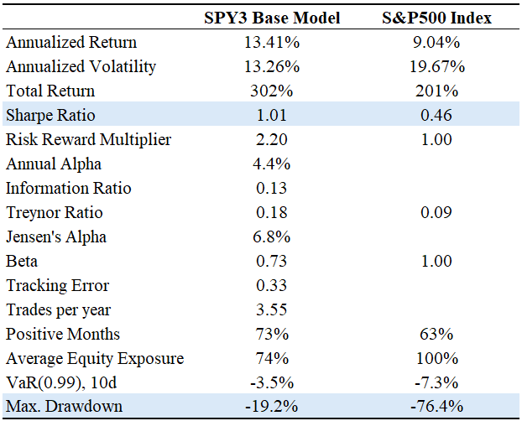
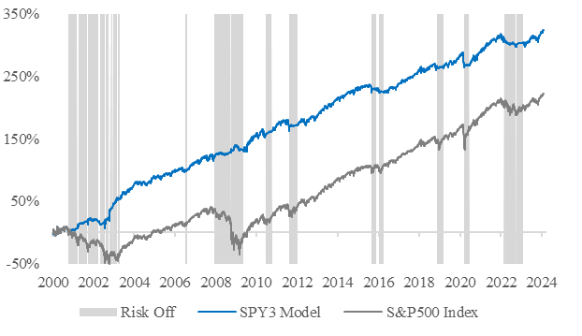

Concluding Remarks
Systematic strategies allow decisions to be made in a methodological manner. Investment objectives and trading rules are transparent and automated, allowing fast, cost-efficient, and real-time trade execution. Systematic strategies benefit from the absence of psychological biases and the presence of adaptive dynamic and data-driven models. Even if most quantitative investment strategies look very opaque from the outside and resemble a black box, in reality these models can be very transparent and easily understandable. In practice, many fund managers cannot beat their benchmark after costs. Instead, they underperform and deliver no real value for their investors. This paper showed how relatively simple a market-timing strategy already beats the S&P500 by both, limiting risk and generating steady excess return. In regard to backtesting, we stay aware of the fact that historical data cannot predict future results perfectly. However, to quote Mark Twain: “History never repeats itself, but it often rhymes”. Our SPY3 base model presented in this paper applies a similar humble attitude. Even though the weak form of the EMH already states that no outperformance can be achieved solely through historical data, the SPY3 base model shows something different, as it performs consistently better than its benchmark – even in changing market environments.

REFERENCES
- Harvey, C., R. (2021), “Why Is Systematic Investing Important?”, Journal of Systematic Investing, 2-6.
- Richardson, S., A. (2022), “Systematic Fixed Income: An Investor’s Guide”, Wiley, 41-56
- Fama, E. F. (1970), „Efficient Capital Markets: A Review of Theory and Empirical Work”, The Journal of Finance 25(2)
- Markowitz, H. (1959), “Portfolio Selection: Efficient Diversification of Investments”, Vol. 16, John Wiley New York
- Bodie, Z., Kane, A. and Marcus, A. J. (2014), “Investments”, 10th edition, McGraw-Hill Education.
- Treynor, J. (1962), “Toward a Theory of Market Value of Risky Assets”
- De Bondt, W. F. and Thaler, R. (1985), „Does the Stock Market Overreact?”, The Journal of Finance
- De Bondt, W. F. and Thaler, R. (1987), „Further Evidence on Investor Overreaction and Stock Market Seasonality”, The Journal of Finance
- Fama, E. F. and French, K. R. (1993), „Common Risk Factors in the Returns on Stocks and Bonds”, Journal of Financial Economics 33(1)
- Fama, E. F. and French, K. R. (2004), „The Capital Asset Pricing Model: Theory and Evidence”, Journal of Economic Perspectives 18(3), 25–46.
- Asness, C., Moskowitz, T. J. and Pedersen, L. H. (2013), „Value and Momentum Everywhere”, The Journal of Finance 68(3)
- Barroso, P., Santa-Clara, P. (2012), “Momentum has its moments”, Journal of Financial Economics, Vol. 116, No. 1, 111-120
- Kent, D., D. (2011), “Momentum Crashes”, Columbia Business School Research Paper 11(03), 3–12
- Sharpe, W. F. (1964), „Capital Asset Prices: A Theory of Market Equilibrium Under Conditions of Risk”, The Journal of Finance 19(3)
- Lamont, O. A. and Thaler, R. H. (2003a), „Anomalies: The Law of One Price in Financial Markets”, Journal of Economic Perspectives 17(4)

