초기설정
ping -c 5 172.16.0.1
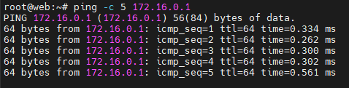

vim /etc/ssh/sshd_config
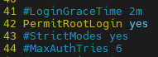

systemctl status ssh
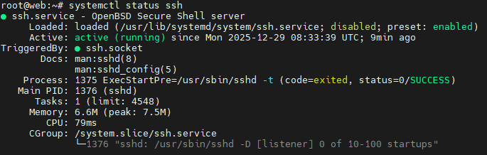

apt -y install net-tools vim wget
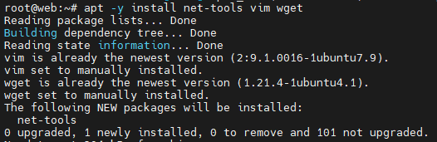

apt -y update && apt -y upgrade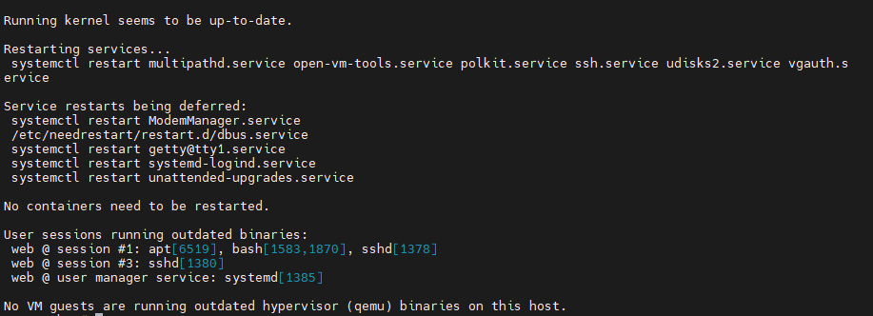

ufw disable
======================================================================

FTP

apt -y install vsftpd
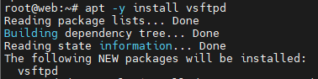

vim /etc/vsftpd.conf
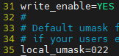
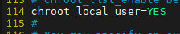
#상세 설정
anonymous_enable=yes
local_enable=YES
write_enable=YES
local_umask=022
xferlog_enable=YES
connect_from_port_20=YES
xferlog_std_format=YES
chroot_local_user=NO
listen=NO
listen_ipv6=YES
pam_service_name=vsftpd
userlist_enable=NO
systemctl restart vsftpd
systemctl enable vsftpd

## ftp 아이디 비밀번호 ##
it : 2025
strategy : asd123!@
administration : happynewyear
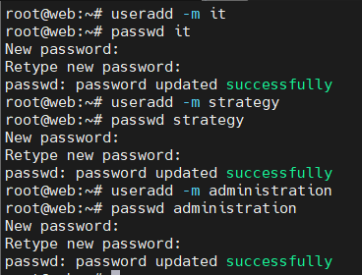

레드팀 요청사항 : it 계정에 sudo 권한을 달라
usermod -aG sudo it
it 계정을 sudo 그룹에 넣어서 /etc/sudoers에 정의된 sudo 권한을 쓰게 함
groups it
사용자 it가 속한 모든 그룹(기본+보조 그룹)을 출력
기본 그룹 : 보조그룹
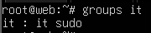

======================================================================

db클라이언트 설치
apt install mariadb-client
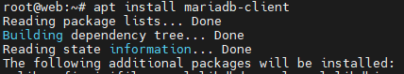
======================================================================

nginx
apt install nginx -y
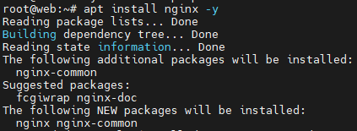

systemctl start nginx
systemctl enable nginx

apt install nginx php-fpm php-mysql -y
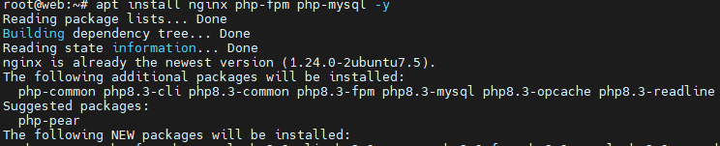

vim /etc/nginx/conf.d/vhost.conf
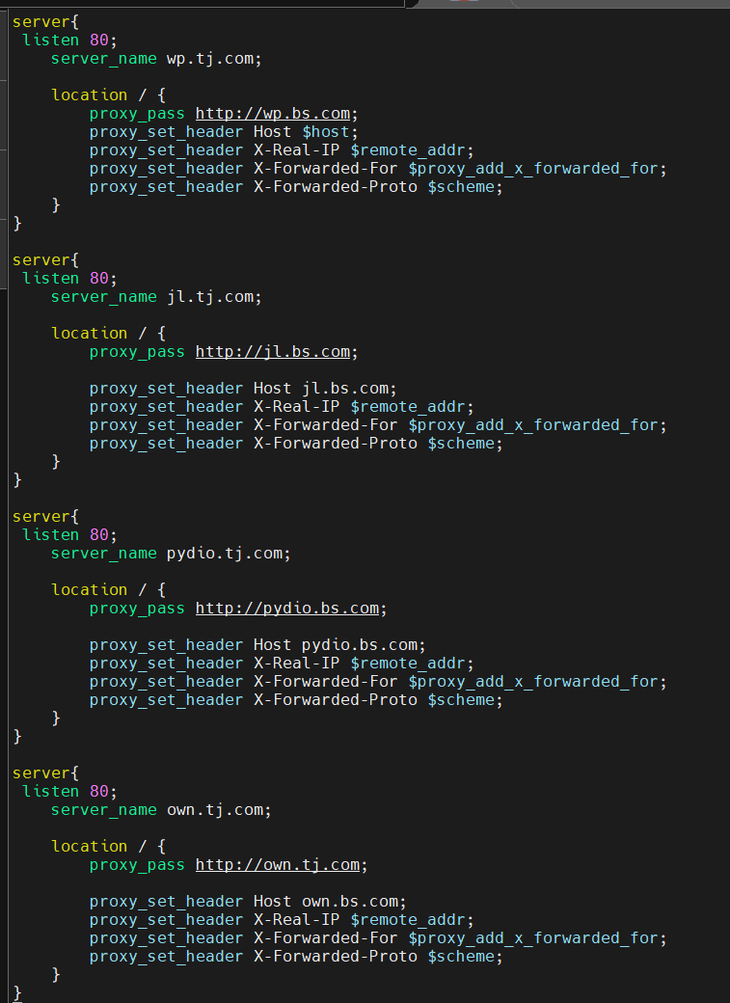
server{
listen 80;
server_name wp.tj.com;

location / {
proxy_pass http://wp.bs.com;
proxy_set_header Host $host;
proxy_set_header X-Real-IP $remote_addr;
proxy_set_header X-Forwarded-For $proxy_add_x_forwarded_for;
proxy_set_header X-Forwarded-Proto $scheme;
}
}

server{
listen 80;
server_name jl.tj.com;

location / {
proxy_pass http://jl.bs.com;

proxy_set_header Host jl.bs.com;
proxy_set_header X-Real-IP $remote_addr;
proxy_set_header X-Forwarded-For $proxy_add_x_forwarded_for;
proxy_set_header X-Forwarded-Proto $scheme;
}
}

server{
listen 80;
server_name pydio.tj.com;

location / {
proxy_pass http://pydio.bs.com;

proxy_set_header Host pydio.bs.com;
proxy_set_header X-Real-IP $remote_addr;
proxy_set_header X-Forwarded-For $proxy_add_x_forwarded_for;
proxy_set_header X-Forwarded-Proto $scheme;
}
}

server{
listen 80;
server_name own.tj.com;

location / {
proxy_pass http://own.tj.com;

proxy_set_header Host own.bs.com;
proxy_set_header X-Real-IP $remote_addr;
proxy_set_header X-Forwarded-For $proxy_add_x_forwarded_for;
proxy_set_header X-Forwarded-Proto $scheme;
}
}

======================================================================

NFS
apt install -y nfs-kernel-server nfs-common
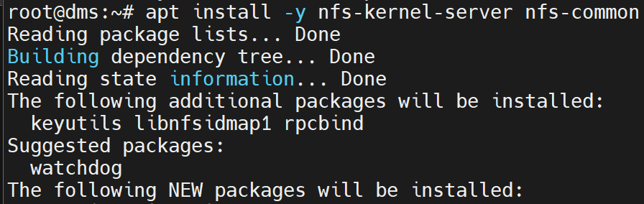

crontab -e (1)
00 00 * * * cp -a /var/log/nginx/access.log /mnt/nfs_share/nginx.${date +\%F].log
00 00 * * * cp -a /etc/nginx/conf.d/vhost /mnt/nfs_share/nginx.${date +\%F].set
00 00 * * * cp -a /home/dvwa /mnt/nfs_share/dvwa.${date +\%F].set
00 00 * * * cp -a /etc/vsftpd.conf /mnt/nfs_share/vsftp.${date +\%F].set
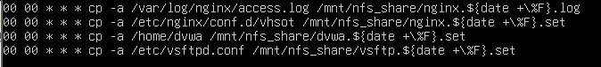

vim /etc/fstab
192.168.80.30:/data/nfs_share/web /mnt/nfs_share nfs defaults 0

mount -t nfs 192.168.80.30:/data_nfs_share/web /mnt/nfs_share/

======================================================================

DVWA

apt -y install git
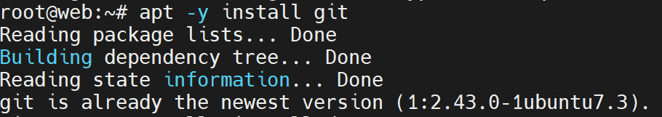
useradd -m dvwa
cd /home/dvwa
git clone https://github.com/digininja/DVWA
mv DVWA/* /home/dvwa
cd /home/dvwa
cp config/config.inc.php.dist config/config.inc.php

vim /home/dvwa/config/config.inc.php
