초기설정
ping -c 5 172.16.0.1
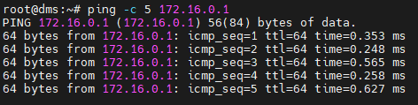
vim /etc/ssh/sshd_config
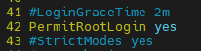

systemctl status ssh
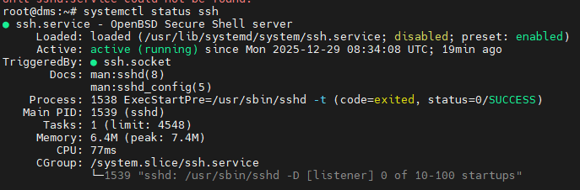

apt -y install net-tools vim wget
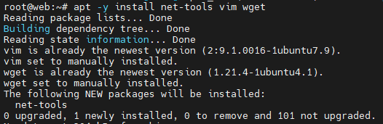
=====================================================================

apache2

apt install apache2 -y
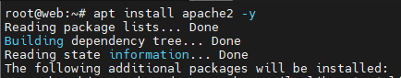

systemctl enable --now apache2

vim /etc/apache2/sites-available/vhost.conf
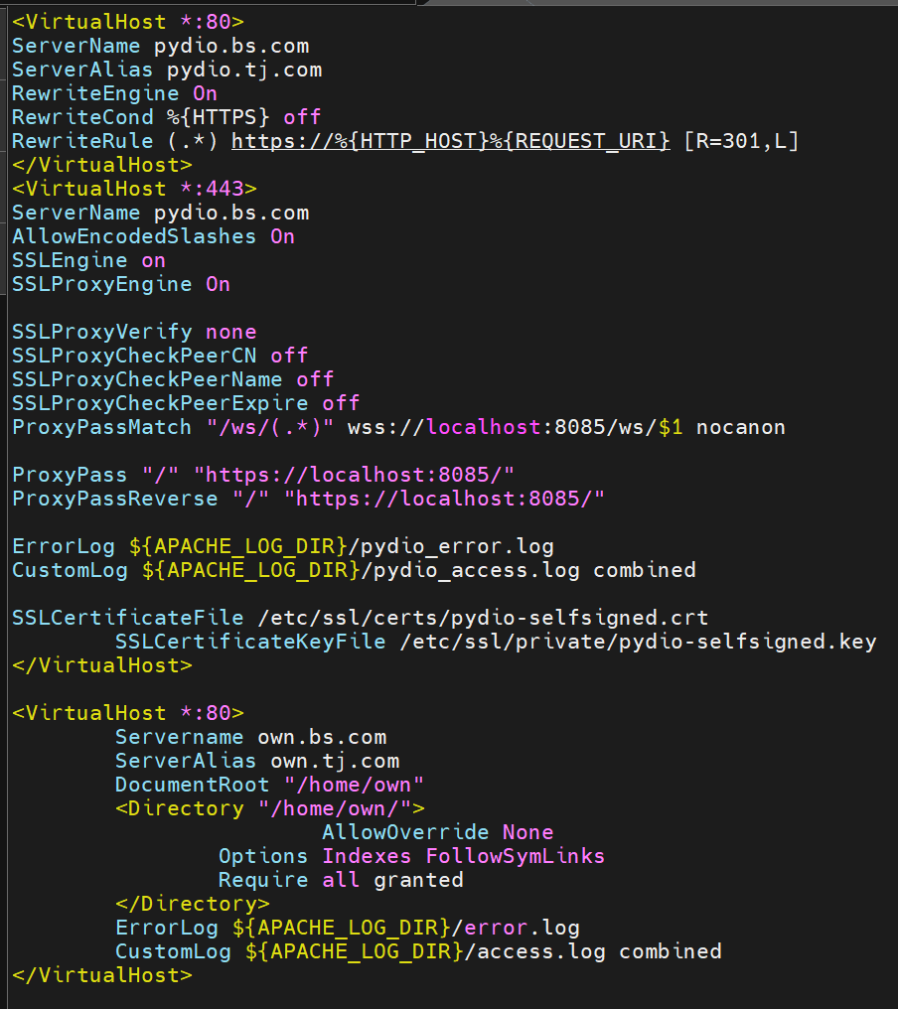

<VirtualHost *:80>
ServerName pydio.bs.com
ServerAlias pydio.tj.com
RewriteEngine On
RewriteCond %{HTTPS} off
RewriteRule (.*) https://%{HTTP_HOST}%{REQUEST_URI} [R=301,L]
</VirtualHost>
<VirtualHost *:443>
ServerName pydio.bs.com
AllowEncodedSlashes On
SSLEngine on
SSLProxyEngine On

SSLProxyVerify none
SSLProxyCheckPeerCN off
SSLProxyCheckPeerName off
SSLProxyCheckPeerExpire off
ProxyPassMatch "/ws/(.*)" wss://localhost:8085/ws/$1 nocanon

ProxyPass "/" "https://localhost:8085/"
ProxyPassReverse "/" "https://localhost:8085/"

ErrorLog ${APACHE_LOG_DIR}/pydio_error.log
CustomLog ${APACHE_LOG_DIR}/pydio_access.log combined

SSLCertificateFile /etc/ssl/certs/pydio-selfsigned.crt
SSLCertificateKeyFile /etc/ssl/private/pydio-selfsigned.key
</VirtualHost>

<VirtualHost *:80>
Servername own.bs.com
ServerAlias own.tj.com
DocumentRoot "/home/own"
<Directory "/home/own/">
AllowOverride None
Options Indexes FollowSymLinks
Require all granted
</Directory>
ErrorLog ${APACHE_LOG_DIR}/error.log
CustomLog ${APACHE_LOG_DIR}/access.log combined
</VirtualHost>

=====================================================================

db client 설치

apt install mariadb-client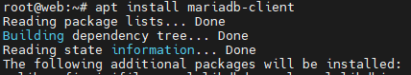
=====================================================================

pydio

useradd -m pydio
cd /home/pydio
wget https://www.pydio.com/cs/c/?cta_guid=5c81c640-06d0-47d7-ac4f-743dc1bfb122
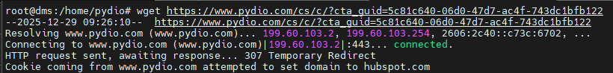
apt install unzip
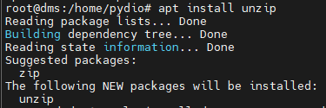
unzip 'index.html?cta_guid=5c81c640-06d0-47d7-ac4f-743dc1bfb122'

cd /home
chmod 755 -R pydio
chown -R pydio:pydio pydio

cd /home/pydio
./cells configure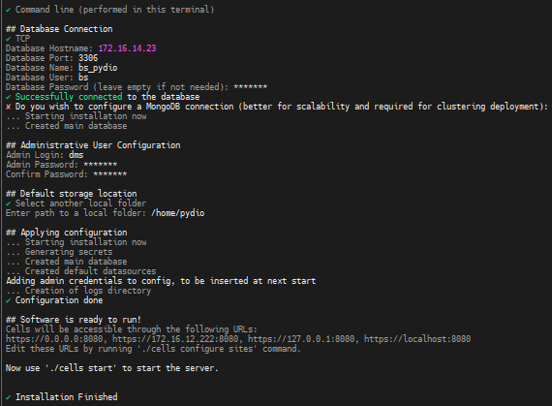
./cells configure sites
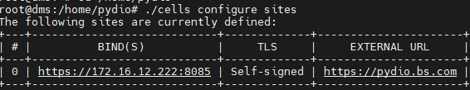

vim /etc/systemd/system/pydio.service
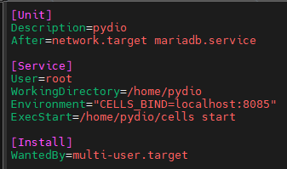
#서비스 파일 생성 아래 내용 추가
[Unit]
Description=pydio
After=network.target mariadb.service

[Service]
User=root
WorkingDirectory=/home/pydio
Environment="CELLS_BIND=localhost:8085"
ExecStart=/home/pydio/cells start

[Install]
WantedBy=multi-user.target

systemctl daemon-reload

모듈 설정
sudo a2enmod proxy
sudo a2enmod proxy_http
sudo a2enmod proxy_connect
sudo a2enmod ssl

======================================================================

owncloud

php -v
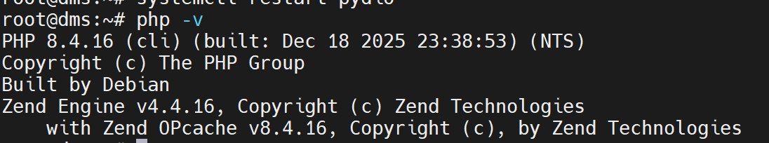
sudo add-apt-repository ppa:ondrej/php -y
apt update
apt install php7.4-mysql php7.4-gd php7.4-curl php7.4-zip php7.4-mbstring php7.4-intl php7.4-bz2 -y
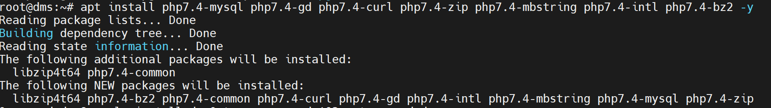
apt install php7.4-xml php7.4-common -y
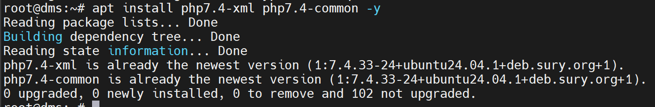
install php7.4-fpm -y
php7.4 -m | grep -E "mysqli|mysqlnd|gd|curl|zip|mbstring|intl"
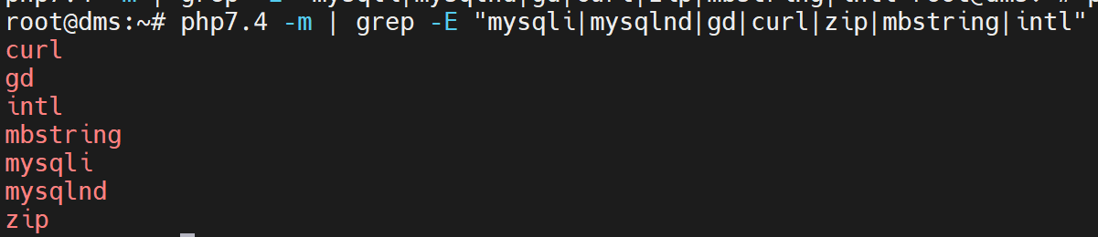
useradd -m own
cd /home/own
wget https://download.owncloud.com/server/stable/owncloud-complete-latest.tar.bz2
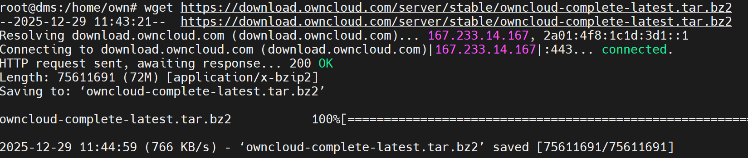
apt install bzip2 -y

tar -xjvf owncloud-complete-latest.tar.bz2
cd owncloud
mv * /home/own

chown -R own:own /home/own
chmod 755 /home/own

mkdir -p /home/own/data
chown -R own:own /home/own
sudo chmod -R 750 /home/own

chmod 755 /home
chmod 750 /home/own
chmod 640 /home/own/index.php
systemctl restart apache2

======================================================================

NFS

apt install -y nfs-kernel-server nfs-common
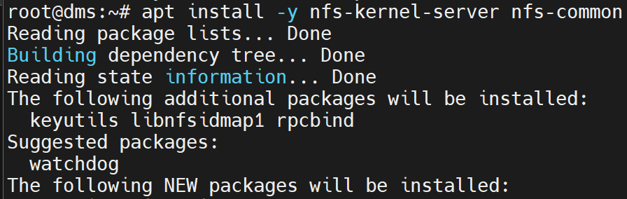

mount -t nfs 20.1.128.30:/data/nfs_share/whd /mnt/nfs_share/

df
192.168.80.30:/data/nfs_share/whd 확인
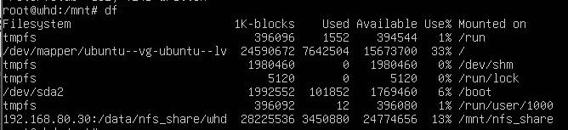

vim /etc/fstab
192.168.80.30:/data/nfs_share/whd /mnt/nfs_share nfs defaults 0 확인
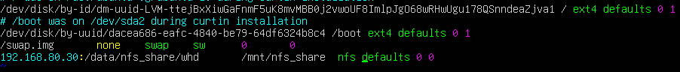

crontab -e (1)
00 00 * * * cp -a /home/pydio /mnt/nfs_share/pydio.${date +\%F}.set
00 00 * * * cp -a /home/own /mnt/nfs_share/own.${date +\%F}.set
00 00 * * * cp -a /etc/apache2/site-available/vhost.conf /mnt/nfs_share/apache.${date +\%F}.set

