NAT Traversal Design Description
Version 0.10
March 19th, 2009
Robert Joly

Table of Contents
1 Introduction 1
1.1 Feature Overview 1
1.2 Assumptions, limitations and dependencies 2
2 Design Overview 4
2.1 High-level Local and Far-End NAT Traversal strategy 4
2.1.1 Using a Media Relay to solve NAT traversal of media 5
3 Input builders for NAT Traversal Agent plug-in 7
3.1 Input #1 - Topology information for callers and callees 7
3.2 Input #2 – Seeing SIP Responses 10
4 NAT Traversal Agent plug-in 11
4.1 NTAP Initialization 12
4.1.1 Reading & parsing the NAT Traversal Rules configuration file 12
4.1.2 Media Relay Initialization 14
4.1.3 Starting a periodic clean-up timer 16
4.1.4 Installing NatTraversalAgent as a SipOutputProcessor 16
4.2 NTAP - Handling of incoming requests 17
4.2.1 Choosing which requests to process 19
4.2.2 Tracking new calls 21
4.2.3 Presenting dialog-forming INVITEs to the CallTracker 21
4.2.4 Determining the location category of the endpoints 22
4.2.5 Reaching endpoints behind remote NATs 25
4.2.6 Performance Optimization Code 28
4.2.7 Code changes made to existing sipXecs components 28
4.3 NTAP - Handling of outgoing messages 29
4.3.1 Adjusting topmost Via for requests 29
4.3.2 Adjusting Record-Route for requests and responses 30
4.3.3 Dispatching SIP requests and responses 30
4.3.4 Request and response processing inside SessionContext 32
4.3.5 Request and response processing inside DialogTracker 34
4.4 NTAP – Maintaining NAT pinholes open 49
4.5 Avoiding Media deadlocks 52
4.6 HA considerations 53
4.6.1 Use of Path Header 53
4.6.2 Avoiding unnecessary spiralling 53
4.7 Special Cases 54
A References 55

- Introduction
  - Feature Overview
One of the key deployment scenarios for sipXecs is to install it inside an enterprise network and provide SIP-based telephony services to users that are connected directly on that enterprise network as well as users that are connecting remotely from their branch offices, homes, hotel rooms or other. At any of these sites, we are very likely to find a non-SIP-aware firewall/NAT that will prevent proper communication to occur. Prior to the implementation of the NAT Traversal feature described in this document, it was impossible to accommodate such deployment scenarios without deploying specialized SBC equipment that took care of the near-end and far-end Firewall and NAT traversal. This solution is both costly and complex; furthermore open source projects such as Asterisk and OpenSER have found ways to overcome this challenge in software, putting sipXecs at a competitive disadvantage.
The purpose of this document is to provide a detailed description of a NAT traversal feature that will allow local and far-end NAT traversal without requiring any external device such as an SBC.

Local Private network
Public network
Remote Private networks 1 & 2
Gateway
sipXecsXECS
Gateway
= NAT + Firewall

Other proxy
Figure 1 - sipXecs deployments with NATs and firewalls
This network diagram above shows a sipXecs sitting in a private enterprise network behind a NAT/Firewall router and connecting to the public Internet. In reference to figure 1, with the assistance of the NAT Traversal feature described in this document, the following will be possible:
- Every phone will be capable of successfully registering with sipXecs
- Every phone will be capable of calling every other phone on the network
- All telephony features will be accessible, e.g. symring, call forwarding, blind transfer, attended transfer, call pickup, call park, paging, instant messaging, video calls, voicemail, auto-attendant, hung groups, MWI notifications and music-on-hold.
- Calls to and from gateways located on the local private network and the public network will be possible. Calls to and from a gateway located in a Remote Private Network may also be possible if that gateway implements STUN or may be possible if static port mapping rules are added in the NAT/Firewall that fronts it to make it accessible from the public network.
- Calls to and from generic SIP proxies or sipXecs located in the public network will be possible. Calls to and from a SIP proxy located in a Remote Private Network will also be possible if static port mapping rules are added in the NAT/Firewall that fronts it to make it accessible from the public network.
Many of the examples and scenarios contained in the document will be based on figure 1. To lighten the discussion, the following notation will be used:
L_1 and L_2 refer to the two SIP endpoints located in the local private network.
P_1 and P_2 refer to the two SIP endpoints located in the public Internet
R1_1 and R1_2 refer to the two SIP endpoints located in remote private network 1
R2_1 and R2_2 refer to the two SIP endpoints located in remote private network 2
  - Assumptions, limitations and dependencies
- When sipXecs is deployed behind a NAT/Firewall, in order to be reachable from the public network, the NAT/Firewall needs to be configured to relay UDP & TCP ports 5060 as well as TCP port 5061 to the IP address of the sipXecs. Furthermore, the UDP port range utilized by the media relay function (not yet introduced in this document) also needs to be relayed to the IP address of the sipXecs.
- This feature does not work for SIP endpoints that do not use symmetric ports for sending and receiving SIP messages. As such, Re-Invites sent for the purpose of performing target refresh operations break the signalling symmetry and in many cases will result in a failed call if the endpoint is located behind a NAT
- This feature will rely on the SIP endpoint’s private and public IP addresses to figure out if media relay is necessary or not. When using nested NATs, topologies exist whereby two SIP endpoints behind distinct NATs themselves behind a common NAT will appear as though they are behind the same NAT. The feature will always employ a Media Relay whenever two endpoints appear to be behind the same NAT.
- This feature does not attempt to provide any kind of topology hiding functionality. As such, SIP headers carrying private IP addresses that do not need to be manipulated to allow NAT traversal will remain untouched.
- This solution does not handle registrations that are made on behalf of another user agent. More specifically, a REGISTER needs to originate from the user agent that is actually registering.
- The content type that the NAT traversal feature will understand and manipulate is application/sdp.
- This solution requires that endpoints register using an IP address as their contact information. Registering against an FQDN is not supported and NAT traversal will be provided as best effort only.
- A sipXecs with NAT Traversal feature support cannot be used as a generic NAT traversal helper device for another non-NAT-traversal-enabled SIP Proxy.
- In order for Call Park and Call Pickup features to work through NATs, all phones in the system need to be configured with sipXecs as their outbound proxy. This measure ensures that all INVITEs generated as a result of REFER processing are seen by sipXecs, even when the Refer-To: points to an IP address that is not the sipXecs.
- When deploying sipXecs in an HA configuration, in order for the NAT Traversal feature to work properly, the systems involved in the HA configuration cannot be separated by NATs.

- Design Overview
Solving that local and Far-End NAT traversal requires many components working in concert. The purpose of this section is to give a high-level overview of the feature’s design and present the general strategy employed by the Far-End NAT traversal feature.
The design can be broken down into 3 parts:
- The NAT Traversal Agent plug-in: A new authorization plug-in that implements the bulk of the NAT Traversal logic.
- Input builders for NAT Traversal Agent plug-in: In order to operate properly, the NAT Traversal Agent plug-in (NTAP), needs access to a number of inputs, the location of the caller and callee being one of them. A number of existing sipXecs components have been modified to provide the NTAP with the inputs it needs.
- High-Availability Considerations: In order to work in a High Availability (HA) deployment, the NAT Traversal feature needs to perform certain operations to ensure that symmetric signalling is used on every call.
The purpose of this section is to first present a very high-level description of the strategy employed by this feature to solve the local and far-end NAT traversal problem. Once this is done, each of the 3 parts enumerated above will be presented in detail in their respective sections.
  - High-level Local and Far-End NAT Traversal strategy
Before starting with the presentation of the components that play an active role in the NAT traversal feature, it is important to understand at a high level the strategy that the NAT traversal feature employs to overcome both local and far-end NATs. The purpose of this subsection is to present that strategy. The reader is assumed to be familiar with the technical problems related to passing SIP messages and associated media through NATs. These problems are outlined section 2 of [1].
The NAT Traversal strategy employed by the feature is not based on STUN/TURN/ICE and does not require any special handling at the SIP endpoints. Instead, the strategy is entirely implemented within sipXecs and is based on three elements: topology information acquisition, media relaying and SIP message manipulation.
- Topology information about the caller and callee that will let the feature know whether or not they are separated by one or more NATs;
- A media relay that is available to relay the media traffic between the caller and the callee when they are separated by one or more NATs;
- The ability to manipulate SIP messages to ensure proper routing of messages through NATs and to enforce the insertion of the media relay in the media path when required.
    - Using a Media Relay to solve NAT traversal of media
When a media offer is received, topology information about the two media endpoints is analyzed to determine whether or not the two endpoints to be involved in a media session are separated by one or more NAT devices.
If NATs interfere with the media path, the NAT traversal feature will request a Media Relay session from the Media Relay to facilitate the media transmission and will manipulate the SIP signalling exchanged to establish the media session in a way that effectively inserts the Media Relay in the media path. A Media Relay is a process that resides on a computing device that is reachable (either directly or through NAT port relay rules) from every endpoint in the deployment. A Media Relay Session is a pair of UDP ports allocated by the Media Relay that work together to provide symmetric media sessions. More specifically, when a packet is received on one of the Media Relay session ports, the source of that packet is recorded and the packet is sent out via the other UDP port. The destination of that packet is the IP and Port that got recorded when the sending UDP port received a packet from its far-end. Please refer to the figure above for an illustration of this process.

Phone is instructed by sipXecs to send its media to Media Relay session @ 200.0.0.1:25002
NAT creates a new port translation for 10.10.10.2:10000. In this example, UDP flow from 10.10.10.2:10000 is translated to 200.0.0.2:20000. It adds 10.10.10.2:10000 <-> 200.0.0.2:20000 mapping to its translation table
Media Relay @ 200.0.0.1
Media Relay Session
Port 25002
F-E=200.0.0.2:20000
Port 25000
F-E=200.0.0.3:30000
Public IP = 200.0.0.2
Public IP = 200.0.0.3
Set A
IP Address = 10.10.10.2
Set B
IP Address = 10.20.20.2
Media Packet
Src=10.10.10.2:10000
Dst=200.0.0.1:25002
Media Packet
Src=200.0.0.2:20000
Dst=200.0.0.1:25002
Media Packet
Src=200.0.0.1:25000
Dst=200.0.0.3:30000
Media Packet
Src=200.0.0.1:25000
Dst=10.20.20.2:20000
NAT looks up its transaltion table and remaps 200.0.0.3:30000 to the Set B’s media IP:port.
LHS of media relay session records source of packet as being 200.0.0.2:20000. Any packets received RHS will be sent to that address
RHS of the media relay session has already learned that the far-end is 200.0.0.3:30000 from a media packet received from Set B (not shown in this example). Media packet is relayed to that address
Figure 2 - Media Relay example
Note that figure 2 follows a media packet travelling from Set A towards Set B. Although not shown, a symmetrical operation happens for packets travelling from Set B towards Set A.
Looking at the example illustrated in figure 2, we can see that the use of the media relay provides the following attributes:
- Given that Media Relay is publically reachable, both Set A and Set B’s media packets can reach it;
- By looking at the source IP:Port of incoming media packets, the Media Relay can learn on the fly the port translation that the NAT applied to an endpoint’s media packets.
- Using the learned port translation, the Media Relay is able to send media packets received from Set A to Set B’s public media IP:Port and vice versa.
- Input builders for NAT Traversal Agent plug-in
We have already established that the bulk of the logic of the NAT Traversal feature resides in the NTAP however that component needs a number of inputs to be able to implement its logic. The purpose of this section is to present the modifications that were made to existing sipXecs components so that they could provide the inputs that NTAP needs.
  - Input #1 - Topology information for callers and callees
The Media Relay is a process that helps solve the NAT traversal problem but involving a media relay in media stream comes at a price:
- Media Relay has a limited capacity;
- It adds delay and jitter to the media path;
- Increases the network hops traversed by media packets.
Given these, the NTAP tries to be frugal in its use of Media Relay and call upon it only when required. In order to make the determination of using a media relay or not for a given media session, the NTAP needs to have access to enough information about the location of the caller and callee. Essentially, if NTAP can determine that two media endpoints negotiating a media session are not separated by any NATs then no media relay will get used, otherwise one will.
The sipXproxy is the component that will be responsible for taking the actions that will ultimately provide the NTAP with the caller and callee topology information inputs it needs to decide whether or not to use a media relay for a given call. That information is carried in proprietary URL parameters added by the sipXproxy to the Request-URI and Contact fields of dialog-forming requests before they get presented to the NTAP:
- If caller and sipXecs are not separated by NAT(s) then Contact header will be of the form:
  - sip:user@<publicIP>[:<publicPort>][;transport=<transport>];sipX-nonat
- If caller and sipXecs are separated by NAT(s) then Contact header will be of the form:
  - sip:user@< publicIP>[:<publicPort>][;transport=<transport>];sipX-privcontact=< privateIP>:<privatePort>[;transport=<transport>]
- If callee and sipXecs are not separated by NAT(s) then Request-URI will be of the form:
  - sip:user@<publicIP>[:<publicPort>][;transport=<transport>];sipX-nonat
- If callee and sipXecs are separated by NAT(s) then Request-URI will be of the form:
  - sip:user@<publicIP>[:<publicPort>][;transport=<transport>];sipX-privcontact= <privateIP>:<privatePort>[;transport=<transport>]
The remainder of the subsection will describe how that operation is achieved.
In order to properly categorize the location of the caller and callee, processing needs to be performed on every incoming request to determine if NATs are in the signalling path. RFC3261, through the ‘received’ URL parameter natively provides mechanisms that allow the receiver of a request to determine if a NAT was crossed. If the top Via header contains a ‘received’ URL parameter, it indicates that a NAT was crossed and the IP address contained in that parameter indicates the public IP address of the NAT whereas the IP address specified as the host is the originator’s native IP address. By looking at the ‘received’ parameter, one can determine the public IP address that got assigned to the originator by a NAT but it does not give any information about its public port. To palliate that shortcoming RCF3581 introduces the notion of the ‘rport’ whereby a SIP user agent can request a proxy to add information relative to the source port in the Via header. The NAT traversal feature requires the source port information in order to function properly, as such the sipXtackLib is modified to always add the ‘rport’ information to the top Via header if a ‘received’ parameter is also added regardless of whether or not the SIP user agent client has requested it. The sipXtackLib will not strip off the ‘rport’ information before sending responses back to the UAC. The UAC is expected to silently ignore any ‘rport’ information that it did not request and/or does not understand.
Code Change
Affected Component | sipXtackLib
Method | SipMessage::getLastVia()
Nature of change | Whenever we add a ‘received’ parameter, also unconditionally add an ‘rport’

Adding caller’s topology information to Contact header
Given that the sipXproxy is the process listening on the SIP ports, it is always the first component to see dialog-forming requests. That component is modified to make use of ‘received’ and ‘rport’ parameters added by sipXtackLib to add proprietary parameters to the Contact of dialog-forming requests. If the topmost Via contains ‘received’ and ‘rport’ parameters, it indicates that the endpoint is behind a NAT. SipXproxy will replace the Contact’s hostport with the endpoint’s public IP address and public port information collected from the top Via and will record the endpoint’s advertized hostport is a proprietary sipX-privcontact URL parameter.
sipX-privcontact=<nativeIP>:<nativePort>[;transport=<transport>]
If the topmost Via does not contain any ‘received’ and ‘rport’, it indicates that there are no NATs between the endpoint and sipXecs - the following parameter will be added to record that fact:
sipX-nonat.
Code Change
Affected Component | sipXproxy
Method | SipRouter::proxyMessage()
Nature of change | Call new method SipRouter::addNatMappingInfoToContacts() when receiving a dialog-forming request to add our proprietary headers.
The NAT traversal feature can find out location information about the caller by inspecting the proprietary sipX-privcontact or sipX-nonat parameters added to the Contact header of a request by sipXproxy.
Adding callee’s topology information to Request-URI
No additional logic is required on top of what has already been presented to add the callee’s topology information to the Request-URI. Essentially, when REGISTER messages are seen by the sipXproxy, their Contact header gets modified to carry our proprietary topology URL parameters. Upon successful registration, the registrar saves the complete Contact header in the registration database against the Address-of-record (AOR). After that point, any request to that AOR will be redirected to the saved Contact that contains our proprietary headers hence making them appear in the request’s Request-URI field. Refer to the sequence diagrams below for an example.
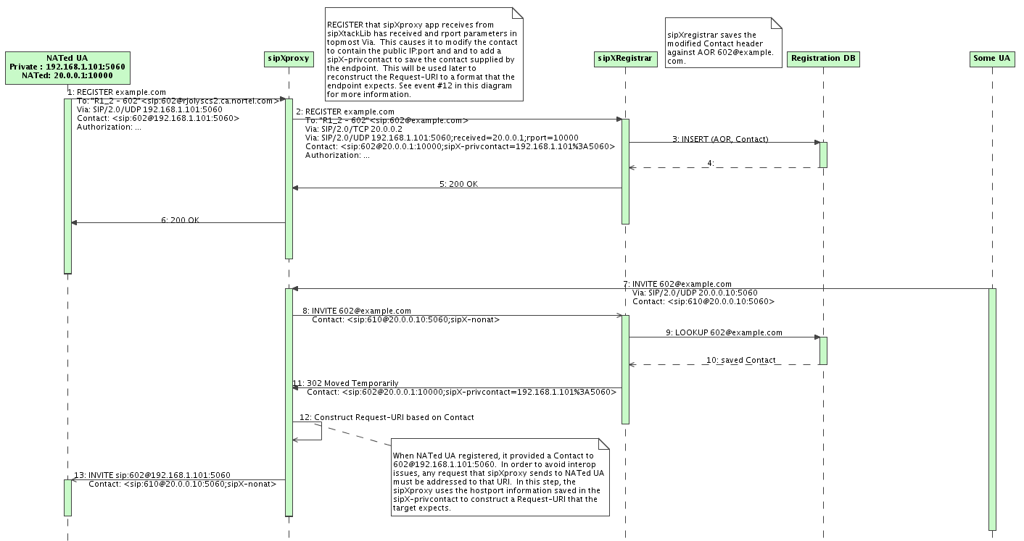
Figure 3 - Registration of a NATed endpoint followed by a call to it
A few notes on the sequence diagram above:
- This shows a simplified view of the system. For one, it does not show the NTAP. The NTAP is inside the sipXproxy and the important take-away for this figure is that message #12 coming out of the sipXproxy contains topology information about the caller in the Contact header and topology information about the callee in the Request-URI
- The SIP messages shown are not complete or well formatted. The objective is to show the minimum set of fields that play a role in the decision logic.
  - Input #2 – Seeing SIP Responses
As stated earlier, NTAP is responsible for implementing most of the NAT Traversal feature logic. One of its duties consists in modifying the media offer/answers to compensate for NATs. This requires the NTAP being able to actually see and modify as needed the SIP requests and responses that flow through sipXecs. The sipXproxy already has mechanisms in place that allow plug-ins to see requests but not responses.
In order to allow NTAP to see and modify responses, a new ‘SipOutputProcessor’ concept was introduced in the siPXtackLib that effectively allows an object to become a SipOutputProcessor and be notified by the sipXtackLib every time a request or response is about to be sent by the stack.
The code in support of that new feature has been delivered as a stand-alone piece of functionality and has been part of the main code since revision 12094. The implementation of that feature will not be discussed further here.
- NAT Traversal Agent plug-in
The NAT Traversal Agent Plug-In (NTAP) is a singleton that is implemented by class NatTraversalAgent in code unit NatTraversalAgent.cpp. NTAP is a SipOutputProcessor as well as an authorization plug-in that sits at the end of the plug-in chain. NTAP is responsible for implementing the bulk of the NAT Traversal feature. Its main responsibilities include:
- Adjusting SIP headers so that SIP requests and responses get properly routed through NATs
- Adjusting SDP offer and answers for NAT traversal
- Act as a client to the Media Relay server and use its XML-RPC interface to configure it to allow proper relaying of media sessions.
At its core, the NTAP is waiting for three types of events:
- As an authorization plug-in, it is waiting for incoming request notifications via its NatTraversalAgent::authorizeAndModify() method.
- As a SipOutpoutProcessor, it is waiting for outgoing requests and responses notifications via its NatTraversalAgent::handleOutputMessage() method.
- It is waiting for periodic timer events via its NatTraversalAgent::signal() method.
With a few exceptions, all the logic required to perform the NAT traversal feature is executed in the scope of the callbacks that handle these three types of events. Because they access shared resources, these three callbacks lock the NTAP mutex before doing any processing and release it when they are done.
The NTAP implementation is not monolithic. It draws on a number of classes and abstractions to implement its logic. The main building blocks are introduced here. Note that the goal is not to exhaustively describe them but rather to briefly present them to facilitate the reading to come. They will be more formally described later in this document.
CallTracker: A CallTracker object is responsible for tracking all the dialogs created within the context of a call-id. CallTracker objects are instantiated and owned by the NTAP.
SessionContext: A SessionContext object is created by a CallTracker for each fork that sipXecs creates. It is responsible instantiating a DialogTracker object for each dialog that will spawn from that fork and allocate the media relay resources that will be shared among its DialogTrackers.
DialogTracker: A DialogTracker object is responsible for tracking the Offer/Answer media negotiation(s) for a specific dialog and requesting the proper SDP transformations and Media Relay configuration changes to allow media to traverse NATs. A given DialogTracker object is instantiated and owned by the SessionContext that created it.
NatTraversalRules: The NatTraversalRules object is responsible for parsing the natTraversalRules.xml configuration file and providing an interface that allows simple access to the configuration and derived information.
  - NTAP Initialization
The initialization process of NTAP consists in four tasks:
- Read & parse the NAT Traversal Rules configuration file
- Initialize the Media Relay
- Start periodic clean-up timer
- Install itself as a SipOutputProcessor.
Initialization steps 1 to 3 are performed within the NatTraversalAgent::readConfig() method which is called by the SipRouter when the NTAP plug-in gets instantiated. Initialization step 4 is performed within the NatTraversalAgent::announceAssociatedSipRouter().
These four initialization steps are described below.
    - Reading & parsing the NAT Traversal Rules configuration file
As part of instantiating the authorization plug-ins, the SipRouter calls the AuthPlugin::readConfig() method on each plug-in. One of the actions performed within AuthPlugin::readConfig() is to read and parse the nattraversalrules.xml file. The task of reading and parsing the nattarversalrules.xml file is performed by the NatTraversalRules class that knows the format of the configuration file and uses the tinyXml parser to extract the configuration information. The nattraversalrules.xml contains the following elements expressed in XPath notation:
Element Path | Description
nattraversal/info/state | Set to ‘enabled’ if the NAT Traversal feature should be enabled.
nattraversal/info/behindnat | Indicates to the NAT traversal feature whether or not the sipXecs is deployed behind a NAT
nattraversal/info/proxyhostport | Represents the native address and port number of the sipXproxy
nattraversal/info/publicaddress | Used to specify the public IP address of the sipXecs. When deployed behind a NAT, this represents the public IP address of the NAT. This field is ignored when the ‘useSTUN’ is enabled as the public IP address will be determined via STUN.
nattraversal/info/publicport | Used to specify the public TCP and UDP ports for sipXecs. When deployed behind a NAT, this represents the TCP and UDP ports of the NAT that are relayed to sipXecs. This field is used even when ‘useSTUN’ as STUN is cannot reliably discover public ports. The default value for this field is 5060.
nattraversal/info/mediarelaypublicaddress | Used to specify the public IP address of the Media Relay. When deployed behind a NAT, this represents the public IP address of the NAT. If left blank and ‘useSTUN’ is enabled then the public IP address of the Media Relay will be determined through STUN.
nattraversal/info/mediarelaynativeaddress | Native IP address of the Media Relay
nattraversal/info/mediarelayxml-rpc-port | Specifies the port to send XML-RCP requests to when talking to the Media Relay
nattraversal/info/concurrentrelays | Specifies the maximum number of Media Relay sessions that NAT Traversal feature will allocate for the purpose of traversing NATs.
nattraversal/info/relayaggressiveness | This setting determines the behavior when tow REMOTE_NATED endpoints with the same public IP address negotiate a media session. When set to ‘Aggressive’, a Media Relay will be used to relay the media between the two endpoints. When set to ‘Conservative’, no Media Relay gets used and the endpoints will a be commanded to stream directly to each other. The default value for this setting is ‘Aggressive’
nattraversal/info/useSTUN | Specifies whether or not STUN should be used to discover sipXecs’ public IP address as well as the media relay’s public IP address if “nattraversal/info/mediarelaypublicaddress” is left blank.
nattraversal/info/STUNRefreshInterval | Specifies the frequency at which STUN refreshes are done. The interval is sprecified in seconds.
nattraversal/info/STUNServer | Specifies the IP address or hostname of the STUN server to discover our public IP address.
nattraversal/localtopology/ipV4subnet[] | Specifies the set of subnets that are considered to be part of the local private network that sipXecs is a part of. These settings are read-only and are borrowed fro mtheInternet Calling feature.
nattraversal/localtopology/dnsWildcard[] | Specifies the set of dns domains that are considered to be part of the local private network that sipXecs is a part of. These settings are read-only and are borrowed from the Internet Calling feature.
Table 1 - nattraversalrules.xml content
The NatTraversalRules class exposes an interface that allows its owners to easily query most of the configuration extracted from the nattraversalrules.xml file.
The NatTraversalRules class does not include any method to query the STUN-related parameters. Instead, when the configuration prescribes the use of a STUN server to discover public IP addresses, it hides the STUN implementation and takes it upon itself to provide a STUN client to discover the public IP addresses for the sipXecs as well as the Media Relay if nattraversal/info/mediarelaypublicaddress is empty. NatTraversalRules users that query the public IP addresses of the sipXecs and the Media Relay via NatTraversalRules:: getPublicTransportInfo() and NatTraversalRules::getMediaRelayPublicAddress() have no idea whether the information they get back was manually entered by the administrator or dynamically acquired though STUN.
The class implementing the STUN client is NatTraversalRules::StubClient and is reusing sipXportLib’s StunQueryAgent to periodically discover the public IP address of the system and report changes back to the NatTraversalRules object.
    - Media Relay Initialization
The Media Relay is a stand-alone process also known as the “Symmitron” that is used by the NAT Traversal feature to successfully pass media through NATs. A full description of the Symmitron is outside the scope of this document, however, in order to understand the media relay initialization code, some concepts specific to the Symmitron implementation used by the NAT Traversal feature will be presented here.
      - Overview of Symmitron concepts
Figure 2 already shows how a media relay can generally be employed to solve the NAT traversal problem for media traffic. The Symmitron used by the NAT Traversal feature is an implementation of such a media relay. The Symmitron is configurable via XML-RPC and offers an API that allows clients (NAT Traversal being an example of one such client) to fully control it. The Symmitron API introduces the following concepts:
Sym: A Sym is a logical entity managed by the Symmitron that listens on a UDP port allocated by the Symmitron. As well, a Sym has a configurable destination IP:port. A Sym has the ability to auto-learn the destination IP:port when configured to do so.
Bridge: A logical association between two Syms for the purposes of relaying packets. Assuming that bridge 1 is created by associating Syms A and B, packets received on Sym A’s UDP port will be sent to Sym B’s destination from its UDP port. Conversely, packets received on Sym B’s UDP port will be sent to Sym A’s destination from its UDP port.
      - Initialization of Symmitron by NAT Traversal feature
Now that we have introduced the basic Symmitron concepts, let’s look at how the NAT traversal feature initializes it. As mentioned earlier, the Symmitron offers an XML-RPC based interface. The XML-RPC interface is asynchronous in nature and given that we do not want to wait for responses to our XML-RPC requests in the call handling path, the Syms and Bridges required by the NTAP are pre-allocated during the initialization phase. The NatTraversalAgent class does not itself directly interface with the Symmitron, instead the MediaRelay class is designed to serve as a facade to the Symmitron and provide a simple interface to make requests to it. After reading the nattraversalrules.xml, if the NAT Traversal feature is enabled, NTAP creates a MediaRelay instance and calls its MediaRelay::initialize() method passing it among other things the Symmitron’s IP address, XML-RPC port number and maximum media relay sessions that need to be allocated as extracted from the nattraversalrules.xml configuration file.
Role of the MediaRelay class in the Symmitron initialization
The MediaRelay class is implemented in code unit MediaRelay.cpp and presents a simple API for requesting services from the Symmitron. The discussion here will not fully describe the functionality provided by the MediaRelay class. Instead it will focus on the portions relevant to the Symmitron initialization which is the topic of this section.
The XML-RPC interface defined by the Symmitron requires that all requests sent to it contain a client instance handle and all responses generated by the Symmitron contain a Symmitron instance handle. These handles must have a specific format: <constant name>:<instance specific name>. The MediaRelay uses the following instance handle: ntap-mediarelay:<pid> where <pid> is the ID of the currently running process. The objective of these instance handles is to allow the Symmitron and its clients (NTAP being one of them) to detect process restarts. To that end, the MediaRelay saves the Symmitron instance handle contained in the first response it receives from the Symmitron. If any future response from the Symmitron shows a different Symmitron instance handle, the NTAP will conclude that the Symmitron process has been restarted and that re-initializartion needs to occur.
All the heavy lifting required to initialize the Symmitron is done in MediaRelay::preAllocateSymmitronResources(). The task of that method is to sign in with the Symmitron and allocate all the Syms and Bridges required to provide the prescribed maximum number of media relays. Given that a media session is composed of both an RTP and RTCP stream, a media relay session requires 4 Syms (1 for RHS RTP traffic, 1 for RHS RTCP traffic, 1 for LHS RTP traffic and 1 for LHS RTCP traffic ) and 2 Bridges (1 associating RHS and LHS RTP Syms and 1 associating RHS and LHS RTCP Syms). The MediaRelay defines a concept called MediaBridgePair to designate a pair of bridges working together to relay both the RTP and RTCP traffic of a media session. The relationship between Syms, Bridges and MediaBridgePair is shown in the figure below:
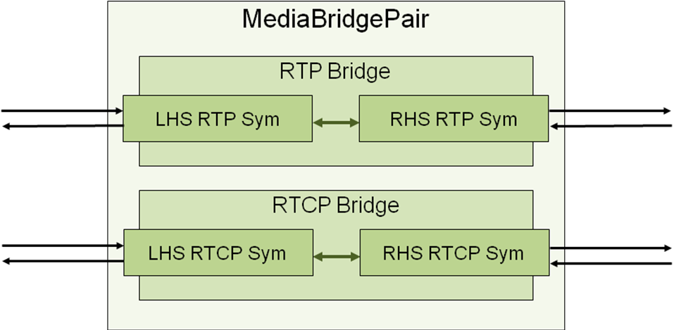
Figure 4 - MediaBridgePair
The first XML-RPC request that is sent to the Symmitron is a SignIn() which is effectively used to exchange instance handles. The MediaRelay saves the symmitron instance handle so that it can detect symmitron process restarts in future responses.
The next step consists in requesting the creation of the Syms. Since we need four Syms per media session, the total number of Syms requested will be 4*<Maximum number for media relay sessions>. In the RTP/RTCP protocol, the parity of port numbers is important – RTP ports should be even and RTCP should be RTP+1. To enforce this requirement, the MediaRelay class will request 4*<Maximum number for media relay sessions> Syms using contiguous UDP ports starting at an EVEN port number. The MediaRelay object allocates a new Sym object for each sym returned by the Symmitron and stores it in the mSymList member variable. The Sym object stores a sym’s Id and IP:Port on the Symitron.
The next step is to ask the Symmitron to create bridges that will associate two Syms together. Assuming the Syms are sorted by ascending port numbers in mSymList, mSymList[0] will be paired with mSymList[num entries in list/2] and so forth until all Syms have been paired. The MediaRelay object allocates a new Bridge object which stores a bridge’s Id as well as pointers to the two associated Sym objects. When a Bridge is created by the Symmitron it is but in ‘initial’ state. In this state, the Bridge is not yet active. The MediaRelay object activates the Bridges it creates by issuing a ‘startBridge’ XML-RPC request followed by a ‘pauseBridge’ request. These operations put the Bridge is a ‘paused’ state. Later on, when we require a Bridge to start relaying media, all that NTAP will have to do is to resume the Bridge via the ‘resumeBridge’ XML-RPC request.
The next step is to take pairs of contiguous bridges and associate them to form a MeidaBridgePair. For each pair of bridges, a new MediaBridgePair object is allocated which stores pointers to the two associated Bridge object. All the resulting MediaBridgePair objects are stored in the mAvailableMediaBridgePairsList.
The final step is to ensure that the Symmitron did not reset while we were pre-allocating all the Syms and Bridges. This is determined by comparing the Symmitron instance Ids of the first and last responses we received from the Symmitron. If they match then we can safely assume that no reset occurred during the pre-allocation. On the other hand, if they differ, this indicates that the Symmitron got reset during the pre-allocation process. This is flagged by returning a failure code. The NatTraversalAgent will re-attempt the initialization 3 more times at 5 seconds intervals before giving up and disabling the NAT Traversal feature altogether.
    - Starting a periodic clean-up timer
As we will see in more detail later in this document, the NatTraversalAgent is responsible for allocating CallTracker objects that track dialogs created in the context of a given call-id. The CallTracker instances need to perform periodic clean-up routines that are timer-based. Instead of having each instance create its own timer, the NatTraversalAgent provides a shared timer and calls CallTracker::handleCleanUpTimerTick() for every CallTracker instance on every timer tick.
NatTraversalAgent::readConfig() uses sipXportLib’s OsTimer to launch a 60 second periodic timer that will be used for that purpose.
    - Installing NatTraversalAgent as a SipOutputProcessor
We have seen earlier that NTAP is a SipOutputProcessor. The sipXtackLib’s SipUserAgent class offers APIs that allows a class to become a SipOutpoutProcessor however, NatTraversalAgent not being a SipUserAgent, it does not have access to those APIs. What NatTraversalAgent really wants to do is to become a SipOutputProcessor for sipXproxy’s SipUserAgent. To get around this problem, a few modifications were made to the existing SipRouter and AuthPlugIn interface to allow NatTraversal to be a SipOutputProcessor for sipXproxy.
The first set of code changes has to do with how an AuthPlugIn learns about its owning SipRouter. Before the proposed modifications, an AuthPlugIn would be told who its owning SiPRouter was on every call made to AuthPlugin::authorizeAndModify(SipRouter*, ...). Given that an AuthPlugin does not change SipRouter owners during its lifetime, supplying that information on every call seemed redundant and prevented AuthPlugins from performing any operation on their owning SipRouter prior to the first call to AuthPlugin::authorizeAndModify(SipRouter*, ...). This feature introduces a change to the AuthPlugin API whereby the owning SipRouter will cease to be supplied as part of AuthPlugin::authorizeAndModify(SipRouter*, ...) and will instead be announced to the AuthPlugin at initialization time via the new AuthPlugin method called AuthPlugin::announceAssociatedSipRouter(SipRouter*).
Code Change
Affected Component | sipXproxy
Method | AuthPlugin::authorizeAndModify()
Nature of change | Remove SipRouter* parameter from method

Code Change
Affected Component | sipXproxy
Method | AuthPlugin::announceAssociatedSipRouter()
Nature of change | Added new method to be used to let the AuthPlugins know who the owning SipRouter is.
Now that we have a reliable way of providing AuthPlugins with their SipRouter information at initialization time, all that is needed to allow NatTraversalAgent to become a SipOutputProcessor for sipXproxy is a series of SipRouter methods that allow the caller to register itself as a SipOutpoutObserver for SipRouter’s SipUserAgent. To that end, two new methods have been added to SipRouter:
Code Change
Affected Component | sipXproxy
Methods | SipRouter::addSipPutputProcessor(SipOutputProcessor*)  SipRouter::removeSipPutputProcessor(SipOutputProcessor*)
Nature of change | Added new methods that allow objects to become SipOutputProcessors for the SipRouter
  - NTAP - Handling of incoming requests
As was mentioned, the NatTraversalAgent plug-in is an authorization plug-in. As such, it implements the AuthPlugin interface and receives a call to authorizeAndModify() for every request that arrives at the sipXproxy. The purpose of this section is to describe how NTAP handles these incoming request notifications. Please refer to the figure below which outlines the implementation of the NatTraversalAgent:: authorizeAndModify() method. The rest of this section will explain its logic and present supporting classes as well as code changes made to existing components to support it.
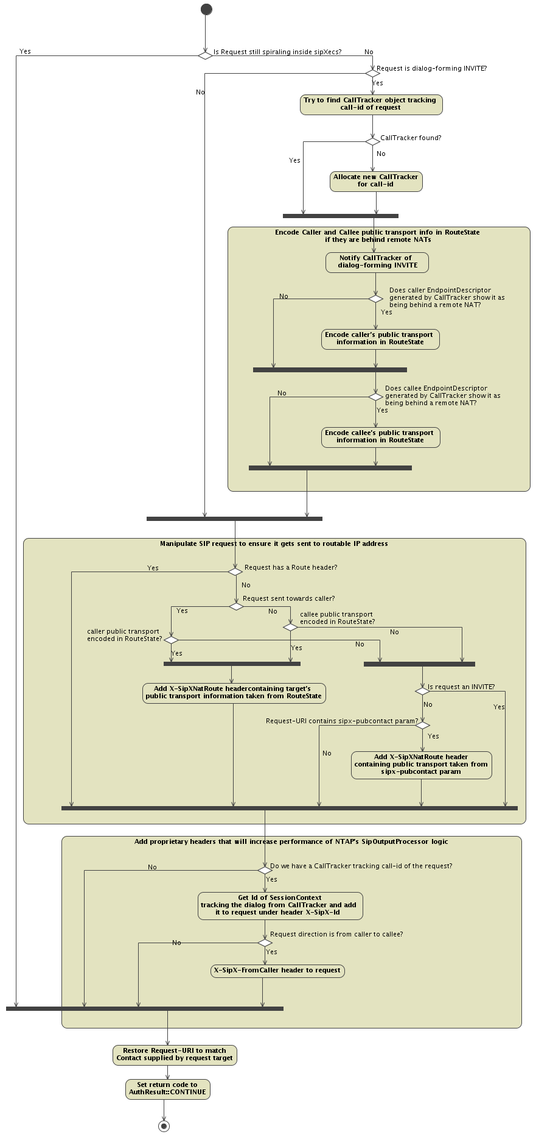
Figure 5 - NatTraversalAgent::authorizeAndModify() logic
    - Choosing which requests to process
When a dialog-forming INVITE arrives at sipXecs, it usually “ping-pongs” (or spirals) between the sipXproxy and the sipXredirectServer one or more times before being sent toward its final destination. The AuthPlugins such as NTAP get a AuthPlugin::authorizeAndModify() callback on every pass. Given that NTAP only needs to process requests that are about to be sent towards their final destination, code has been put in place in NTAP will only pay attention to those requests. This is accomplished by the addition of a new flag parameter to the AuthPlugin::authorizeAndModify() method called bSpiralingRequest.
The bSpiralingRequest flag will be set to 'true' when the request being presented to the plug-in is still spiraling inside sipXecs. That means that the sipXproxy still hasn't identified the request's final target for the request and that it will be presented to the plug-in at least once more before being sent it toward the final target.
The bSpiralingRequest will be set to 'false' when the request presented to the plug-in has finished its spiral inside the sipXecs. This means that sipXproxy has identified the final target for the request and that it is presenting it to the plug-in for the last time before sending it toward the final target.
As seen in the figure above, the NTAP will only process incoming requests when the bSpiralingRequest flag is false.
The SipRouter is responsible for properly initializing the bSpiralingRequest before invoking auhtorizeAndModify() for all its authorization plug-ins. In support of this new flag, the SipRouter has to be instrumented to reliably determine when a given request has finished spiraling. Essentially, sipXproxy can know that a request has finished spiraling when the request target is not the sipXregistrar/redirect server. To that end, the forwardingrules.xml file has been changed to add a proprietary ‘routetoreg’ URL parameter to the routes that point to the sipXregistrar/redirect server. When the sipXproxy evaluates the forwarding rules, it inspects the returned route looking for the ‘routetoreg’ URL parameter. If one is found, it is removed and the bSpiralingRequest flag is set to true when calling authorizeAndModify() for all the authorization plug-ins, otherwise the bSpiralingRequest flag is set to false.

Code Change
Affected Component | sipXproxy
Method | AuthPlugin::authorizeAndModify()
Nature of change | Add a new bSpiralingRequest parameter that tells authorization plug-ins whether or not the request to authorize and modify is still spiralling inside sipXecs.  A request can spiral numerous times inside sipXecs and it will be presented to the authorization plug-ins on every loop of the spiral. Plug-ins that are only concerned with the final requests and not the spiraling ones can make use of that flag to skip the processing of spiraling requests by returning AuthResult::CONTINUE when bSpiralingRequest == true and only process the requests that have bSpiralingRequest == false.  Note that the necessity or lack thereof of processing spiraling requests is entirely dictated by the function that a certain plug-in is implementing.  Some plug-ins will need to process a request on every loop of the spiral whereas some can get away with only processing the final request as it is about the exit the spiral and be sent toward the final target. As a CPU conservation measure, plug-ins that do not need to process spiraling requests should skip them and only process the final request (bSpiralingRequest == false).

Code Change
Affected Component | sipXproxy
Method | SipRouter::proxyMessage()
Nature of change | Inspect route returned by ForwardingRules::getRoute() looking for ‘routetoreg’ parameter to determine whether or not the request is still spiralling and set the bSpiralingRequest flag correctly when calling AuthPlugin::authorizeAndModify()

Code Change
Affected Component | sipXconfig
File | sipXconfig/neoconf/etc/commserver/forwardingrules.vm
Nature of change | Adding ‘routetoreg’ URL parameter to the route of the following rules:  - SUBSCRIBE request catch-all rule that directs non-matching SUBSCRIBEs to the sipXregistrar/redirect server.  - Default catch-all rule that directs non-matching requests to the sipXregistrar/redirect server.
    - Tracking new calls
The NTAP needs to keep state information for all the media session negotiations that happen in the system to properly manipulate the SDP offers and answers for NAT Traversal. The NTAP relies on three kinds of objects to accomplish that task – CallTrackers, SessionContexts and DialogTrackers. The relationship between the NatTraversalAgent and these objects are as follows:
Figure 6 - Relationship between NatTraversalAgent, CallTracker, SessionContext and DialogTracker
If the incoming request is a dialog-forming request as determined by the RouteState being mutable, the NTAP will extract the Call-id from the request and use it as a key to index the mCallTrackersMap. If the lookup returns nothing, the NTAP will allocate a new CallTracker object and save its pointer into the mCallTrackersMap against the Call-id. The CallTracker design will be detailed later in this section.
    - Presenting dialog-forming INVITEs to the CallTracker
We have already seen that the CallTracker is used to track all the dialogs that happen in the context of a specific Call-id. Whenever the NTAP sees a dialog-forming INVITE, it will present it to the CallTracker for that Call-id by calling CallTracker:: notifyIncomingDialogFormingInvite() so that it can do the necessary to initiate tracking of that new dialog.
For normal cases, the logic of CallTracker:: notifyIncomingDialogFormingInvite() is quite straight-forward but it can get somewhat complicated in cases where dialog-forming requests visit the sipXecs twice before reaching the final destination. In this section, we will only present the simple case and we will deal with the more complicated case later.
The CallTracker, upon being notified of an incoming dialog-forming INVITE will instantiate a new SessionContext object to track the dialog. That SessionContext is assigned a Session Context Handle which is chosen by the creating CallTracker - that handle is not derived from any field in the INVITE request. The CallTracker saves the pointer to the SessionContext in mSessionContextsMap using the chosen Session Context Handle as the key. The CallTracker then encodes the chosen handle in the RouteState under parameter name ‘id’. This will ensure that every in-dialog request carries its associated Session Context Handle encoded in the RouteState. The CallTracker also interrogates the EndpointDescriptor created for the caller endpoint to find out its location category. If the caller is REMOTE_NATED, the pinhole that was created by the NAT/FW to relay the dialog-forming INVITE to sipXecs must be maintained open to ensure any in-dialog requests reach it. To that end, the public IP Address and port of the caller are communicated to the NatMaintainer via NatMaintainer:: addEndpointToKeepAlive() to maintain the pinhole. Please refer to section 4.4 for more information.
In summary, the in-dialog request’s Call-Id lets the NatTraversalAgent retrieve the CallTracker object tracking the call and the ‘id’ parameter of the RouteState allows CallTracker to retrieve the SessionContext object that handles the specific dialog.
    - Determining the location category of the endpoints
Note: in the discussion that follows, the word ‘transport’ does not denote a transport protocol as the ‘transport=’ SIP URL parameter does. Instead it is used in a broader sense to designate the tuple formed by an IP address, port number and transport protocol.
      - Determining endpoint location category
We have seen in Figure 5 that one of the steps of the NatTraversalAgent::authorizeAndModify() logic is to encode public transport information about the caller and callee when they are behind remote NATs. This present sub-section will shed some light on how this is achieved and will present the logic that determines the location of the caller and callee.
We have already seen in section 3.1 how the sipXproxy adds sipx-privcontact or sipx-nonat to the Contact and Request-URI fields to convey location information about the caller and the callee respectively. This section will show how the NTAP turns these inputs into the location information it needs to carry out its business. Essentially, the NatTraversalAgent needs to classify each caller and callee into one of four location categories:
- PUBLIC: Designates an endpoint that has a direct presence on the public internet without any intervening NATs. P_1 and P_2 in Figure 1 are examples of public endpoints.
- REMOTE_NATED: Designates an endpoint that is located inside a NAT-fronted private network that is remote from the sipXecs. R1_1 and R2_1 in Figure 1 are examples of remote NATed endpoints.
- LOCAL_NATED: Designates an endpoint that is located in same network as the sipXecs and that network is fronted by a NAT. L_1 and L_2 in Figure 1 are examples of remote NATed endpoints.
- UNKNOWN: Designates an endpoint whose location cannot be determined due to lack of sipx-… parameters
The logic that categorizes the location of the caller and callee is found in a class called EndpointDescriptor. When a SessionContext object gets instantiated by CallTracker, it allocates two EndpointDescriptors, one called mpCaller to describe the caller and the other called mpCallee that describes the callee.
The EndpointDescriptor knows to look for the proprietary sipx-privcontact and sipxnonat parameters in URIs to deduce the location of an endpoint.
When constructing the EndpointDescriptor object representing the caller, SessionContext passes it the URI extracted from the Contact header. Conversely, when constructing the EndpointDescriptor object representing the callee, SessionContext passes it the Request-URI as well as a pointer to the Registration DB. The following diagram shows how the EndpointDescriptor uses the provided information to extract the native and public transport information and to figure out which location category an endpoint falls into.

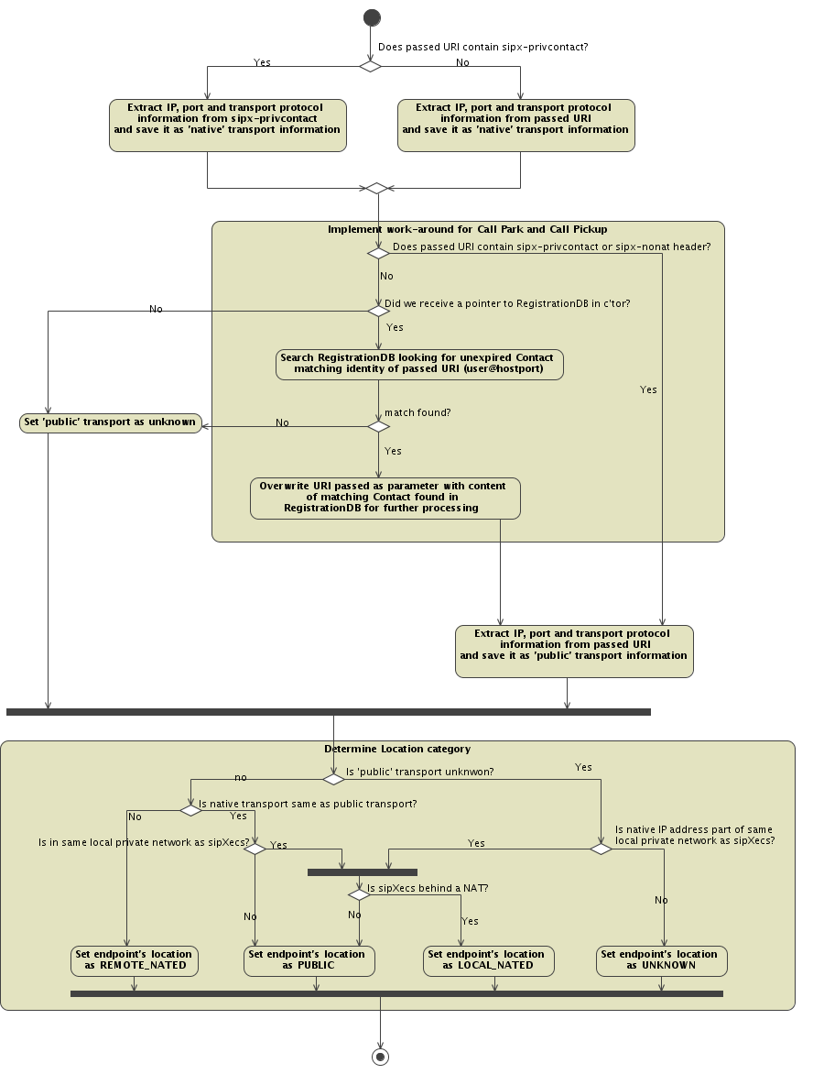
Figure 7 - Determining location category as well as Native and Public Transport information
      - Working around Call Pickup and Call Park features
When unparking a packed call, the Call Park server sends a REFER containing a Refer-To carrying a URI taken from a Contact header. This typically causes the processing device to send out an INVITE containing an IP address in the Request-URI. Assuming that the sipXecs is configured as the outbound proxy for that phone, it will receive that INVITE and because its Request-URI is not part of the SIP domain that sipXecs is authoritative for, the sipXregistrar will not be consulted meaning that our sipx-privcontact and sipx-nonat which are vital to the determination of the location category will not be added to the Request-URI.
A similar problem exists with Call Pickup whereby the URI in the Contact header of the 302 Moved Temporarily it generates has the IP address of the ringing phone meaning that the INVITE produced by sipXproxy while recursing through the 302 will have a Request-URI exempt of our sipx-privcontact and sipx-nonat.
The absence of sipx-privcontact and sipx-nonat means that the NTAP cannot accurately categorize the location of the endpoint. To get around this problem a scheme has been devised whereby whenever an EndpointDescriptor gets passed a URI that does not contain any of our proprietary location headers, it will try to find an unexpired Contact in the registration database that matches the identity of the URI. So, for example, if EndpointDescriptor is passed a URI of value “sip:3000@192.168.9.1:5060;paramXYZ”, it will search the database looking for a registered contact containing “3000@192.168.9.1:5060”. If one is found, it will contain either a sipx-privcontact or sipx-nonat (as all contacts in RegistrationDB do) which will get used to determine the location of the user.
This scheme is a brute force approach to a problem that cannot be solved any other way until GRUU becomes widely adopted. It also has the limitation that if two distinct UAs register the exact same contact (which can happen if they are inside distinct remote private networks with overlapping private IP address ranges), the logic will not know which to prefer and will have to choose one arbitrarily.
      - sipXecs local private network
We can see in Figure 7 some decision points related to sipXecs’s local private network. This sub-section clarifies that point. Referring to Table 1,we can see that the nattraversalrules.xml contains ipV4Subnet and dnsWildcard elements that define the set of subnets and DNS sub-domains that constitute the private network that sipXecs is part of. Together, ipV4Subnet(s) and dnsWildcard(s) define the network that we refer to here as sipXecs’s local private network. The NatTraversalRules class already introduced earlier in this document has a method called isPartOfLocalTopology() that allows its caller to determine if a given IP address or FQDN is inside sipXecs’s local private network. EndpointDescriptor employs NatTraversalRules:: isPartOfLocalTopology() in its logic for that purpose.
    - Reaching endpoints behind remote NATs
      - SipXNatRoute - a mechanism to overrule SIP routing decisions within the stack
Endpoints that are behind remote NATs (i.e. belonging to location category REMOTE_NATED) require special handling to ensure that requests can be delivered to them. If we solely relied on existing SIP mechanisms, requests to such endpoints would get sent to their private IP addresses which are non-routable. To overcome this problem, the NAT Traversal feature introduces a mechanism called the sipXNatRoute to overrule the SIP request routing decisions that would normally occur within the sipXtackLib.
The SipxNatRoute can be viewed as a temporary route construct that is only understandable by the sipXtackLib and takes precedence over all other SIP routing headers (Route, maddr, Request-URI) when sending requests. The SipXNatRoute allows applications such as NAT Traversal to customize the way requests are being sent out to ensure that the intended endpoints receive their request.
Code Addition
Affected Component | sipXtackLib
Method | [new] SipMessage::getSipXNatRoute()  [new] SipMessage::setSipXNatRoute()  [new] SipMessage::removeSipXNatRoute()
Nature of change | New methods to get, set and remove the x-SipXNatRoute proprietary header in a SIP message

Code Change
Affected Component | sipXtackLib
Method | SipTransaction::prepareRequestForSend()
Nature of change | Change routing logic so that x-SipXNatRoute takes precedence over all other SIP routing mechanisms.

Code Change
Affected Component | sipXtackLib
Method | SipUserAgent::dispatch()
Nature of change | Added code to systematically remove x-SipXNatRoute headers from every incoming request. This is done to prevent upstream SIP devices to control how sipXecs will route requests with x-SipXNatRoute headers.

      - Using SipXNatRoute to reach REMOTE_NATED endpoints
Endpoints that are categorized REMOTE_NATED will not receive requests from sipXecs unless NatTraversalAgent intervenes.
When processing a dialog-forming INVITE
When processing dialog-forming requests, NatTraversalAgent calls CallTracker::notifyIncomingDialogFormingInvite() which returns EndpointDescriptors for both the caller and the callee. NatTraversalAgent looks at the location categories of the returned caller and callee EndpointDescriptors to see if these endpoints are located behind a remote NAT. If so then special processing is required to ensure that the requests will be sent to the endpoint's public IP address and not its private IP address as will be the case if nothing is done about it. The approach is as follows. The caller and callee’s EndpointDescriptors are interrogated to obtain their locations categories. If the caller is REMOTE_NATED then a 'CrT' (CallerTransport) parameter containing the caller's public transport information will be encoded in the RouteState. If the callee is REMOTE_NATED then a 'CeT' (CalleeTransport) parameter containing the callee's public transport information will encoded in the RouteState. Having the caller and callee’s public transport encoded directly in the RouteState ensures that this information can be directly extracted from any subsequent in-dialog request without having to perform CallTracker and SessionContext object lookups.
When processing any request
We have seen in the previous paragraph how NatTraversalAgent encodes in the RouteState the public transport information of REMOTE_NATED endpoints when processing dialog-forming INVITEs. This paragraph will show the information encoded in RouteState is utilized to overrule SIP routing decisions via the SipXNatRoute.
Before adding a SipXNatRoute, the NatTraversalAgent performs a number of checks. First, NTAP checks to see if the message has a Route header. If it does, it means that the request will not be sent to endpoint directly but rather, to an intermediate node. In such cases we refrain from using SipXNatRoute as it would bypass that node.
Next, NTAP checks whether the request is traveling in the caller->callee direction or the other way around. This is determined by interrogating RouteState which already has that knowledge built in. If the request is travelling towards the callee then NTAP looks for a ‘CeT’ parameter in the RouteState. If one is found, NTAP requests the addition of a SipXNatRoute header set to the value of CeT parameter. A symmetrical operation is performed when the request is found to travel towards the caller.
Note that RouteState is only employed for INVITE requests. Other requests such as SUBSCRIBE do not have a RouteState meaning that no ‘CeT’ or ‘CrT’ can ever be found for those requests. In such cases, a SipXNatRoute is added to the hostport of the Contact which is assumed to contain the public IP:port of the endpoint. Such a mechanism makes it possible for non-INVITE requests to reach REMOTE_NATED phones.
    - Performance Optimization Code
The final operation performed by NatTraversalAgent::authorizeAndModify() aims at reducing the amount of work that NatTraversalAgent::handleOutputMessage() will have to do when it processes the request as it exits the system. More specifically, the optimization relieves the NatTraversalAgent::handleOutputMessage() method from having to decode a request's RouteState to extract two pieces of information that are encoded in it that it requires, namely, the Session-Id ("id") and the directionality of the request. Given that the operation of decoding the RouteState from a message is somewhat expensive and given that NatTraversalAgent::authorizeAndModify() has already decoded it, the method simply writes these two information elements in plain-text as proprietary headers that it adds to the request. NatTraversalAgent::handleOutputMessage() can simply extract the information it needs from the headers without having to decode the RouteState and then remove the headers from the message.
RouteState’s “id” parameter is copied in a X-SipX-Id header.
If the request is traveling towards the callee, a X-SipX-FromCaller header is added.
    - Code changes made to existing sipXecs components
As we have seen NatTraversalAgent::authorizeAndModify() plays an important role in the NAT Traversal feature. One of its key roles is to ensure that all requests reach endpoints that are REMOTE_NATED by adding SipXNatRoute headers. Prior to the implementation of the NAT Traversal feature, SipRouter refrained from presenting ACK requests to the AuthPlugins. Given that NatTraversalAgent::authorizeAndModify() needs to see all requests to ensure that they reach their intended destination, SipRouter was modified to also present ACKs to its authorization plug-ins.
Code Change
Affected Component | sipXproxy
Method | SipRouter::proxyRequest()
Nature of change | Removed check that presented AuthPlugin::authorizeAndModify() from being called for ACK requests
  - NTAP - Handling of outgoing messages
When an overview of NatTraversalAgent was given it was mentioned that in addition to being an Authorization plug-in, the NatTraversalAgent is also a SipOutputProcessor for sipXproxy meaning that it will receive a NatTraversalAgent::handleOutputMessage( destIP, destPort ) call each time a request or response is about the leave the proxy.
It is in the NatTraversalAgent::handleOutputMessage() that the NatTraversalAgent accomplishes most of the work required to traverse NATs:
- It adjusts the value of the topmost Via of requests so that UAS can route responses back to sipXecs;
- It adjusts the value of Record-Route of both requests and responses to ensure that UAC and UAS can reach sipXecs in subsequent in-dialog requests;
- With the help of CallTracker, SessionContext and DialogTracker, it tracks the media offer/answer exchanges and adjusts them to ensure NAT traversal of media. It also configures the Symmitron accordingly.
The following sections discuss the design of the various functions of NatTraversalAgent::handleOutputMessage() in greater detail.
    - Adjusting topmost Via for requests
Whenever NatTraversalAgent::handleOutputMessage(destIP, destPort) is called to notify the NTAP of an outgoing request, that request and its destination IP address and port are analyzed to figure out if the topmost Via should be adjusted before being sent.
By default, the transport layer of the SIP stack will add a top Via containing the native IP address of the sipXproxy. Since the SipOutputProcessors are after the transport layer of the SIP stack, they get to see the Via that just got added.
Looking at NatTraversalRules, if the sipXecs is not behind a NAT then having the native IP address of the sipXecs in the topmost Via is correct given that it is reachable from the request’s destination. However, if sipXecs is behind a NAT, the NatTraversalRules are consulted again to determine if the request’s destination is part of sipXecs’s local private network. If it is then having sipXecs’s native IP address in the top is correct again as it is reachable from the request’s destination. On the other hand, if the request’s destination is not part of sipXecs’s local private network, the Via needs to be changed to carry sipXecs’s public IP address to ensure that the request’s destination will be able to route the response back to sipXecs. The NatTraversalAgent::adjustViaForNatTraversal() method implements the logic just described.
    - Adjusting Record-Route for requests and responses
The task of adjusting the Record-Route is somewhat more complicated than adjusting the Vias as described above. The main difference is that the logic needs to treat requests and responses differently.
      - Adjusting Record-Route headers in requests
By default, the sipXproxy Record-Routes dialog-forming requests using its native IP address. A logic very similar to the one used to adjust Vias is applied here to ensure that the sipXecs IP address carried in the topmost Record-Route is reachable from the downstream SIP element so that it can successfully route in-dialog requests originated by the UAS.
      - Adjusting Record-Route headers in responses
The adjustment of the Record-Route headers in responses is required to ensure that the sipXecs IP address carried in the Record-Route is reachable from upstream SIP elements so that the UAC can successfully initiate subsequent in-dialog requests. The Record-Route fields that a response carries are a copy of the Record-Routes that the request accumulated while it travelled through the network. No assumptions can be made about the number of Record-Route fields or the position of the sipXecs ones. It is also possible to find multiple Record-Routes for the same sipXecs if it got visited numerous times by a request while it was being routed towards its final destination. Given that, the logic needs to scan the Record-Route fields starting from the top in search of one that matches either our public or private IP address and has not yet been ‘adjusted’. When such a Record-Route is found, its IP address is modified if required to make it reachable by the upstream SIP element using the same criteria that were used for Via adjustments. Once this is done, the Record-Route field is marked as ‘adjusted’ by adding a ‘SipX-Done’ URL parameter to it. This marking is done to handle cases where a response contains several Record-Route entries for sipXecs – the ‘SipX-Done’ marker will prevent sipXecs from re-adjusting a Record-Route header that it already adjusted.
    - Dispatching SIP requests and responses
This section describes the steps taken to dispatch each SIP requests and response to the objects that are responsible for tracking them. More specifically, the section will detail how requests and responses get passed from NatTraversalAgent::handleOutputMessage() to the correct CallTracker instance and from there to the correct SessionContext instance and then to the correct DialogTracker instance where they will finally be processed.
      - Dispatching requests and responses to CallTracker
Once the NatTraversalAgent::handleOutputMessage() has completed the tasks of adjusting the Via and Record-Route(s) header(s), it is ready to present the outgoing message to the CallTracker object that is in charge of the call for further analysis and processing. To that end, the NTAP extracts the call-id from the message and uses it as a key to index the mCallTrackersMap UtlHashMap. If a CallTracker object exists for the call-id, it will be returned by the look-up. If the message is a request, CallTracker::handleRequest() will be called otherwise CallTracker::handleResponse() will.
      - Handling of requests and responses by CallTracker
The CallTracker is an object that is used to track the dialogs that share a common call-id. The CallTracker itself does not implement the state machines to track dialogs – it delegates that task to SessionContext objects that it creates when new dialogs are detected.
The main task of CallTracker, when it comes to handling outgoing requests and responses, is to figure out which of its SessionContext objects should handle it.
Dispatching requests to the correct SessionContext object
In the case of requests, the task of finding which SessionContext object should handle it is quite simple since the handle of the SessionContext responsible for handling the request is available in plain-text from the X-SipX-Id (section 4.2.6 already showed how NatTraversalAgent::authorizeAndModify() adds this header to make CallTracker’s life easier). The CallTracker extracts the SessionContext handle from that header and uses it as a key to lookup mSessionContextsMap and retrieve the associated SessionContext object. CallTracker calls that object’s bool SessionContext::handleRequest(SipMessage& message, const char* destAddress, int destPort, bool bFromCallerToCallee ) method.
It is important to note that the SessionHandle::handleRequest() returns a boolean flag. This flag is a way for SessionContext to indicate to CallTracker whether or not it wants to be notified of the response(s) to that request. We will see in the next paragraph how that return code is handled by CallTracker.
Dispatching responses to the correct SessionContext object
The task of dispatching responses to the correct SessionContext object is a little more convoluted because the SessionContext handle is not readily available anywhere in the response by default. To associate responses with SessionContext objects, the CallTracker relies on information it adds to Via headers. More specifically, when the SessionContext::handleRequest() returns true indicating that the response to the request should be tracked, CallTracker adds a proprietary Via parameter called ‘id’ containing the SessionContext handle to the second Via.
That way, when a response is seen by CallTracker::handleResponse() it looks at the topmost Via and extracts the SessionContext handle from the ‘id’ parameter it previously added and uses it to lookup mSessionContextsMap which yields the SessionContext object that is interested in the response. Although this strategy works most of the time, there is a scenario where it does not work. More specifically, for reasons that remain unknown, when sipXproxy is selecting the ‘best’ response for forked calls and that ‘best’ response happens to be a non-200 final response, the topmost Via of that response drops our ‘id’ parameter such that it is impossible to retrieve the SessionContext to handle the response. To get around that problem, every time the CallTracker creates a new SessionContext to handle a new fork of the call, it will save the branch-id of the second Via it against the handle of the SessionContext in mBranchIdToSessionHandleMap. When the CallTracker fails to find its ‘id’ parameter in the topmost Via and it is dealing with a non-200 final response to an INVITE, it extracts the branch-id of the topmost Via and performs a lookup of mBranchIdToSessionHandleMap to get back a SessionContext handle that will then be used to look-up mSessionContextsMap to get the SessionContext instance that is responsible for handling the response..
Clarification about the use of Vias: We have seen that the branch-id of the second Via of requests gets used to insert elements into mBranchIdToSessionHandleMap while the top Via of responses are used to perform the lookup. That asymmetry may seem puzzling at first – the explanation has to do with the point at which SipOutputProcessors get notified of requests and responses relative to when the SIP Stack adds and removes Via headers. In the case of requests, the SipOutpoutProcessor sees the request after the transport layer of the SIP stack meaning that the topmost Via will be the one that was freshly added by the stack – let’s call this Via header via_fresh. In the case of responses, the transport layer removes the top Via header when the message enters it which means that by the time SipOutputProcessor sees the response as it leaves the sipXproxy, via_fresh has long been removed. From the point-of-view of the response SipOutputProcessor, the top Via is the one that was under via_fresh when the request was initially seen by the SipOutputProcessor. That behaviour explains why the branch-id of the second Via is used for requests while the branch-id from the top one is used for responses. Note that this logic is somewhat dangerous as it assumes that the second Via of a request is not found in any other transaction. In the current design, this is guaranteed by the fact that sipXproxy sends every forked dialog-forming INVITE to itself which ensures the uniqueness of the Via however if that ‘sending-to-self’ behaviour were to be removed from sipXproxy, that would impact this feature.
    - Request and response processing inside SessionContext
The previous section described how the outgoing requests and responses get presented to the correct instance of SessionContext for processing. This section describes the role of SessionContext and explains the processing that it performs on incoming requests and responses.
The main responsibility of the SessionContext object is to instantiate a DialogTracker object for each dialog that gets established (early or confirmed) by the responses it processes. It is also responsible for dispatching the incoming requests and responses to the DialogTracker tracking the dialog they belong to. Finally, it is responsible for allocating the Symmitron resources that will be shared among the DialogTrackers and expose methods via its SessionContextInterfaceForDialogTracker interface through which its DialogTrackers can interact with the Symmitron.
      - Request processing inside SessionContext
A SessionContext object is informed that a SIP request needs to be processed when the owning CallTracker calls its SessionContext::handleRequest() method. The purpose of this present sub-section is to describe how SessionContext handles these requests.
When a SIP request is presented to SessionContext for processing via a call to its SessionContext::handleRequest() method, it tries to identify which of its DialogTracker is tracking the dialog that this request belongs to. To that end, if the request is in the caller-to-callee direction it extracts the tag from the To field, otherwise it extracts it from the From field. The extracted tag is then used to look up its mDialogTrackersMap HashMap which maps a discriminating tag to a DialogTracker instance. If the look-up turns up a DialogTracker (as it should in normal cases), the retrieved tracker’s DialogTracker::handleRequest() method is called so that it can process it.
If instead the To-tag is nil, this is usually indicative of a dialog-forming request meaning that no DialogTracker has yet been assigned to track it. If the request is an INVITE and it is traveling in the caller->callee direction, it is assumed to be a dialog-forming request that requires special handling worthy of its own sub-section.
        - Special handling of dialog-forming INVITEs
When the SessionContext sees a dialog-forming INVITE, it does not yet have a DialogTracker allocated for it as the dialog is in the process of being formed; yet, the request needs to be handled by a DialogTracker so that it can receive proper treatment for NAT compensation. To that end, upon receiving its first dialog-forming INVITE, the SessionContext allocates what will be called a ‘reference’ DialogTracker that does not really track a specific dialog but instead is used to process the dialog-forming request until a dedicated DialogTracker can be allocated to track it if/when established. This ‘reference’ DialogTracker does not differ from the other DialogTrackers in implementation. Its only distinction is in how it is being used by SessionContext: it is not tracking a specific dialog and will only be called upon to process the dialog-forming INVITE until dialog-specific DialogTrackers get allocated as dialogs get established. In its lifetime, a given ‘reference’ DialogTracker will only process one event and that is the dialog-forming INVITE.
We will see in the next section how the ‘reference’ DialogTracker will be used to seed the DialogTrackers that will be created to track established dialogs.
      - Response processing inside SessionContext
A SessionContext object is informed that a SIP response needs to be processed when the owning CallTracker calls its SessionContext::handleResponse() method. The purpose of this present sub-section is to describe how SessionContext handles these responses.
When a SIP response is presented to SessionContext for processing via a call to its SessionContext::handleResponse() method, it tries to identify which of its DialogTracker is tracking the dialog that this response belongs to. To that end, if the response is in the caller-to-callee direction it extracts the tag from the To field, otherwise it extracts it from the From field. The extracted tag is then used to look up its mDialogTrackersMap HashMap which maps a discriminating tag to DialogTracker a instance. If the look-up turns up a DialogTracker, the retrieved tracker’s DialogTracker::handleResponse() method is called so that it can process it. On the other hand, if the look-up fails to return a DialogTracker, what happens next depends and the response code as explained next.
- If the response is a provisional or success response (1xx-2xx) to the dialog-forming INVITE based on its CSeq and carries a non-nil discriminating tag, then we are in the presence of a response that establishes a dialog (‘early’ for 1xx responses or ‘confirmed’ for 2xx) and as a consequence a new DialogTracker needs to be allocated for it. The new DialogTracker is created as an exact copy of the ‘reference’ DialogTracker which already processed the dialog-forming INVITE request. This leaves the new DialogTracker’s state machine in a state where it is ready to handle the responses to that request. Once the copy is made, the new DialogTracker is added to the mDialogTrackersMap using its discriminating tag as the key and its DialogTracker::handleResponse() is called to handle the response.
- If the response is a final failure response (>4xx) and we cannot connect its discriminating tag to any of the already allocated dialogs, this indicates that the downstream device is rejecting our attempt to establish a session. As a result, all the dialogs created in the context of the SessionContext need to be aborted. This is done by presenting the failure response to every DialogTracker that SessionContext had allocated by calling their DialogTracker::handleResponse() method.
    - Request and response processing inside DialogTracker
The basic idea is simple: whenever the endpoints (A and B) involved in a dialog are separated by NAT(s) the DialogTracker needs to intervene in the media negotiation process to insert the Symmiton in the media path. The net result is that endpoint A will exchange media packets with a Sym on the Symmitron. Endpoint B will exchange media packets with another Sym on the Symmitron. The two Syms form a Bridge on the Symmitron so that media packets pass back and forth between them et voila.
The sub-sections that immediately follow will describe the functionality that is required to implement that ‘basic idea’ and show how requests and responses get massaged to pass media through NATs.
      - DialogTracker class overview
DialogTracker instances are owned by a parent SessionContext and each DialogTracker is allocated to track one specific dialog.
The DialogTracker makes use of a state machine to track the media negotiations that happen within a dialog. The public interface of the DialogTracker class can be divided into three categories:
- External events notification methods: methods to be called by owning SessionContext object to tell DialogTracker that is needs to process an event. There are basically three kinds of events that the DialogTracker can handle: SIP request, SIP response and the ‘clean-up’ timer tick. These events constitute the entire set of inputs to the state machine.
- State Machine Helper methods: Each state of the state machine used by DialogTracker to track media negotiations is implemented as a data-less class. All the data needed by the state machine is held inside the DialogTracker class. DialogTracker offers a series of methods that let the various state machine state classes access and modify that data.
- Miscellaneous: Methods required by UtlContainable and UtlFsm, ...
      - Finite State Machine used by DialogTracker
The heart of the DialogTracker logic resides in the Finite State Machine (FSM) it uses and the methods it provides to support it. The FSM is implemented using sipXportLib’s UtlFsm framework which provides template-based constructs to facilitate the implementation of state machines. In the UtlFsm framework, each state in the state machine is modeled by a Class whose member functions represent all the events that the state can handle. Each state class is ultimately derived from the same base class which provides a default implementation for all the possible events that the state machine can receive. The default implementation usually consists in handling retransmitted SIP messages or logging an ‘unexpected event received’ message. The state classes do not hold any data. Instead when they receive an event, they get passed a reference to the associated DialogTracker instance. Using DialogTracker’s state machine helper methods, a state Class can operate on the data information stored in it. The following figure shows the class diagram of the state classes that make up the FSM used by DialogTracker and the figure following it shows the state diagram of the FSM.
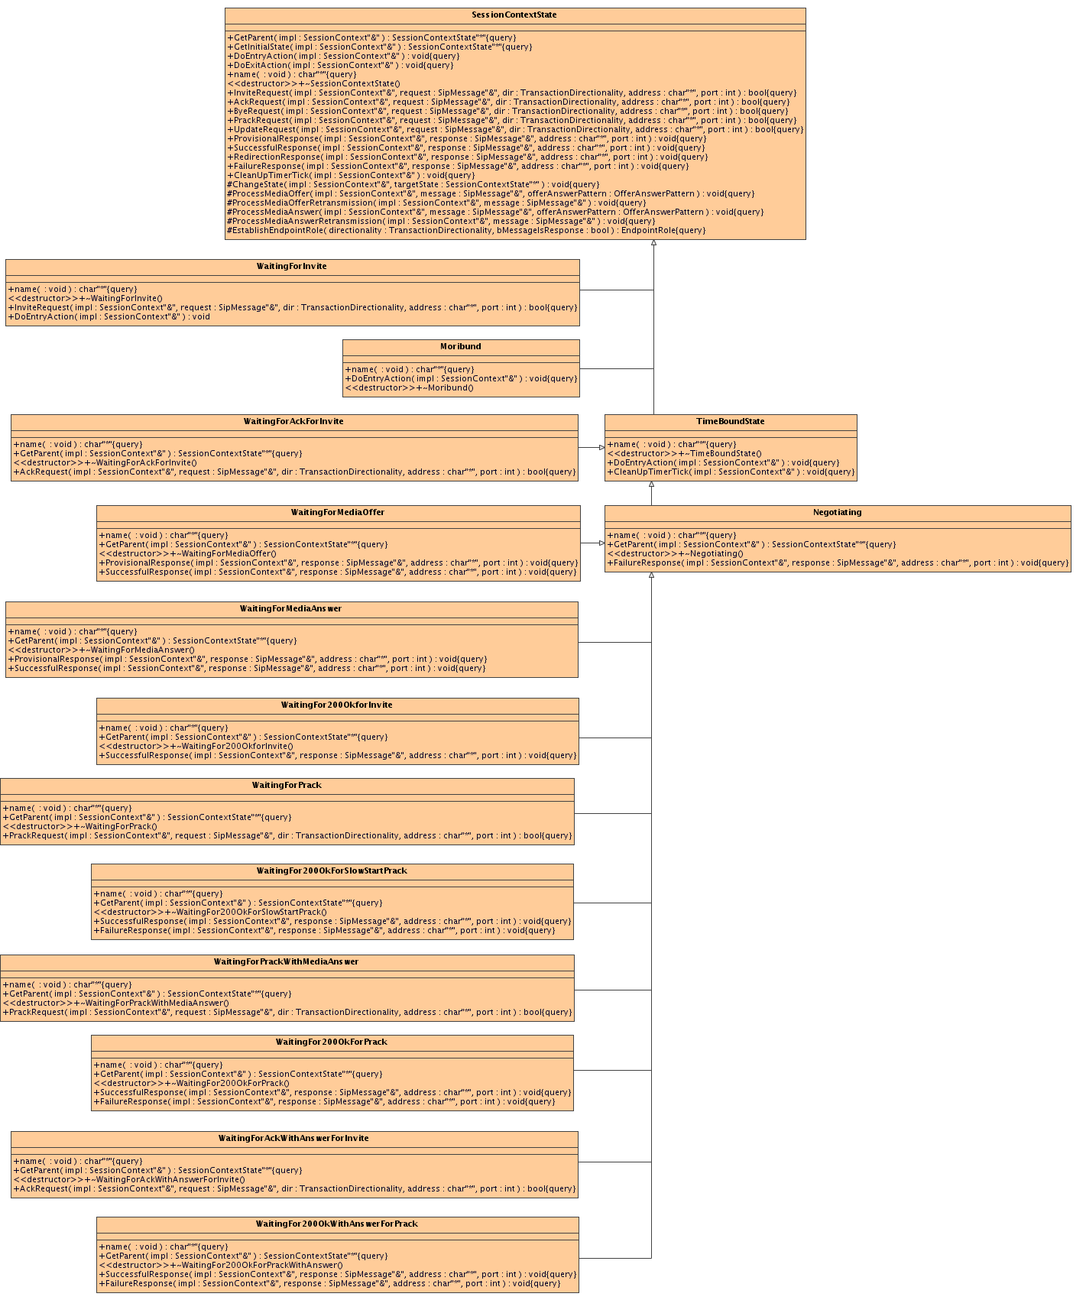
Figure 8 - State classes making up the FSM used by DialogTracker
Each of the classes depicted in Figure 8 represents a state of the FSM. Taking the ‘WaitingForInvite’ class as an example:
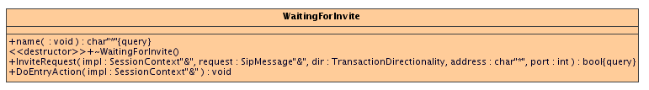
We can see that the class has three methods and a destructor.
The WaitingForInvite::name() method is required for all state classes utilizing the UtlFsm framework and is use report the name of the state for logging purposes.
The WaitingForInvite::DoEntryAction() is an optional method that is implemented by states that need to perform specific actions upon entry. The UtlFsm framework will automatically call that method every time the state machine transitions to that state.
The WaitingForInvite::InviteRequest() is called when the current state of the FSM is ‘WaitingForInvite’ and an INVITE request needs to be processed. That call is made by DialogTracker when it receives an incoming INVITE request event via its DialogTracker::handleRequest() method. The implementation behind WaitingForInvite::InviteRequest() does whatever the state needs to do to handle that event. Possible actions include accessing/modifying DialogTracker data through its State Machine helper methods, generating a log entry or causing a change state by calling UtlFsm’s StateAlg::ChangeState() method.
The following figure shows how all the states seen in Figure 8 come together to form the FSM that DialogTracker utilizes to track media offer/answer exchanges.
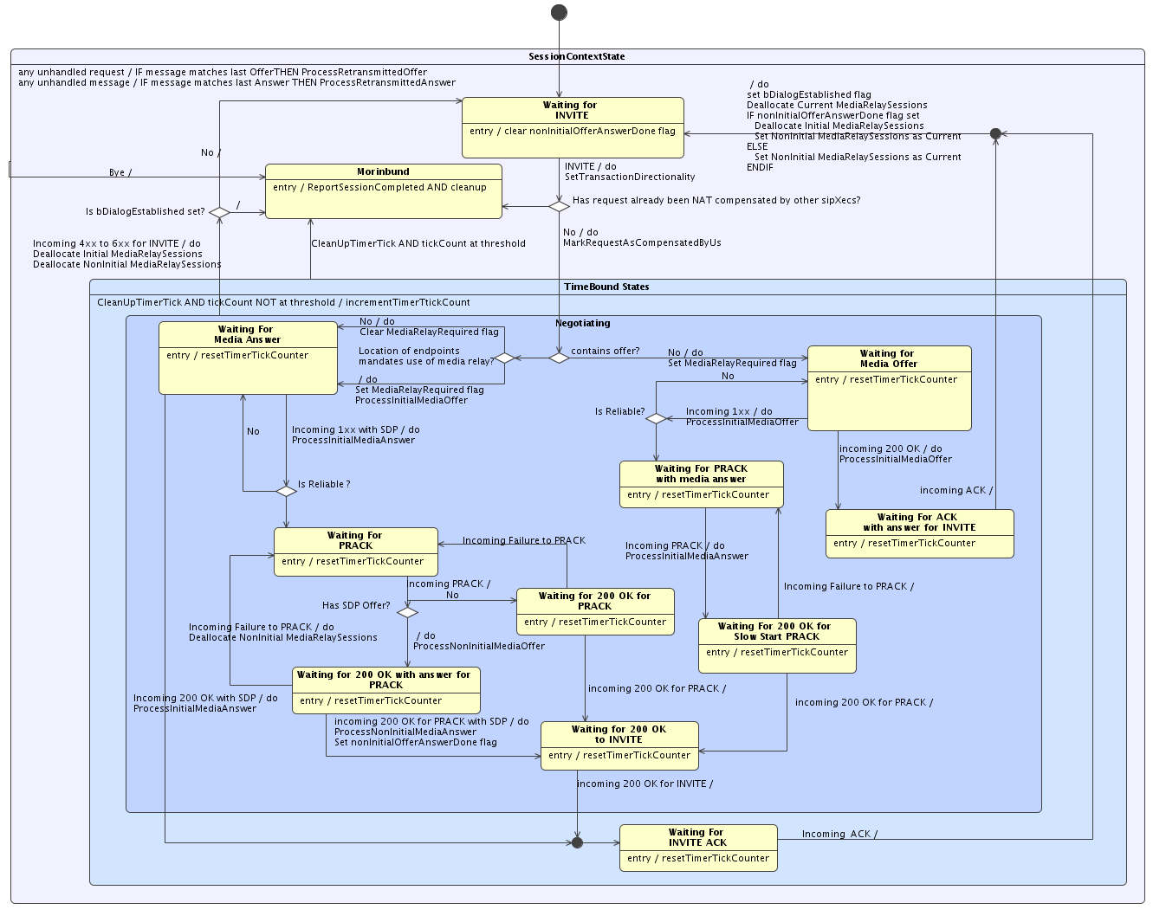
Figure 9 - State diagram for FSM used by DialogTracker
The FSM provides the following functionality:
- Handles Media Offer/Answer negotiation patterns of various types:
  - INVITE/reliable provisional response
  - INVITE/unreliable provisional response
  - INVITE/200 OK for INVITE
  - 200 OK for INVITE/ACK
  - reliable provisional response/PRACK
  - PRACK/200 OK for PRACK
- Handles request and response retransmissions
- Implements timer to detect ‘stuck’ condition
- Provides Offer/Answer roll-back when re-INVITEs fail
      - Determining if Symmitron is required for media session
One of the key operations of the state machine is to determine whether or not an Offer/Answer needs NAT compensation, i.e. whether or not the Symmitron needs to be inserted in the media path. This decision is made in the transition logic coming out of the WaitingForInvite state and the MediaRelayRequiredFlag is set to reflect it. The purpose of this section is to describe the algorithm that makes that decision.
If the received INVITE contains an SDP, an assumption is made that the endpoints that will ultimately be involved in a media session are the UAC and UAS of the transaction, therefore the logic looks at their location information to decide whether to media relay the call or not.
The logic provides special handling for the case where both the UAC and the UAS are in REMOTE_NATED locations. In such a case, the behaviour of the NAT Traversal feature is configurable via the ‘relay aggressiveness’ mode already presented. When set to ‘Conservative’, the logic will compare the public IP addresses of the UAC and UAS and if they match, it will assume that they are behind the same NAT and that they call directly reach each other by their private IP addresses therefore not requiring the use of a Media Relay. When set to ‘Aggressive’, the logic will impose the use of a Media Relay to ensure that the media will flow between the two endpoints. This mode is used to guard against deployments where the UAC and UAS are behind distinct NATs but these NATs are themselves behind a single NAT. In such a scenario, the UAC and UAS would have the same public IP address (thus appearing as being behind the same NAT) but would not be able to send media to each other using their private IP addresses.
UAC | UAS | Relay Aggressiveness Mode | Relay Media?
Unknown | Don’t care | Don’t care | Yes
Public | Public | Don’t care | No
Public | Local NATed | Don’t care | Yes
Public | Remote NATed | Don’t care | Yes
Public | Unknown | Don’t care | Yes
Local NATed | Public | Don’t care | Yes
Local NATed | Local NATed | Don’t care | No
Local NATed | Remote NATed | Don’t care | Yes
Local NATed | Unknown | Don’t care | Yes
Remote NATed | Local NATed | Don’t care | Yes
Remote NATed | Public | Don’t care | Yes
Remote NATed | Remote NATed | Aggressive | Yes
Remote NATed | Remote NATed | Conservative but public IP addresses do not match | Yes
Remote NATed | Remote NATed | Conservative and public IP addresses match | No
If the received INVITE does not carry an SDP offer, it might be that the UAC tries to initiate a 3PCC call. If that turns out to be the case, given that the ultimate media endpoints of the calls will not be the UAC and UAS of the transaction, making a decision to use Symmitron or not based on their location could lead to errors. To err on the side of caution, the use of Symmitron will be imposed whenever an SDP-less INVITE is seen.
      - Processing of media offers
It can be seen from Figure 9 that several state transitions cause media offers to be processed. These are shown as “ProcessInitialMediaOffer” and “ProcessNonInitialMediaOffer” transition actions in the state machine. These actions are logical names used to simplify the state machine diagram. In reality, the ProcessInitialMediaOffer action seen in the state machine translates into code that calls DialogTracker::processMediaOffer( sipMessage, INITIAL_OFFER_ANSWER ) whereas ProcessNonInitialMediaOffer translates into a call to DialogTracker::processMediaOffer( sipMessage, NON_INITIAL_OFFER_ANSWER ). This present subsection will explain how media offers are actually being processed.
The media offers requiring processing that are seen by the state machine are processed by calling DialogTracker::processMediaOffer( SipMessage&, OfferAnswerPattern ). The logic implemented by that method varies based on whether or not the offer appears to be coming from a 3PCC call. This section will present the handling of normal, non-3PCC calls, as it is more straight-forward. The handling of 3PCC calls will be presented as a special case later in this document in the “Special Cases” section.
The actions performed by the DialogTracker::processMediaOffer() method to handle non-3PCC calls can be summarized as follows:
- Determine the role of the endpoint that originated the message carrying the offer;
- For each Media Description section in the SDP offer (m= line) do the following:
  - Allocate a MediaDescriptor object if one does not already exist and save SDP’s Media Description section information in it;
  - Request the allocation of a media relay session if a media relay is required for the call;
  - Designate offerer as the destination for the Sym it will be sending media packet to;
  - Adjust directionality of the media to ensure NAT traversal;
  - Patch the Media Description section of the SDP to insert Symmitron in the media path;
- Initialize Retransmission Descriptor to handle potential retransmissions of the message carrying the offer.
The following paragraphs will explain each step in details.
Determining the role of the endpoint
In order to properly process the request, the processMediaOffer() needs to determine whether the originator of the message carrying the offer is the ‘caller’ or the ‘callee’. This is important since many of the data structures used by processMediaOffer() carry elements that are role-specific i.e. have a notion of ‘caller’ and ‘callee’. Therefore, the logic needs to know if the offer being processed comes from the caller or the callee to access the correct members in such data structure (for example a MediaRelaySession has mCallerRtpPort and mCalleeRtpPort members used to remember the port numbers that the caller and the callee have on the Symmitron). In this feature, we define the caller as the UAC that sent the dialog-forming request and the callee as the UAS that ultimately received it. For example, let’s say that Alice calls Boris (Bob is on vacation), for every message processed in that dialog, Alice will be considered as the caller and Boris as the callee even if Boris later is the initiator of a re-INVITEs within the dialog.
Note: The words ‘caller’ and ‘callee’ appearing within this section are to be interpreted using these definitions.
The role of the endpoint that has originated the offer currently processed in established using two elements of information:
- The directionality of the current INVITE transaction as determined by calling RouteState:: directionIsCallerToCalled() on that INVITE;
- The type of message carrying the Offer – request or response.
The following table shows the mapping between these two information elements and an endpoint’s role.
Directionality of INVITE | Type of message | Role
CALLER->CALLEE | Request | CALLER
CALLER->CALLEE | Response | CALLEE
CALLEE->CALLER | Request | CALLEE
CALLEE->CALLER | Response | CALLER
The method DialogTracker::EstablishEndpointRole() implements that logic.
Processing SDP Media Description sections
The processMediaOffer() looks at each Media Description section of an SDP body individually. The following section will describe how an individual Media Description section is processed. That processing is repeated for each Media Description section present in the SDP.
Processing an SDP Media Description section
Step #1: Allocating and initializing a MediaDescriptor: The first thing that is done when processing an SDP Media Description section of an SDP body is to save the pertinent information about it in an instance of the MediaDescriptor class. The following table shows the information stored in a MediaDescriptor:
Information Element | Description
Type | Holds the type of media session e.g. “audio” and “video”.
MediaDescriptionIndex | Position of the related Media Description section in the SDP body. (position is 0-based)
Directionality | Directionality of the media session as seen in the offer e.g. “sendrecv”, “sendonly”, “recvonly”, “inactive”
DirectionalityOverride | New directionality imposed on media offer by NAT Traversal feature. We will see later in the document why the directionality sometimes needs to be overriden.
Caller | Saves the media endpoint information of the caller, i.e. connection IP address, RTP and RTCP ports.
Callee | Saves the media endpoint information of the callee, i.e. connection IP address, RTP and RTCP ports.
CurrentMediaRelayHandle | Handle of the MediaRelaySession that is currently being used to relay the media session negotiated via this Media Description section
TentativeInitialMediaRelayHandle | Handle of the MediaRelaySession that was allocated to relay the media for the ‘initial’ media session negotiation. That tentative handle will replace the ‘current’ one should the re-INVITE be successful and no ‘non-initial’ media negotiation took place.
TentativeNonInitialMediaRelayHandle | Handle of the MediaRelaySession that was allocated to relay the media for the ‘non-initial’ media session negotiation. That tentative handle will replace the ‘current’ one should the re-INVITE be successful
Table 2 - MediaDescriptor data
The DialogTracker saves all the allocated MediaDescrptors in a vector called mMediaDescriptors. The indices in mMediaDescriptors represent the 0-based position of the media description section inside the SDP body that a given MediaDescriptor relates to. For example, mMediaDescriptors[0] holds a pointer to the MediaDescriptor that was allocated to save information about the first media description section of the SDP body. mMediaDescriptors[1] holds information about the second and so forth.
When processing an SDP Media Description section, if a MediaDescriptor object does not already exist for it, one is created otherwise the existing one is recalled. The MediaDescriptor object is updated to hold the current Type, Directionality and the IP address, RTP and RTCP ports of the media endpoint that originated the offer. This information will either get saved in MediaDescriptor’s Caller or Callee members based on the role of the endpoint.
Step #2: Request the allocation of a media relay session: We have seen in section 4.3.5.3 that the MediaRelayRequiredFlag is set by the state machine when the INVITE is seen and indicates whether or not Symmitron needs to be inserted in the media path. If the MediaRelayRequiredFlag is set to ‘true’ then one of the available pre-allocated MediaBridgePair needs to be marked as reserved and set aside for this media negotiation. The process of tracking the available and reserved MediaBridgePairs is handled by the MediaRelay class which was already introduced earlier in this document. Basically, the MediaRelay maintains two lists to track which MediaBridgePairs are available and which ones are currently being used to relay active media sessions. These lists are called mAvailableMediaBridgePairsList and mBusyMediaBridgePairsList respectively. When DialogTracker makes a request to the MediaRelay object to allocate a Media Relay Session, it removes a MediaBridgePair from the mAvailableMediaBridgePairsList and moves it into mBusyMediaBridgePairsList. The MediaBridgePair is a construct that is internal to the MediaRelay therefore, when a requester asks the MediaRelay to allocate a media relay session, what it gets back is a handle to a MediaRelaySession object and not the MediaBridgePair object. MediaRelaySession is basically a wrapper around the MediaBridgePair that provided an API which exposes only the information that the requester needs without having to understand the structure of Syms and Bridges and their relationship. The mediaRelaySession handle returned is saved in the MediaDescriptor as either the TentativeInitialMediaRelayHandle or the TentativeNonInitialMediaRelayHandle based on parameters that the state machine passes to DialogTracker::processMediaOffer() when calling it. These tentative media relay handles exist to allow roll-back of media sessions when reINVITEs fail. As an example, if a reINVITE fails, the TentativeInitialMediaRelayHandle and TentativeNonInitialMediaRelayHandle (if set) get de-allocated and the CurrentMediaRelaySession stays unchanged. On the other hand, if a reINVITE succeeds, the CurrentMediaRelaySession will be deallocated and will be replaced by the TentativeNonInitialMediaRelayHandle if set, otherwise by TentativeInitialMediaRelayHandle. This logic is implemented in DialogTracker:: promoteTentativeMediaRelaySessionsToCurrent() and is called by the state machine when the ACK to a successful INVITE is seen.
Step #3: Designate the offerer as the destination for the Sym: [Note that this step is only done if MediaRelayRequiredFlag is set]. It was already mentioned earlier in this document that the Syms of the Symmitron have the ability to learn on the fly the IP address and port number of the endpoint it is supposed to relay packets to by looking at the IP address and port number of the packets it is receiving. That auto-learning of destination is quite handy when media endpoints are behind NATs as their public media IP:port is not known in advance. As handy as it is, the NAT Traversal feature still tries to minimize its use of the auto-learning feature as much as possible and only rely on it when it is absolutely necessary. Two reasons support that decision:
- If an inter-system call results in two auto-learning media relays streaming to each other, if both are in auto-learning mode, it means that they will both wait to learn the destination from a received a packet before sending anything out resulting in a media deadlock. We will see later the mechanisms put in place to avoid this scenario when the inter-system call involves two sipXecs boxes.
- When in auto-learning mode, the Symmitron will accept packets from anybody and relay them. This gives a malicious user the ability to inject a packet that will be relayed to the media far-end. It also causes the Symmitron to temporarily learn the malicious user’s IP:Port until the real endpoint sends another packet. This operation will disrupt the call in both directions.
The Symmitron supports three auto-learning modes:
  - Auto-learned IP and Port;
  - Pre-determined IP address and auto-learned Port;
  - Pre-determined IP address and Port (no auto-learning done in this mode)
The method called SessionContext::linkFarEndMediaRelayPortToRequester() is responsible for implementing the bulk of the logic that aims at setting the destination of a Sym on the Symmitron. In order for the SDP offer recipient’s media packet to reach the SDP offerer, the Sym that the offerer will send its media packets to on the Symmitron needs to be configured to use that SDP offerer as its destination. The following figure shows the logic that is employed to set the destination of the Sym.
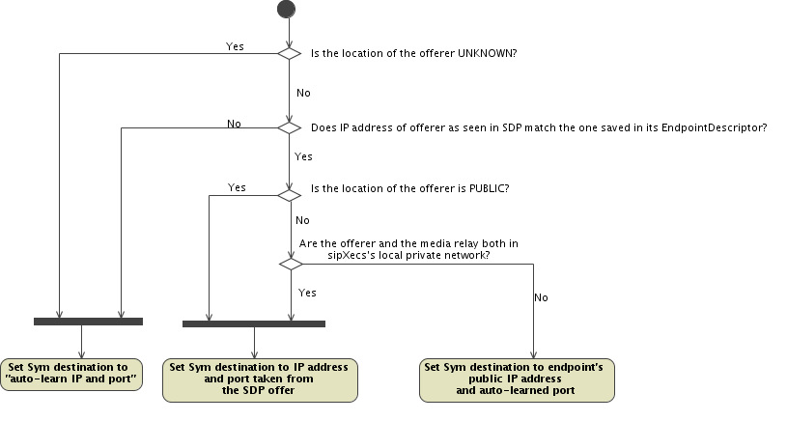
From the figure we see that both the IP address and port will be auto-learned in cases where the location of the offerer is unknown or when the IP address it advertizes in the SDP does not line up with the IP address of the UA that sent it. In both these cases, the logic cannot be exactly sure of where the media endpoint is in the network and therefore assumes that NATs will be present as a safety measure justifying why both the IP address and port numbers are auto-learned.
If the offerer is categorized as PUBLIC or if it is part of the same network as the Symmitron then we can be sure that no NATs exist between the offerer and the Symmitron. We can therefore set the destination of the Sym to the IP address and port as seen in the SDP offer.
If the offerer does not fall in any of the categories above then the offerer is remote NATed. Being remote NATed, we already collected that endpoint’s public IP address in the EndpointDescriptor that was created for it so we set the Sym’s detination IP address to it however the port is set to auto-learn because it cannot be determined ahead of time - it will be chosen by the NAT when it sends its first media packet.
Step #4: Adjusting the directionality of the media offer to ensure NAT traversal: [Note that this step is only done if MediaRelayRequiredFlag is set]. The NAT traversal feature relies on a few principles that govern the behaviour of NATs. One of those behaviours is the following: a public endpoint will be able to reach a private endpoint residing on the private side of the NAT provided that the private endpoint recently sent a packet to public endpoint. Given that, now let’s consider a unidirectional media stream flowing from public endpoint to private endpoint. Since private endpoint is behind a NAT, the packets sent by public endpoint will fail to reach it as they will be dropped by the NAT due to absence of traffic in the private endpoint-to-public endpoint direction. To overcome that situation, when the directionality of the media offer is ‘sendonly’ or ‘recvonly’ an the endpoint that will be at the receiving end of that unidirectional media stream is not in the same subnet as the Symmitron, an assumption is made that NATs will be crossed and the directionality of the media offer is overridden to be ‘sendrecv’. When the SDP answer comes back and gets processed, the directionality will be converted back to a setting that will be acceptable to the offerer based on the original directionality setting and the one found in the SDP answer. In addition, in the case of ‘sendonly’ unidirectional streams, the media relay will be configured to discard the media traffic in the answerer->offerer direction to avoid subjecting the offerer to a media stream it does not expect. Conversely, in the case of ‘recvonly’ unidirectional streams, the media relay will be configured to discard the media traffic in the offerer ->answerer direction to avoid subjecting the answerer to a media stream it does not expect. The section that describes how SDP Answers are processed will explain that process in more details.
Step #5: Patch the Media Description section of the SDP: [Note that this step is only done if MediaRelayRequiredFlag is set]. This step consists in modifying the media description section under investigation in the SDP offer to insert to Symmitron in the media path. To accomplish that, the following modifications are made to the SDP body:
- Add (or modify if it exists) the c= line of the media description section to bear the IP address of the Symmitron. If the intended SDP offer receiver is in the same local private network as the Symmitron, the IP address will be Symmitron’s native IP address otherwise it will be its public one to ensure that it is reachable from it.
- Change the RTP port in the media description’s m= line to carry the port that the Sym representing the offerer is listening on.
- Remove the ‘a=rtcp’ attribute in case it was present. When Symmitron is used, the RTCP port is derived using the standard ‘RTP+1’ rule.
- Add (or modify if present) a proprietary a=x-ntap=<sipXecs Native IP address>;<MediaRelayHandle> parameter that will be used to handle special 3PCC call scenarios as discussed in the Special Cases section.
Initializing RetransmissionDescriptor to handle potential retransmissions
We have seen all the processing that is required to handle a message carrying an SDP offer. If that message were to be retransmitted because it or its acknowledgement got lost, the same transformations that got applied to the original message should be applied to every retransmitted copy ideally without having to reprocess everything. In support of this, DialogTracker provides two classes: RequestRetransmissionDescriptor and ResponseRetransmissionDescriptor and has a member variable of each type. The RequestRetransmissionDescriptor holds an SDP Body, a sequence number (CSeq) and a method. The ResponseRetransmissionDescriptor also has these information elements and in addition it has a response code. When an SDP offer is completely processed, if it was carried in a request, the transformed SDP body as well as method and sequence number get saved in DialogTracker’s RequestRetransmissionDescriptor. If the was carried in a response instead, the transformed SDP body as well as method, response code and sequence number get saved in DialogTracker’s ResponseRetransmissionDescriptor.
Every time the state machine receives a message that is not expected by its current state, there is a possibility that this message is a retransmission. The default handling for all such message that can carry SDP is to check if it matches the RequestRetransmissionDescriptor’s sequence number and method or ResponseRetransmissionDescriptor’s sequence number, response code and method based on the type of message. If it does, we are dealing with a retransmitted message and the SDP saved in the matching retransmission descriptor gets applied to it.
      - Processing of media answers
The previous sub-section showed how the media offers were processed. This present section will focus on the processing of media answers.
It can be seen from Figure 9 that several state transitions cause media answers to be processed. These are shown as “ProcessInitialMediaAnswer” and “ProcessNonInitialMediaAnswer” transition actions in the state machine. These actions are logical names used to simplify the state machine diagram. In reality, the ProcessInitialMediaAnswer action seen in the state machine translates into code that calls DialogTracker::processMediaAnswer( sipMessage, INITIAL_OFFER_ANSWER ) whereas ProcessNonInitialMediaAnswer translates into a call to DialogTracker::processMediaAnswer( sipMessage, NON_INITIAL_OFFER_ANSWER ). This present subsection will explain how media answers are actually being processed.
The media answers requiring processing that are seen by the state machine are processed by calling DialogTracker::processMediaAnswer( SipMessage&, OfferAnswerPattern ). The actions performed by the DialogTracker::processMediaAnswer() method to handle incoming media answers can be summarized as follows:
- Determine the role of the endpoint that originated the message carrying the answer;
- For each Media Description section, do the following:
  - Save answerer’s information in MediaDescriptor;
  - For each accepted media session, do the following:
    - Restore directionality back to a setting that offerer will accept;
    - Designate answerer as the destination for the Sym it will be sending media packet to;
    - Patch the Media Description section of the SDP to insert Symmitron in the media path;
  - For each rejected media session, do the following:
    - Deallocate the MediaRelaySession that was tentatively allocated to relay the media for the now-refused media session.
- Initialize Retransmission Descriptor to handle potential retransmissions of the message carrying the answer.
The following paragraphs will explain each step in details.
Determining the role of the endpoint
This step is identical to what has been described in 4.3.5.4. A call to DialogTracker::EstablishEndpointRole() is made to determine if the originator of the answer is the CALLER or the CALLEE. This role information will be used to access the right data in data structures that store role-dependant information.
Processing SDP Media Description sections
The processMediaAnswer() looks at each Media Description sections of an SDP body individually. It will only process the ones that have a corresponding MediaDescriptor saved in mMediaDescriptors. For example, if the SDP answer carries four Media Description sections but mMediaDescriptors contains only three MediaDescriptors, it means that the answerer added one extra Media Description section in its SDP answer which is a violation of the Offer/Answer model and thus all the extra Media Description sections detected will be ignored by processMediaAnswer().
The MediaDescriptor object corresponding to the Media Description section being processed is updated to hold the current Type, Directionality and the IP address, RTP and RTCP ports of the media endpoint that originated the answer. This information will either get saved in MediaDescriptor’s Caller or Callee members based on the role of the endpoint.
The following section will describe how an individual Media Description section is processed. That processing is repeated for each Media Description section present in the SDP that have a matching MediaDescriptor in mMediaDescriptors .
Processing an SDP Media Description section for an accepted media session
This section will detail the steps taken to process a Media Description section for an accepted media session as indicated by a non-zero media port value.
Step #1: Restoring the directionality: [Note that this step is only done if MediaRelayRequiredFlag is set] We have seen that processMediaOffer() sometimes modifies the directionality of an offer from a unidirectional to bidirectional to facilitate NAT traversal. The answer that is now being processed carries the directionality setting chosen by the answered based on the offer it saw. In cases where the directionality of the offer has been overridden, logic has to be put in place to restore the directionality to something that is acceptable to the offerer. Consider the example below:
processMediaOffer()
processMediaAnswer()
Offerer
Answerer
SDP Offer(sendonly)

SDP Offer(sendrecv)

SDP Answer(sendrecv)

SDP Answer(recvonly)

In the example above, processMediaOffer() overrides the ‘sendonly’ directionality with ‘sendrecv’ to ensure proper relaying of media packets. The Answerer generates an SDP answer based on the overridden directionality. processMediaAnswer() sees that the SDP answer is ‘sendrecv’ and it recalls from the MediaDescriptor that the original directionality seen in the SDP offer was ‘sendonly’. processMediaAnswer() will override the directionality of the SDP answer to a setting that intersects the original directionality of the offer with the directionality from the answer. In the example, this intersection is ‘recvonly’. The following table shows how processMediaOffer() and processMediaAnswer() select the overriding directionality setting.

Offer directionality | Offer directionality override by processMediaOffer | Answer directionality | Answer directionality override by processMediaAnswer
inactive | No override | any | No override
sendonly | sendrecv | sendrecv | recvonly
sendonly | sendrecv | other | No override
recvonly | sendrecv | sendrecv | sendonly
recvonly | sendrecv | other | No override
sendrecv | No override | any | No override

Step #2: Designate the answerer as the destination for the Sym: [Note that this step is only done if MediaRelayRequiredFlag is set]. The Media Offer Processing logic has an identical step. Please refer to section 4.3.5.4 for details.
Step #3: Patch the Media Description section of the SDP: [Note that this step is only done if MediaRelayRequiredFlag is set]. The Media Offer Processing logic has an identical step. Please refer to section 4.3.5.4 for details.
Processing an SDP Media Description section for a rejected media session
When the answerer refuses a media session by setting the media port to a value of zero, the MediaRelaySession that was tentatively allocated to handle relaying of the media traffic is de-allocated.
Initializing RetransmissionDescriptor to handle potential retransmissions
The Media Offer Processing logic has an identical step. Please refer to section 4.3.5.4 for details.
  - NTAP – Maintaining NAT pinholes open
When a User Agent behind a NAT/FW sends a message to sipXecs, it creates a pinhole that allows sipXecs to communicate back to it. This pinhole is maintained open by the NAT/FW until the traffic flowing through it stops. The sipXecs requires this pinhole to be maintained open so that it can send SIP messages to the User Agent behind the NAT/FW. To that end, the NAT Traversal feature includes a component that will periodically send a SIP message to every UA known to the system that is behind a NAT. The purpose of this section is to provide details for that component.
Basically, sipXecs needs to maintain pinholes for every endpoint behind a NAT/FW that it may send messages to. These endpoints are:
- REMOTE_NATED endpoints that are registered to sipXecs: On an incoming call to such endpoints, sipXecs will have to send an INVITE to their public IP:port therefore requiring the pinhole to be open;
- REMOTE_NATED endpoints that have active subscriptions on the sipXecs: sipXecs will need to send NOTIFY messages to these endpoints’ public IP:port therefore requiring the pinhole to be open;
- REMOTE_NATED endpoints that are involved in a call: While on a call, an endpoint behind a remote NAT may be the recipient of in-dialog requests which will be sent to their public IP:Port therefore requiring the pinhole to be open.
In non-HA deployments, item #1 is a superset of items #2 and #3 however in HA deployments these items are not fully overlapping so to ensure full coverage, all three items must be considered by the pinhole-maintaining component.
That NatMaintainer is a class implemented in code unit ‘NatMaintainer.cpp’ and is responsible for maintaining NAT pinholes alive. An instance of the NatMaintainer class is created by NatTraveralAgent only when the NAT Traversal feature is enabled.
The list of pinholes that it needs to maintain is built from three sources:
- Registration DB: NatMaintainer queries the registration DB looking for unexpired contacts that containing a ‘sipx-privcontact’ URL parameter to find REMOTE_NATED endpoints;
- Subscription DB: NatMaintainer queries the subscription DB looking for unexpired contacts that containing a ‘sipx-privcontact’ URL parameter to find REMOTE_NATED endpoints.
- External Pinhole List: NatMaintainer exposes methods to be invoked by components of the NAT Traversal feature to dynamically add and remove pinholes that need to be maintained. Such methods are used by the CallTracker when REMOTE NATED endpoints initiate calls to ensure that their pinholes get maintained by NatMaintainer for the duration of the call.
Note that the NatMaintainer would not need to maintain pinholes for registration DB entries that do not belong to the primary registrar. Such entries indicate that the pinhole on the NAT created by the registration process was between the User Agent behind it and another sipXecs therefore trying to maintain the pinhole when not the primary registration creates unnecessary traffic however, currently the NatMaintainer does not take the registration owner in consideration and tries to maintain pinholes for all NATed User Agents. Addressing this deficiency is left as a future exercise.
The NatMaintainer implements a thread that wakes up every 20 seconds. Upon waking up, it sends the following bogus SIP Options message to every pinhole it needs to maintain:
OPTIONS sip:anonymous@anonymous.invalid SIP/2.0
To: sip:anonymous@anonymous.invalid"From: \"SipXecs Keepalive\"<sip:anonymous@anonymous.invalid>;tag=305…cb40866edd3295b-reniatniamtan
Call-ID: f88dfabce84b6a2787ef024a7dbe8749-reniatniamtan
Cseq: 1 OPTIONS
Via: SIP/2.0/UDP willgetpatched:5060;branch=z9hG4bK-234fc22f2nnthda-reniatniamtan
Max-Forwards: 20
Accept: application/sdp
Contact: anonymous@anonymous.invalid
Content-Length: 0
There is one problem however; the three sources of pinhole information presented above, namely the registration DB, subscription DB and the external pinhole list may contain many entries in common. Considering the following HA deployment:
- 1000 REMOTE NATED endpoints
- 2 systems in the HA deployment of equal priority and weight
- Each user subscribes to MWI
- 10% of the users are on a call at any given time
At any given system in the HA, statistically the registration DB will contain 500 REMOTE NATED endpoints chosen randomly. The subscription DB will also contain 500 REMOTE NATED endpoints chosen randomly. Statistically, the registration DB and the subscription DB will have 250 endpoints in common and will each have 250 unique endpoints. 50 REMOTE NATED endpoints have initiated a call – probabilistically, most of these endpoints will already be found either in the registration DB or the subscription DB. Systematically sending the keep-alive OPTIONS message to every endpoint found in the Registration DB, Subscriber DB and external pinhole list could be very wasteful as it would result in endpoints receiving multiple keep-alive messages when one would have sufficed. To avoid wasting CPU resources, the following algorithm is implemented to reduce the number of unnecessary messages.
Duplication reduction algorithm
The primary motivation for reducing unnecessarily sent keep-alive messages is to reduce the load on the CPU. This imposes that the duplication reduction algorithm be very lean on the CPU to actually yield benefits – this immediately rules out maintaining a map of all the refreshed endpoints as it would result in too many inserts, look-ups, news and deletes. The algorithm that was chosen tries to limit the insert & lookup times and eliminate the need for dynamic memory allocation at the expense of memory. The strategy that has been chosen relies on the assumption that the public port numbers allocated by a NAT when opening a pinhole are somewhat random.
The NatMaintainer allocates an array of 65536 KeepAliveEndpointDescriptors each one containing a 16-byte character array used to store an IP address and a 32-bit refreshRoundNumber. The total size of the array is 1.3Mb. When the NatMaintainer wakes up to send out its keep-alive OPTIONS messages, it starts by incrementing the ‘current refresh round number’. For each endpoint that it wants to send a keep alive to, the NatMaintainer performs the following:
Let port be the public Port number that the keep-alive needs to be sent to
Let ip be the public IP address that the keep-alive needs to be sent to
Let currentRefreshRound be a counter incremented on every NatMaintainer wake-up
Let pDescriptor point to KeepAliveEndpointDescriptors[port]
Let bSendKeepAlive be a flag that indicates whether or not the keep-alive should be sent
IF pDescriptor->refreshRoundNumber != currentRefreshRound
// we have yet to send a keep-alive to an endpoint with that port in this round
pDescriptor->refreshRoundNumber = currentRefreshRound
pDescriptor->ipAddress = ip
bSendKeepAlive = true
ELSE
// we have already sent a keep-alive to an endpoint with that port – check IP address
IF pDescriptor->ipAddress == ip
// we have already sent a keep-alive to that endpoint, do not send another one
bSendKeepAlive = false
ELSE
// the endpoint we have on record is not the same, so send the keep-alive
bSendKeepAlive = true
ENDIF
ENDIF
So, to summarize the algorithm, the KeepAliveEndpointDescriptors[65536] is used to remember the first IP address that got sent a keep-alive message in the current refresh round for a given port used as an index to the array. This algorithm works well when public ports are non-colliding however when 2 or more endpoints have the same public port number and these endpoints appear multiple times in the list of endpoints to be refreshed, the algorithm will fail to prevent the transmission of unnecessary keep-alive messages. Consider the following example:
A Subscription DB contains the following 3 endpoints to be kept alive:
- 20.20.20.20:6666
- 30.30.30.30:6666
- 30.30.30.30:6666
We can see that all entries have the same port and that entries 2 and 3 are the same endpoint. When NatMaintainer wakes-up and starts sending keep-alive OPTIONS to the entries found in the subscription DB, it will first consider 20.20.20.20:6666. A look-up of KeepAliveEndpointDescriptors[6666] will reveal that NatMaintainer has yet to send a keep-alive to an endpoint with port 6666 in this refresh round. It will save the “20.20.20.20” and the current refresh round number in KeepAliveEndpointDescriptors[6666]. Next, it considers 30.30.30.30:6666. Looking up KeepAliveEndpointDescriptors[6666] it will see that a keep-alive was already sent to an endpoint with port 6666 in this refresh round however the IP address of that endpoint does not match 30.30.30.30 so a keep-alive will be sent to 30.30.30.30:6666. Finally, NatMaintainer will consider the third entry which is 30.30.30.30:6666 again. The logic will yield the same logic as earlier resulting in an unnecessary keep-alive being sent to 30.30.30.30:6666 again.
Although the algorithm does not eliminate all unnecessary keep-alive transmissions, it will manage to eliminate a significant portion of them in scenarios where endpoints get assigned port numbers that are non-colliding. This will be the case when many endpoints are deployed at a remote site behind a common NAT which his viewed as a high runner scenario.
The following code changes to existing components where made to accommodate the NatMaintainer:
Code Change
Affected Component | sipXcommserverLib - sipdb
Method | [new]RegistrationDB::getUnexpiredContactsFieldsContaining()
Nature of change | Added method that allows the retrieval of Contact fields containing the specified substring from the registration database.

Code Change
Affected Component | sipXcommserverLib - sipdb
Method | [new]SubscriptionDB::getUnexpiredContactsFieldsContaining()
Nature of change | Added method that allows the retrieval of Contact fields containing the specified substring from the subscription database.

Code Change
Affected Component | sipXproxy
Method | [new]SipRouter::sendUdpKeepAlive()
Nature of change | Added method that exposes the capability of using SipRouter to send SIP messages on sipXproxy UDP port.
  - Avoiding Media deadlocks
When a call set-up spanning multiple systems results in two media relays with auto-learning capabilities streaming to each other, media deadlock can occur as each media relay will wait to learn the destination of the other before relaying any media packet.
The NAT traversal feature puts mechanisms in place to avoid such media deadlocks when calls span multiple sipXecs systems. Whenever a sipXecs takes on the responsibility of handling the NAT traversal for a dialog, it adds a proprietary ‘x-sipX-handled:<sipXecs private IP>:<sipXecs public IP>’ to the dialog-forming INVITE. A sipXecs that receives a dialog-forming INVITE carrying a ‘x-sipX-handled’ with private and public IP addresses not matching its own will conclude that an upstream sipXecs is already compensating for NATs and will yield to it by not applying any NAT compensation to the call. This mechanism ensures that a single sipXecs works at compensating for NATs for an given dialog therefore eliminating the risks of media deadlocks.
Note that if two sipXecs systems are separated by a SIP device that removes the proprietary ‘x-sipX-handled’ headers, the media deadlock avoidance mechanism is essentially defeated and media deadlocks may occur.
  - HA considerations
    - Use of Path Header
The use of path headers is required by the NAT Traversal feature to accommodate HA deployments. Let's consider that an HA deployment is composed of systems SA and SB. When a given user, U1, wants to register with the HA system, a DNS SRV lookup will point it to either SA or SB therefore opening a NAT/FW pinhole from U1 to the elected system. For the sake of this example, let's say that the system that got chosen is SA. The nature of NATs is such that most will only accept incoming messages from SA and will reject incoming messages SB. For that reason, it is important to force messages coming to U1 to originate from SA and not SB (note that this effectively negates most the HA benefits for that specific NATed user). To force messages destined to U1 to originate from SA, its sipXproxy adds a Path header pointing to SA to the REGISTER sent by U1. This Path header will ensure that dialog-forming requests destined to U1 are sent by the system that processed the REGISTER and for which a pinhole exists and is being maintained.
The Path headers are saved in the registration DB by the registrar and get acted upon in the SipRedirectorRegDb redirector plug-in. When SipRedirectorRegDb sees a registration DB entry with a Path header, it will turn the URL it contains into a ROUTE header parameter for the corresponding Contact header to be placed in the 302 Response therefore ensuring that SA is the system that will ultimately deliver the request to U1.
    - Avoiding unnecessary spiralling
SipRedirectorAuth redirector plug-in’s role consists in ensuring that Contact headers in 302 Moved Temporarily responses do not contain ROUTE header parameters that would circumvent the authorization function of the local sipXproxy. Given that the use of Path headers may result in Contact headers containing ROUTE header pointing to ‘other’ proxies, if no special logic was added, that plug-in would add the local sipXproxy as the first ROUTE header resulting in the local sipXproxy being unnecessarily visited before the one prescribed by the Path.
To get around this inefficiency, the concept of a signed URL was created. Building on our previous example, the next paragraph will show how the signed URL gets used: When the sipXproxy at SA sees the REGISTER, it will add a Path header containing a URL to SA that is signed, i.e. one that can guarantee that its user@host part has been crafted by the system. Now, let's say that an INVITE for U1 is received by SB, the SipRedirectorDb plug-in will add the Contact carrying a ROUTE header parameter with the signed URL pointing to SA. The INVITE will later visit SB's SipRedirectorAuth plug-in whose role consists in verifying that Contact headers do not contain ROUTE header parameters that would circumvent the authorization function of SB. The Contact has a ROUTE header pointing to SA, however it sees that the URL it contains is properly signed. It can therefore be know that the ROUTE is pointing to a trusted system and as a result can let the request go without having to force it to spiral to back to SB’s sipXproxy for authentication. The following diagram illustrates the example just described:
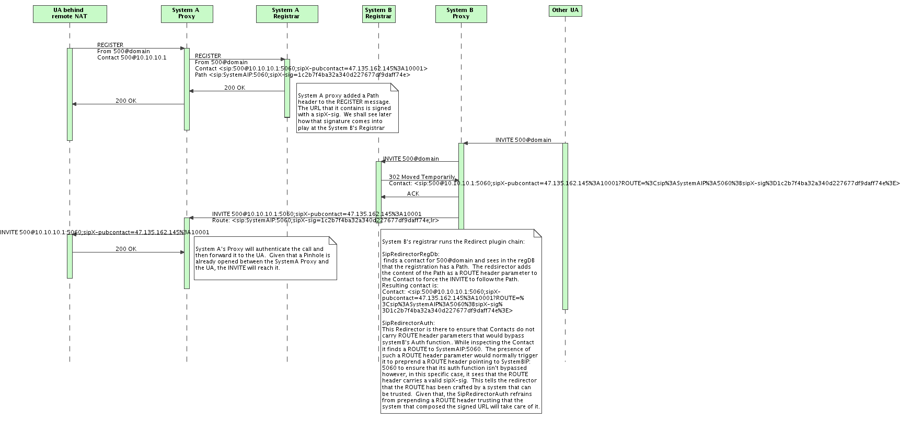
  - Special Cases

- References
- http://www.tech-invite.com/SIPWGs/02-WG-SIPPING/Drafts/draft-ietf-sipping-nat-scenarios-08.txt

Revisions prior to 14951 used the following format instead: sip:user@<privateIP>[:<privatePort>][;transport=<transport>] ;sipX-privcontact=< publicIP>:<publicPort>[;transport=<transport>]. This format was changed in favor of the one described in this section to handle cases where a remote NATed phone had the same private IP address as sipXecs. Having the private IP & private port as the hostport of the Contact caused requests to such remote NATed phones to be misrouted by sipXecs.
The definition of ‘initial’ media session negotiation is borrowed from table 1 of draft-ietf-sipping-sip-offeranswer-08.txt. It essentially designates offer/answer patterns that happen at least in part on the INVITE transaction.
‘non-initial’ media session negotiations designate offer/answer patterns that happen outside of the INVITE transaction. The only such pattern that this feature supports is PRACK(offer)/200 PRACK resp(answer).

