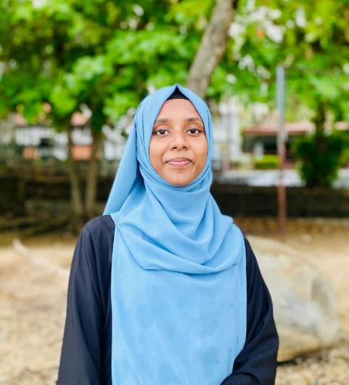



Z
I Hereby Certify That All The Information I Have Above Mentioned Is True And Correct.
2019 G.C.E. Ordinary Level
SUBJECT | GRADE
Islam | C
Tamil | C
Mathematics | S
English | S
Science | S
History | S
Sinhala | A
Tamil Lit | C
Health | C
2022 G.C.E. Advanced Level – Art Stream
SUBJECT | GRADE
Islam | S
Tamil | S
Geography | S
General English | S
- Successfully Completed Diploma in English at British Way English Academy - Matara.
- Successfully Completed NVQ Level 4 In Tailor (Ladies.) At NAITA - Walasmulla.
- Successfully Completed Certificate in Web Development at Orion International Campus.
- Successfully Completed Certificate in Computer System and Hardware at Orion International Campus.
- Currently Following HND In IT At Advanced Technological Institute – Tangalle.

EDUCATION

Tamil
English
Sinhala
12/B Badabadda, Mi-Ella, Hakmana,Matara
I Am a Confident, Self-Motivated Person Who Communicates Well, Work with An Enthusiasm and Has Good Interpersonal Skills with Be Adaptability for Any Demanding Situation. I Look for Work to Gaining a Valuable Experience Which Will Help Me to Become a Professional in The Corporate World. I Also Will Be Making a Good Contribution with Service from My Heart That Offers Me and Opportunity to Be Excelled in The Challenging Career.

OBJECTIVE

NASIRINA NISAM
Female
:-
Un Married
Civil Status
:-
Sri Lanka
Nationality
Gender
:-
12/B Badabadda, Mi-Ella, Hakmana, Matara.
:-
:-
:-
:-
Mohomad Nisam Hanifa Fathima Nasirina
2003 May 02
200362300288
Address
NIC
DOB
Name
PERSONAL INFORMATION

Signature
……………………………………
Date
……………………………………
- Right Attitude
- Quick Thinking Ability
- Able To Work Under The Pressure
- Leadership

LANGUAGES
SKILLS

Nasaanisam2003@gmail.com
076 325 3200

CONTACT

