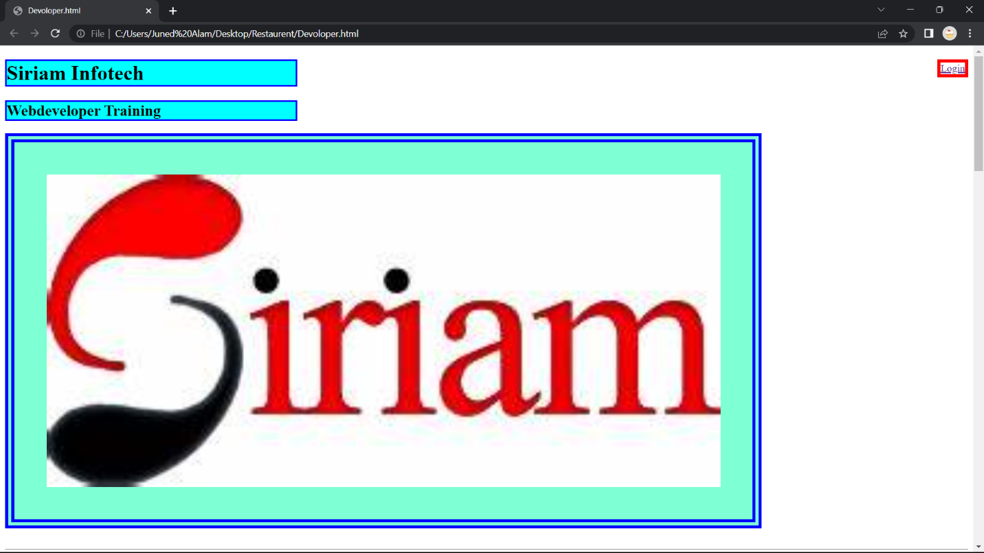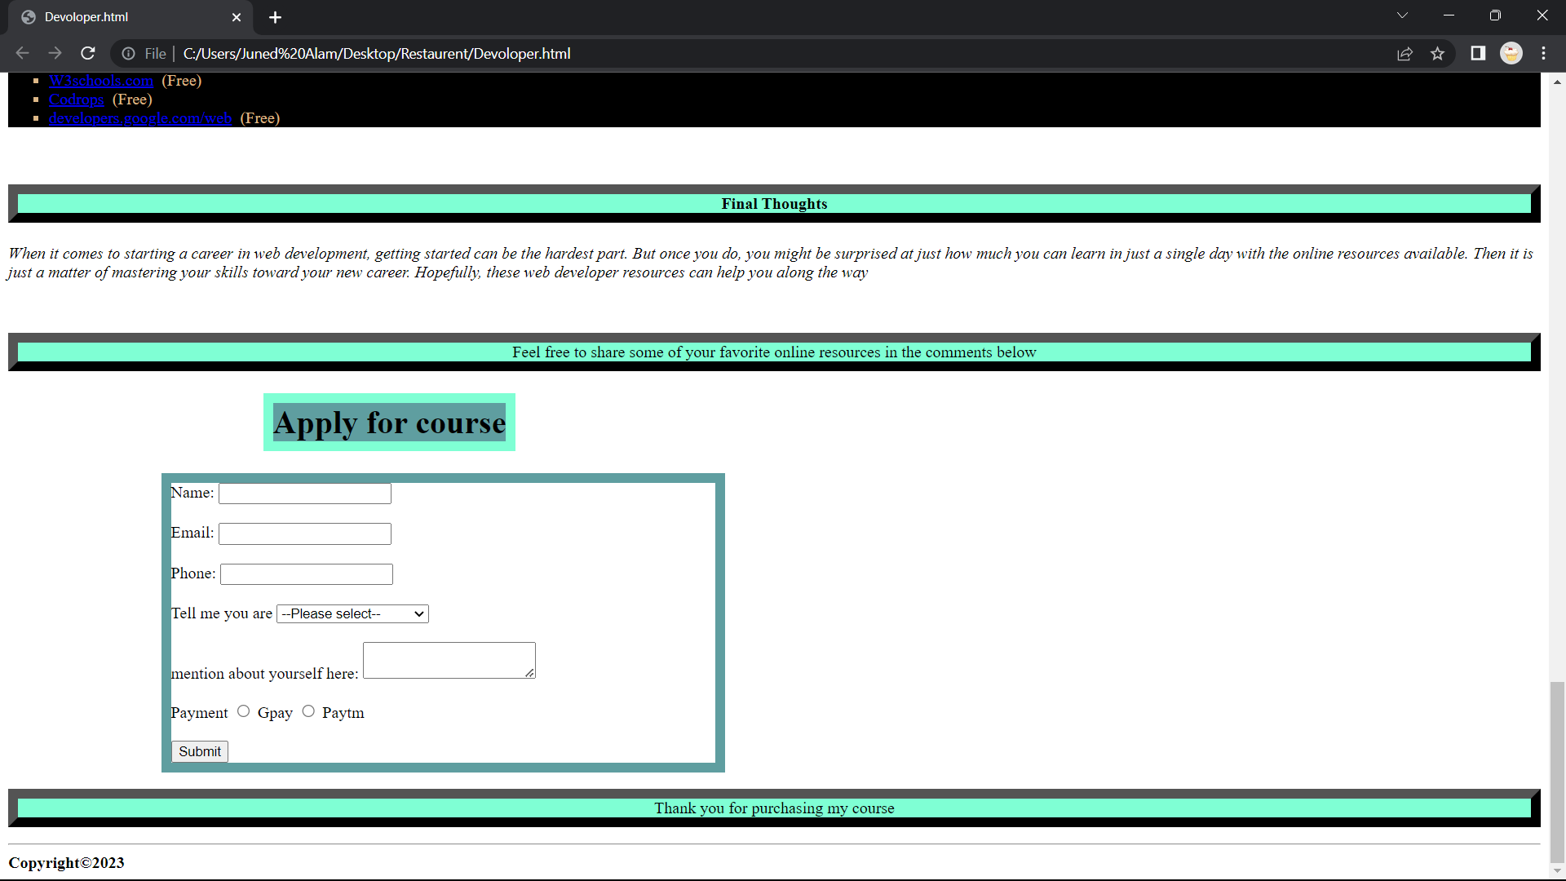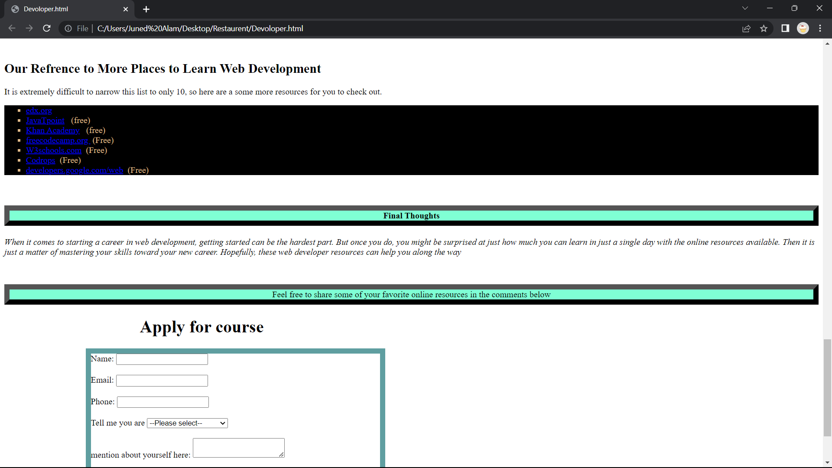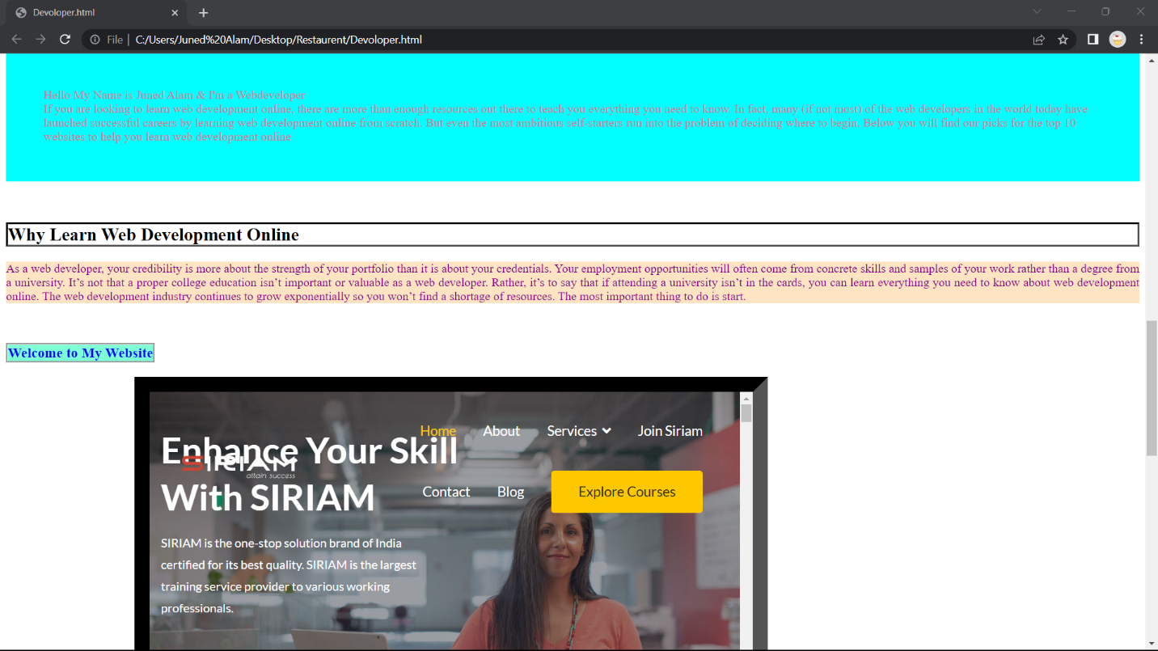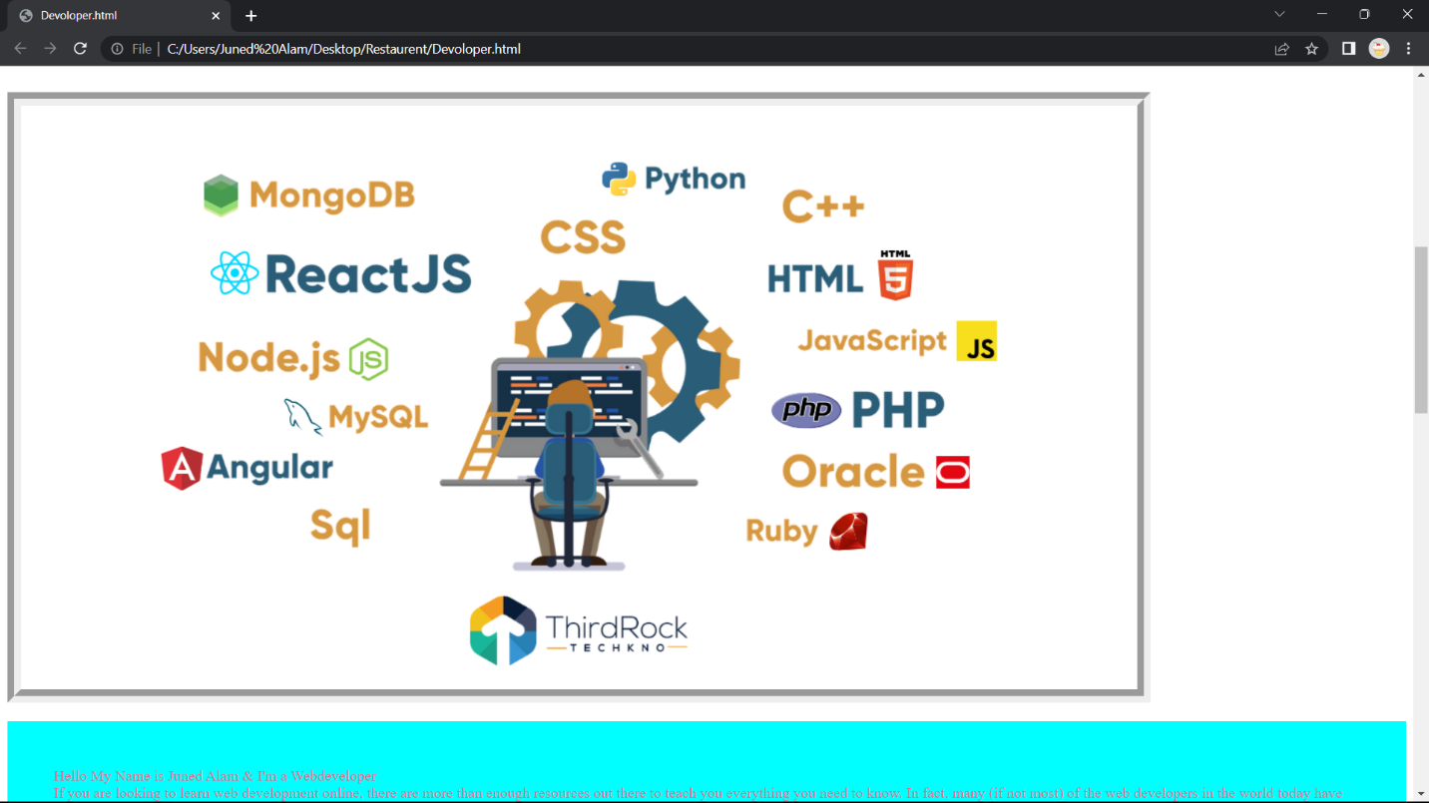

Hello Sir

Today I Covered Some Topics of CSS and implemented those topics on my Website.  
Topics that I Covered Today  
Colors  
Background  
border  
margin  
padding  
font  
text-align  
etc