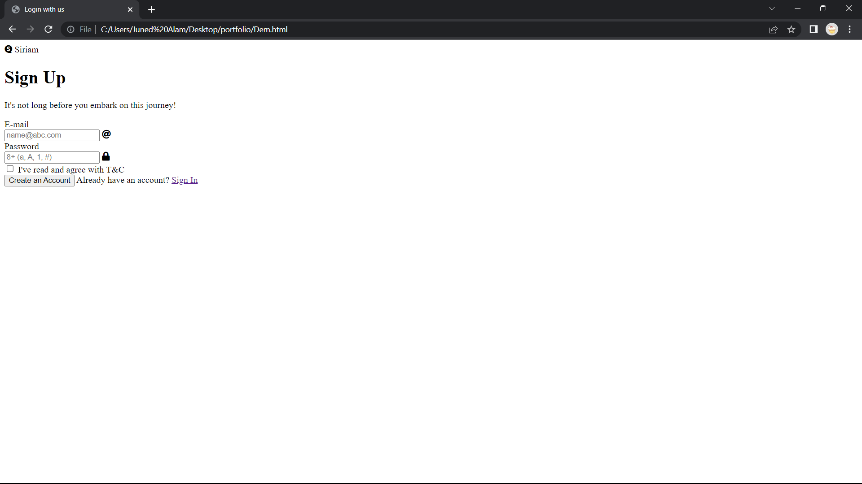



Good Evening Sir,

Today I have Implemented a Landing Page.

Yesterday I have Created a website and today I added a new signup page.

People can click on login and then it will land them to a new page.