R markdown lab

Jeff Leek

July 3, 2015

1. Try compiling this document using the "Knit HTML" button. What files are produced?
2. Edit the output to be "pdf_document" and recompile. What files are produced?
3. Edit the output to be "word_document" and recompile. What files are produced?
4. What does the label "chunk1" do in the following code chunk?

x = rnorm(100)  
plot(x)

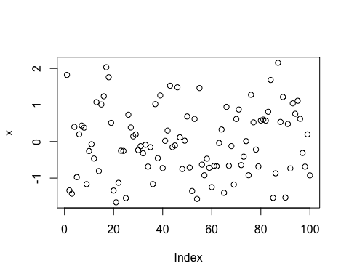

### This is a primary header. Add a secondary header with ## on the line below and recompile.

1. Change fig.height to something larger/smaller and see what happens

x = rnorm(100)  
plot(x)

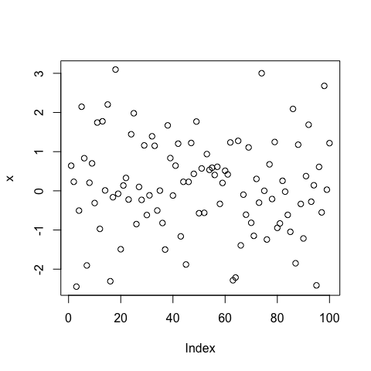

1. Add a chunk option of fig.align="center" to center this plot

x = rnorm(100)  
plot(x)

1. Add a chunk option of echo=FALSE and see what happens

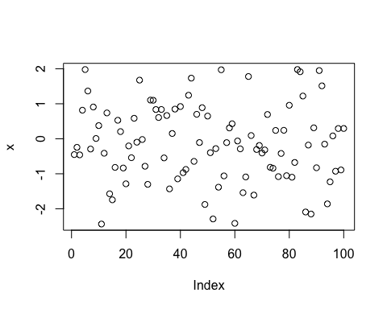

1. Uncomment this code and recompile the document. Then add a chunk command cache=TRUE and recompile. What files are created? Try compiling one more time.

Sys.sleep(10)

1. Check out the docs at: <http://rmarkdown.rstudio.com/> and look under formats. See if you can create and compile an R markdown presentation.
2. Add the command devtools::session_info() to this chunk and look at the output