**Size Productivity Trophic Level Chart**

A script to produce "Size Productivity Trophic Level Charts" as described in

Froese, R., Palomares, M. L. D., Bailly, N., Coro, G., Garilao, C., Pauly, D. (2022) "A framework for the exploration of functional biodiversity".

GitHub code available at https://github.com/SISTA16/SizeProductivityTrophicLevelChart

[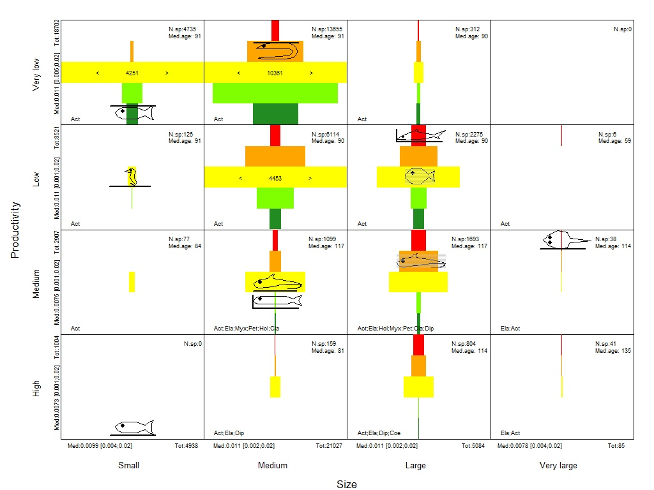](https://github.com/SISTA16/SizeProductivityTrophicLevelChart/raw/main/BioDiv_14_spt.jpg)

The following code reports examples to run the script with different options. More examples can be found in the **usage_example_size_productivity_trophiclevel_chart.R** script.

source("size_productivity_trophiclevel_chart.R")

setwd("./")

#Default value:

#sp.classes.df = data.frame(sp.class.names = c("Myx","Pet","Hol","Ela","Cla","Act","Coe","Dip"), sp.class.codes = c(1,2,3,4,9,6,10,11))

#axes.labels = data.frame(productivity.labels<-c("High","Medium","Low","Very-low"),size.labels<-c("Small","Medium","Large","Very large"))

#input files

file = "./BioDiv_14.csv"

#example 1 - produce the chart with default labels and don't save the plot (default)

sptchart(file=file)

#example 2 - produce the chart with default labels and save the plot

sptchart(file=file,save.plot = T)

#set custom labels and codes:

sp.classes.df = data.frame(sp.class.names = c("My","Pe","Ho","El","Cl","Ac","Co","Di"), sp.class.codes = c(1,2,3,4,9,6,10,11))

axes.labels = data.frame(productivity.labels<-c("H","M","L","VL"),size.labels<-c("S","M","L","VL"))

#example 3 - produce the chart with custom class labels

sptchart(file=file,sp.classes.df=sp.classes.df)

#example 4 - produce the chart with custom labels and save the plot

sptchart(file=file,sp.classes.df=sp.classes.df,axes.labels=axes.labels,save.plot = T)

#example 5 - produce the chart with custom axes labels

sptchart(file=file,axes.labels=axes.labels)

order.age.file = "./OrderAge.csv"

#example 6 - produce the chart using custom order-age file

sptchart(file=file,order.age.file=order.age.file)

shapesToDisplay.file = "./shapesToDisplay.csv"

#example 7 - display shapes at custom locations

sptchart(file=file,shapesTodisplayFile = shapesToDisplay.file)

#example 8 - display shapes and save

sptchart(file=file,shapesTodisplayFile = shapesToDisplay.file, save.plot=T)