**Chapter 1:**

**INTRODUCTION**

**1.1 Overview of Introduction:**

The presence of technology has reached its maximum of providing sustainable technology towards quality education through delivery and effective learning. Attendance is very important in every student, a single absent is big difference in performance in the school, colleges.

Attendance systems of old practises are not quite efficient today for keeping track on student’s attendance. Due to the availability of large resources over the internet today, it is very hard to motivate the students to attend lectures without fail have become more challenging. In order to drag the attention of students and make them interactive in observing technologies we move on to latest upcoming trends on developing attendance systems. This is the strong reason for college attendance management system has to come up with an approach that ensures strong contribution of students in classrooms.

To track attendance of the students, many attendance management systems are introduced in the market. With the introduction of this variety of attendance system, skipping classes without the staff’s knowledge have become difficult for the students. For few view of college attendance systems that were used earlier in the market are based on RFID systems, punch card systems, swipe card systems, biometric systems that includes fingerprint analysis, iris analysis etc. Although these systems all are lagged in their own respective so which lead to the new way practise on AMS. In smart AMS we are going to mark the attendance of the student by capturing the image of the person for identifying correctly.

**Chapter 2:**

**LITERATURE REVIEW**

Attendance systems of old practices are not quite efficient today for keeping track on student’s attendance. Due to the availability of large resources over the internet today, it is very hard to motivate the students to attend lectures without fail have become more challenging. In early days we can maintain attendance manually, but this task is very difficult. Avoids a proxy attendance of the student and ensures that the students of other class are not entering. That’s why, in smart AMS (Attendance Monitoring System) we are going to developed to provide a reliable, secure, and efficient method of recording student attendance by capturing the face of the person for identifying correctly.

**2.1 METHODS FOR FEATURE EXTRACTION / FACE RECOGNITION**

THE "PCA" ALGORITHM

STEP 1: Convert image of training set to image A training set consisting of total M images vectors Each image is of size NxN

STEP 2: Convert image of training set to image A training set consisting of total M image vectors foreach (image in training set) { 1 Image converted to vector NxN Image N …… Ti} Vector • Free vector space

STEP 3: Normalize the face vectors 1. A training set consisting of total M Calculate the average face vectors image Image converted to vector Calculate average face vector „U‟ U …… Ti • Free vector space

STEP 4: Normalize the face vectors 1. Calculate the average face vectors 2. Subtract avg face A training set consisting of total M image vector from each face vector Image converted to vector Calculate average face vector „U‟ U …… Then subtract mean(average) face Ti vector from EACH face vector to get to get normalized face vector Øi=Ti-U • Free vector space

STEP 5: Normalize the face vectors 1. Calculate the average face vectors 2. Subtract avg face A training set consisting of total M image vector from each face vector Image converted to vector Øi=Ti-U U …… Eg. a1 – m1 Ti a2 – m2 Ø1= . . . . • Free vector space a3 – m3

STEP 6: Calculate the Eigenvectors (Eigenvectors represent the A training set consisting of variations in the faces) total M image Image converted to vector To calculate the eigenvectors, we U need to calculate the covariance …… vector C Ti C=A.AT where A=[Ø1, Ø2, Ø3,… ØM]

**2.2 Procedure of Recognition system**:

**2.2.1Eigenfaces Initialization**

1. Acquire an initial set of face images (the training set)

2. Calculate the Eigen faces from the training set, keeping only the M images that correspond to the highest Eigen values These M images define the face space. As new faces are experienced, the Eigen faces can be updated or recalculated

3. Calculate the corresponding distribution in M-dimensional weight space for each known

Individual, by projecting their face images onto the “face space.”

**2.2.2 Eigen faces Recognition**

1. Calculate a set of weights based on the input image and the M Eigenfaces by projecting the

Input image onto each of the Eigenfaces.

2. Determine if the image is a face at all by checking to see if the image is sufficiently close to

“Face space.”

3. (Optional) Update the Eigenfaces and/or weight patterns.

4. If it is a face, classify the weight pattern as either a known person or as unknow

**Chapter 3:**

**OBJECTIVE AND SCOPE**

**3.1Problem Statement**

In schools, attendance is important and mandatory. Nowadays, due to enlarge of information technology environment, it is efficient to use School Attendance Monitoring System to manage attendance in schools. In recent years, system designers have expands many ways and characteristics in design a good system. The problem of this study is to identify important characteristics to design a good system, set up a requirement model, and build a prototype for testing user acceptance. The requirement model must meet the user needs, goals and constraints in order to determine the important feature, relations and design implications. The requirement must be specify clearly about what and how the system should perform.

**3.2Object**

Attendance Monitoring System (AMS) can be made into smarter way by using face recognition technique, where we use a camera to be fixed at the entry point of a classroom, which automatically captures the image of the person and checks the observed image with the face database using android enhanced smart phone.

It is typically used for two purposes. Firstly, marking attendance for student by comparing the face images produced recently and secondly, recognition of human who are strange to the environment i.e. an unauthorized person

For matching the captured images with the database, Eigen faces methodology was used. Observance of Eigen faces method was explained as,

a) Single structure of face pattern only allowed.

b) Gallery images must be of same size.

c) Requires full frontal face to be presented for each time.

d) Does not endure to the variations of brightness effect, pose and different expressions of face.

e) Effective only for low dimensional structure of face patterns.

**3.3 Finalizing out of scope**

* It only take attendance and make the report.
* We not providing the automatic SMS facility for defaulters.
* This is limited to the one class only.

**Chapter 4:**

**REQUIREMENT ANALYSIS**

**4.1 Software Requirements**

* Operating System  **-** Windows XP with SP2 or Windows Vista, Android
* Database - SQL LITE
* Technologies - JAVA ,Android
* IDE - Eclipse indigo,SDK,JDK 7
* Browser -IE, Mozilla Firefox

**4.1.1 SQLite Database System:**

SQLite is developed by the D. Richard Hipp. SQLite is a relational database management system contained in a C programming library. In contrast to other database management systems, SQLite is not a separate process that is accessed from the client application, but an integral part of it. SQLite is ACID-compliant and implements most of the SQL standard, using a dynamically and weakly typed SQL syntax that does not guarantee the domain integrity.

SQLite is a popular choice as embedded database for local/client storage in application software such as web browsers. It is arguably the most widely deployed database engine, as it is used today by several widespread browsers, operating systems, and embedded systems, among others. SQLite has bindings to many programming languages.

**4.1.2 Eclipse:**

In computer programming, Eclipse is an integrated development environment (IDE). It is developed by Eclipse Foundation. The stable release is Stable release 4.4.1 (Luna) / 26 September 2014. It contains a base workspace and an extensible plug-in system for customizing the environment. Written mostly in Java, Eclipse can be used to develop applications. By means of various plug-INS, eclipse may also be used to develop applications in other programming languages: Ada, ABAP, C, C++, COBOL, Fortran, Haskell, JavaScript, Lasso, Natural, Perl, PHP, Prolog, Python, R, Ruby (including Ruby on Rails framework), Scala, Clojure, Groovy, Scheme, and Erlang. It can also be used to develop packages for the software Mathematical. Development environments include the Eclipse Java development tools (JDT) for Java and Scala, Eclipse CDT for C/C++ and Eclipse PDT for PHP, among others.

The initial codebase originated from IBM Visual Age. The Eclipse software development kit (SDK), which includes the Java development tools, is meant for Java developers. Users can extend its abilities by installing plug-ins written for the Eclipse Platform, such as development toolkits for other programming languages, and can write and contribute their own plug-in modules.

* + 1. **JDK:**

The Java Development Kit (JDK) is an implementation of either one of the Java SE, Java EE or Java ME platforms released by Oracle Corporation in the form of a binary product aimed at Java developers on Solaris, Linux, Mac OS X or Windows. The JDK includes a private JVM and a few other resources to finish the recipe to a Java Application. Since the introduction of the Java platform, it has been by far the most widely used Software Development Kit (SDK).[citation needed] On 17 November 2006, Sun announced that it would be released under the GNU General Public License (GPL), thus making it free software. This happened in large part on 8 May 2007, when Sun contributed the source code to the OpenJDK.

The stable release of the JDK is Java Standard Edition 8 Update 20 (1.8.0_20) / August 19, 2014. The developer(s) are Oracle Corporation.

* + 1. **Android Operating System:**

Android is a mobile operating system (OS) based on the Linux kernel and currently developed by Google OHA. With a user interface based on direct manipulation, Android is designed primarily for touch screen mobile devices such as smart phones and tablet computers, with specialized user interfaces for televisions (Android TV), cars (Android Auto), and wrist watches (Android Wear). The OS uses touch inputs that loosely correspond to real-world actions, like swiping, tapping, pinching, and reverse pinching to manipulate on-screen objects, and a virtual keyboard.

Android is the most popular mobile OS. As of 2013, Android devices sell more than Windows, iOS, and Mac OS devices combined, with sales in 2012, 2013 and 2014 close to the installed base of all PCs.. A developer survey conducted in April–May 2013 found that 71% of mobile developers develop for Android. At Google I/O 2014, the company revealed that there were over 1 billion active monthly Android users (that have been active for 30 days), up from 538 million in June 2013.

Android's source code is released by Google under open source licenses, although most Android devices ultimately ship with a combination of open source and proprietary software. Initially developed by Android, Inc., which Google backed financially and later bought in 2005, Android was unveiled in 2007.The Android’s Initial release is in September 23, 2008 and the latest release is in the 4.4.4 Kit Kat / June 19, 2014. The first release of android is Alpha (1.0).

**4.2 Hardware Requirements**

1. Tablet

2. RAM 512 kb to1 GB

3. HDD 20 to 40 GB

**Chapter 5:**

**DESIGN**

**5.1 Modules**

* Registration -
* Image capturing
* Identification
* Verification
* Marking attendance

**i) REGISTRATION**

First phase of the system, actually deals with registering the information of the student in a particular classroom. The information includes

(1) Name of the student

(2) Register or Roll number

(3) Image of the student (taken by camera).

These details are placed in the student database from which the actual comparison will be done.

**ii) IMAGE CAPTURING**

The cameras are used for capturing the images of the student which will be in active mode during the hours of college. The use of camera is that it is capable of capture the image of high quality and also at different angles view.

**iii) IDENTIFICATION**

To identify the student image, tablet which holds the image database of the student, checks for the match using face recognition software technique.

Steps followed in face recognition technique are:

1. Obtained image is cropped.

2. To the cropped image a Face algorithm of canonical face matching is applied to get different face reactions of the particular image.

**iv) VERIFICATION**

By the time of verification, dual process is done. One, the images of the students that are captured recently is compared for the match in student database. In two of the probabilities the images are checked. If the captured image matches with the image that has been registered before are processed for attendance management. Second, if it is observed to be unmatched with student database then the image of the person will be consider as new and saved in the separate database called stranger database. The separation of the database will provide some information about the stranger who is new to the environment and gives the information about the person who has been entered. It not only ensures security but also make some fear to the people who needed to be entered without any authority.

**v) MARKING ATTENDANCE**

The image of the student which is obtained, matched with student database and the attendance will be marked and the information is sent to the server which controls the overall database of the student. The software is installed in the tablet that would have much additional functionality that would improve the AMS features and helps in finding the report of each student.

**5.2USE CASE DIAGRAM**

**Description:**

A use case diagram is the simplest representation of a user's interaction with the system and depicting the specifications of a use case. A use case diagram can define the different types of users of a system and the various ways that they interact with the system. They provide the simplified and graphical representation of what the system must actually do.

The purpose of the use case diagrams is simply to provide the high level view of the system and convey the requirements.

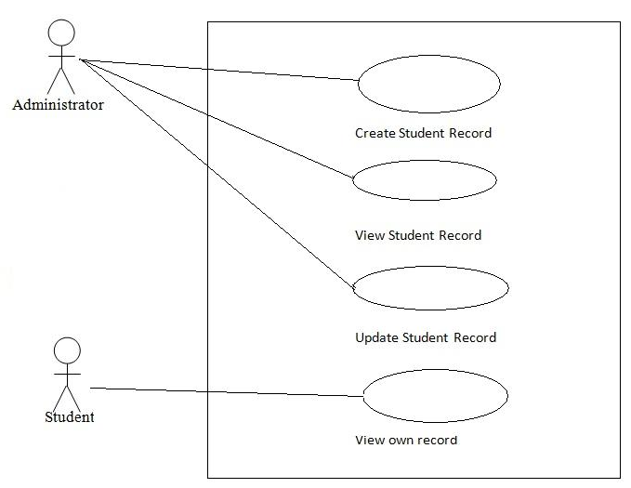

Fig.5.2 Use case diagram

|  |  |
| --- | --- |
| **Use Case** | **Description** |
| **User** | User is the main Actor/Sender in this phase. The main flow of events:   1. User click on user (student) button. 2. User can fill the information. 3. User saves the filled information. 4. User can view the information. 5. Also user can update the information. |
| **Administrator** | User is the main Actor/Receiver in this phase. The main flow of events:   1. User click on admin 2. Give the roll number & password 3. Take the photo of student or capture the photo. 4. Comparison the image to the training image 5. Mark the attendance   Save the attendance in the database |

Table 5.2.1: Use Case Scenario Table

**5.3 SEQUENCE DIAGRAM**

**Description:**

A **Sequence diagram** is an [interaction diagram](http://en.wikipedia.org/wiki/Interaction_diagram) that shows how processes operate with one another and in what order. It is a construct of a [Message Sequence Chart](http://en.wikipedia.org/wiki/Message_Sequence_Chart). A sequence diagram shows object interactions arranged in time sequence. It depicts the objects and classes involved in the scenario and the sequence of messages exchanged between the objects needed to carry out the functionality of the scenario. Sequence diagrams are typically associated with use case realizations in the Logical View of the system under development. Sequence diagrams are sometimes called **event diagrams** or **event scenarios.**

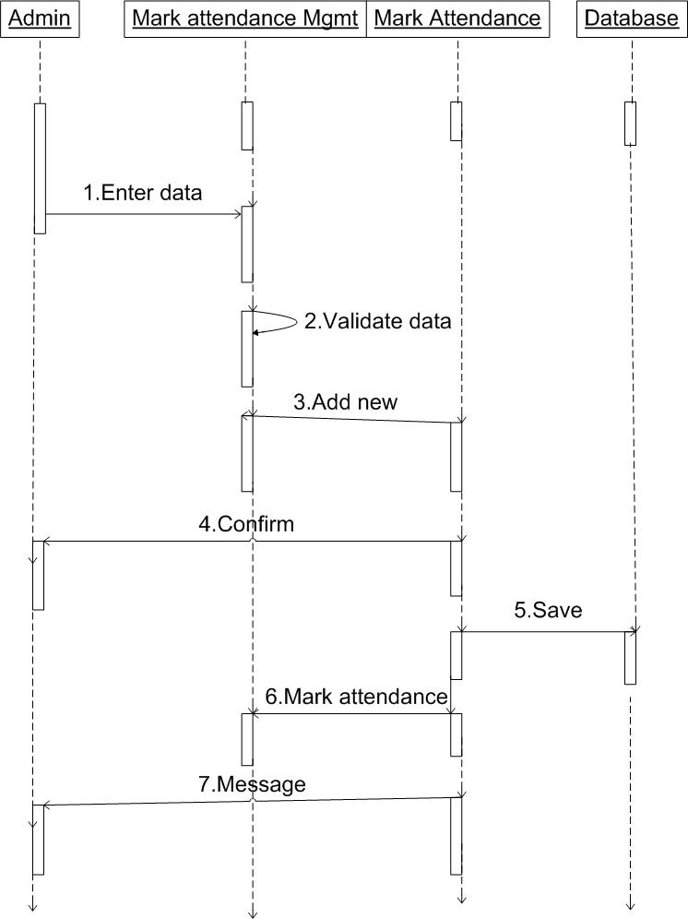

Fig.5.3 Sequence diagram

**5.4 CLASS DIAGRAM**

**Description:**

A UML class diagram describes the object and information structures used by your application, both internally and in communication with its users. It describes the information without reference to any particular implementation. Its classes and relationships can be implemented in many ways, such as database tables, XML nodes, or compositions of software objects.

* Class: A definition of objects that share given structural or behavioral characteristics.
* Attribute: A typed value attached to each instance of a classifier.
* Operation: A method or function that can be performed by instances of a classifier.

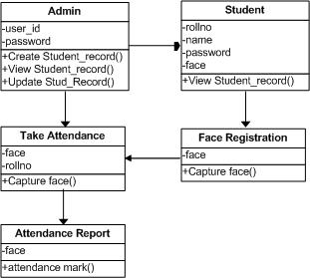

Fig.5.4 Class diagram

**Chapter 6:**

**CONCLUSION**

The aimed of requirement model for Student Attendance Monitoring System is to help system designer in designing a good attendance system and also conduct them to develop the attendance system in the future. Attendance system are important because can gives many benefit to schools such as security on attendance, reduce work time on taking attendance and create connection between school staffs and parents. There is no comprehensive and generally accepted manual on how to design good human factors into computer systems (Shackle, 1984) but there is a lot of guideline on how to design a system.

However, this requirement model can guide any system designers who want straightly focus to design Student Attendance Monitoring System. Creativity and innovation are required to make a great AMS. The system should be usable. Usability consists of many pieces such as system performance, system functions, and user interfaces organization and so on. In this project has provided a convenient method of attendance marking compared to the traditional method of attendance system. By using databases, the data is more organized. This system is also a user friendly system as data manipulation and retrieval can be done finally, this attendance system can be improved by adding a feature where the attendance system indicates when a student is late for work or classes as the case maybe.

**REFERENCES**

1. www.akashlab.org.in

2. Ononiwu G, Chiagozie. “Radio Frequency Identification (RFID) Based Attendance System with Automatic Door Unit”. In *Academic Research International*, ISSNL-L: 2223-9553. 2012; 2(2).

3. Zatin Singhal and Rajneesh Kumar Gujral. “Anytime Anywhere- Remote Monitoring of Attendance System based on RFID using GSM Network”. in *International Journal of Computer Applications* (0975–8887). 2012; 39(3).