
SITools2 V0.9
Developer’s guide

17/10/2011
CNES



SITools2 V0.9
Developer’s Guide

Written by:  Cyril MOZDZIERZ  Matthieu MARSEILLE  Jean-Pascal BOIGNARD  Mathieu GOND  David ARPIN | Issued to:  Jean-Christophe MALAPERT
Approved by:
Jean-Pascal BOIGNARD

RECORD OF CHANGES

Vers. | Date | Paragraph | Changes made
01.0 | 22/12/10 |  | Creation of the document
R2-S4 | 25/03/11 | See Contents | R2-S4 updated
R2-S7 | 23/05/2011 | 8, formatting | Development of resource plug-ins
R3-S1 | 07/07/2011 | 3  5 Filters  9 | Creation of form components  Addition of default filters notion  Addition of plug-in validation
R3-S5 | 13/10/2011 | 8, 9  6 | Application, Resource and Filter plug-ins.  SVA

TABLE OF CONTENTS

1 introduction 9
1.1 Installation of the Eclipse project 9
1.1.1 Installation 9
1.1.2 Starting Eclipse 9
1.1.3 Adding SVN Plug-ins 11
1.2 Get the SITools2 project from SVN 13
1.2.1 Adding a Subversion directory 13
1.2.2 Exporting SVN directories 15
1.2.3 Creating Eclipse project 15
1.2.4 Organize the projects in “working set” for better visibility (optional) 17
1.2.5 Configuring the execution platform 19
1.2.6 Additional notes about projects 23
1.2.6.1 Restlet 23
1.2.6.2 Restlet plug-ins used 24
1.2.6.3 Solr – Lucene 26
1.2.6.4 Other libraries 26
1.2.7 Reference databases 26
1.2.7.1 User database 26
1.2.7.2 The CNES FUSE database (unit tests, optional) 26
1.2.8 Eclipse installation and extensions (optional) 27
1.2.9 The main projects in SItools2 27
1.3 Project Build 28
1.3.1 Creating and configuring a customized build.properties: 28
1.3.2 Launching Ant tasks 29
1.3.2.1 Under Eclipse 29
1.3.2.2 Under console 30
1.3.2.3 Expected output 30
1.3.3 Extensions project 31
1.3.4 build-sitools project 31
1.3.5 The izPack-Install project 31
1.4 DEVELOPMENT, LAUNCH AND TESTS 31
1.4.1 Developing Sitools2 31
1.4.2 Launching Sitools2 with Eclipse 32
1.4.3 Launching Sitools2 without Eclipse 32
1.4.4 Unit tests with Eclipse 33
1.5 Installation WITH IzPack 33
2 CREATION OR MODIFICATION OF A COMPONENT TYPE FOR BASIC FORMs 34
2.1 CREATING A COMPONENT TYPE 34
2.1.1 For the administrator MMI: 34
2.1.2 For Java: 34
2.1.3 For JavaScript: 34
2.1.3.1 Administrator object: 35
2.1.3.2 User Object: 35
2.1.4 Client-server: 35
2.2 CREATING PREDICATES IN THE SERVER 36
2.3 CREATING components with units 36
3 datasets views 37
3.1 Creating a dataset view 37
3.2 Configuring the dataset 37
3.3 Services 37
4 CREATION OF AN OUTPUT CONVERTER 38
4.1 CREATING AN OUTPUT CONVERTER 38
4.1.1 Constructor 38
4.1.2 The getConversionOf method 39
4.2 Adding a converter in sitools 2 39
4.2.1 Method with Eclipse 39
4.2.2 Method without Eclipse 40
5 CREATION OF AN INPUT FILTER 41
5.1 CREATING AN INPUT FILTER 41
5.1.1 The constructor 41
5.1.2 The createPredicats method 42
5.1.3 The getRequestParamsDescription method 43
5.1.4 Use of unit conversion 43
5.1.5 Control of SQL injection 43
5.2 adding a FILTER in sitools 2 43
5.3 THE NOTION OF DEFAULT FILTERS 43
6 ADDITION OF A SVA BY A DEVELOPER 44
6.1 OPERATING MODE 44
6.2 CODING THE CLASS 45
6.2.1 Constructors 45
6.2.2 Parameters 45
6.2.3 Access the dataset data request 46
6.2.4 Access the DatasetApplication and apply the converters 46
6.2.5 Obtain a direct connection to the data source 47
6.2.6 Access HTTP request parameters 47
6.2.7 Add a predicate 47
6.2.8 Create a file 48
6.2.9 Copy an existing file 48
6.2.10 Zip a set of files 48
6.2.11 Other functionalities 49
6.3 LIST OF OBJECTS SET IN THE CONTEXT 49
6.4 the SvaUtils class 49
6.5 PRECAUTIONS 49
6.6 ACCESS TO REMOTE FILES 49
6.7 SVA LOGS 50
7 ADDING AN APPLICATION PLUG-IN 51
7.1 CODING THE CLASS 51
7.1.1 The constructor 51
7.1.2 The createInboundRoot method 51
8 ADDING A RESOURCE PLUG-IN 52
8.1 LOCATING 52
8.2 Creating a resource plugin 52
8.2.1 Creating the resource 52
8.2.2 Model 53
8.2.3 Helper 54
8.3 Using the resource 54
9 filtres plugins 55
9.1 Adding a filter 55
9.1.1 Creating the Model class 55
9.1.2 Creating the filter class 55
9.1.2.1 Generic filter: 55
9.1.2.2 Specific case: filter on datastorage 55
9.1.3 Helper modification 56
9.2 Use of filters in SITools2 56
10 VALIDATION OF THE PLUG-INS 57
11 NOTIFICATION OF SCHEDULED shut-downS 59
12 Integration of a JAR ARCHIVE in SITools2 60
12.1 Creating a new JAVA project 60
12.2 Creating the directory META-INF/services 60
12.3 Creating the JAR archive 61
12.4 Integration in SITools2 61
12.4.1 Case of a start from .bat or .sh 61
12.4.2 Case of a start from Eclipse 61
13 WADL DOCUMENTATION FOR THE SITOOLS2 API 62
13.1 WADL PRINCIPLE FOR THE DESCRIPTION OF A WEB SERVICE API 62
13.2 ACCES TO WADL DOCUMENTATION 62
13.3 DESCRIPTION OF THE METHODS IN THE SITOOLS2 SOURCE CODE 62
13.4 Generic creation of the wadl documentation by the unit tests 62
14 EXECUTION OF UNIT TESTS 64
14.1 UNIT TEST OBJECTIVES 64
14.2 Prerequisites 64
14.3 Execution 64
14.4 EXECUTION Report 64
15 IzPack installer 65
15.1 sitools-install-izpack project 65
15.2 Steps during the compilation process 65
15.2.1 Prerequisite 65
15.2.2 Installer compilation 66
15.2.3 Script creation 66
15.2.4 Properties files creation 66
15.2.5 Installer creation 66
15.3 Izpack installer description 66
15.4 Setting according to the SITools2 needs 66
15.4.1 Checking the database connection 67
15.4.2 Creating User and test tables 67

introduction
This document describes how the development environment is set up and constitutes a useful guide for developers, allowing them to develop Sitools2 extensions.

Installation of the Eclipse project
The different paths are provided for information only, indicating what has been done at AKKA. They should be adapted to the developer’s context.

Installation
The latest version of Eclipse can be found at the following address: http://www.eclipse.org/downloads/. The necessary Eclipse version for an optimal use of SITools2 project is the Eclipse IDE JAVA EE Developer version. Once the archive is uncompressed, the directory is named “eclipse”
Eclipse is installed in
- D:\eclipse\eclipse (Windows)
- <HOME>/eclipse (Linux)
Workspace directory (to be created before the first launch of Eclipse): A root directory is created in order to contain the whole project SITools2. This directory can have whichever name.
- D:\sitools-distribution\
- <HOME>/sitools-distribution
This directory must also contain a workspace directory, which is the base directory of Eclipse:
- D:\sitools-distribution\workspace
- <HOME>/sitools-distribution/workspace
Patch for an installation under Linux behind a proxy:
To allow Eclipse to access the network behind a proxy, a preliminary step may be necessary under Linux. It consists in adding the following line in the eclipse.ini file (root directory of the eclipse installation):
-Dorg.eclipse.ecf.provider.filetransfer.excludeContributors=org.eclipse.ecf.provider.filetransfer.httpclient
Eclipse needs to be restarted after this operation.

Starting Eclipse
Select the workspace:
At the first start, Eclipse asks for the workspace configuration. Configure this workspace by setting the path to the workspace directory (see Figure 1).
In order to keep the same workspace after Eclipse restarts, check the box “Use this as default and do not ask again” (see Figure 1)
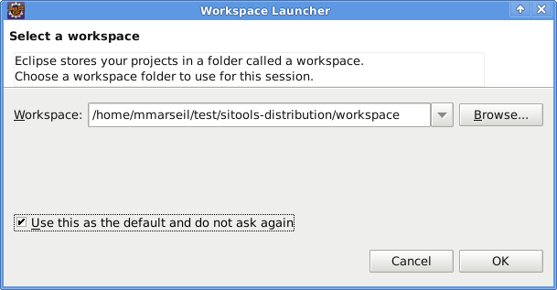
Figure 1: Selection of the workspace at the first start
Configuration of a proxy under Linux (see Figure 2):
The installation of necessary plug-ins for the use of SVN under Linux needs a network connection. When a proxy must be configured, you can do it via the Windows menu > Preference > General > Network connections. Then, use the configuration “Active Provider > Manual” to add your proxy parameters by editing the three protocols available (HTTP, HTTPS and SOCKS). Apply changes and click on OK.
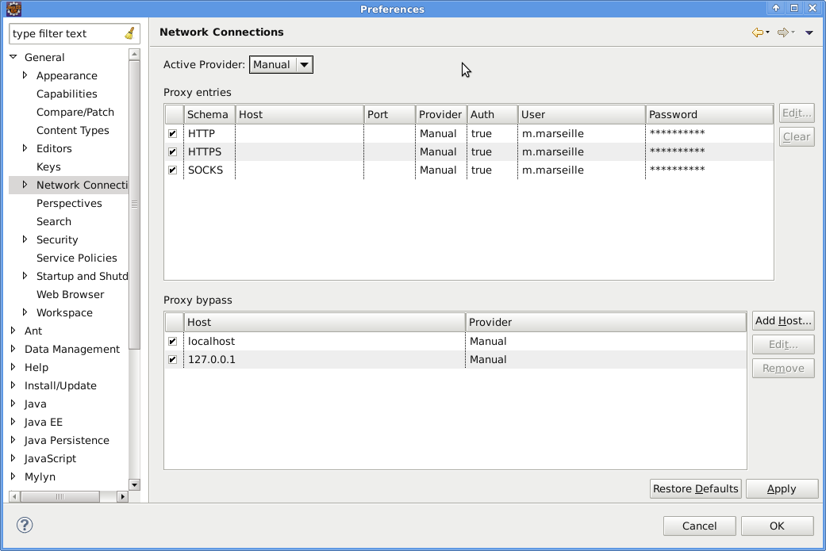
Figure 2: Proxy configuration (N.B: hosts and ports are not yet set in this screenshot)

Adding SVN Plug-ins
SVN plug-in is essential to get and use SITools2 project.
A plug-in Eclipse can be installed through the window: Help > Install new Software. Another solution is also to set the following URL address http://subclipse.tigris.org/update_1.6.x in the field called “Work with » and to hit Enter in order to get the list of available plug-ins. We can also click on “Add…” and set the fields “Name” and “Location” (see Figure 3).
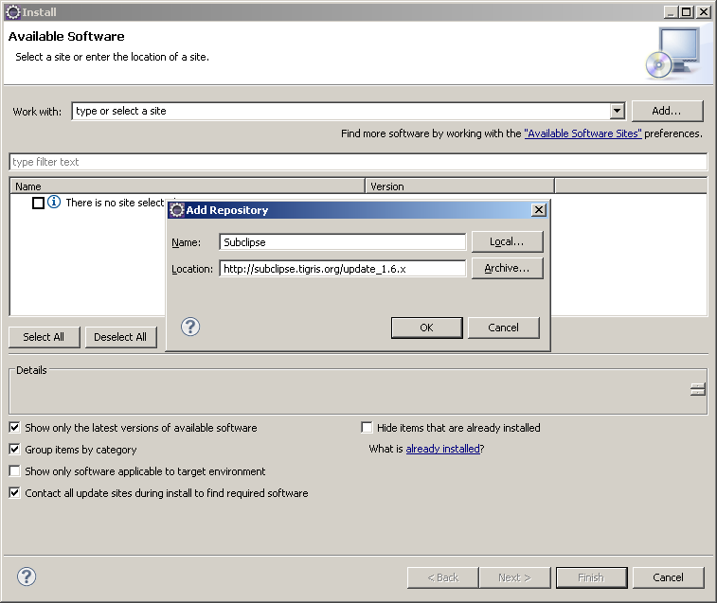
Figure 3: Adding a URL to get Eclipse plug-ins
Select all the plug-ins that are proposed and click on “Next” (see Figure 4).
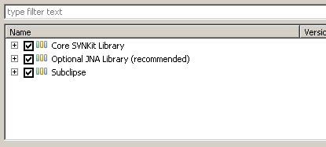
Figure 4: available plug-ins
When the plug-ins are installed, restart Eclipse.

Get the SITools2 project from SVN

Adding a Subversion directory
To get the different projects that SITools2 contains, it is necessary to create a link to the SVN repository at first. It is necessary to open the SVN perspective that is available in Eclipse (see Figure 5).
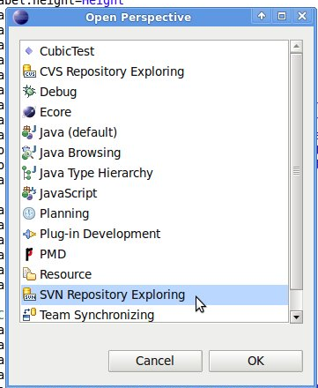
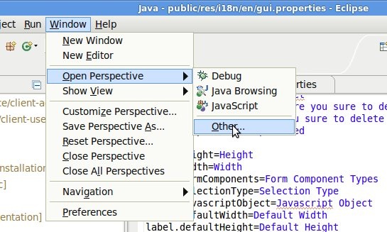
Figure 5: the SVN perspective

Then, type in the URL of the SVN repository:
https://sitools2.svn.sourceforge.net/svnroot/sitools2 (see Figure 6)
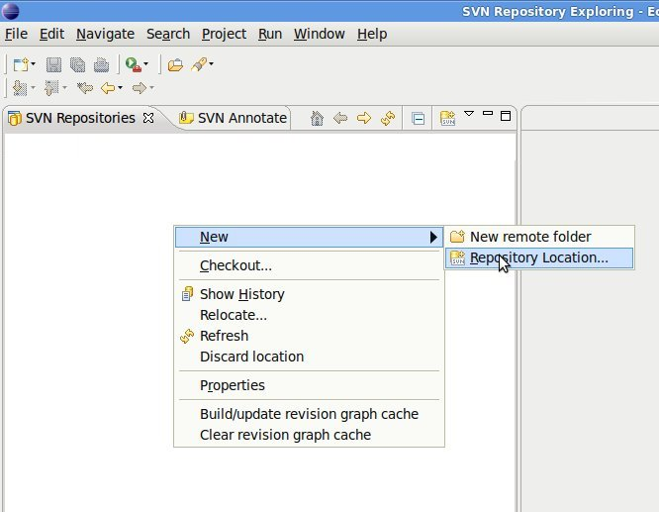
Figure 6: Creating a new SVN repository location
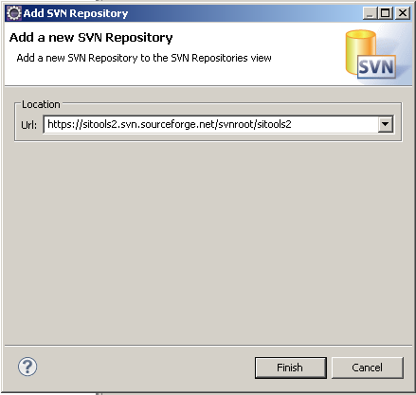

Exporting SVN directories
The available directories in the “trunk” or “tags” part from Sourceforge SVN repository are retrieved in local thanks to tools of SVN Eclipse. It is necessary to right click on each directory and to choose “Export…”, then to set the <HOME>/sitools-distribution as target directory (see Figure 7).
The four directories: cots, data, database and workspace must be exported this way one after the other. Once this operation is over, quit the SVN perspective to come back to JAVA perspective.

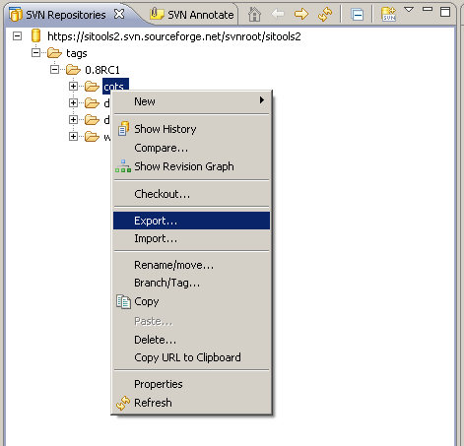
Figure 7: Exporting directories from a repository to a local directory

Creating Eclipse project
Once the set of directories is located in <HOME>/sitools-distribution, Eclipse is able to locate all available projects in order to instantiate them.
Click on File > Import… and select Existing Projects into Workspace (See Figure 8)
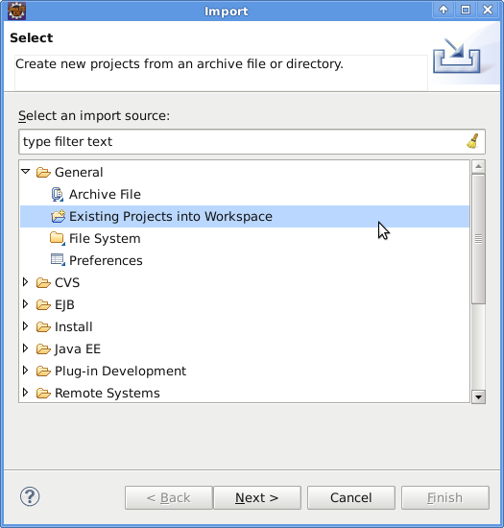
Figure 8: Importing existing projects
Then, click on Next and select the directories that contain the retrieved projects: <HOME>/sitools-distribution/workspace. Select all projects and click on Finish (see Figure 9).
Warning: Eclipse will import and will compile these projects. This can take time. It is important to wait that Eclipse finishes compiling all projects before doing anything with Eclipse otherwise you will need to restart the complete procedure (workspace installation …).
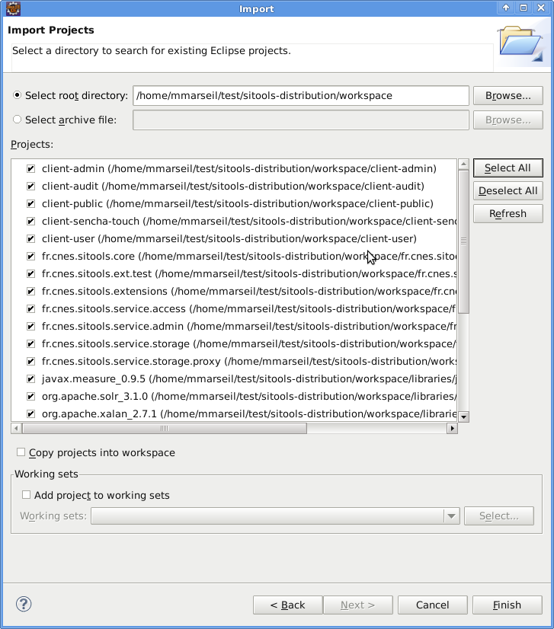
Figure 9: Selecting and importing SItools2 projects under Eclipse

Organize the projects in “working set” for better visibility (optional)
Change the perspective to the Java perspective
Select the working set package organization
Create your working sets and add projects to them
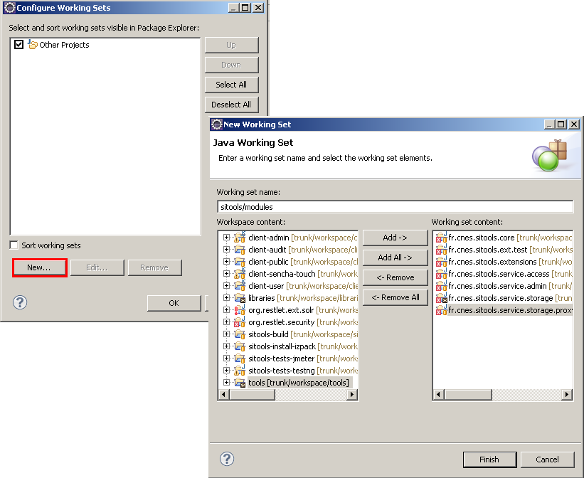
Figure 10: Working sets creation
The resulting organization is shown below:
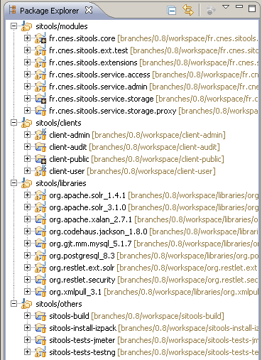

Configuring the execution platform
To launch Sitools2 in Eclipse, you have to define a “Target platform”. This contains the libraries required to run Sitools2 in OSGI mode and in standard mode.
- In Eclipse, open the preferences
- Select “Target Platform” in the “Plug-in development" section
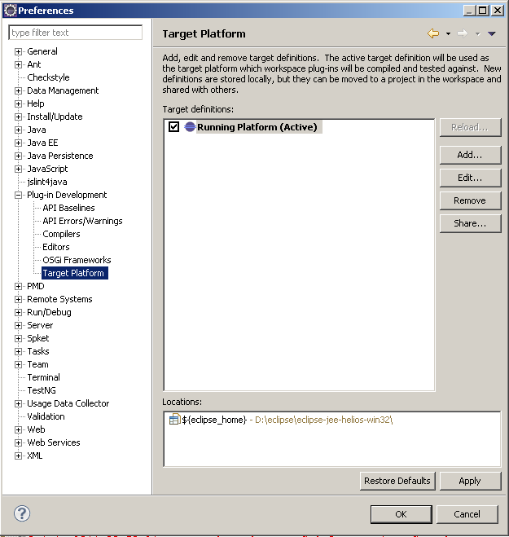
Figure 11: Edition of preferences of the plug-in development platform
- Add a new platform (see Figure 11)
- Add two folders to the platform: (see Figure 12)
  - The Restlet folder: <HOME>/sitools-distribution/cots/restlet-2.0.5-patched
  - The folder where Eclipse is installed: <HOME>/eclipse

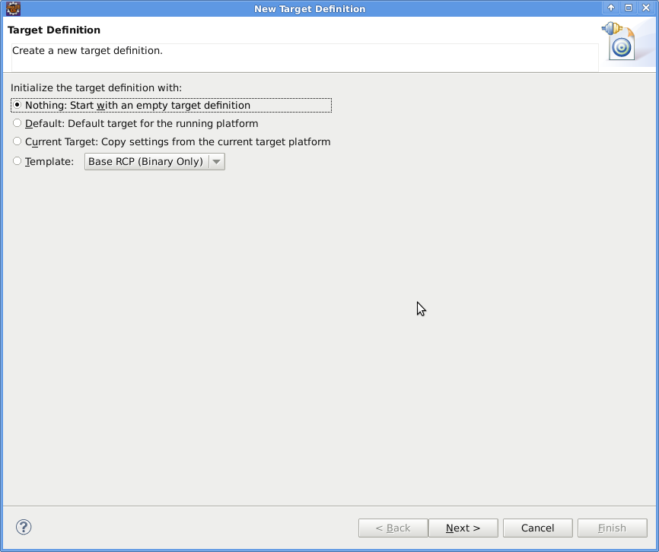
Figure 12: Add a target platform from scratch
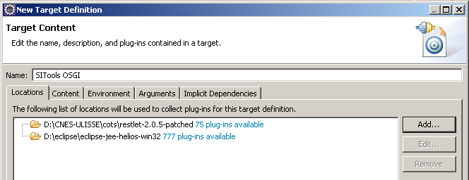
Figure 13: Add paths that contain the necessary plug-ins

- Select:
  - All the libraries in the Restlet folder
  - The three OSGI libraries in the Eclipse folder (see Figure 13)
    - org.eclipse.osgi.services
    - org.eclipse.osgi.util
    - org.eclipse.osgi
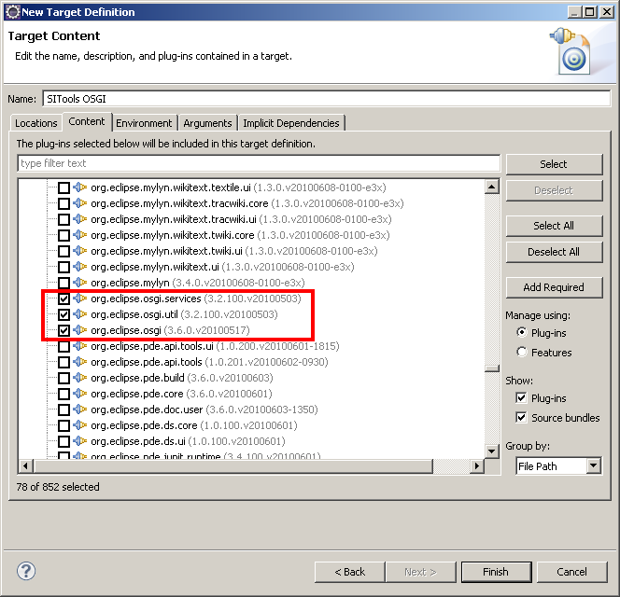
Figure 14: Add Eclipse plug-ins for OSGI
- Check the ‘target platform’ that has been added to activate it (See Figure 14). The workspace will self-build and after that step the projects shoudn’t be in error anymore. Click ok to quit.
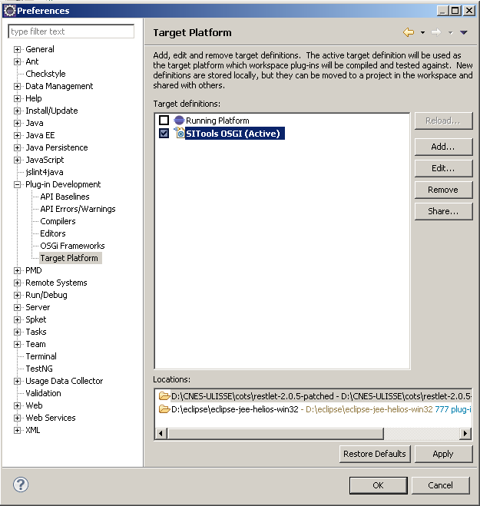
Figure 15: Select a new platform

Additional notes about projects

Restlet
Current version: [version=2.0.5]
The application must operate in standalone mode with Jetty.
The J2EE operating mode of an application deployed in a Tomcat or Jetty servlet container was not selected as a requirement, in favor of studying deployment on an OSGi platform.
To deal with this particular constraint, we had to modify a few Restlet files to constitute a “restlet-2.0.5-patched” version.

Restlet plug-ins used
List of libraries
- org.restlet.jar
- xstream extension
org.restlet.ext.xstream.jar
com.thoughtworks.xstream.jar: The advantage of this extension lies in being able to indifferently perform Java class <> flux xml/json mapping. However, the disadvantage is that the definition of the xsd schema must be performed “manually”.
- pool extension of jdbc connections
org.apache.commons.dbcp.jar
org.apache.commons.pool.jar
- fileupload extension
org.restlet.ext.fileupload.jar
org.apache.commons.fileupload.jar
org.apache.commons.httpclient.jar
org.apache.commons.io.jar
org.apache.commons.logging.jar
- freemarker extension
org.restlet.ext.freemarker.jar
org.freemarker.jar
- json extension
org.restlet.ext.json.jar
org.json.jar
- RSS and syndication extensions
org.restlet.ext.atom
org.restlet.ext.rome
com.sun.syndication
org.jdom
- email extension
org.restlet.ext.javamail
javax.mail
- Solr extension
org.apache.solr_3.1.0
org.restlet.ext.solr (library folder)

org.restlet.ext.httpclient.jar
org.restlet.ext.xml.jar
This is not an exhaustive list in view of the fairly frequent modifications made to the project dependencies. The precise list of dependencies is available in the file MANIFEST.MF of the project fr.cnes.sitools.core (fr.cnes.sitools.core/META-INF/MANIFEST.MF)
org.restlet.ext.jdbc.jar
This extension is used to produce representations of the contents of databases.
Our needs:
- metadata > representation in a standard format of table/column descriptions
- data > representation in a standard format of the content of databases, joins, with streaming, paging, etc.
This component was initially explored during the REST-Restlet study.

org.restlet.ext.wadl.jar
The need is to produce the API documentation of a Restlet server and of each of its applications in standard WADL format and in HTML (Yahoo "WADL2HTML.xslt” type sheet).
We do not use the WADL file to instantiate the servers / applications because the possibilities seem limited at present.

Solr – Lucene
Restlet has a Lucene extension. For Sitools2’s requirements, we have created a library (librairies/org.apache.solr_3.1.0) in the library folder containing all the solr jars. We also updated the Reslet Lucene extension (org.restlet.ext.solr) to make it compatible with solr version 3.1.

Other libraries
org.junit.jar
mysql-connector-java-5.1.7-bin.jar
postgresql-8.3-603.jdbc3.jar
xpp parser XML

Reference databases

User database
Registering and managing Sitools2 users requires a PostgreSQL or MySQL type database, included but which needs to be correctly configured.
For PostgreSQL, you must create a database on the server and add a “sitools2” user. You must then run the script “pgsql_sitools.sql” (available in the folder "database/PGSQL” at the root of the project).
You must do likewise for MySQL by executing all the scripts available in the folder "database/ MYSQL_CNES » on a previously created database.
Once the database has been created and filled, you must configure Sitools2 so that it points to this database (property "Starter.DATABASE_URL" of the file sitools.properties or directly in the installer IZPack during installation).

The CNES FUSE database (unit tests, optional)
The project unit tests use a database table which is provided and which must be correctly configured, namely in terms of access rights.
To configure the database for the tests, you must run all the scripts available in the “database” folder at the root of the project on previously-created databases.

Eclipse installation and extensions (optional)
The installation of the Sitools2 development environment first requires that certain elements be installed and configured. This mainly includes the Eclipse IDE and certain plug-ins that go with it.
- PMD plug-in (code measurement, optional): http://pmd.sf.net/eclipse
- CHECKSTYLE plug-in (syntax verification, optional): http://eclipse-cs.sf.net/update/

The main projects in SItools2
The main projects created are:
- client-admin: JavaScript project containing Sitools2 Admin MMI information
- client-user: JavaScript project containing Sitools2 MMI information (Portal and Desktop)
- client-public: containing common sources: Java scripts, i18n files, etc.
- fr.cnes.sitools.core: the project’s main Java project (Restlet Server, Object Classes, Libraries, Ant procedures, unit tests, etc.)
- fr.cnes.sitools.extensions: project associated with fr.cnes.sitools.core, for creating Java objects to be instantiated by the server (converters, filters)
- fr.cnes.sitools.ext.tests : same as fr.cnes.sitools.extensions but for tests purpose.
- sitools-tests-testNG: automated and non-automated MMI tests
- sitools-tests-jmeter: performance tests
- sitools-build: to build the project, properties, jars, shells, etc.
- sitools-install-izpack: to build the izpack installer

The following projects for the OSGi platform are added to those projects:
- fr.cnes.sitools.service.admin: Sitools2 service for the OSGi platform administration and the other Sitools2 services.
- fr.cnes.sitools.service.access: Sitools2 access service particularly corresponding to the majority of the current applications exposed by the core server.
- fr.cnes.sitools.service.storage: datastorage service corresponding to the Storage service of the OAIS

To these projects are added the library projects which are of use to Sitools2:
- org.apache.solr_3.1.0: All of the Solr apache jars
- org.codehaus.jackson_1.8.0: Jackson 1.8 version
- org.postgresql_8.3: JDBC driver for PostgreSQL
- org.gjt.mm.mysql_5.1.7: JDBC driver for MySQL
- org.xmlpull_3.1
- org.apache.xalan_2.7.1

Project Build
In addition to the compilation of Java classes (automatic under Eclipse), use of the project requires a set of resources to be distributed according to the development project user configuration. This function is carried out by two Ant tasks which must be run to be able to develop, test or use Sitools2. Organizing the projects in “OSGI mode” also requires the definition of an execution platform or “target platform” to be able to use Sitools2 within Eclipse.

Creating and configuring a customized build.properties:
The fr.cnes.sitools.core project contains a series of conf/build/properties/build-*.properties files, each one being associated with the configuration of the developer's environment. The one that the Ant task will use is designated by the master file build.properties.
For example, a configuration file named build-yourID.properties and placed in the directory conf/build/properties/ has the form:
#----------------------------------------------------------
# build.properties
# dependent platform properties
# version 1.0
#----------------------------------------------------------
ROOT_DIRECTORY=<HOME>/sitools-distribution/
HOST_DOMAIN=<LOCAL ADDRESS>|localhost|127.0.0.1
DATABASE_URL=<USERS DATABASE URL>
DATABASE_USER=<NAME TO ACCESS DB>
DATABASE_PASSWORD=<PASSW TO ACCESS DB>
PUBLIC_HOST_DOMAIN=http://localhost:8182

# Example:
ROOT_DIRECTORY=/home/mmarseil/sitools-distribution/
HOST_DOMAIN=silo68.silogic.fr|localhost|127.0.0.1
DATABASE_URL=jdbc:postgresql://odysseus4.fr.akka.corp:5432/CNES-hudson
DATABASE_USER=sitools
DATABASE_PASSWORD=sitools
PUBLIC_HOST_DOMAIN=http://localhost:8182
Simply modify build.properties as follows:
#----------------------------------------------------------
# build.properties
# local platform properties
#----------------------------------------------------------
HOST = yourID

Launching Ant tasks

Under Eclipse
Ant tasks can be launched with Eclipse via a special view that is available as shown below:
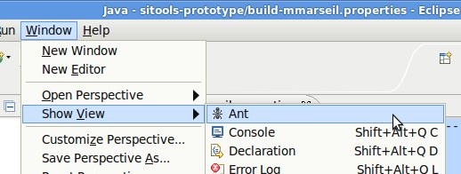

You can then drag and drop the project’s Ant task files (build.xml) into the Ant panel for execution:
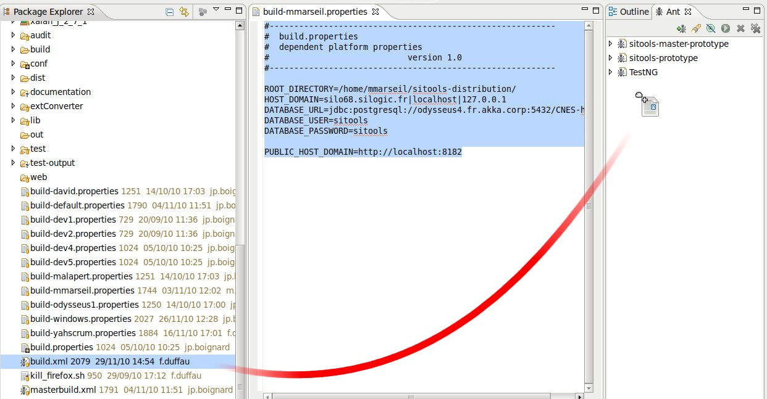
Run in the following order, in the Ant view:
- refresh-properties
- refresh-userlibraries
- refresh-properties allows you to rebuild all the properties of the project while including the specifics indicated by the developer in his build-devname.properties. It creates a new file sitools.properties in the fr.cnes.sitools.core project.
- refresh-userlibraries presents all the libraries for the project in the form of absolute paths (which therefore depend on build-devname.properties) and places them in sitools.userlibraries.eclipse.xml. These libraries are essential to the correct compilation of the project, so they must be incorporated into the project’s properties after this step.

Under console
Simple, go to fr.cnes.sitools.core and type “ ant <target>” where target can be empty by default, but it can be one of the predefined targets from the build.xml file as well.

Expected output
After the compilation stage, several files must be located to the root directory of the project:
- fr.cnes.sitools.core.jar: Executable JAR that contains the classpath of other projects in the MANIFEST.MF file. The classpath may also contain extension JAR provided by the administrator.
- fr.cnes.sitools.tests.jar: Executable JAR that allows running tests. This feature needs extra-steps (configuration of a database)
- startSitools.bat: BATCH script under windows. This script is built from an XSLT transformation during the ANT task called refresh-userlibraries. The XSLT is available at:
conf/build/userlibrairies/sitools.userlibraries.xsl
- startSitools.sh: BASH script under Linux. This script is also built from an XSLT transformation at the same place than the startSitools.bat
- sitools2: script to start/stop/monitor for Linux. This script is a direct copy from conf/bin/sitools

Extensions project
In order to develop new classes of converters or filters, the prospective developers must go to the project fr.cnes.sitools.extensions. Once the Java sources have been created, the project’s main Ant task (build-extensions) enables to rebuild the file fr.cnes.sitools.extensions.jar. This file must be located in the Sitools2 execution classpath in order to identify and use the plug-in classes.

build-sitools project
The build-sitools project allows the ROOT_DIRECTORY parameter to be quickly modified in the different projects of the workspace. This project contains a set of conf/build/build-*.properties files, one for each configuration (as for the fr.cnes.sitools.core project). You must therefore enter the ROOT_DIRECTORY in the file corresponding to your configuration and enter the HOST parameter in the build.properties file. You must then launch the sitools-build project’s default Ant task. This step should be performed before starting any compilation of the projects sitools-install-izpack, sitools-tests-jmeter or client-audit.

The izPack-Install project
This project enables to generate an automated Java installer using the IzPack project. First, you must update the file build.properties by using the build-sitools project and following the instructions in paragraph 2.3.6. Then simply launch the build-install.xml file’s default Ant task to start creating the installer. The Ant task does not compile sources, so the sources also need to be compiled before generating the installer.

DEVELOPMENT, LAUNCH AND TESTS

Developing Sitools2
The preliminary rules for developing Sitools2 are:
- Development in JavaScript projects (client-admin and client-user) do not normally require any adjustments to be made to Eclipse.
- It is necessary to reboot the server for JAVA development of the server to take effect.
- Changes to critical architecture (addition of a source folder, for example) requires to make changes to the Ant tasks and thus a global re-build of the project.
- JAVA classes that may be considered as “external” to Sitools2 should be introduced via the extension project fr.cnes.sitools.extensions or via a project with a similar structure. For a new project, be sure to modify the compilation and execution classpaths (Ant tasks + xsl).

Launching Sitools2 with Eclipse
To launch Sitools2 with Eclipse, you must create a “build”:
- Go to the “run configuration” window
- Add a new “Java application”
  - Select the project: fr.cnes.sitools.core
  - Select the Main class: fr.cnes.sitools.server.Starter
- If you want to use the extensions, add the project fr.cnes.sitools.extensions to the classpath
- Add the Jetty’s server JAR in order to be sure to launch Sitools2 with Jetty standalone server:
  - In the Classpath tab, select « User Entries » in the tree
  - Click « Add External JARs »
  - Add the fallowing JARs :
      - All JARs in the cots/restlet-2.0.5-patched/org.eclipse.jetty directory
      - The JAR « org.restlet.ext.jetty.jar » in the cots/restlet-2.0.5-patched directory
      - The JAR « javax.servlet.jar » in the cots/ restlet-2.0.5-patched/javax.servlet_2.5 directory
You can then launch Sitools2 by executing the “build” defined above.

Launching Sitools2 without Eclipse
In order to launch outside of Eclipse, you have to build the “fr.cnes.sitools.core” project as explained in the 1.3.2.2 part. You need to do the same for the “fr.cnes.sitools.extensions” project.
Then you have to execute the following command in the “fr.cnes.sitools.core” directory:
./sitools start
NB: At startup, all JARs included in the “ext” folder will be automatically added to the JAR’s MANIFEST.MF. This is done using the “sitools-update-classpath.jar”. The added JARs are now added to the classpath and can be used inside Sitools2.

Unit tests with Eclipse
Unit tests may be launched via the package fr.cnes.sitools (right-click + Run As … + Junit Test), in "test/src".

Installation WITH IzPack
Sitools2 can be installed with an IzPack installer. Simply launch the “SITools2-<version>-install.jar” jar with the command “java –jar SITools2-<version>-install.jar” or double-clicking on it. You then have to follow the instructions and enter the information requested.
Note: in Windows, you must select a short installation path with no spaces. (e.g.: D:/sitools2)
Sitools2 must be configured during the installation with IzPack. You can therefore select the parameters of the sitools2 virtual host, database and email as well as the proxy parameters. The proxy parameters are useful if the server that hosts Sitools2 needs to access resources located behind a proxy.
The virtual host parameters enable to enter the addresses behind which Sitools2 is accessible via the “host domain” parameter (list of domain names or IP addresses separated by |).
If you are configuring Sitools2 behind a proxy, it must be configured during the installation. If a proxy is configured, all the calls made by the Sitools2 server will be sent to the proxy. To avoid internal calls being sent to the proxy, you must configure the “non proxy host” parameter (list of domain names or IP addresses separated by |). This parameter must contain at least the addresses defined as “host domain”, as well as all other addresses available without using a proxy.

CREATION OR MODIFICATION OF A COMPONENT TYPE FOR BASIC FORMs

CREATING A COMPONENT TYPE

For the administrator MMI:
Administrators may create component types for forms.
A component type is defined by:
- Type
- Default Height
- Default Width
- JavaScript Object for the administration interface
- JavaScript Object for the user interface
- The URL of the file containing the definition of the administration object
- The URL of the file containing the definition of the user object
- The priority, order in which the JavaScript files will be included in the HTML pages

Type is a unique key on the component type list.

For Java:

Each form component will use the dataset search API. To enrich this search API, different filters may be associated with a Dataset.
Therefore, for the components to function correctly, it is vital that the filters be implemented and associated with the Dataset. It is also vital that the columns of the dataset are configured with the “filter” attribute in order to filter on these columns.
Each developer may develop their own filters to enrich the search API for a Dataset.

For JavaScript:
The user and administrator JavaScripts must be defined in the files and placed on the server at an accessible location. Setting the parameters of the component type will allow you to make the connection to these files and include them dynamically.

Administrator object:
The developer will have to create a JavaScript object which will be instantiated when the administrator decides to add this new component type to one of his forms.
This object must extend the Ext.form.panel class and implement a _onValidate() method.
This method describes the behavior when the administrator validates his parameter settings for this component type: add or modify one of the form components currently being edited.
It accepts the grid containing all the form components and the action currently underway as parameters.
For example: client-admin/js/forms/componentsAdminDef/OneParam/TextField.js

User Object:
The developer will also have to create a JavaScript object which will be instantiated when the user displays the form.
This object must extend the Ext.form.Field class and implement a getParameterValue() method which will return the component’s signature (which will be read by the search API). This object must also contain a type property: “sitoolsFormContainer”
This object will be instantiated with the parameters described in the following paragraph.

Client-server:
The exchange model for each component is defined by the object ParameterDTO, each form therefore contains a list of ParameterDTOs.
You must therefore convert the parameter into an ExtJs component to display the form:
In the file formParameterToComponent.js, according to the type, you instantiate the defined object in the component type by assigning to it the parameters defined by the administrator.
This setting of parameters is presently limited to:
ParameterId: the ID of the parameter (unique in a form)
Values: the table of possible values for the component (optional)
Code: a dataset column alias table
Type: the component type
Label: the component label
Height: the component height
WidthBox: the component width
ValueSelection: for certain components, the way in which the values are loaded (S: specific values, D: values from a data table)
ParentParam: the parent parameter for inter-linked components
DataUrl: the URL on which data may be loaded
AutoComplete: parameter setting for the textfield (true or false)
FormId: the ID of the form
Unit: the unit relative to the component
Css: an additional css class
DefaultValues: any default values, as the case may be.

The getParameterValue() method of the component will be used for searching on the Dataset. That way, when the request is generated, each component entered will create a parameter in the form:
P[n] =getParameterValue()
Each non p[n] parameter will be consumed by the filters associated with the dataset and will generate the predicates under the conditions set in each filter.

CREATING PREDICATES IN THE SERVER
See Using filters.

CREATING components with units
Units are handled in JavaScript description of a component under the shape of an Ext.Button. The behavior of this component is defined in each form component. The behavior of this button from the client side mainly consists in:
- Displaying a unit when a column, for which the component is defined, has one.
- Displaying a list of available unit according to the dimension that has been defined with this component.
NB: In the case of cone-search component, the reference unit will always be degree. It means that there will be a conversion between the given unit and degree when using a cone-search component.

datasets views

Creating a dataset view
The administrator can create dataset views for each dataset.
A data view is defined by:
- Name,
- Description,
- JavaScript Object,
- File Url,
- Image,
- Priority: order in which JavaScript files are included in HTML pages.
Once datasetview is created in the administration interface, simply put the JavaScript file at the place you set when you create the datasetview.

Configuring the dataset
When a dataset is defined, the administrator must choose a datasetView so that data is presented in it.

Services
Each Dataset view must implement services themselves. The two default views (sitools infinite scrolling and sitools dataview) have the same services (sort, multiple filter, plot, details, SVA…)

CREATION OF AN OUTPUT CONVERTER
Converters may be used to perform a conversion after the database runs the request. It has a set of input parameters, internal parameters (constants) and output parameters.

CREATING AN OUTPUT CONVERTER
The creation of an output converter amounts to the implementation of a Java class processing output data.
This class must extend the AbstractConverter class and implement the getConversionOf method.
The skeleton of such a class is as follows:
public class MyConverter extends AbstractConverter {

public LinearConverter() {
//initialization of the details of the converter
//declaration of the parameters
}

@Override
public final Record getConversionOf(final Record rec) throws Exception {
//retrieval of the parameters
//execution of the converter
return rec.
}
}

Constructor
The constructor has to define the details of the converter, that is:
- Its name, description, author and version
- The list of its parameters, specifying:
  - The name and a description
  - The type (INTERN, IN, OUT or IN_OUT)
An IN, OUT or IN_OUT parameter is mapped to a dataset column. During the configuration the administrator will be given the choice between all the columns of dataset to fill this parameter. An INTERN parameter is a constant that has to be entered by the administrator.
A parameter is created by creating an object of the ConverterParameter class. The types of parameters are defined in the ConverterParameterType listing.
It is then added by invoking the addParam method of the Abstractconverter class. It is also possible to attribute default values to internal parameters
A converter can have two constructors:
- A mandatory one by default, with no parameters
- Another constructor with a Context type object as a parameter. In this Context you can find the Dataset (“DATASET” attribute). This constructor allows for a list of parameters which depends on the dataset and makes the converter even more flexible.

The getConversionOf method
This method is run while the converter is being run.
First, you must retrieve all the converter parameters. You must use the getInParam, getInternParam, getInOutParam and getOutParam methods of the AbstractConverter class.
Once the parameters have been retrieved, simply process the data as required.
With this method, you can also retrieve certain variables from the context. These variables are SitoolsSettings, DataSetApplication and the previously made HTTP request.
Simply retrieve them from the context parameters with the keys: “DataSetApplication” and “ContextAttributes.SETTINGS” and “REQUEST”.
In DataSetApplication, it is possible to obtain a connection to the database:
// complete retrieval of the dataset
DataSet ds = datasetApp.getDataSet();

// obtaining a connection to the data source
Connection con = SitoolsDataSourceFactory.getInstance()
.getDataSource(ds.getDatasource().getName()).getConnection();
Where datasetApp is the DataSetApplication retrieved from the context.

Adding a converter in sitools 2

Method with Eclipse
If you are using Eclipse, and you have retrieved all the sources, it is very simple to add a converter.
Indeed, all you have to do is add this class to the extensions project and add the complete name of the class to the file fr.cnes.sitools.converter.ConverterHelper.
Then, you must run the Ant task present in the extensions project to include the new class in the list of extensions. You also must re-start Sitools2 in order to take the new Jar into account.

Method without Eclipse
If you are not using Eclipse and the extensions project does not exist, you must create the relevant tree “manually”.
Even so, this tree is quite simple. All you need are the folders containing the sources at the root, along with a META-INF/services folder containing a file called fr.cnes.sitools.converter.ConverterHelper in which to put the class names.
The tree therefore looks like this:
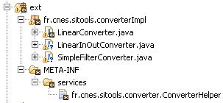
You must then
- Compile the sources with the Sitools2 jar and Restlet jar in the classpath.
- Create a jar by including the compiled classes and the META-INF/services folder.
- Add this jar to the Sitools2 classpath

CREATION OF AN INPUT FILTER
Filters allow a more precise filtering during the request on a dataset. Each filter may add predicates to the request, which is then run by the database. A filter has a set of input parameters, internal parameters (constants) and output parameters.

CREATING AN INPUT FILTER
The creation of a filter amounts to the implementation of a Java class returning a set of predicates.
This class must extend the AbstractFilter class and implement the getConversionOf method.
The skeleton of such a class is as follows:
public class MyFilter extends AbstractFilter {

public BasicFilter() {
//initialization of the details of the filter
//declaration of the parameters
}

@Override
public final ArrayList<Predicat> getConversionOf(Request request, ArrayList<Predicat> predicats) throws Exception {
//retrieval of the parameters
//creation of the predicates
//return of the list of predicates
}
}

The constructor
The constructor has to define the details of the filter, that is:
- Its name, description, author and version
- The list of its parameters, specifying:
  - The name and a description
  - The type (INTERN, IN, OUT or IN_OUT)
An IN, OUT or IN_OUT parameter is mapped to a dataset column. During the configuration the administrator will be given the choice between all the columns of dataset to fill this parameter. An INTERN parameter is a constant that has to be entered by the administrator.

A parameter is created by creating an object of the FilterParameter class. The types of parameters are defined in the FilterParameterType listing.
- The list of the request parameters in order to generate the search API for a dataset
It is then added by invoking the addParam method of the FilterConverter class. It is also possible to attribute default values to internal parameters
A Filter can have two constructors:
- A mandatory one by default, with no parameters
- Another constructor with a Context type object as parameter. In this Context you can find the Dataset (“DATASET” attribute). This constructor allows for a list of parameters which depends on the dataset and makes the filter even more flexible.

The createPredicats method
This method is run while the filter is being run.
First you must retrieve all the filter parameters. You must use the getInParam, getInternParam, getInOutParam and getOutParam methods of the FilterConverter class.
Once the parameters have been retrieved, simply create the relevant predicates according to the columns for which the parameters have been set and the constants.
With this method, you can also retrieve certain variables from the context. These variables are SitoolsSettings and the DataSetApplication.
All you have to do is retrieve them from the context parameters with the keys: “DataSetApplication” and “ContextAttributes.SETTINGS”.
In DataSetApplication, it is possible to obtain a connection to the database:
// complete retrieval of the dataset
DataSet ds = datasetApp.getDataSet();

// obtaining a connection to the data source
Connection con = SitoolsDataSourceFactory.getInstance()
.getDataSource(ds.getDatasource().getName()).getConnection();
Where datasetApp is the DataSetApplication retrieved from the context.

The getRequestParamsDescription method
Overloading this method in a filter enables to generate a search API at Dataset level according to the parameter settings of each filter.

Use of unit conversion
The classes that inherit from the abstract class AbstractFilter have one method to implement:
Double convert(String unitFormName, String unitToName, String valueFrom, String dimension) that returns the conversion from a given value (valueFrom) in one specific unit (unitFromName) to another unit (unitToName) by using a SITools2 dimension (dimension). Therefore, this method can be used in the createPredicats() method in order to create a request according to the unit that is stored in an attribute of a dataset. This method sends back an exception ResourceException when the unit or the dimension is unknown for SITools2. An example of this method is visible in checkValues method from NumericBetweenFilter.

Control of SQL injection
Each filter must avoid SQL injection. When expected values are numerical values, it is necessary to cast expected values in double. When expected values are String, it is necessary to use the following method:
String value = SQLUtils.quote(parameters[VALUES]);

adding a FILTER in sitools 2
Filters are added in the same way as converters. The only difference is that the class list must be located in the fr.cnes.sitools.filter.FilterHelper file.

THE NOTION OF DEFAULT FILTERS
Filters are now the only way to enrich the search API on a dataset, and therefore the only way to generate predicates using request parameters.
Form components and data filtering in the liveGrid now use filters to generate predicates.
In the interests of streamlining management for the administrator, we have added the “default” notion to a filter. When a dataset is created, all the default filters will be automatically associated with the new Dataset via a Trigger mechanism.
The default character of a filter may therefore be defined by the developer in the implementation of the filter.

ADDITION OF A SVA BY A DEVELOPER

An SVA is developed in the same way as a converter or a filter. Simply:
- Write the class
- Add it to the “extensions” project
- Add the complete class name to the “fr.cnes.sitools.sva.SvaHelper” file in the META-INF folder
- Compile the “extensions" project and re-start Sitools2.

The procedure itself is quite simple but requires information on writing the SVA class.
SVA classes are used in two ways: in synchronous mode (GET and POST method) and in asynchronous mode (POST method). The use of one or other of these modes is transparent for the developer but attention should be paid to the way the class is coded. The developer can give the administrator some guidance by putting certain default values (method, asynchronous or synchronous mode) to help him with his configuration.

OPERATING MODE
An SVA can operate in two different ways. The developer must select the one that best suits his needs.
- The result is a Representation
Here, a representation must be returned for storage on the server. It may be consumed when the execution has terminated but may only be consumed once.
- The result is a file
Here, the result of the SVA must be stored in a file and null must be returned at the end of the SVA. The URL of the result file must also be entered so that it may be accessed several times at the end of the execution.
This type of operating mode is not currently compatible with execution that uses the GET method.

There are two ways to set parameters on an SVA:
- By using a dataset record consultation API
- By including the URL of a file in the body of the request. This file must contain a list of records containing at least the key of each record. This file must be in JSON format and have the form
{"orderRecord":{"records":[ list of records ]}}
The use of either of these ways is transparent when developing an SVA.

CODING THE CLASS

Constructors
An SVA can have two constructors:
- A mandatory one by default, with no parameters
- Another constructor with a Context type object as a parameter. In this Context you can find the Dataset (“DATASET” attribute). This constructor allows for a list of parameters which depends on the Dataset and makes the SVA even more flexible.
In these constructors, you can give the administrator some guidance on how to configure his SVA. You can therefore specify:
- The method
//indications concerning the method to employ
this.setMethod("GET");
- The run type
//indications concerning the run type
this.setRunType(SvaRunType.SVA_FORCE_RUN_ASYNC);

Parameters
In the constructor we can specify parameters that will be filled by the administrator. Different parameter types are:
- PARAMETER_IN: Mapped to a column as in parameter.
The value of the column can be retrieved during the execution using the following method:
AttributeValue getInParam(String name, Record rec)
- PARAMETER_OUT: Mapped to a column as out parameter.
The value of the column can be retrieved during the execution using the following method:
AttributeValue getOutParam(String name, Record rec)
- PARAMETER_INOUT: Mapped to a column as both in and out parameter.
The value of the column can be retrieved during the execution using the following method:
AttributeValue getInOutParam(String name, Record rec)
- PARAMETER_INTERN: a constant parameter.
The value of the constant can be retrieved during the execution using the following method:
SvaParameter getInternParam(final String name)

In an SVA, it is possible to perform almost any type of processing and it responds to the dataset data consultation API. Therefore, you can:

Access the dataset data request
//Retrieve the context
Context context = getContext();
//Get the request parameters
DatabaseRequestParameters params = (DatabaseRequestParameters) context
.getAttributes().get("DatabaseRequestParameters");
//Instantiate a request using a factory
DatabaseRequest databaseRequest = DatabaseRequestFactory .getDatabaseRequest(params);
//Create a request according to the request type (distinct or normal)
if (params.getDistinct()) {
databaseRequest.createDistinctRequest();
} else {
databaseRequest.createRequest();
}
You can then close the loop on the records using the boolean :nextResult() method and retrieve a record using the Record :getRecord() method.
try {
while (databaseRequest.nextResult()){
//retrieving a record
Record rec = databaseRequest.getRecord();
After it has run, you must close the connection to the data source:
} finally {
if (databaseRequest != null) {
databaseRequest.close();
}
}
Ensure that the connection to the database is closed. In addition, if the connection is used in the code of a representation, you must create the request and close it in the write method (do not take the connection in the constructor and close it in write).

Access the DatasetApplication and apply the converters
You can also apply the converters defined in the dataset. You must retrieve the DatasetApplication from the context and apply the converters.
//Retrieve the DatasetApplication
DataSetApplication datasetApp = (DataSetApplication) context
.getAttributes().get("DataSetApplication");

//retrieval of the converters
ConverterChained converterChained = datasetApp.getConverterChained();

To apply a converter, invoke the Record :getConversionOf(Record) method of the ConverterChained class on each of the records. If the converter is using the HTTP request, it should be added to the context of the converter before it is run. The process is quite simple:
if (converterChained != null) {
converterChained.getContext().getAttributes().put("REQUEST", request);
}

You can also access the Dataset by retrieving it from the DatasetApplication.

Obtain a direct connection to the data source
// complete retrieval of the dataset
DataSet ds = datasetApp.getDataSet();

// obtaining a connection to the data source
Connection con = SitoolsDataSourceFactory.getInstance()
.getDataSource(ds.getDatasource().getName()).getConnection();

Access HTTP request parameters
An SVA can enrich the dataset record consultation API by retrieving other parameters in the HTTP request. Simply retrieve their value in the Request object set as a parameter in the SVA.
request.getResourceRef().getQueryAsForm().getFirst("limit");

Add a predicate
It is possible to add a predicate to enrich the request to the database before it is run. Simply use the following code:
Predicat pred = new Predicat();
pred.setLogicOperator("AND");
pred.setLeftAttribute(primaryKey); //primaryKey is a Column type object
pred.setCompareOperator("=");
pred.setRightValue("?"); // params is a DatabaseRequest type object

params.getPredicats().add(pred);

Create a file
It is possible to create files while an SVA is being run. There is a method in the AbstractSVA class for doing it:
public final String addFile(Representation repr, String urlDest, ClientInfo clientInfo) throws SitoolsException
This method takes a Representation as a parameter, as well as a URL where the file will be created. This URL must contain the name of the file. This method also takes a ClientInfo as a parameter in order to check the access rights on the destination repository.
It must specify the representation media type according to the type of file. The file extension must also be compatible with this media type. (For example, if you want to create a file named “test.html”, the representation media type must be “MediaType.TEXT_HTML”).
In order to obtain an available destination URL, there is one method:
public final String getUserAvailableFolderPath(SvaTask svaTask)
This destination URL points to the user space of the user that requested the SVA to run or in the temporary file if the SVA is requested without a user.

Copy an existing file
In the same way, it is possible to copy a present file to a given URL in another URL.
public final String copyFile(String fileUrl, String destUrl, ClientInfo clientInfo) throws SitoolsException

Zip a set of files
It is possible to put a set of files in a zip file. Simply indicate a list of accessible file names and the local path of a zip file on the server.
public final void zipFiles(ArrayList<String> listOfFiles, String destFilePath, ClientInfo clientInfo)throws SitoolsException
The zip file can only be created locally on the server. It may then be copied to another directory then deleted. For example, in the case of the order SVA (SVAOrder), the zip file is created in the temporary file (SittolsSettings.getInstance().getTmpFolderUrl()) then copied to the user space.

Other functionalities
The class AbstractSVA provides some methods which are useful retrieve parameter values.

LIST OF OBJECTS SET IN THE CONTEXT
DataSetApplication: "DataSetApplication"
DatabaseRequestParameters:"DatabaseRequestParameters"
SvaTask: "SvaTask"
SitoolsSettings: "SETTINGS" or "ContextAttributes.SETTINGS"
All the visible columns in the dataset: "ALL_VISIBLE_COLUMNS"

the SvaUtils class
There is now a SvaUtils class offering certain functions which are useful for simplifying the development of an SVA. For example, accessing variables present in the context is possible via functions:
//retrieval of DatabaseRequestParameters
DatabaseRequestParameters params = SvaUtils.getDatabaseRequestParameters(context);

PRECAUTIONS
- Avoid making connections to the database on the creation of the SVA (in the SVA’s code) and closing them during retrieval of the result (in the code of the associated Representation).
- Avoid excessively lengthy processing or give the administrator advance warning to force asynchronous run mode.
- In an SVA, it is possible to perform almost any type of processing, so attention should be paid to the processing that is carried out.

ACCESS TO REMOTE FILES
It may be necessary to configure a proxy to enable the SVAs to access remote files or services. This configuration is performed in the file “sitools.properties”. The following properties must therefore be entered:
- Starter.WITH_PROXY=true or false
- Starter.PROXY_HOST=Proxy host
- Starter.PROXY_PORT=Proxy port
- Starter.PROXY_USER=Proxy user
- Starter.PROXY_PASSWORD=Proxy Password
- Starter.NONPROXY_HOST=List of domains (separated by |) which will not be sent via proxy for calls from Sitools as the client.
To access a file, simply use the previously defined getFile method. To access a remote service using the proxy, you have to add a few instructions to take the proxy authentication into account:
//creation of the request
request = new Request(Method.GET, url);
//proxy authentication application
if((ProxySettings.getProxyAuthentication()!=null)&&reqGET.getProxyChallengeResponse() == null){
request.setProxyChallengeResponse(ProxySettings.getProxyAuthentication());
}
//run the request
org.restlet.Response r = context.getClientDispatcher().handle(request);

SVA LOGS
Each SVA execution (task) has its own log file. This log can be found in the folder data/svas_logs.
To add something the log you must get the logger and call the log method:
// get the task logger
java.util.logging.Logger logger = svaTask.getLogger();
// log
logger.log(Level.INFO, "log");

ADDING AN APPLICATION PLUG-IN
The system allows for the addition of an application like a plug-in via the same mechanism as converters or SVAs.

To add an application, simply:
- Write its class, it must extend “AbstractApplicationPlugin”
- Add it to the “extensions” project
- Add the complete class name to the “fr.cnes.sitools.application.ApplicationPluginHelper” file in the META-INF folder
- Compile the “extensions" project and re-start Sitools2.

CODING THE CLASS
There are two important steps when coding an application, the constructer enabling the parameters to be defined and the createInboundRoot method which defines the behavior of the application and associates the resources. The coding is no different from that of a standard Restlet application.

The constructor
It is possible to define parameters on the constructor. These parameters will be entered by the user and used during instantiation of the application. There is only one type of parameter that acts in the same way as the internal parameters of the converters.

To add a parameter, simply:
//create the parameter
ApplicationPluginParameter param1 = new ApplicationPluginParameter();
param1.setName("param1");
param1.setDescription("Description of param1");
//add the parameter
this.addParameter(param1);

The createInboundRoot method
This method defines the operation of the application and enables to associate different resources. This is the method that lets you use the values of the parameters defined in the constructor.
You retrieve a parameter in the following way:
//retrieval of the parameter, “param1” is the name of the parameter
ApplicationPluginParameter param = this.getParameter("param1");

ADDING A RESOURCE PLUG-IN
The system lets you develop a resource plug-in that you can associate with a SITools2 Restlet application
NB Currently, resource plugin can be attached only to Dataset and project administration and access applications. However the system design allows to attach resource plugin on other Sitools2 applications
.

LOCATING
Resource plug-ins are developed in the package fr.cnes.sitools.extensions.

Creating a resource plugin

Creating the resource
A resource plug-in must extend the abstract class SitoolsParametrizedResource. It must implement the GET method.
package fr.cnes.sitools.resources.basic;

import org.restlet.representation.Representation;
import org.restlet.representation.StringRepresentation;

import fr.cnes.sitools.common.resource.SitoolsParametrizedResource;

/***
*/
public class BasicParametrizedResource extends SitoolsParametrizedResource {

@Override
public void doInit() {
super.doInit();
}

@Override
public Representation get() {
return new StringRepresentation("This is a dynamic resource sending the text : "
+ getModel().getParametersMap().get("text").getValue());
}

@Override
public void sitoolsDescribe() {
setName(this.getClass().getName());
setDescription("Test class for dynamic resource");
}

}

Model
The serialized object is the model associated with this resource. As for the other extensions, this model contains the set of configurable parameters used during instantiation of the resource (i.e. each time this resource is invoked by the application with which it is associated). A model is associated to a resource plug-in in a unique way (see the example below).
The above-mentioned model must extend the class ParametrizedResourceModel and in its constructor, it must contain the declaration of the parameters that define it, the name of the associated resource plug-in, its default name, description, version, author (see BasicParametrizedResourceModel).
Three types of parameter are available for the model:
- Association parameters: the administrator can configure multiple parameters constituting the number of paths with which a single resource will associate itself.
- Internal parameters: these are the parameters that the administrator will be able to use in the resource code in order to modify its behavior.
- Modifiable parameters by end-user. This parameter is a parameter that the end-user is able to change in the URL during the request. This parameter is read for WADL building purpose.

Examples:
public class BasicParametrizedResourceModel extends ParametrizedResourceModel {
/**
* Constructor
*/
public BasicParametrizedResourceModel() {

super();

setClassAuthor("AKKA");
setClassVersion("0.1");
setName("BasicParametrizedResourceModel");
setDescription("Resource model");
setResourceClassName("fr.cnes.sitools.resources.basic.BasicParametrizedResource");

ParametrizedResourcesParameter textToSend = new ParametrizedResourcesParameter("text", "text to send", ParametrizedResourcesParameterType.PARAMETER_INTERN);

textToSend.setValue("FooBar"); // default value

addParam(textToSend);
this.completeAttachUrlWith("basicresource/{yourtext}");
}

The important methods in the constructor:
setResourceClassName: Name of the class associated to the model
this.completeAttachUrlWith("basicresource/{yourtext}") :

In the constructor of the ResourceModel, we attach at each resource one parameter having the type PARAMETER_ATTACHMENT with /plugin as default value. The method completeAttachUrlWith set the right URL to this parameter.

In the previous example, it is possible to get the value of “yourtext” from the URL, via the
(String)this.getRequestAttributes().get(“yourtext”) method.

To get the value of other parameters, we use the basic methods:
getModel().getParametersMap().get(“text”).getValue()

Helper
Finally, the developer needs to modify the fr.cnes.sitools.plugin.ResourceHelper file by adding the Model class previously created.

Using the resource
Each resource can be attached to an application that inherits from ParametrizedApplication. Only ProjectAdministration, ProjectApplication, DatasetAdministration and DatasetApplication are currently concerned/
Behind the URL attachment to the application, we can request the resource by using the URL defined in the configuration.

filtres plugins
SITools2 allows the administrator or developer to add filter plug-ins.

Adding a filter

Creating the Model class
This class must inherit from FilterModel.
In the constructor, we can add parameters, as other plug-ins, that will be used later. In this model, we also define the name of the Model class as well the name of associated class.
setClassName("fr.cnes.sitools.filter.authorizer.DataStorageAuthorizerModel");

setFilterClassName("fr.cnes.sitools.filter.authorizer.DataStorageAuthorizer");

Creating the filter class

Generic filter:
This class must inherit from org.restlet.routing.Filter.
It must define its own constructor with the context as parameter:
public DataStorageAuthorizer(Context context) {
this.context = context;

filterId = (String) this.context.getAttributes().get("FILTER_ID");
filterModel = (FilterModel) this.context.getAttributes().get("FILTER_MODEL");

FilterParameter authorizeParameter = filterModel.getParameterByName("authorize");
if (authorizeParameter != null) {
try {
bauthorize = Boolean.parseBoolean(authorizeParameter.getValue());
}
catch (Exception e) {
// TODO Auto-generated catch block
e.printStackTrace();
}
}
}

Specific case: filter on datastorage
The filter DataStorageAuthorizer is a filter implementation that inherits from org.restlet.security.Authorizer
Therefore, it is necessary to overload the following method:

public boolean authorize(Request arg0, Response arg1) {

}

Helper modification
Finally, the developer must modify the fr.cnes.sitools.plugins.FilterPluginHelper file by adding the Model class previously created.

Use of filters in SITools2
The filters are only used in datastorages. Via the administration panel, the administrator can attach a filter class defined in helper to a datastorage.

VALIDATION OF THE PLUG-INS
There is a mechanism available that enables to carry out a validation when the administrator adds a plug-in. The developer can therefore implement a class that performs a validation at the same time a plug-in is created.
In this case, the plug-ins are SVAs, converters, filters, the resource plug-ins and application plug-ins.
To set up the validation during the coding of a plug-in class, simply implement the getValidator<T>() method. This method must return a “Validator” instance on an object which implements “Validable” (all the abstract plug-in classes implement the interface "Validable").
Example of validation for an AbstractFilter:
public Validator<AbstractFilter> getValidator() {
// Create a new Instance of Validator on an AbstractFilter object
return new Validator< AbstractFilter >() {
// Implement the validate method
@Override
public Set<ConstraintViolation> validate(AbstractFilter item) {
// create a new Set
HashSet<ConstraintViolation> constraints = new
HashSet<ConstraintViolation>();
// Get a param to validate
FilterParameter param = item.getParametersMap().get("1");
if (!param.getValue().equals("param1_value")) {
// Create a new ConstraintViolation
ConstraintViolation constraint = new ConstraintViolation();
constraint.setMessage("Param 1 value must be param1_value");
constraint.setInvalidValue(param.getValue());
constraint.setLevel(ConstraintViolationLevel.CRITICAL);
// Add it to the Set of constraints
constraints.add(constraint);
}
// return the Set of constraints
return constraints;
}
};
}

There are two types of criticality:
- CRITICAL
A critical anomaly causing a plug-in creation error
- Warning:
A warning anomaly. There is a parameter (to be specified in sitools.properties: Starter.plugin.suppressWarning) which enables to specify whether this type of anomaly causes an error or not.

NOTIFICATION OF SCHEDULED shut-downS
The RSS feeds part of Sitools2 is used to give notification of scheduled shut-downs. You can therefore specify scheduled shut-downs on a set of data or on a project.

The procedure is as follows:
Add an RSS feed to the administrator interface:
- Click on the menu “Project Feeds”
- Select the project
- Click on “create”
- Enter the RSS feed information
  - Title (must be simple, no accents or spaces because it is used in the feed’s URL, in the event the feed is subsequently modified, the title given upon creation is the one used).
  - Description
  - A link
  - An author and his email
  - A feed type (RSS2 or ATOM)
- Add an “item” specifying the scheduled shut-down in the “Feed items” tab.
  - Click on “Add”
  - Enter the information concerning the scheduled shut-down
    - Title
    - Description
    - A link
    - An author and his email
    - A publication date
    - An updating date
  - Click on OK
- Click on OK

The feed is then added and becomes visible in the user interface on the portal and on the project desktop.

You may also wish to include a link to this feed in the service status page (page displayed when the requested resource does not exist, in our case this is when the project has been stopped).

You must modify the file "status.ftl” which is found in the folder “fr.cnes.sitools.core/conf/resources/templates”
You must then add an HTML link to the RSS feed. The RSS feed URL is:
<name of Sitools2 host> :<port>/sitools/projects/<project name>/clientFeeds/<feed title>

Integration of a JAR ARCHIVE in SITools2
The simplest way to develop a new plug-in in SITools2 is to create a JAR file from a new JAVA project. The explanations are given bellow for Eclipse as example.

Creating a new JAVA project
To be able to compile, the plug-in project must only have fr.cnes.sitools.core.jar library that contains the abstract classes for which the plug-in classes must inherit (see previous sections).
- Under Eclipse, the creation of a new JAVA project is done via le menu File > New … > Java Project
- Fill the project name and click on « Next »
- In the Libraries tab, add the main JAR of SITools2. For this, click on « Add Jars … » and choose fr.cnes.sitools.core/fr.cnes.sitools.core.jar. Then click on « Finish ».
The packages and classes can be developed in « src » directory, by following the instructions described in previous chapters.

Creating the directory META-INF/services
To discover the plug-in classes by SITools2, it is necessary to create a META-INF/services directory in the (src) directory. This one must contain the Helper according to plug-in that is developed.
Example: a project in which Filters, SVAs and Converters are developed must contain the following files: fr.cnes.sitools.filter.FilterHelper, fr.cnes.sitools.sva.SvaHelper and fr.cnes.sitools.converter.ConverterHelper. Each of these files contains the list of plug-in class that is developed. For instance, in fr.cnes.sitools.filter.FilterHelper :
fr.cnes.sitools.newlib.NewFilter1
fr.cnes.sitools.newlib.NewFilter2
fr.cnes.sitools.newlib.NewFilter3
…
We get the following tree:
src
+--fr
| +--cnes
| +--sitools
| +--newlib
| +--NewFilter1.java
| +--NewFilter2.java
| +..
| +--NewConverter.java
| +--NewSva.java
+--META-INF
+--services
+--fr.cnes.sitools.filter.FilterHelper
+--fr.cnes.sitools.converter.ConverterHelper
+--fr.cnes.sitools.sva.SvaHelper
Under Eclipse, create a directory is done by a right click on « src »: New >> Folder

Creating the JAR archive
As command line, the creation of a JAR archive is possible thanks to « jar » command and its options (http://download.oracle.com/javase/6/docs/technotes/tools/windows/jar.html). The created JAR does not need a particular MANIFEST.MF file.
Under Eclipse, the creation of a JAR archive is possible thanks to a right click on « src »: Export …
- Choose export type: Java > JAR file
- Choose the target
- Click on « Next »
- Selection the resources to export: here the directory src
- Click on « Next »
- It is possible to save the JAR description in a .jardesc file to make easier the future export (a double-click on the file under Eclipse will send back all saved information and will propose the same export.
- Click on « Finish »

Integration in SITools2
Depending on how the server is started, from startSitools or directly under Eclipse, the discovery of new extensions can be done in different ways.

Case of a start from .bat or .sh
To integrate the new plug-ins, simply copy the JAR in the « ext » directory within fr.cnes.sitools.core, then restart the server and that’s all!

Case of a start from Eclipse
If the server is directly started from Eclipse, then simply modify the Run configuration corresponding to the Starter. Simply follow the procedure described in 1.4.2 section.

WADL DOCUMENTATION FOR THE SITOOLS2 API

WADL PRINCIPLE FOR THE DESCRIPTION OF A WEB SERVICE API
WADL is a documentation format specific to the WEB service APIs. It describes the different URLs exposed by the server, the types of messages sent and received, the options allowing the behavior of the services invoked to be modified.
WADL documentation is initially in XML format. In the interests of legibility, the RESTlet API that is integrated in Sitools2 provides this documentation in HTML format (using an XSLT conversion).
This documentation is made up of:
- a description of the server application which is interrogated,
- the list of accessible URLs associated with a Sitools2 server application,
- the complete list of representations that can be sent or received using this application
- the detailed list of each resource associated with each URL,
- for each resource, the list of available HTTP methods (GET, POST, PUT, DELETE), their actions and options,
- the detailed list of representations received and sent by the application, with more details than in the header.
WADL documentation therefore constitutes an essential tool for browsing the functionalities of the Sitools2 API.

ACCES TO WADL DOCUMENTATION
There are two ways to access WADL documentation for the Sitools2 applications:
Via the Sitools2 administration MMI, in the list of available applications in the main configuration panel (menu Applications, click on the button “?” at the end of the line describing the application).
Via the API, by directly interrogating the application via the OPTION method in the HTTP protocol.

Example: http://localhost:8182/sitools/dictionaries?method=options

DESCRIPTION OF THE METHODS IN THE SITOOLS2 SOURCE CODE
Sitools2 uses the RESTlet API in order to describe each method used, in each application and each resource of the server. Since there are numerous common representation types in Sitools2 (JSON and XML), standard methods have been created to quickly describe applications and resources. They will be accessible by all the applications that stem from SitoolsApplication and all the resources that stem from SitoolsResource. For further details on how to describe applications and methods, the most useful link is:
http://wiki.restlet.org/docs_2.0/13-restlet/28-restlet/72-restlet.html

Generic creation of the wadl documentation by the unit tests
The unit tests included in the Sitools2 distribution invoke each of the applications present though the HTTP OPTIONS method, thus retrieving the associated WADL documentation (in rough XML format and in HTML format).
This documentation is then automatically stored in the folder documentation/wadl, which in turn contains a folder for each of the applications interrogated.
It should also be noted that when the application which is directly targeted by the HTTP OPTIONS request is involved (root URL of the associated resources), all the documentation for this application is generated. If it concerns a specific URL corresponding to one resource that is interrogated, the documentation for this resource only will be returned.

EXECUTION OF UNIT TESTS

UNIT TEST OBJECTIVES
A set of unit tests are integrated into the distribution of Sitools2, covering all the integrated WEB service applications and their main functionalities. These tests are executed to:
- check that Sitools2 has not regressed following the development of a new component,
- generate the Sitools2 customized API documentation,
- generate the WADL documentation (XML and HTML) for each application.
The unit tests are placed in the test/src directory of the distributed software.

Prerequisites
Most of the unit tests are based on the creation of a data source and on the manipulation of this source via the Sitools2 API. The unit tests therefore require the presence of a previously existing, unchanging database. In this case it is the Fuse table of the Sitools2 database delivered with the software.

Execution
An Ant task is used to execute of all the unit tests in Sitools2:
# compilation of Sitools2
ant –f build.xml
# execution of the tests
ant –f build.xml execute-test
Important! It may take several minutes to execute the tests. If a single test has to be run, it will be necessary to build a new associated Ant task.
To simplify the operation, the unit tests may of course be launched with Eclipse, by right-clicking on the test package (directory test/src) fr.cnes.sitools -> run As …-> JUnit test. They may also be launched individually in the same way. It should however be noted that in very rare cases unit tests may appear defective on group execution with Eclipse. If in doubt, an individual test, followed by running the execution Ant task for all the tests will confirm whether or not there is a problem.

EXECUTION Report
When using the Ant task to run all the tests, a final report in HTML format is available in the folder test/reports/index.html.

IzPack installer
The aim of this section is to explain the architecture of « sitools-install-izpack » project if a developer would like to add a development. This documentation does not include how to add Izpack features. For this, please look at IzPack documentation:
http://izpack.org/documentation/ or http://docs.codehaus.org/display/IZPACK/User+documentation

sitools-install-izpack project
Sitools2 can be installed thanks to the installer that is built by the use of IzPack version 4.3.4. The sitools-install-izpack project contains a set of files that are needed to build the installer.

This project contains a set of directories:
- src: Java classes that check the connection to the database and the creation of SQL tables
- bin: JAR files that are the results from the compilation of src directory
- conf: Ant scripts to compile classes contained in src directory
- install-res: Different files to switch the language of the installer (french, english).
- lib: IzPack library as well as JDBC driver
- res: Set of resources that are needed to build the installer
  - data: Directory and files that are copied into data directory during the installation
  - database: Database installation scripts for PostgreSQL and MySQL
  - ext: classpath update classpath jar.
  - img: Images used by the installer
  - properties: Properties files built during the compilation stage
  - script: Script to start Sitools2 under Linux and Windows. Some of these scripts are generated during the compilation stage

Other files in the project are also important:
- install.xml: the file that describes the IzPack installer
- build.xml: ant script that allows the installer compilation.

Steps during the compilation process
The compilation is done by an ant script. There are some steps that are needed during the compilation:

Prerequisite
First, compile the project fr.cnes.sitools.core and the project fr.cnes.sitools.extensions. Then update the property ROOT_DIRECTORY_LOCAL in the build.properties file (this property contains the path of the directory that contains the current workspace).

Installer compilation
The IzPack project contains Java classes that allow checking the right configuration of the database. It also contains SQL tables and SQL tests tables. This step compiles these sources and creates two jar files: one for connection checking and another one for tables creation...

Script creation
The scripts to start Sitools2 are created in the way they can be modified by the installation process. In other words, some variables in these scripts are replaced during the installation process.

Properties files creation
The SItools2 properties file is also created with variables, which will be replaced during the installation process.

Installer creation
The installer is created with a « target ant » that is contained in the standalone-compiler.jar jar (in the lib directory)

Izpack installer description
The install.xml file contains the description of the installer.
The different packs (installable packages) are the following:
- Server: Required package, set of packages from the server part
  - Sitools: SITools2 core under a jar files
  - Librairies: Set of libraries for Sitools2
  - Cots-Restlet: Restlet framework
  - Scripts: Set of scripts to start Sitools2
  - Config: Cofiguration files for SItools2
  - Data: Preconfiguration files for SItools2
  - Database: Database installation scripts

- Server Extension: Optional package, set of extension packages for SITools2 server
  - Extensions: Extension Jar for SItools2 server

- Client: Optional package, set of packages for the client part
  - Ext-js: Ext-js librairies
  - Client-public: Public resources for both graphical admin and user interfaces
  - Client-user: Resources for the graphical user interface
  - Client-admin: Resources for the graphical admin interface

Setting according to the SITools2 needs
2 features have been added in the Izpack installer:
- Database connection checking.
- Tables creation within a database

Checking the database connection
This step is done by « Validator » IzPack. It includes Java classes that allow checking the database connection during the installation process.
Then we created the following class (fr.cnes.sitools.izpack.validator.JDBCConnectionValidator). This class implements the « DataValidator » interface and checks database parameters that user enters.

Creating User and test tables
To create user and test tables, we create a new step during the installation process.
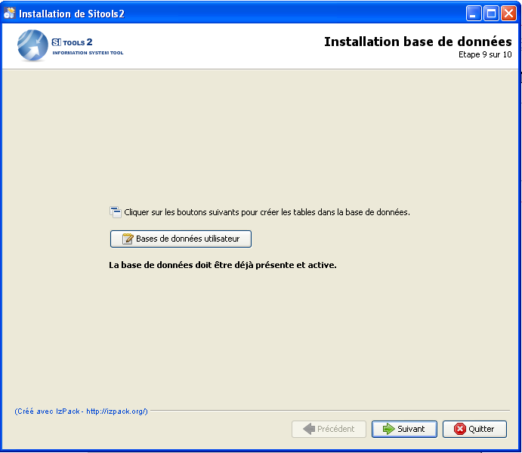
Figure 16: User and test tables creation
To create this panel (see figure 16), we create a new class (fr.cnes.sitools.izpack.panel.DatabasePanel ) that inherits from IzPanel.

