Week 7 Report

Variable Name | Description
Vessel | Vessel ID, unique
Ware | Make, categorical
VesType | Vessel Type, categorical
RimStyle | Style of the rim, squared or rolled.
RimDiameter | Measured in cm
RimWidth | Measured in cm
RimHeight | Measured in cm
Body Thickness at Rim | Measured in cm
Body Thickness 1 cm Below Rim | Measured in cm
Body Thickness 2cm Below Rim | Measured in cm

Plot one
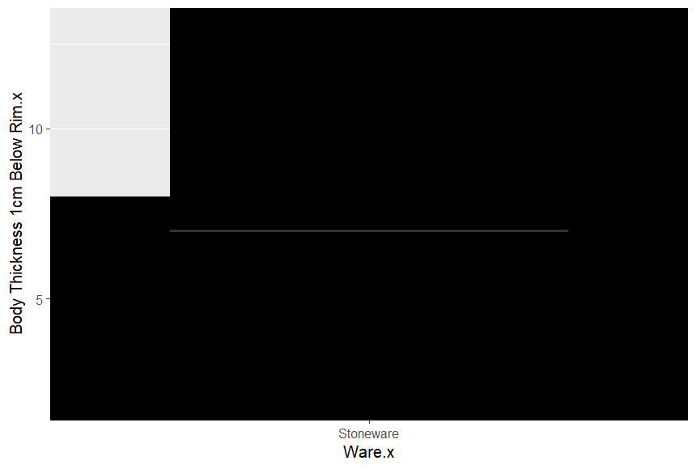

Plot two
s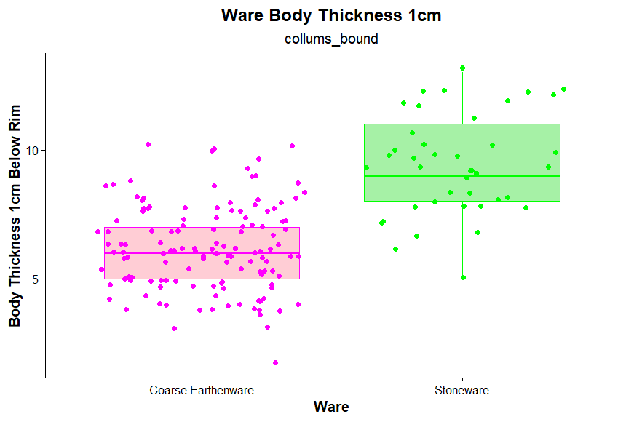

The data set I will be going over is Dr. Greer’s pottery dataset. Accessed March 1, 2026. This data has (n=176) observations. This data also has 10 variables, including Ware, Rim Diameter, Vessel type, etc. Ware means a type of Pottery. Rim Diameter means the measurement of the rim of the vessel in centimeters. Vessel type means what type of container was ceramic or pottery.

Q1: Is there a difference in RimDiameter between Ware types?
Yes, there is a difference between RimDiameter and Ware types, so I did a mass_shaptest for both types of Ceramics, which are Stoneware and Coarse Earthenware. The results for Stoneware were W = 0.92133, p-value = 0.0108, and the results for Coarse Earthenware were W = 0.93074, p-value = 1.071-05. These results mean that Earthenware had smaller Rim Diameters than Stoneware’s rim Diameters. I also did two histograms to show this difference and a box plot.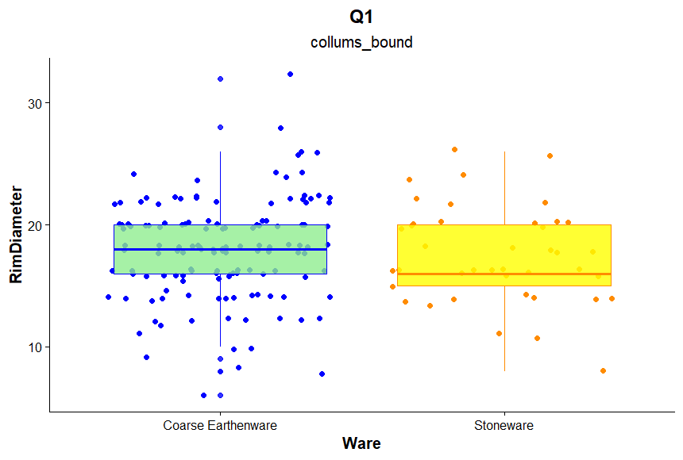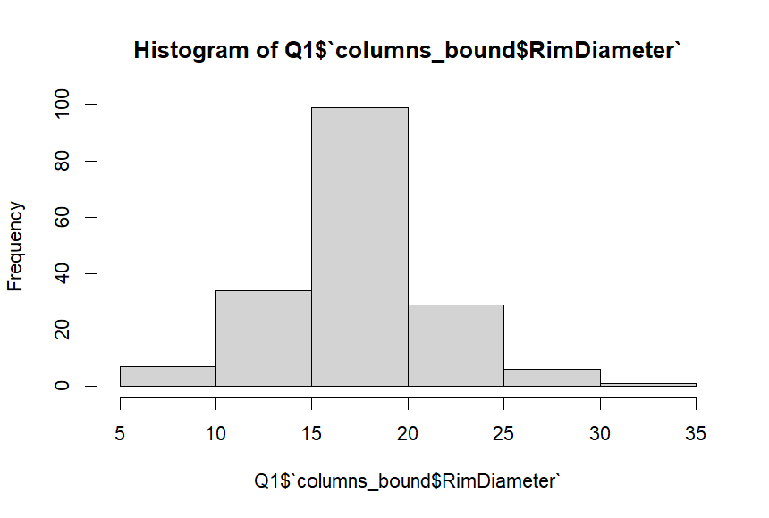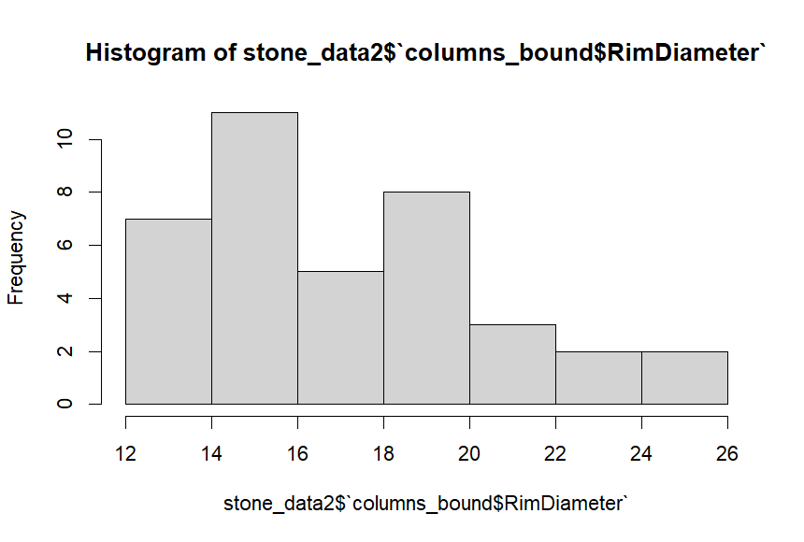

Q2: Is there a difference in the distribution of Crocks or Jars as vessel types regarding Ware types?
Yes, there is a difference in the distribution of Crocks or Jars and Vessel types regarding ware types. I had done a few Chi-Square tests to prove this. The first Chi-square test was with both Ware and Ve Types. The results from this first test were X-squared = 30.562, do = 2, p-value = 2.31e-07. This showed the whole data and its relation to each other, but the more important results are when I did a Chi-Square test on both Ves Types and Ware types. The first Chi-Square evaluation I did was for the Ves types. The results of this test were X-squared = 44.909, do = 2, p-value = 1.771e-10. The results for the ware types from their Chi-square test were X-squared = 50.205, do = 1, p-value = 1.385e-12. These results mean that there is a bigger distribution of ware types for Crock or Jars than for Vessel Types.

