Week 7 Report

Name: Paulo Vitor Mendes
Date:28/02/2026

Data representation:
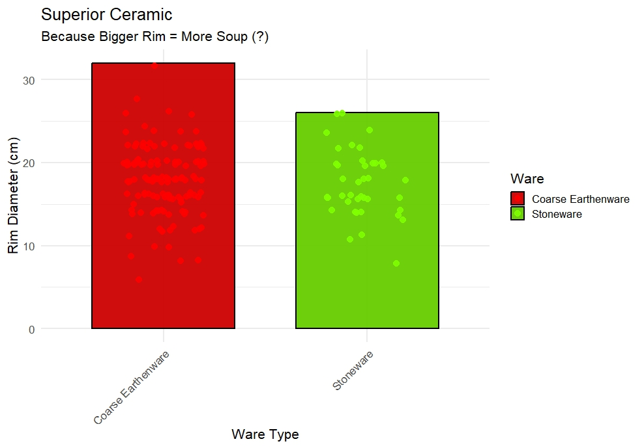
Figure 1. Poor visualization of Rim Diameter by Ware type.

I wanted to create a bad graphic that could lead to wrong. I presented Ware type in relation to Rim Diameter, suggesting that because Coarse Earthenware had one of the highest values, it would therefore be a “superior” type of ceramic since a larger rim could mean it holds more volume.
There are several issues with this graphic. Starting with the interpretation itself, the premise is obviously wrong. Ceramics can serve very different purposes, and even if rim diameter were equal to more overall internal area (which is not necessarily true), that still would not automatically make one ceramic type better than another. Functionality depends on many other factors.
Another issue is that the bar actually represents only the largest vessel within each ware type, not the overall or typical rim size. This makes the graph misleading, especially if that highest value is an outlier. The title also reinforces bias and pushes the viewer toward an erroneous interpretation of the results.
Lastly, the color scheme it’s not great for accessibility or overall visualization.

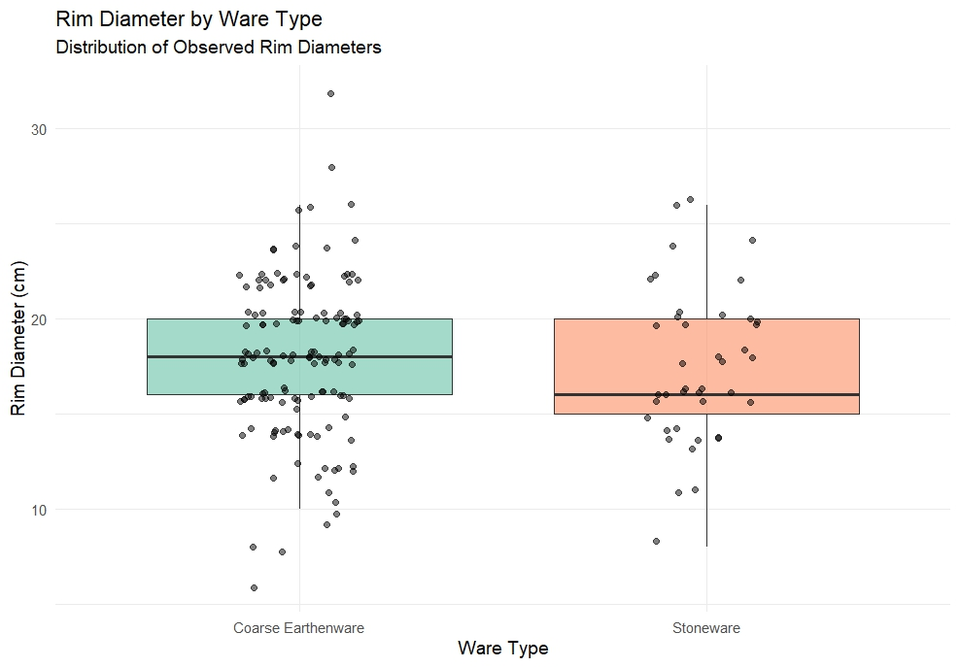
Figure 2. Improved visualization of Rim Diameter by Ware type

The second graphic is better in several ways. First, it does not create an idea of superiority by manipulating the data. Instead, it simply shows the full distribution of rim diameters within each ware type. This makes the comparison more transparent and less exaggerated. By using boxplots along with jittered individual data points, we can clearly see the typical values and the variation within each group, rather than focusing only on extreme cases.
The title is also more neutral and does not push the reader toward a specific interpretation or frame the comparison as a competition between ware types. Additionally, the color choices are much more appropriate. They are easier to distinguish, more accessible for individuals with color vision deficiencies, and more suitable for grayscale printing

Data Analysis:
A t-test was conducted to examine whether there was a significant difference in rim diameter between ware types. The results show that there was no significant difference in rim diameter between Coarse Earthenware and Stoneware; t(67.97) = 0.60, p =0 .55
A chi-square test of independence was performed to examine the relation between ware and vessel type. The relation between these variables was significant, χ²(2, N = 176) = 30.56, p <0 .01.
The data seems to point to Coarse Earthenware vessels been more likely to be classified as uncertain (crock or jar).
I would have to look at the ceramics or ask Matt about it to be sure, but I would imagine this result may have something to do with a fragmentary nature of the vessels making positive identification harder.
If that’s true, I would associate it with the material type. Coarse earthenwares are fired at lower temperatures, while stonewares are fired at higher temperatures, which causes them to be harder and less porous, giving them that vitrified appearance. This more fragile nature of earthwares could justify the data pointing to more uncertainty in their identification as either one of the other types.

