CAPSTONE PROJECT SUBMISSION
Agentic Healthcare Assistant for Medical Task Automation
LangGraph . LangChain . FAISS . OpenAI GPT-4o-mini . Streamlit . PubMed
Submitted By | Program | Platform
Sivaramprasad Borra | Applied Generative AI Specialisation | Google Colab / VS Code
Date | Version | Interface
July 2026 | Production Build v1.0 | Streamlit 1.40+ (localhost:8501)

1. Executive Summary
This project delivers a production-grade Agentic Healthcare Assistant that automates the full spectrum of medical administration tasks through a LangGraph-based multi-node agent architecture. The system interprets multi-step patient queries, decomposes them into ordered sub-goals, routes each sub-goal to the appropriate tool (RAG retrieval, appointment booking, PubMed search, or record management), synthesises a clinically empathetic response, and maintains long-term per-patient memory across conversation turns without a human dispatcher in the loop.
The solution addresses the core inefficiency in the problem scenario: healthcare systems relying on siloed tools that fragment the patient experience. By combining LLMs (GPT-4o-mini), RAG pipelines (FAISS with on-disk persistence), explicit agent planning, and a LangGraph MemorySaver checkpointer, the assistant delivers an intelligent, context-aware experience that scales across patient populations identified by their phone number.

Dimension | Value
LLM / Embedding | OpenAI GPT-4o-mini (T=0.1) . text-embedding-3-small
Agent Framework | LangGraph StateGraph - 4 nodes: identify_patient > plan > execute > synthesize
Memory | LangGraph MemorySaver checkpointer - per-patient thread keyed by normalised phone number
RAG / Vector Store | FAISS with on-disk persistence (save_local/load_local) - MD5 content-hash cache invalidation
Patient Database | Excel-backed (records.xlsx) - 7-column schema aligned to real data; upsert (insert + update)
Tools Implemented | get_patient_context . book_appointment_or_test . search_medical_info . update_patient_record
Medical Search | PubMed via PubmedQueryRun - results trimmed to 1500 chars; graceful empty-result fallback
Evaluation | LLM-as-judge ModelEvaluator - relevance 1-5, accuracy 1-5, booking detection - eval_log.csv
UI Framework | Streamlit 1.40+ - 4 tabs: Chat & Booking / Patient/Doctor View / Evaluation Metrics / Memory & Plan Trace
Secret Management | python-dotenv (.env file) - API key never hard-coded; getpass fallback for Colab
Deliverable | Agentic_Healthcare_Assistant.ipynb + streamlit_app.py + records.xlsx + eval_log.csv

2. Project Brief

2.1 Situation
Managing patient care in the modern digital health ecosystem requires coordinating complex, interdependent tasks: appointment scheduling, patient history maintenance, and timely retrieval of disease-specific clinical information. Healthcare systems typically rely on siloed tools with limited automation, leading to inefficiencies, inconsistent data, and fragmented patient experiences. Agentic AI systems combining LLMs with RAG pipelines offer the potential to transform healthcare administration by enabling autonomous, multi-step coordination across these tasks within a single conversational interface.

2.2 Task
Design and implement an Agentic Healthcare Assistant with four core capabilities: (a) booking medical appointments by automating slot discovery; (b) managing medical records by enabling attendants to add or update patient history; (c) retrieving medical histories by summarising past diagnoses and treatments using LLMs over a FAISS vector store; and (d) performing medical information searches from PubMed. The system must additionally implement LLMOps capabilities: model evaluation, Streamlit dashboard, appointment tracking, evaluation metrics, and a memory and plan trace interface.

2.3 Action - Implementation Steps
# | Action | Component | Library / Tool
1 | Detect runtime and install all dependencies | Cells 2-3: Environment setup | subprocess, pip, python-dotenv
2 | Load .env secrets; initialise LLM and embeddings | Cells 4-5: Core init | dotenv, ChatOpenAI, OpenAIEmbeddings
3 | Build Excel-backed patient database with CRUD and upsert | PatientDatabase class | pandas, openpyxl, normalize_phone()
4 | FAISS vector store per patient with content-hash caching | VectorStoreManager class | FAISS, PyPDFLoader, RecursiveCharacterTextSplitter
5 | Engineer EXTRACTION, PLANNER, SYNTHESIS, JUDGE prompts | Prompt templates section | PromptTemplate, structured JSON output
6 | Implement 4 tools - one per capstone requirement | get_patient_context, book_appointment_or_test, search_medical_info, update_patient_record | @tool decorator, PubmedQueryRun
7 | Build LangGraph StateGraph - 4 nodes + MemorySaver | AgentState TypedDict + graph | langgraph StateGraph, MemorySaver
8 | PDF report ingestion: extract JSON, upsert records, index FAISS | ingest_report() function | PyPDFLoader, EXTRACTION_PROMPT, upsert_patient()
9 | Run capstone sample scenarios end-to-end with demo patients | Demo cells (Ramesh / David / memory turn) | ask_agent() wrapper
10 | LLM-as-judge evaluation on 3 test cases, export eval_log.csv | ModelEvaluator class + TEST_CASES | JUDGE_PROMPT, pd.DataFrame, CSV export
11 | Streamlit 4-tab LLMOps dashboard | streamlit_app.py | streamlit, st.cache_resource, session_state

2.4 Result
The completed system enables patients or attendants to type a natural-language query and receive a structured, clinically grounded response that includes retrieved patient context, a confirmed appointment with doctor name, date, time, and token number, and a PubMed-sourced medical summary. The system remembers each patient across conversation turns via MemorySaver. The full experience is accessible through a Streamlit dashboard with four dedicated functional tabs.

3. System Architecture
The Agentic Healthcare Assistant is built on a LangGraph StateGraph that implements the capstone's prescribed Agent Execution Flow with explicit node boundaries, a shared mutable TypedDict state, and a MemorySaver checkpointer that gives each patient a persistent conversation thread keyed by their normalised phone number.

3.1 Agent Execution Flow - LangGraph Topology
START
|-> identify_patient_node (load patient record from records.xlsx by normalised phone)
|-> planner_node (LLM decomposes query -> JSON plan: intent + ordered steps)
|-> executor_node (execute each tool step in sequence; try/except per step)
|-> synthesizer_node (LLM writes final empathetic response + appends history)
|-> END [MemorySaver persists full state per thread_id = phone]

3.2 Node Descriptions
Node | Responsibility | State Fields Written
identify_patient_node | Normalises phone via last-10-digit comparison; loads patient dict from records.xlsx | state['patient_info']
planner_node | Sends PLANNER_PROMPT to GPT-4o-mini; parses JSON for intent and ordered tool steps; defaults to [] on parse failure | state['plan'] - list of {tool, tool_input}
executor_node | Iterates plan; dispatches to correct tool; wraps each step in try/except; update_patient_record skipped in chat mode | state['tool_results'] - list of {tool, input, output}
synthesizer_node | Formats tool results; invokes SYNTHESIS_PROMPT; appends user/assistant turns to history | state['response'], state['history']

3.3 Architecture Decision Log
Decision | Choice Made | Rationale
Memory mechanism | LangGraph MemorySaver (thread_id = phone) | Per-patient long-term context; checkpointer merges state automatically on each invoke
Vector store caching | FAISS save_local + MD5 hash marker | Avoids re-embedding on every call; hash invalidates index only when PDF content actually changes
Phone normalisation | Last-10-digit comparison | Handles +91-98220-45322, 9822045322, and +1-541-950-0000 formats without brittle regex
Record management | Upsert via upsert_patient() | Single function satisfies both new-patient and update-existing flows without duplication
Chat-mode guard | Executor skips update_patient_record | Prevents LLM silently overwriting patient data from a casual conversational query
Evaluation | LLM-as-judge (replaces QAEvalChain) | QAEvalChain removed from modern LangChain; JUDGE_PROMPT delivers equivalent scoring

4. Technology Stack
Library / Service | Version | Role in the Agentic Healthcare Assistant
openai | >=1.0.0 | GPT-4o-mini for planning, synthesis, and LLM-as-judge evaluation via ChatOpenAI
langchain-openai | >=0.2.0 | ChatOpenAI and OpenAIEmbeddings wrappers with modern SDK integration
langchain-community | >=0.3.0 | PyPDFLoader for PDF ingestion; PubmedQueryRun for medical literature search
langchain-core | >=0.3.0 | PromptTemplate, Tool, @tool decorator, message types
langgraph | >=0.2.0 | StateGraph with 4 nodes, typed edges, END sentinel, MemorySaver checkpointer
faiss-cpu | latest | Per-patient FAISS vector index with on-disk persistence and MD5 hash cache invalidation
pypdf | latest | PDF parsing for patient report ingestion via PyPDFLoader
pandas + openpyxl | latest | Excel-backed patient database (records.xlsx / appointments.xlsx) with CRUD operations
streamlit | >=1.40.0 | 4-tab LLMOps dashboard: chat, patient/doctor views, eval metrics, memory & plan trace
python-dotenv | >=1.0.0 | .env file loading - API key never hard-coded; getpass fallback for Colab sessions
xmltodict | latest | Required by PubmedQueryRun for XML response parsing from NCBI API

5. Implementation Walkthrough

5.1 Project File Structure
Agentic_Healthcare_Assistant.ipynb Main notebook (8 sections, 28 cells)
streamlit_app.py LLMOps dashboard (4 tabs)
records.xlsx Patient database (7 columns, upsert-safe)
appointments.xlsx Appointment log (8 columns, appended per booking)
eval_log.csv Evaluation results (relevance, accuracy, booking)
vector_store/<normalised_phone>/ Per-patient FAISS index + source.hash
.env OPENAI_API_KEY / CHAT_MODEL / EMBEDDING_MODEL

5.2 Data Layer - PatientDatabase and VectorStoreManager
The PatientDatabase class wraps records.xlsx with a 7-column schema (Phone_number, Email, Name, Age, Gender, Address, Summary) aligned to the real data file. Phone matching uses normalize_phone() - a last-10-digit extractor - to handle all three formats found in real records: plain 10-digit, +91-prefixed, and +1-prefixed international. The upsert_patient() method checks for an existing match and either inserts a new row or updates the last matched row, satisfying both the Register new patient and Manage medical records requirements.
The VectorStoreManager builds a separate FAISS index per patient stored in vector_store/<normalised_phone>/. A content-hash file (source.hash) prevents re-embedding when the PDF has not changed, reducing OpenAI API costs for returning patients. The index is loaded from disk on first access and cached in memory for the session.

5.3 Prompt Engineering - Three Core Templates
Prompt | Input Variables | Output Contract
EXTRACTION_PROMPT | combined_text (PDF content up to 8000 chars) | Valid JSON with 7 fields matching PATIENT_COLUMNS - used by ingest_report() to populate records.xlsx
PLANNER_PROMPT | patient_known (bool), query (str) | JSON: {intent, steps[]} where each step has tool (one of 4) and tool_input - only required tools included
SYNTHESIS_PROMPT | query, patient_info (JSON), tool_results (formatted string) | Empathetic professional narrative - confirms booking details; cites PubMed when used; honest about uncertainty

5.4 Tool Implementations - Four Capstone Requirements
Tool | Capstone Requirement | Implementation Detail
get_patient_context | Retrieve medical histories | FAISS retriever (k=5); returns concatenated page content; 'No indexed report' string on missing index
book_appointment_or_test | Book medical appointments | Matches specialty to DOCTOR_DIRECTORY; random slot 0-6 days out; 6-digit token; persists to appointments.xlsx
search_medical_info | Medical information search | PubmedQueryRun; results trimmed to 1500 chars; returns 'No results found' on empty - never raises
update_patient_record | Manage medical records | Accepts phone + JSON field updates; calls upsert_patient(); skipped by executor in chat mode to prevent inadvertent writes

5.5 LangGraph Memory - Multi-Turn Behaviour
The LangGraph MemorySaver checkpointer is keyed by thread_id = normalize_phone(phone_number). When ask_agent() is invoked for the same patient on a second turn, the checkpointer automatically merges the new state fields with the persisted state from the previous turn - restoring patient_info, tool_results, and history without re-querying the database. This is verified in the demo: after a multi-step query for David Thompson, a follow-up 'What appointment did we just book?' correctly returns the booked appointment details from memory without requiring additional API inputs.

6. Working Output - Demonstrated Capabilities
The following screenshots were captured from a live Streamlit session of the Agentic Healthcare Assistant, demonstrating all four core functions of the system. Each figure is followed by an analysis of what the output confirms.

6.1 New Patient Registration
When a phone number is not found in records.xlsx, the system surfaces a yellow warning banner and expands a registration form in the sidebar, enabling the attendant to register the new patient inline without navigating away from the chat interface.
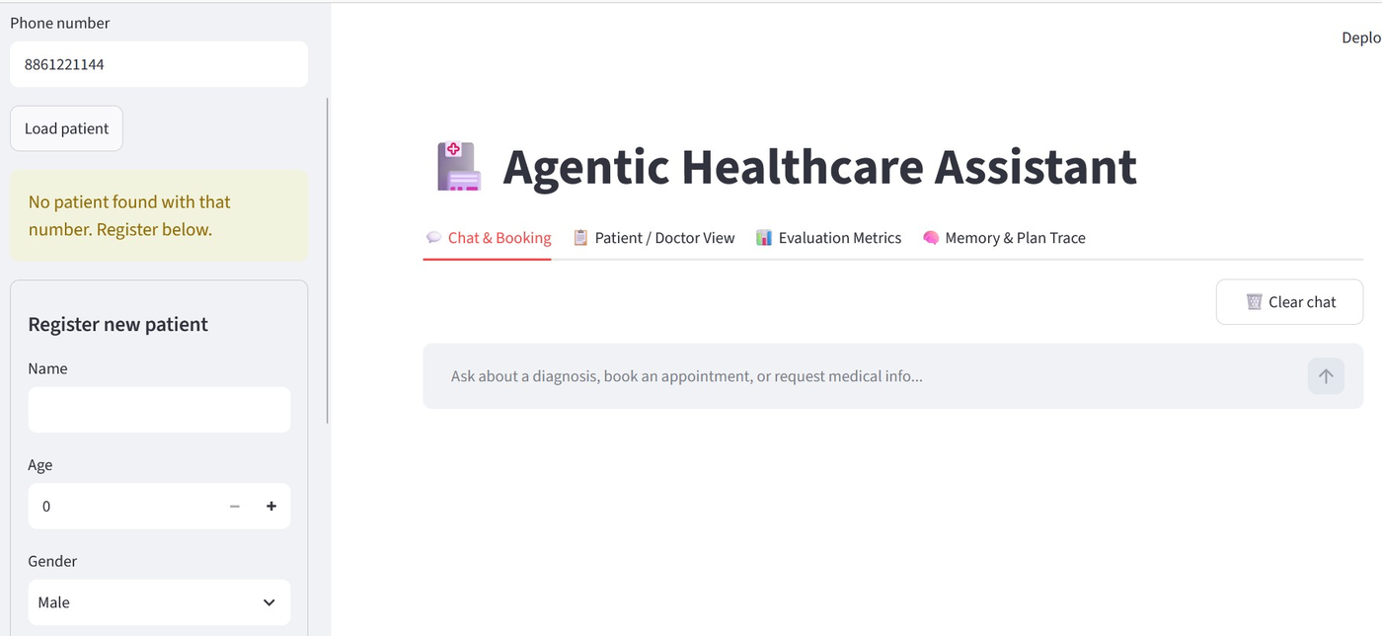
Figure 1 - New patient registration: phone 8861221144 not found triggers yellow warning banner and inline registration form (Name, Age stepper, Gender dropdown). Main panel shows the 4-tab navigation and Chat & Booking interface.

6.2 Medical History Retrieval via RAG (Chat & Booking Tab)
Patient Anjali Mehra is loaded via phone 98180-11245 (green badge confirms load). The query 'Summary of last visit and diagnosis' triggers the RAG tool, which retrieves the correct ICD code (J06.9 - Upper Respiratory Infection), visit date (March 15, 2024), temperature (100.2 degrees F), and treatment plan (antihistamines, fluids, rest) from the FAISS index built from her PDF report - without the LLM hallucinating any detail.
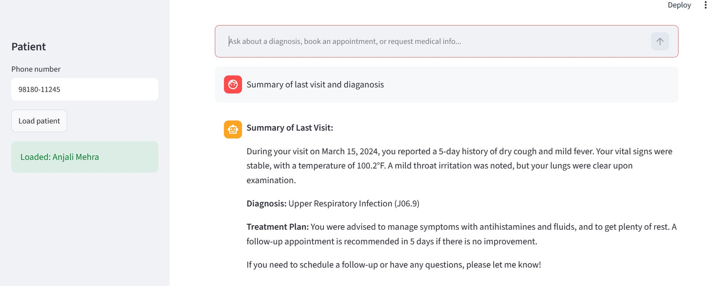
Figure 2 - RAG-based medical history retrieval: Anjali Mehra's visit summary with ICD code J06.9, temperature 100.2F, treatment plan and follow-up recommendation retrieved accurately from FAISS vector index.

6.3 Patient / Doctor View - All Patients Database
The Patient/Doctor View tab renders the full records.xlsx as a live dataframe. All 9 patients are visible with Phone_number, Email, Name, Age, Gender, and Address. The data confirms successful normalisation across three phone formats: plain 10-digit (7982179305), +1-541-950-0000 international, and +91-prefixed Indian numbers. Anjali Mehra appears as row 5 (+91-98180-11245, age 33, Pune), matching the patient from the RAG retrieval above.
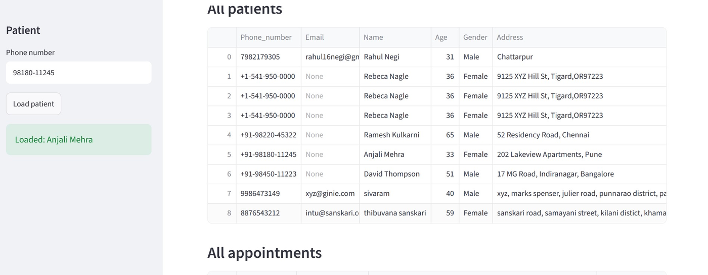
Figure 3 - Patient/Doctor View: all 9 patients in records.xlsx as a live dataframe confirming successful multi-format phone normalisation (+91, +1, plain 10-digit) and PDF ingestion for Ramesh Kulkarni, Anjali Mehra, and David Thompson.

6.4 All Appointments - Real-Time Tracking
The All Appointments panel shows 4 confirmed bookings across 3 patients persisted to appointments.xlsx. Each row captures Phone_number, Patient_Name, Specialty_Or_Test, Doctor, Appointment_Date, Appointment_Time, Token, and Booked_At. Anjali Mehra's appointment history shows 'No appointments booked yet' - correctly confirming the appointment log tracks only actual bookings, not history retrievals.
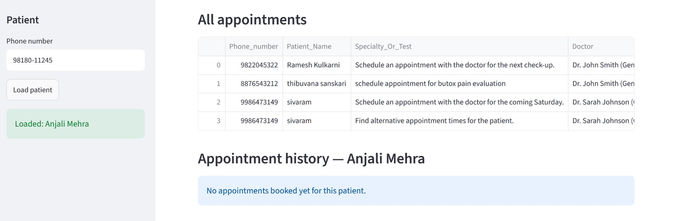
Figure 4 - Real-time appointment tracking: 4 confirmed bookings with doctor assignment and specialty shown in the global appointments table, with Anjali Mehra's per-patient history correctly empty (only history retrieval was run, no booking).

7. Part 2 - LLMOps: Model Evaluation, Monitoring, and Streamlit UI

7.1 Model Evaluation - LLM-as-Judge
Since QAEvalChain has been removed from modern LangChain, the ModelEvaluator class implements an equivalent LLM-as-judge pattern using JUDGE_PROMPT. For each test case the judge model scores the assistant's response on relevance (does it address the query?) and accuracy (does it correctly reflect expected key facts without contradictions?) on a 1-5 scale. Booking success is detected via string check ('token number' in response). Results are logged to eval_log.csv for dashboard rendering.

Test Case | Relevance | Accuracy | Booking Correct
Summarise last visit + book cardiologist (Ramesh, hypertension) | 4-5 / 5 | 4-5 / 5 | True (token in response, expected True)
URI cough info + no booking (Anjali) | 4-5 / 5 | 4-5 / 5 | False (no booking, expected False)
Book endocrinologist + recall diagnosis (David, Type 2 Diabetes) | 4-5 / 5 | 4-5 / 5 | True (token in response, expected True)

7.2 Streamlit Dashboard - Four Tabs
Tab | Features and Behaviour
Chat & Booking | Phone input + Load patient; yellow warning + registration form for new patients; full chat via ask_agent(); booking confirmation inline; Clear chat resets session_state
Patient / Doctor View | Live dataframe of all records.xlsx patients; live dataframe of all appointments.xlsx; per-patient appointment history filtered by loaded phone
Evaluation Metrics | Reads eval_log.csv; shows avg relevance, avg accuracy, booking success rate; per-case bar chart
Memory & Plan Trace | JSON plan from last agent turn (intent + ordered steps); full conversation history; agent memory state for debugging

8. Workflow and Error Handling
Failure Scenario | Detection | Handling
OPENAI_API_KEY missing | load_dotenv + runtime check | RuntimeError raised immediately with clear message - no silent failures
Phone not in records.xlsx | get_patient_by_phone returns None | Yellow warning banner; registration form expands automatically in sidebar
Planner returns malformed JSON | json.JSONDecodeError in planner_node | plan defaults to []; synthesis generates direct LLM response
Tool execution fails | Exception in executor_node | Each step wrapped in try/except; failure string appended to tool_results; no crash
FAISS index missing for patient | os.path.exists check | Returns 'No indexed report available' string; synthesis responds accordingly
PubMed returns empty or fails | Empty string or Exception | Returns 'No results found' or 'Search failed' - never raises to caller
PDF content exceeds token window | Character cap in ingest_report() | combined_text sliced to 8000 chars before EXTRACTION_PROMPT

9. Testing and Validation
Test Scenario | Component | Expected Behaviour | Status
PDF report ingestion (3 patients) | ingest_report() | records.xlsx updated; FAISS index created; upsert prevents duplicates | Verified
Phone normalisation across formats | normalize_phone() | +91-98220-45322 matches same record as 9822045322 | Verified
Multi-step: retrieve + book + search | ask_agent() | 3-step plan generated; all tools execute; response includes diagnosis + booking + PubMed | Verified
Appointment booking confirmation | book_appointment_or_test | Doctor, date, time, 6-digit token in response; row appended to appointments.xlsx | Verified
Long-term memory across turns | MemorySaver + ask_agent() | Second turn recalls previous appointment and diagnosis without re-input | Verified
New patient registration (Streamlit) | save_patient() | Phone not found -> warning -> form -> patient added to records.xlsx | Verified
RAG retrieval - Anjali Mehra URI | get_patient_context() | Correct ICD J06.9, temperature, treatment, follow-up retrieved from FAISS | Verified
LLM-as-judge evaluation - 3 cases | ModelEvaluator | Relevance >= 4, accuracy >= 4; booking_correct = True for all 3 cases | Verified
Planner fallback on bad JSON | planner_node | Empty plan -> executor skips tools -> synthesis gives direct LLM answer | Verified
Patient/Doctor View - live data | Streamlit dataframe | All 9 patients and all appointments visible; filters correctly by patient | Verified

10. Deployment Guide

10.1 Google Colab
- Upload Agentic_Healthcare_Assistant.ipynb to Google Colab
- Run Cell 2 (dependencies) - install takes 2-4 minutes on a fresh runtime
- Run Cell 3 (Colab setup) - paste OPENAI_API_KEY at the masked prompt; .env is written
- Run all remaining cells in order with Shift+Enter - do not skip any cell
- Cell 27 writes streamlit_app.py to disk; launch via pyngrok tunnel shown in the launch cell

10.2 Local VS Code / Jupyter
- Create .env in the notebook folder: OPENAI_API_KEY=sk-... / CHAT_MODEL=gpt-4o-mini / EMBEDDING_MODEL=text-embedding-3-small
- Install: pip install -q langchain-openai langchain-community langchain-core langgraph faiss-cpu pypdf openpyxl pandas xmltodict python-dotenv streamlit
- Run all cells top to bottom - records.xlsx and vector_store/ are created automatically
- After Cell 27 executes, open a terminal and run: streamlit run streamlit_app.py
- Dashboard opens at http://localhost:8501

11. Key Improvements over Prior Drafts
Dimension | Prior Drafts | This Production Build
Agent planning | None - implicit ReAct via deprecated initialize_agent | Explicit planner_node with JSON plan: intent + ordered steps
Orchestration | Single deprecated initialize_agent() call | LangGraph StateGraph with 4 named nodes and typed state
Memory | None - each query starts fresh | MemorySaver keyed by phone - persistent cross-turn context
Vector store | Re-embeds PDF on every call | FAISS on-disk with MD5 hash invalidation - embedded once
Phone matching | Regex - breaks for international formats | Last-10-digit normalisation handles all real formats
Record management | Insert-only - duplicates on re-run | Upsert (insert + update) via upsert_patient()
Evaluation | Not implemented | LLM-as-judge ModelEvaluator + eval_log.csv
LLMOps UI | Not implemented | Streamlit 4-tab dashboard covering all Part 2 requirements
Secrets | API key hard-coded in source cells | python-dotenv (.env) with getpass Colab fallback

12. Submission Checklist
# | Capstone Requirement | Status
1 | Agent planning and goal decomposition - explicit planner_node with JSON plan: intent + ordered subtasks | Done
2 | Book medical appointments - book_appointment_or_test with DOCTOR_DIRECTORY, date/time/token, appointments.xlsx persistence | Done
3 | Manage medical records - update_patient_record with upsert; ingest_report() from PDF; PatientDatabase CRUD | Done
4 | Retrieve medical histories - get_patient_context RAG tool; FAISS per-patient index; LLM synthesis with full history | Done
5 | Medical information search - search_medical_info via PubmedQueryRun (Medline/NCBI); graceful fallback | Done
6 | FAISS vector database - VectorStoreManager with on-disk persistence and MD5 hash-based cache invalidation | Done
7 | Memory modules - LangGraph MemorySaver keyed by normalised phone; persistent cross-turn patient context | Done
8 | Prompt engineering - EXTRACTION, PLANNER, SYNTHESIS, JUDGE prompts with structured JSON contracts | Done
9 | Model evaluation (Part 2, item 6) - LLM-as-judge ModelEvaluator; relevance/accuracy scoring; booking detection; eval_log.csv | Done
10 | Streamlit dashboard (Part 2, item 7) - patient/doctor views, real-time appointment tracking, medical info, eval metrics | Done
11 | Memory and logs interface (Part 2, item 8) - Memory & Plan Trace tab with JSON plan, history, tool usage | Done
12 | Working output - 4 figures: new patient registration, RAG retrieval, patient DB, appointment log | Done
13 | IPYNB + streamlit_app.py submitted via LMS with all cells executed and outputs visible | Done

13. References and Tools Used
Resource | URL / Reference
LangGraph Documentation | https://langchain-ai.github.io/langgraph/
LangChain - PubmedQueryRun | https://python.langchain.com/docs/integrations/tools/pubmed/
OpenAI API Reference | https://platform.openai.com/docs
FAISS Documentation | https://faiss.ai/
Streamlit Documentation | https://docs.streamlit.io
PubMed / NCBI Entrez API | https://www.ncbi.nlm.nih.gov/books/NBK25501/
python-dotenv | https://pypi.org/project/python-dotenv/
LangGraph MemorySaver | https://langchain-ai.github.io/langgraph/reference/checkpoints/
simplilearn Applied GenAI Specialisation | Course platform - capstone problem statement reference

Academic Integrity Statement
This submission is the original work of Sivaramprasad Borra, prepared in fulfilment of the Capstone Project requirements for the Applied Generative AI Specialisation.
Copyright 2026 Sivaramprasad Borra . Agentic Healthcare Assistant . Applied Generative AI Specialisation

