16-08-2024 ASSIGNMENT -1 2022503045

1. Exercise 1: Hello friends:

CODE:

public class HelloFriends {  
 public static void main(String[] args){  
 if(args.length==0) {  
 System.*out*.print("No commands");  
 }  
 else{  
 for(String str:args){  
 System.*out*.print(str);  
 }  
 }  
 }  
}

output:

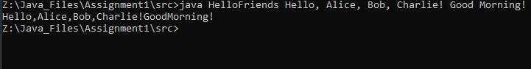

2. Find the maximum Compile time and Run time error messages of simple one line output message.

Errors messages

1.deleting one of the semicolon

public class error {  
 public static void main(String[] args){  
 System.*out*.println("Deleting one of the semicolons");  
 System.*out*.println("Hello")  
 }  
}

OUTPUT:

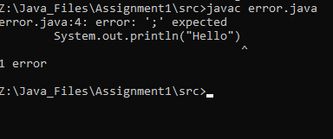

2.Swap the word public, static, void, main

public class error {  
 static public void main(String[] args){  
 System.*out*.println("SWAPPING static public");  
  
 }  
}

OUTPUT:

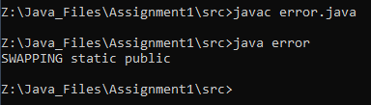

public class error {  
 static void public main(String[] args){  
 System.*out*.println("SWAPPING public void");  
  
 }  
}

OUTPUT:

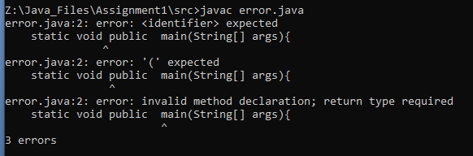

public class error {  
 public void static main(String[] args){  
 System.*out*.println("SWAPPING VOID STATIC ");  
  
 }  
}

OUTPUT:

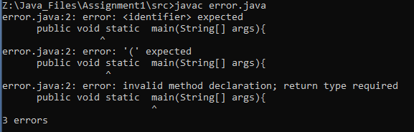

public class error {  
 public void main static(String[] args){  
 System.*out*.println("swapping main static");  
  
 }  
}

output:

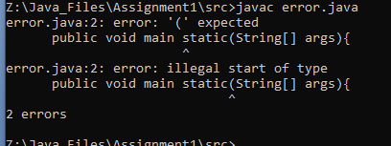

• Omit the word public, static, void, main

public class error {  
 public void main(String[] args){  
 System.*out*.println("without static");  
  
 }  
}

output:

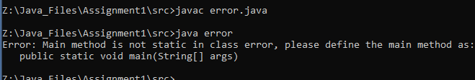

public class error {  
 static void main(String[] args){  
 System.*out*.println("without public");  
  
 }  
}

output:



public class error {  
 public static main(String[] args){  
 System.*out*.println("without void");  
  
 }  
}

output:

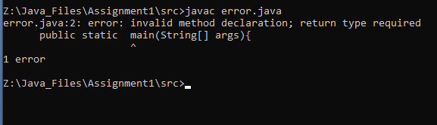

public class error {  
 public static void{  
 System.*out*.println("without main");  
  
 }  
}

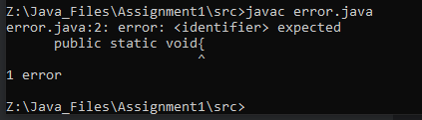

• Remove the array Subscript around string

public class error {  
 public static void main(String args){  
 System.*out*.println("args");  
  
 }  
}

output:

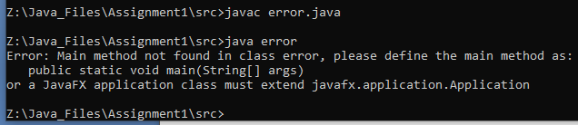

• Replace Sring with int or float

public class error {  
 public static void main(int[] args){  
 System.*out*.println("args");  
  
 }  
}

OUTPUT:



• Replace String[] as String…

public class error {  
 public static void main(String... args){  
 System.*out*.println("args");  
  
 }  
}

output:

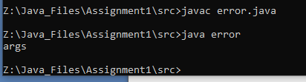

3.CONVERSATION

CODE :

import java.util.Scanner;  
public class Conversation {  
 public static void main(String[] args){  
 Scanner sc=new Scanner(System.*in*);  
 String java;  
 String[] Python={" I'm Python. Nice to meet you!"," I'm best for rapid development and scripting tasks.","I use dynamic typing for more flexibility."," I'm portable with the Python interpreter on any system."," Perfect for web development and data analysis.","I excel in ease of use and quick development cycles.","Use me for ease and speed in development.","Bye!"};  
 for(String str:Python){  
 System.*out*.print("Java:");  
 java=sc.nextLine();  
 System.*out*.println();  
 System.*out*.print("Python:"+str);  
 System.*out*.println();  
  
 }  
  
 }  
}

OUTPUT:

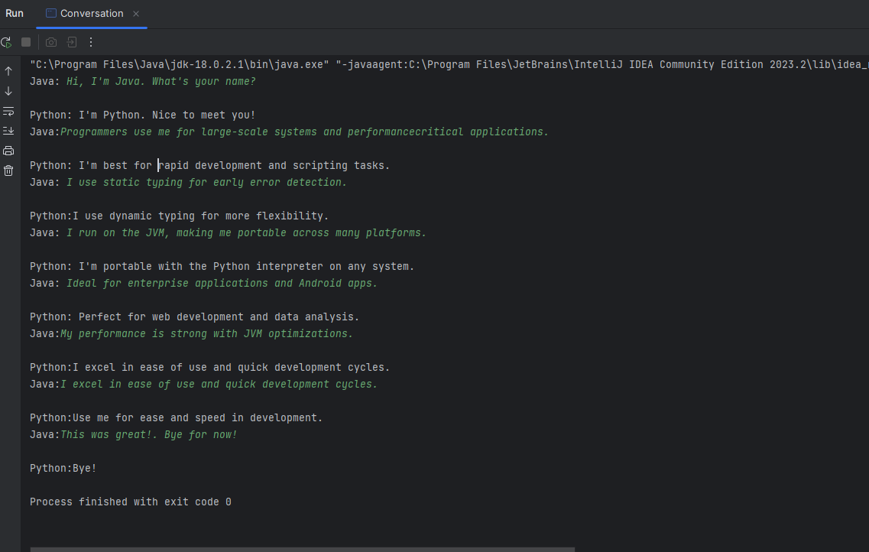

4.Leap year

CODE:

import java.util.Scanner;  
  
public class LeapYear {  
 public static void main(String[] args) {  
 Scanner sc = new Scanner(System.*in*);  
 System.*out*.print("Enter a year :");  
 int year = sc.nextInt();  
 if(*leap*(year)){  
 System.*out*.println(year+" is a leap year");  
 int nextYear=year+4;  
 while(!*leap*(nextYear)){  
 nextYear=nextYear+4;  
 }  
 System.*out*.print("Next Leap year is "+nextYear);  
 }  
 else{  
 System.*out*.println(year +"is not leap year");  
 int nextYear=year+1;  
 while(!*leap*(nextYear)){  
 nextYear=nextYear+1;  
 }  
 System.*out*.print("Next Leap year is "+nextYear);  
  
 }  
 }  
 static boolean leap(int year){  
 if(year%4==0){  
 if(year%100==0){  
 if(year%400==0)  
 return true;  
 else  
 return false;  
 }  
 return true;  
 }  
 return false;  
 }  
}

OUTPUT:

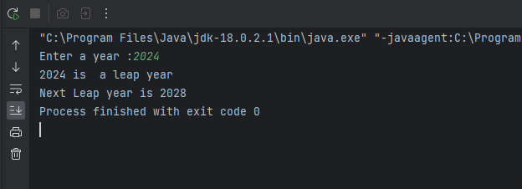

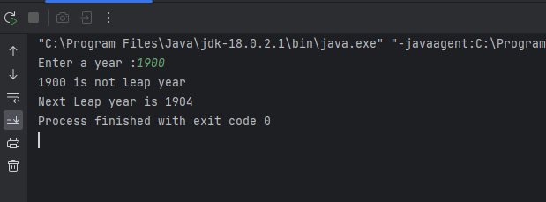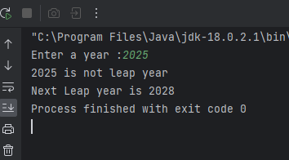

5. Write a program that takes a date as input and prints the day of the week that date falls on. Read the three int input as m(month), d(day) and y(year). Use 1 of m for January, 2 for February, and so forth. For output print 0 for Sunday, 1 for Monday and so forth. Use the following formula for the Gregorian calendar.

CODE:

import java.util.HashMap;  
import java.util.Scanner;  
  
public class DayOfWeek {  
 public static void main(String[] args){  
 HashMap<Integer,String> days=new HashMap<>();  
 Scanner sc=new Scanner(System.*in*);  
 days.put(0,"Sunday");  
 days.put(1,"Monday");  
 days.put(2,"Tuesday");  
 days.put(3,"Wednesday");  
 days.put(4,"Thursday");  
 days.put(5,"Friday");  
 days.put(6,"Saturday");  
 System.*out*.print("Enter the month (1 for jan,2 for feb and so on):");  
 int m=sc.nextInt();  
 System.*out*.println();  
 System.*out*.print("Enter the day (1 to 31):");  
 int d=sc.nextInt();  
 System.*out*.println();  
 System.*out*.print("Enter the year");  
 int y=sc.nextInt();  
 System.*out*.println();  
 int y0=y-(14-m)/12;  
 int x=y0+y0/4-y0/100+y0/400;  
 int m0=m+12*((14-m)/12)-2;  
 int d0=(d+x+(31*m0)/12)%7;  
 System.*out*.print(days.get(d0));  
  
  
 }  
}

OUTPUT:

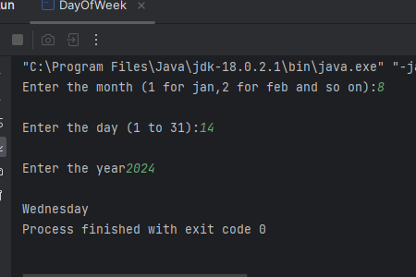

6. Write a Java program to create a Indian Flag.

code:

public class IndianFlag {  
 public static void main(String[] args){  
 *part*();  
 }  
 static void part(){  
 int t=3;  
 while(t>0){  
 int i;  
 for(i=1;i<=30;i++){  
 System.*out*.print('_');  
 }  
 int n=2;  
 if(t==2){  
 n=n+1;  
 }  
 while(n>0){  
 System.*out*.println();  
 for(int j=1;j<=30;j++){  
 if(j==1||j==30){  
 System.*out*.print("|");  
 }  
 if(t==2){  
 if(j>=12 && j<=17){  
 System.*out*.print("*");  
 }  
 else{  
 System.*out*.print(" ");  
 }  
 }  
 else{  
 System.*out*.print(" ");  
 }  
  
 }  
  
 n--;  
 }  
 System.*out*.println();  
 t--;  
 }  
 int i;  
 for(i=1;i<=30;i++){  
 System.*out*.print('_');  
 }  
 System.*out*.println();  
 for(i=1;i<=10;i++){  
 System.*out*.println("|");  
 }

}  
}

OUTPUT:

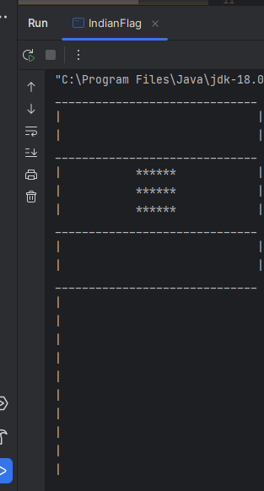

7. Write a program to model the AND gate using the linear combination of inputs formula Y=Bias +W0⋅X1+W1⋅X2

CODE:

import java.util.Scanner;

public class OrGate{

    public static void main(String[] args){

        Scanner sc=new Scanner(System.in);

        double basis=0.5;

        double Y;

        double W0,W1;

        int X1,X2;

        for(int i=0;i<4;i++){

            System.out.println("\nEnter X1 AND X2 input :");

            X1=sc.nextInt();

            X2=sc.nextInt();

            //determine w0 w1

            W0=0.1;

            W1=0.2;

                Y=basis+W0*X1+W1*X2;

                if(Y>basis){

                    System.out.println("1");

                }

                else{

                    System.out.println("0");

                }

        }

    }

}

OUTPUT:

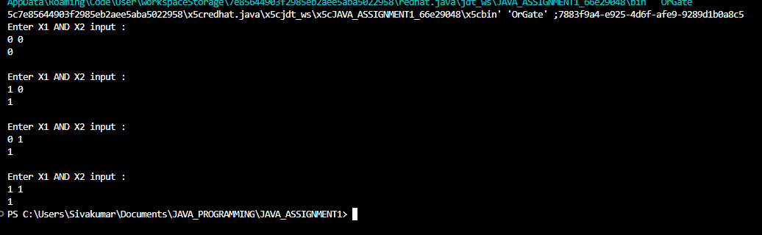

8.Write a program that converts a given integer into its equivalent words representation. The program should handle negative numbers and checks if the input is within the specified range of 0 to 999.

CODE :

import java.util.Scanner;

import java.util.HashMap;

public class NumberToText {

    public static void main(String[] args){

     Scanner sc=new Scanner(System.in);

     HashMap<Integer,String> number=new HashMap<>();

     number.put(1,"One");

     number.put(2,"Two");

     number.put(3,"Three");

     number.put(4,"Four");

     number.put(5,"Five");

     number.put(6,"Six");

     number.put(7,"Seven");

     number.put(8,"eight");

     number.put(9,"nine");

     number.put(10,"Ten");

     number.put(11,"eleven");

     number.put(12,"twelve");

     number.put(13,"thirteen");

     number.put(14,"fourteen");

     number.put(15,"fifteen");

     number.put(16,"sixteen");

     number.put(17,"seventeen");

     number.put(18,"eighteen");

     number.put(19,"nineteen");

     number.put(20,"twenty");

     number.put(30,"thirty");

     number.put(40,"fourty");

     number.put(50,"fifty");

     number.put(60,"sixty");

     number.put(70,"seventy");

     number.put(80,"eighty");

     number.put(90,"ninety");

     System.out.print("\nEnter the number :");

     int num=sc.nextInt();

     String text="";

     if(num/100>0){

        text+=number.get(num/100)+" hundred";

        num=num%100;

        if(num>0){

            text+=" and ";

        }

     }

     if(num>=10 && num<20){

        text+=number.get(num);

     }

     else{

        if(num>=20){

            text+=number.get((num/10)*10)+" ";

            if(num%10>0){

                text+=number.get(num%10)+" ";

            }

        }

        else{

            text+=number.get(num)+" ";

        }

     }

     System.out.println(text);

      sc.close();

    }

}

OUTPUT:

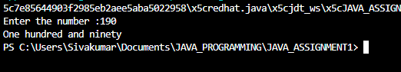

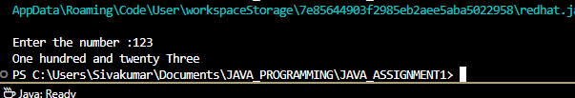

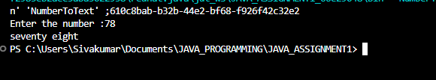

9. Casino Game Write a Java program to simulate a simple Casino game where the player starts with 1000 credit points. Each roll costs 100 credits (the bet amount). For each roll, If the sum of the two dice is 7 or 11, the player wins and gains 100 credits or If the sum of the dice is 2, 3, or 12, the player loses 100 credits or For any other sum (4, 5, 6, 8, 9, or 10) there is no change in credits. The game continues until the player either goes bankrupt (reaches 0 credits) or reaches the target win amount of 2000 credits

CODE:

import java.util.Random;

public class DiceGame {

    public static void main(String[] args){

        int currentCredit=1000;

        DiceGame player1=new DiceGame();

        player1.Play(currentCredit, 1);

    }

    public void Play(int credits,int player){

        Random rand=new Random();

        int max=12;

        int min=2;

        System.out.println("Player "+player+" starts playing with "+credits+" credits");

        while(credits>0 && credits<2000){

           System.out.println("Rolling the dice....");

           int n=rand.nextInt(max-min+1)+min;

           System.out.println("Dice sum :"+n);

           if(n==7||n==11){

              credits+=100;

              System.out.println("You won 100 credits!\nNew credits : "+credits);

           }

           else if(n==2||n==3||n==12){

            credits-=100;

            System.out.println("Oops! You lost 100 credits!\n New credits: "+credits);

           }

           else{

            System.out.println("No change in the credits New Credits :"+credits);

           }

        }

        System.out.println("Game Over ...");

        System.out.println("Final credits :"+credits);

        System.out.println("Thank you Player"+player);}}

OUTPUT:

