12.a.calculator

Code:

Web.xml

<?xml version="1.0" encoding="UTF-8"?>  
<web-app version="2.4"  
 xmlns="http://java.sun.com/xml/ns/j2ee"  
 xmlns:xsi="http://www.w3.org/2001/XMLSchema-instance"  
 xsi:schemaLocation="http://java.sun.com/xml/ns/j2ee  
http://java.sun.com/xml/ns/j2ee/web-app_2_4.xsd">  
  
 <servlet>  
 <servlet-name>calculator</servlet-name>  
 <servlet-class>CalculatorServlet</servlet-class>  
 </servlet>  
 <servlet-mapping>  
 <servlet-name>calculator</servlet-name>  
 <url-pattern>/calculate</url-pattern>  
 </servlet-mapping>  
</web-app>

Index.html

<!DOCTYPE html>  
<html lang="en">  
<head>  
 <meta charset="UTF-8">  
 <title>Calculator</title>  
</head>  
<body>  
<h1>Simple Calculator</h1>  
<form method="post" action="calculate">  
 <label>Enter First Number:</label>  
 <input type="text" name="num1" required><br><br>  
 <label>Enter Second Number:</label>  
 <input type="text" name="num2" required><br><br>  
 <label>Operation:</label>  
 <select name="operation" required>  
 <option value="add">Addition</option>  
 <option value="subtract">Subtraction</option>  
 <option value="multiply">Multiplication</option>  
 <option value="divide">Division</option>  
 </select><br><br>  
 <input type="submit" value="Calculate">  
</form>  
</body>  
</html>

CalculatorServlet.java

import jakarta.servlet.http.HttpServlet;  
import jakarta.servlet.http.HttpServletRequest;  
import jakarta.servlet.http.HttpServletResponse;  
  
import java.io.IOException;  
import java.io.PrintWriter;  
  
public class CalculatorServlet extends HttpServlet {  
 @Override  
 protected void doPost(HttpServletRequest req, HttpServletResponse res) throws IOException {  
 try {  
 res.setContentType("text/html");  
 PrintWriter out = res.getWriter();  
  
 // Retrieve form parameters  
 String num1Str = req.getParameter("num1");  
 String num2Str = req.getParameter("num2");  
 String operation = req.getParameter("operation");  
  
 // Validate inputs  
 double num1 = Double.parseDouble(num1Str);  
 double num2 = Double.parseDouble(num2Str);  
 double result = 0;  
  
 // Perform calculation  
 switch (operation) {  
 case "add":  
 result = num1 + num2;  
 break;  
 case "subtract":  
 result = num1 - num2;  
 break;  
 case "multiply":  
 result = num1 * num2;  
 break;  
 case "divide":  
 if (num2 != 0) {  
 result = num1 / num2;  
 } else {  
 out.println("<h2>Error: Division by zero is not allowed.</h2>");  
 return;  
 }  
 break;  
 default:  
 out.println("<h2>Error: Invalid operation selected.</h2>");  
 return;  
 }  
  
 // Display the result  
 out.println("<h1>Calculation Result</h1>");  
 out.println("<p>" + num1 + " " + operation + " " + num2 + " = " + result + "</p>");  
 out.println("<a href='index.html'>Back to Calculator</a>");  
 } catch (NumberFormatException e) {  
 res.getWriter().println("<h2>Error: Invalid input. Please enter numbers only.</h2>");  
 } catch (Exception e) {  
 e.printStackTrace();  
 }  
 }  
}

pom.xml

<?xml version="1.0" encoding="UTF-8"?>  
<project xmlns="http://maven.apache.org/POM/4.0.0"  
 xmlns:xsi="http://www.w3.org/2001/XMLSchema-instance"  
 xsi:schemaLocation="http://maven.apache.org/POM/4.0.0  
http://maven.apache.org/maven-v4_0_0.xsd">  
 <modelVersion>4.0.0</modelVersion>  
 <packaging>war</packaging>  
 <name>Demo</name>  
 <properties>  
 <maven.compiler.source>11</maven.compiler.source>  
 <maven.compiler.target>11</maven.compiler.target>  
 </properties>  
 <groupId>com</groupId>  
 <artifactId>Demo</artifactId>  
 <version>1.0-SNAPSHOT</version>  
 <build>  
 <plugins>  
 <plugin>  
 <groupId>org.mortbay.jetty</groupId>  
 <artifactId>maven-jetty-plugin</artifactId>  
 <version>6.1.7</version>  
 <configuration>  
 <connectors>  
 <connector  
 implementation="org.mortbay.jetty.nio.SelectChannelConnector">  
 <port>8888</port>  
 <maxIdleTime>30000</maxIdleTime>  
 </connector>  
 </connectors>  
  
 <webAppSourceDirectory>${project.build.directory}/${pom.artifactId}-  
 ${pom.version}</webAppSourceDirectory>  
 <contextPath>/</contextPath>  
 </configuration>  
 </plugin>  
 </plugins>  
 </build>  
 <dependencies>  
  
 <!-- https://mvnrepository.com/artifact/jakarta.servlet/jakarta.servletapi -->  
 <dependency>  
 <groupId>jakarta.servlet</groupId>  
 <artifactId>jakarta.servlet-api</artifactId>  
 <version>5.0.0</version>  
 <scope>provided</scope>  
 </dependency>  
 </dependencies>  
</project>

Output :

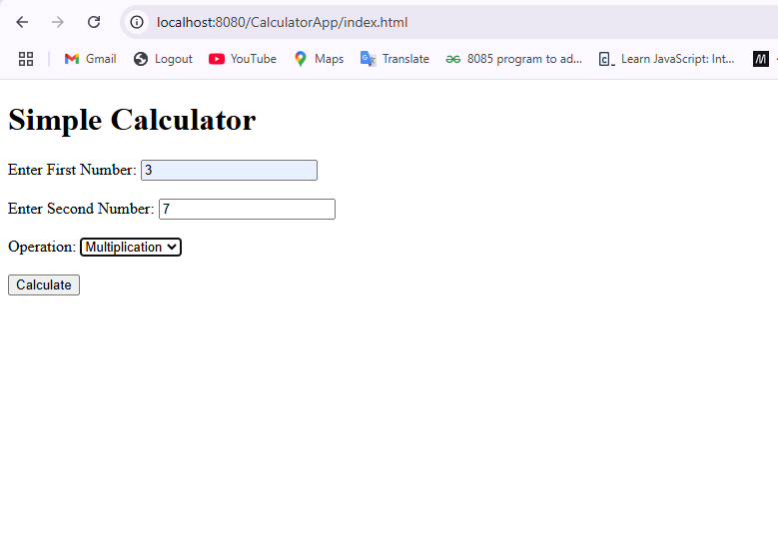

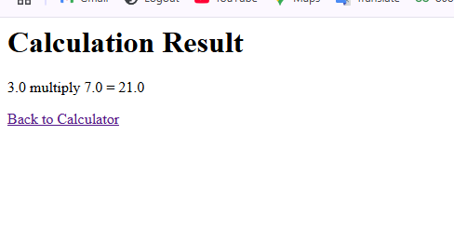

12.b.Student registration

Pom.xml

<?xml version="1.0" encoding="UTF-8"?>  
<project xmlns="http://maven.apache.org/POM/4.0.0"  
 xmlns:xsi="http://www.w3.org/2001/XMLSchema-instance"  
 xsi:schemaLocation="http://maven.apache.org/POM/4.0.0  
http://maven.apache.org/maven-v4_0_0.xsd">  
 <modelVersion>4.0.0</modelVersion>  
 <packaging>war</packaging>  
 <name>StudentRegisterApp</name>  
 <properties>  
 <maven.compiler.source>11</maven.compiler.source>  
 <maven.compiler.target>11</maven.compiler.target>  
 </properties>  
 <groupId>com</groupId>  
 <artifactId>StudentRegisterApp</artifactId>  
 <version>1.0-SNAPSHOT</version>  
  
 <build>  
 <plugins>  
 <plugin>  
 <groupId>org.mortbay.jetty</groupId>  
 <artifactId>maven-jetty-plugin</artifactId>  
 <version>6.1.7</version>  
 <configuration>  
 <connectors>  
 <connector  
 implementation="org.mortbay.jetty.nio.SelectChannelConnector">  
 <port>8888</port>  
 <maxIdleTime>30000</maxIdleTime>  
 </connector>  
 </connectors>  
  
 <webAppSourceDirectory>${project.build.directory}/${pom.artifactId}-  
 ${pom.version}</webAppSourceDirectory>  
 <contextPath>/</contextPath>  
 </configuration>  
 </plugin>  
 </plugins>  
 </build>  
 <dependencies>  
  
 <!-- https://mvnrepository.com/artifact/jakarta.servlet/jakarta.servletapi -->  
 <dependency>  
 <groupId>jakarta.servlet</groupId>  
 <artifactId>jakarta.servlet-api</artifactId>  
 <version>5.0.0</version>  
 <scope>provided</scope>  
 </dependency>  
 <dependency>  
 <groupId>mysql</groupId>  
 <artifactId>mysql-connector-java</artifactId>  
 <version>8.0.33</version>  
 </dependency>  
  
 </dependencies>  
</project>

Index.html

<!DOCTYPE html>  
<html lang="en">  
<head>  
 <meta charset="UTF-8">  
 <title>Student Registration</title>  
</head>  
<body>  
<h1>Student Registration Form</h1>  
<form method="post" action="register">  
 <label>Name:</label>  
 <input type="text" name="name" required><br><br>  
  
 <label>Age:</label>  
 <input type="number" name="age" required><br><br>  
  
 <label>Email:</label>  
 <input type="email" name="email" required><br><br>  
  
 <label>Department:</label>  
 <input type="text" name="department" required><br><br>  
  
 <label>10th Percentage:</label>  
 <input type="number" step="0.01" name="tenthPercentage" required><br><br>  
  
 <label>12th Percentage:</label>  
 <input type="number" step="0.01" name="twelfthPercentage" required><br><br>  
  
 <label>Date of Birth:</label>  
 <input type="date" name="dob" required><br><br>  
  
 <label>Expected Graduation Year:</label>  
 <input type="number" name="graduationYear" required><br><br>  
  
 <input type="submit" value="Register">  
</form>  
</body>  
</html>

StudentRegistration.java

import jakarta.servlet.http.HttpServlet;  
import jakarta.servlet.http.HttpServletRequest;  
import jakarta.servlet.http.HttpServletResponse;  
  
import java.io.PrintWriter;  
import java.sql.Connection;  
import java.sql.DriverManager;  
import java.sql.PreparedStatement;  
  
public class StudentRegistrationServlet extends HttpServlet {  
 @Override  
 protected void doPost(HttpServletRequest req, HttpServletResponse res) {  
 res.setContentType("text/html");  
 try (PrintWriter out = res.getWriter()) {  
 // Retrieve form data  
 String name = req.getParameter("name");  
 int age = Integer.*parseInt*(req.getParameter("age"));  
 String email = req.getParameter("email");  
 String department = req.getParameter("department");  
 double tenthPercentage = Double.*parseDouble*(req.getParameter("tenthPercentage"));  
 double twelfthPercentage = Double.*parseDouble*(req.getParameter("twelfthPercentage"));  
 String dob = req.getParameter("dob");  
 int graduationYear = Integer.*parseInt*(req.getParameter("graduationYear"));  
  
 // JDBC connection details  
  
  
 String jdbcURL = "jdbc:mysql://localhost:3306/java_assignment"; // Replace with your database name  
 String dbUser = "root"; // Replace with your DB username  
 String dbPassword = "root"; // Replace with your DB password  
  
 // Insert data into the database  
 String sql = "INSERT INTO students (name, age, email, department, tenth_percentage, twelfth_percentage, dob, graduation_year) VALUES (?, ?, ?, ?, ?, ?, ?, ?)";  
 try (Connection connection = DriverManager.*getConnection*(jdbcURL, dbUser, dbPassword);  
 PreparedStatement statement = connection.prepareStatement(sql)) {  
  
 // Set parameters  
 statement.setString(1, name);  
 statement.setInt(2, age);  
 statement.setString(3, email);  
 statement.setString(4, department);  
 statement.setDouble(5, tenthPercentage);  
 statement.setDouble(6, twelfthPercentage);  
 statement.setString(7, dob);  
 statement.setInt(8, graduationYear);  
  
 // Execute update  
 int rowsInserted = statement.executeUpdate();  
  
 if (rowsInserted > 0) {  
 out.println("<h1>Registration Successful!</h1>");  
 } else {  
 out.println("<h1>Error: Registration Failed</h1>");  
 }  
 } catch (Exception e) {  
 e.printStackTrace();  
 out.println("<h1>Error: " + e.getMessage() + "</h1>");  
 }  
  
 out.println("<a href='index.html'>Back to Registration Form</a>");  
 } catch (Exception e) {  
 e.printStackTrace();  
 }  
 }  
}

