ASSIGNMENT-2

REG NO:2022503045

NAME:SIVARANJANI S

DATE:21-08-2024

1. Write a program to read an integer of randomly in a 1D array and character array using the random integer. Apply the method to sort the array content and return the number of comparisons done. Apply method to Print the sorted array with array index position

Code :

import java.util.Random;  
import java.util.Scanner;  
  
public class Sort_3045 {  
 int n;  
 int[] randomArray;  
 int comparison=0;  
 public void readArray(){  
 Scanner sc=new Scanner(System.*in*);  
 Random rand=new Random();  
 System.*out*.print("Enter the number of elements : ");  
 n=sc.nextInt();  
 randomArray=new int[n];  
 for(int i=0;i<n;i++){  
 if(rand.nextBoolean()){  
 randomArray[i]=65+rand.nextInt(26);  
 }  
 else{  
 randomArray[i]=97+rand.nextInt(26);  
 }  
 }  
 sort();  
  
 }  
 public void sort(){  
 boolean swapped;  
  
 for(int i=0;i<randomArray.length;i++){  
 swapped=false;  
 for(int j=0;j<randomArray.length-i-1;j++){  
 if(randomArray[j]>randomArray[j+1]){  
 int temp=randomArray[j];  
 randomArray[j]=randomArray[j+1];  
 randomArray[j+1]=temp;

comparison+=1;

swapped=true;  
 }  
 }  
 if(!swapped)  
 break;  
 }  
  
 }  
 public void displayContent(){  
 *printDashes*(n);  
 System.*out*.print("|");  
 for(int i=0;i<n;i++){  
 System.*out*.printf("%3d |",i);  
 }  
 System.*out*.println();  
 *printDashes*(n);  
 System.*out*.print("|");  
 for(int i=0;i<n;i++) {  
 System.*out*.printf("%3d |", randomArray[i]);  
 }  
 System.*out*.println();  
 *printDashes*(n);  
 System.*out*.print("|");  
 for(int i=0;i<n;i++){  
 System.*out*.printf("%3s |",(char)randomArray[i]);  
 }  
 System.*out*.println();  
 System.*out*.print("No of comparisons: "+comparison);  
 }  
 public void printDashes(int n){  
 for(int i=0;i<n;i++){  
 System.*out*.print("------");  
 }  
 System.*out*.println();  
 }  
 public static void main(String[] args){  
 System.*out*.println("Sivaranjani-2022503045");  
 Sort_3045 obj =new Sort_3045();  
 obj.readArray();  
 obj.displayContent();  
  
 }  
  
}

OUTPUT:

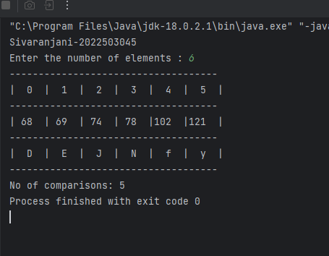

2. Write a program to read n random integer in a 1D array of A and B of size n. Apply method to search the occurrence of element in B and print the number of B element occurrence in A .

CODE:

import java.util.HashMap;  
import java.util.Random;  
import java.util.Scanner;  
  
public class Search_3045 {  
 int n;  
 int[] A;  
 int[] B;  
 Random rand=new Random();  
 Scanner sc=new Scanner(System.*in*);  
 HashMap<Integer,Integer> frequencyB=new HashMap<>();  
 public void readArrays(){  
 System.*out*.print("enter the number of elements:");  
 n=sc.nextInt();  
 A=new int[n];  
 B=new int[n];  
 int max=20;  
 int min=1;  
 for(int i=0;i<n;i++){  
 A[i]=rand.nextInt(max-min+1)+min;  
 B[i]=rand.nextInt(max-min+1)+min;  
 frequencyB.put(A[i],0);  
 }  
 }  
 public void searchInA(){  
 for(int a:A){  
 frequencyB.put(a,frequencyB.get(a)+1);  
 }  
  
 }  
 public void displayFrequency(){  
 for(int b:B){  
 System.*out*.println(b+" --> "+frequencyB.get(b));  
 }  
 for(int i=0;i<n;i++){  
 System.*out*.print(A[i]+" ");  
 }  
 }  
 public static void main(String[] args){  
 Search_3045 obj=new Search_3045();  
 obj.readArrays();  
 obj.searchInA();  
 obj.displayFrequency();  
 }  
}

OUTPUT:

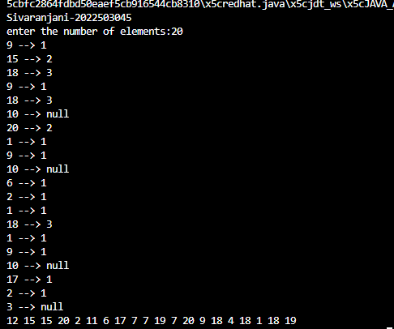

3. Write a program to read two 2D array. Apply method to perform column major sum and sort the array based on the sum of columns.

Code:

import java.util.Scanner;

public class SumOfArray_3045{

    int[][] arr1;

    int[][] arr2;

    int[][] sum;

    int[] columnSum;

    int n;

    Scanner sc=new Scanner(System.in);

    public void readArrays(){

        System.out.println("\n enter the dimension of n*n arrays:");

        n=sc.nextInt();

        arr1=new int[n][n];

        arr2=new int[n][n];

        System.out.println("Enter the elements of first array :");

        for(int i=0;i<n;i++){

            for(int j=0;j<n;j++){

                   arr1[i][j]=sc.nextInt();

            }

        }

        System.out.println("Enter the elements of second array :");

        for(int i=0;i<n;i++){

            for(int j=0;j<n;j++){

                   arr2[i][j]=sc.nextInt();

            }

        }

    }

    public void sumArray(){

       sum=new int[n][n];

       for(int i=0;i<n;i++){

        for(int j=0;j<n;j++){

            sum[i][j]=arr1[i][j]+arr2[i][j];

        }

       }

       System.out.println("Sum Array before sorting:");

       for(int i=0;i<n;i++){

        for(int j=0;j<n;j++){

            System.out.print(sum[i][j]+" ");

        }

        System.out.println();

       }

       columnSum();

    }

    public void columnSum(){

         columnSum=new int[n];

         for(int j=0;j<n;j++){

            int temp=0;

            for(int i=0;i<n;i++){

                temp+=sum[i][j];

            }

            columnSum[j]=temp;

         }

         sort();

    }

    public void sort(){

        boolean swapped;

        for(int i=0;i<n;i++){

            swapped=false;

            for(int j=0;j<n-i-1;j++){

                if(columnSum[j]>columnSum[j+1]){

                    int temp=columnSum[j];

                    columnSum[j]=columnSum[j+1];

                    columnSum[j+1]=temp;

                    swapColumn(j,j+1);

                    swapped=true;

                }

            }

            if(!swapped)

               break;

        }

    }

    public void swapColumn(int j,int k){

        for(int i=0;i<n;i++){

            int temp=sum[i][j];

            sum[i][j]=sum[i][k];

            sum[i][k]=temp;

        }

    }

    public void displaySorted(){

        System.out.println("Sum array after sorted by columnSum:");

        for(int i=0;i<n;i++){

            for(int j=0;j<n;j++){

                System.out.print(sum[i][j]+" ");

            }

            System.out.println();

        }

    }

    public static void main(String[] args){

        System.out.println("\nSivaranjani - 2022503045");

        SumOfArray_3045 obj=new SumOfArray_3045();

        obj.readArrays();

        obj.sumArray();

        obj.displaySorted();

    }

}

OUTPUT:

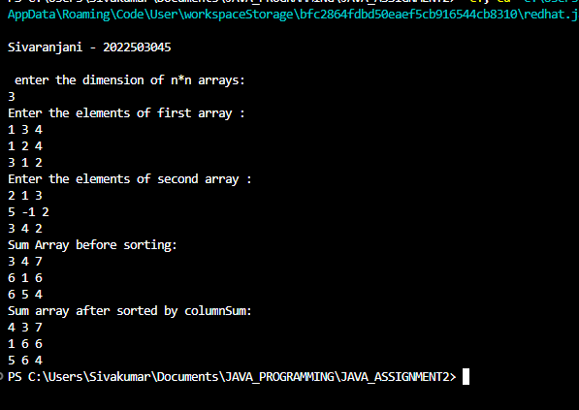

4.Magic square Write a magic square gameusing 2darray suchthatAllthe row, column and diagonal sum are equal. Create a 3 X 3 grid using array of the integers 1 to n^2. Read the random integer for the middle position and then fill the other places to obtain magic square

CODE:

import java.util.Scanner;

public class MagicArray_3045 {

    public static void main(String[] args) {

        Scanner sc = new Scanner(System.in);

        System.out.println("Enter Numbers(1 to 9):");

        int [][] arr = new int[3][3];

        System.out.println("Enter Middle Element:");

        int m = sc.nextInt();

        System.out.println("Sivaranjani-2022503045");

            arr[0][0] = m+1;

            arr[0][2] = m+3;

            arr[2][0] = m-3;

            arr[2][2] = m-1;

            arr[1][1] = m;

            int diagSum = m + arr[0][0] + arr[2][2];

            arr[0][1] = diagSum - (arr[0][0] + arr[0][2]);

            arr[1][0] = diagSum - (arr[0][0] + arr[2][0]);

            arr[2][1] = diagSum - (arr[2][0] + arr[2][2]);

            arr[1][2] = diagSum - (arr[0][2] + arr[2][2]);

            for(int i =0;i < 3 ; i++){

                for(int j =0; j< 3; j++){

                    System.out.print(arr[i][j] + " ");

                }

                System.out.println();

            }

    }

}

OUTPUT:

