ASSIGNMENT – 5

DATE : 11-09-2024

REG NO :2022503045

1. Write a program that first reads a piece of text entered by a user on one line, and

then reads a key on the second line. The program displays the frequency with

which the key has occurred in the piece of text.

CODE:

import java.util.Scanner;

public class Counter_3045{

      int frequency=0;

      String paragraph;

      String key;

      public void getInputs(){

        Scanner sc=new Scanner(System.in);

        System.out.println("enter the paragraph :");

        paragraph=sc.nextLine();

        System.out.println("enter the key:");

        key=sc.nextLine();

        sc.close();

      }

      public void count(){

        String[] words=paragraph.split(" ");

        for(String str:words){

            if(str.equals(key)){

                frequency+=1;

            }

        }

      }

      public static void main(String[] args){

        Counter_3045 obj=new Counter_3045();

        System.out.println("Sivaranjani -2022503045");

        obj.getInputs();

        obj.count();

        System.out.println(obj.frequency);

      }

}

OUTPUT :

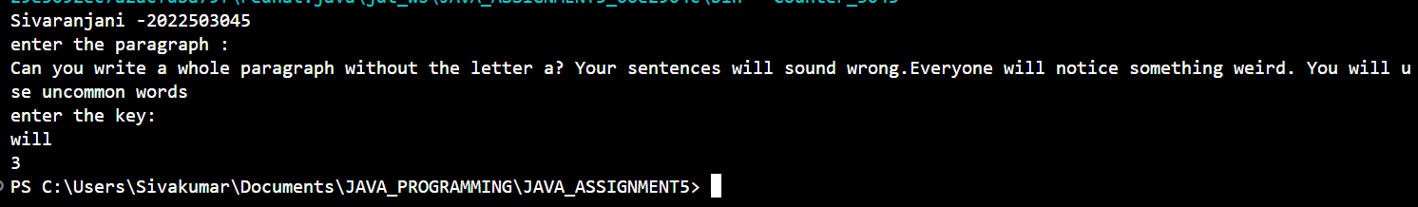

2. Write a program that accepts a string from the user and prints whether it is a palindrome or not. Ignore the case of the characters.

CODE:

import java.util.Scanner;

public class Palindrome_3045 {

    public boolean isPalindrome(String str){

        int len=str.length();

        int start=0;

        int end=len-1;

        str=str.toLowerCase();

        while(start<=end){

            if(str.charAt(start)!=str.charAt(end)){

                return false;

            }

            start++;

            end--;

        }

        return true;

    }

    public static void main(String[] args){

        System.out.println("Sivaranjani -2022503045");

        Scanner  sc=new Scanner(System.in);

        System.out.println("enter the string:");

        String input=sc.nextLine();

        Palindrome_3045 obj=new Palindrome_3045();

        System.out.println(input+" "+obj.isPalindrome(input));

    }

}

OUTPUT:

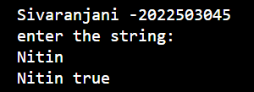

3. Write a program as per the following specification: The input to the program is a string. The string contains substrings 'not' and 'bad' such that 'bad' comes after 'not'. There are only single occurrences of 'not' and 'bad'. The program outputs a string such that the whole 'not...bad' substring in the input is replaced by 'good.

CODE:

import java.util.Scanner;

public class Good_3045 {

    public String replaceGood(String str){

        int start=-1;

        int end=-1;

        int index=-1;

        String result=str;

        StringBuilder sb=new StringBuilder();

        for(int i=0;i<str.length();i++){

            if(str.charAt(i)==' '||!(str.charAt(i)>='a' && str.charAt(i)<='z'||str.charAt(i)>='A' && str.charAt(i)<='Z')){

                if(sb.toString().equalsIgnoreCase("not") && start==-1){

                    start=index;

                }

                else if(sb.toString().equalsIgnoreCase("bad") && start!=-1){

                    end=index +sb.length()-1;

                    String toreplace=str.substring(start, end+1);

                    result=result.replace(toreplace,"good");

                    start=-1;

                    end=-1;

                }

                index=-1;

                sb=new StringBuilder();

            }

            else{

                  sb.append(str.charAt(i));

                  if(index==-1){

                    index=i;

                  }

            }

        }

        if(sb.toString().equalsIgnoreCase("bad") && start!=-1){

            end=index+sb.length()-1;

            String toreplace=str.substring(start, end+1);

            result=result.replace(toreplace,"good");

        }

        return result;

    }

    public static void main(String[] args){

        System.out.println("Sivaranjani -2022503045");

        Good_3045 obj=new Good_3045();

        Scanner sc=new Scanner(System.in);

        System.out.println("enter the line :");

        String input=sc.nextLine();

        System.out.println(obj.replaceGood(input));

    }

}

OUTPUT:

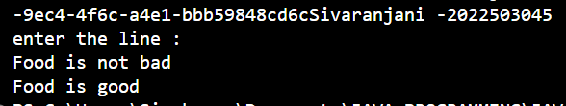

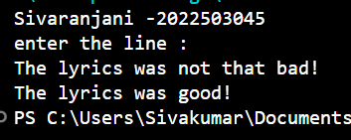

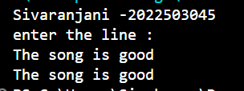

4. Write a program to print the frequency of characters in a string in the given format.

CODE:

import java.util.HashMap;

import java.util.Scanner;

public class Character_3045 {

    HashMap<Character,Integer> characters=new HashMap<>();

    public void count(String str){

        for(int i=0;i<str.length();i++){

            if(str.charAt(i)!=' '){

                characters.put(str.charAt(i),characters.getOrDefault(str.charAt(i),0)+1);

            }

        }

    }

    public void display(){

        int i=1;

        for(char c:characters.keySet()){

            System.out.print(c+":"+characters.get(c));

            if(i!=characters.size()){

                System.out.print(", ");

                i++;

            }

        }

    }

    public static void main(String[] args){

        Character_3045 obj=new Character_3045();

        System.out.println("Sivaranjani -2022503045");

        Scanner sc=new Scanner(System.in);

        System.out.println("enter the string :");

        String input=sc.nextLine();

        obj.count(input);

        obj.display();

    }

}

OUTPUT:

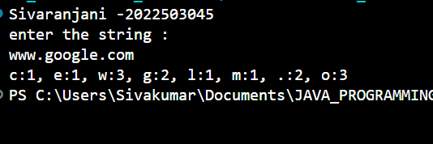

5. Write a program to check whether an input string is a pangram or not. Pangrams are words or sentences containing every letter of the alphabet at least once. Ignore the case of the characters.

CODE:

import java.util.Scanner;

public class Pangram_3045 {

    boolean[] alphabets=new boolean[26];

    public boolean isPangram(String str){

        str=str.toLowerCase();

        for(int i=0;i<str.length();i++){

            if(str.charAt(i)>='a' && str.charAt(i)<='z'){

                alphabets[str.charAt(i)-'a']=true;

            }

        }

        for(int i=0;i<26;i++){

            if(alphabets[i]==false)

                return false;

        }

        return true;

    }

    public void missingLetters(){

        for(int i=0;i<26;i++){

            if(alphabets[i]==false){

                System.out.print((char)(i+97)+",");

            }

        }

    }

    public static void main(String[] args){

        System.out.println("Sivaranjani -2022503045");

        Scanner sc=new Scanner(System.in);

        System.out.println("Enter the string:");

        String input=sc.nextLine();

        Pangram_3045 obj=new Pangram_3045();

        if(obj.isPangram(input)){

            System.out.println("Yes, the string is a pangram.");

        }

        else{

            System.out.print("No, the string is NOT a pangram. Missing letter(s) is(are) ");

            obj.missingLetters();

        }

    }

}

OUTPUT:

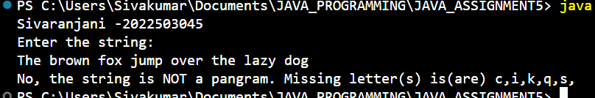

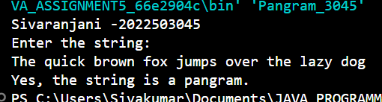

6. Write a program to create a ComplexNumber class with the following features:

CODE:

public class ComplexNumber_3045{

    double real,imag;

    ComplexNumber_3045(double real,double imag){

        this.real=real;

        this.imag=imag;

    }

public ComplexNumber_3045 add(ComplexNumber_3045 other) {

    double newReal = this.real + other.real;

    double newImag = this.imag + other.imag;

    return new ComplexNumber_3045(newReal, newImag);

}

public ComplexNumber_3045 subtract(ComplexNumber_3045 other) {

    double newReal = this.real - other.real;

    double newImag = this.imag - other.imag;

    return new ComplexNumber_3045(newReal, newImag);

}

public ComplexNumber_3045 multiply(ComplexNumber_3045 other) {

    double newReal = this.real * other.real;

    double newImag = this.imag * other.imag;

    return new ComplexNumber_3045(newReal, newImag);

}

public ComplexNumber_3045 divide(ComplexNumber_3045 other) {

    double newReal = this.real / other.real;

    double newImag = this.imag / other.imag;

    return new ComplexNumber_3045(newReal, newImag);

}

    @Override

    public String toString(){

        return this.real+" + "+this.imag+"i";

    }

    public boolean equals(ComplexNumber_3045 obj){

        if(this.real==obj.real){

            if(this.imag==obj.imag){

                return true;

            }

        }

        return false;

    }

    public static void main(String[] args){

        ComplexNumber_3045 c1 = new ComplexNumber_3045(3,4);

        ComplexNumber_3045 c2 = new ComplexNumber_3045(1,-2);

        System.out.println("Sivaranjani -2022503045");

        System.out.println("c1: " + c1);

        System.out.println("c2: " + c2);

        ComplexNumber_3045 sum = c1.add(c2);

        System.out.println("The sum is: "+sum);

        ComplexNumber_3045 difference = c1.subtract(c2);

        System.out.println("The difference is: "+difference);

        ComplexNumber_3045 product = c1.multiply(c2);

        System.out.println("The product is: "+product);

        ComplexNumber_3045 quotient = c1.divide(c2);

        System.out.println("The quotient is: "+quotient);

        boolean isEqual = c1.equals(c2);

        System.out.println("c1 equals c2: " + isEqual);

    }

}

OUTPUT:

