AI POWERED HONEYPOTS FOR ADVANCE THREAT DETECTION AND ANALYSIS

TABLE OF CONTENTS
CHAPTER | TITLE | PAGE NO
 | ABSTRACT
 | INTRODUCTION
 | - General Introduction
 | - Project Objectives
 | - Problem Statement
 | SYSTEM PROPOSAL
 | - Existing System
 | - Disadvantages
 | - Proposed System
 | 2.2.1 Advantages
 | - Literature Survey
 | SYSTEM DIAGRAMS
 | - Architecture Diagram
 | - Flow Diagram
 | - UML Diagrams
 | IMPLEMENTATION
 | - Modules
 | - Modules Description
 | SYSTEM REQUIREMENTS
 | - Hardware Requirements
 | - Software Requirements
 | - Software Description
 | - Testing of Products
 | CONCLUSION
7. | FUTURE ENHANCEMENT
8. | SAMPLE CODING
9. | SAMPLE SCREENSHOT
10. | REFERENCES

TABLE OF DIAGRAM

CHAPTER | DIAGRAM | PAGE NO
3.1 | SYSTEM DIAGRAMS
3.1.1 | Architecture Diagram
3.1.2 | Flow Diagram
3.1.3 | UML Diagram
3.1.4 | ER Diagram
3.1.5 | Sequence Diagram
3.1.6 | Activity Diagram

ABSTRACT
In an era where cyber threats are growing in complexity and frequency, traditional defense mechanisms often fall short in identifying sophisticated intrusion patterns. This project introduces an AI-powered honeypot system designed to proactively detect, classify, and analyze cyber-attacks using deep learning techniques. By simulating common attack vectors such as DDoS, brute-force login attempts, and malware probes, the system collects real-time data which is then analyzed using autoencoder-based feature extraction and Convolutional Neural Networks (CNNs) for multi-class classification of intrusion types.

The honeypot is capable of simulating various attack scenarios at different intensities, capturing both network behavior and attacker patterns. Through robust preprocessing, feature engineering, and the application of machine learning, the model achieves high accuracy in detecting and categorizing intrusion types such as DoS, R2L, Probe, and U2R attacks. This AI-driven approach significantly enhances early threat detection, allowing for faster and more accurate incident response in modern network environments.

CHAPTER 1
INTRODUCTION
INTRODUCTION
With the ever-expanding digital landscape, the frequency and sophistication of cyberattacks have surged dramatically. Organizations today face threats ranging from Distributed Denial-of-Service (DDoS) attacks to stealthy intrusions like Remote-to-Local (R2L) and User-to-Root (U2R) attacks. Traditional intrusion detection systems (IDS) are often reactive, limited in their ability to adapt to novel attack patterns. This has led to the growing interest in proactive cybersecurity mechanisms like honeypots, which can deceive, detect, and study malicious activities in controlled environments.
A honeypot acts as a decoy system that mimics vulnerable services and systems to lure attackers, enabling security teams to monitor and analyze unauthorized access attempts without exposing real assets. While conventional honeypots are effective at capturing threats, the analysis and classification of attack data often require manual effort or rule-based systems, which are limited in scalability and adaptability. This project bridges that gap by integrating artificial intelligence into the honeypot framework.
By leveraging deep learning techniques such as autoencoders and convolutional neural networks, the honeypot system can automatically extract features from raw intrusion data and classify it into various attack categories. The use of autoencoders allows for dimensionality reduction and feature refinement, while CNNs handle multi-class classification tasks with high accuracy and resilience to noisy data. This AI integration not only enhances the detection rate but also reduces false positives, enabling smarter threat intelligence.

Furthermore, the system includes a simulated attack generator that mimics real-world attack behaviors, allowing for dynamic testing and training of detection models. The continuous learning capability ensures that the system evolves with the threat landscape, making it a valuable asset for modern cybersecurity infrastructure.

  - GENERAL INTRODUCTION

In today’s hyper-connected digital world, cybersecurity has become a critical concern for organizations, governments, and individuals alike. With the rapid advancement of technology, cybercriminals have developed more sophisticated tools and methods to exploit vulnerabilities in networks and systems. Traditional security measures such as firewalls and signature-based intrusion detection systems (IDS) often fall short when it comes to identifying new or evolving threats. As a result, there is a growing need for intelligent, adaptive security solutions that can detect and respond to these threats in real-time.

One innovative approach to enhancing cybersecurity is the use of honeypots—decoy systems intentionally designed to attract and trap malicious actors. Honeypots act as bait, luring attackers into a controlled environment where their behavior can be monitored and analyzed without putting real systems at risk. While traditional honeypots are effective in capturing attack data, their usefulness is limited without advanced analysis tools that can process the data efficiently and extract meaningful insights.

This is where Artificial Intelligence (AI), particularly machine learning and deep learning, plays a transformative role. By integrating AI with honeypot systems, it becomes possible to automate the detection and classification of cyberattacks based on behavioral patterns and anomalies. Deep learning models such as autoencoders and Convolutional Neural Networks (CNNs) can learn complex attack signatures from raw data, enabling accurate classification of multiple types of intrusions, such as DoS, Probe, R2L, and U2R attacks.

This project aims to develop an AI-powered honeypot system capable of simulating real-world cyberattacks and analyzing them using deep learning techniques. By doing so, the system not only detects threats more effectively but also contributes valuable threat intelligence that can be used to improve overall network security. Through continuous learning and adaptation, such a system can evolve to handle emerging threats, making it a vital component in modern cybersecurity defense strategies.

  - PROJECT OBJECTIVE
The primary objective of this project is to design and implement an AI-powered honeypot system capable of detecting, classifying, and analyzing various types of cyberattacks in real time. By combining traditional honeypot mechanisms with deep learning-based analytics, the system can intelligently recognize intrusion patterns, extract meaningful features from network traffic, and categorize attacks into predefined classes such as DoS, Probe, R2L, and U2R. The integration of feature extraction through autoencoders and classification using Convolutional Neural Networks (CNNs) allows for a high degree of accuracy and adaptability in detecting both known and previously unseen threats.

A secondary objective is to simulate real-world attack scenarios—such as port scans, brute-force attempts, DDoS floods, and malware probes—against the honeypot environment. This provides valuable data for model training and validation while also stress-testing the system's detection capabilities. The project ultimately aims to enhance proactive threat intelligence gathering, reduce false positive rates in detection systems, and support automated response strategies for network security teams.

  - PROBLEM STATEMENT
As cyber threats become more sophisticated, existing intrusion detection systems (IDS) often struggle to keep pace with novel attack techniques, leading to missed threats or overwhelming volumes of false positives. Traditional honeypots are effective in capturing malicious activity but lack the intelligence to analyze and respond to complex attack patterns on their own. Without automation and intelligent processing, vast amounts of raw honeypot data go underutilized, delaying response times and increasing the risk of compromise.

There is a critical need for a system that not only captures attack attempts but also applies intelligent analytics to classify and respond to them dynamically. This project addresses that gap by integrating deep learning algorithms into the honeypot framework, enabling automated threat analysis and detection with minimal human intervention. The solution must be robust, adaptive to different attack types, and scalable enough to handle high-frequency threat simulations without performance degradation.

  - PROJECT SCOPE
The scope of this project includes the development of a functional honeypot capable of simulating various cyberattacks and capturing relevant network behavior for analysis. The system will implement multiple types of simulated attacks including port scans, brute-force login attempts, malware upload probes, and denial-of-service attacks. These attacks will be logged and analyzed in real-time using an AI-based detection engine built with deep learning techniques. The system will also track suspicious IP addresses and block further interaction if attack thresholds are exceeded.

Additionally, the scope includes the use of data preprocessing techniques, feature standardization, and label encoding to prepare captured attack data for machine learning. Autoencoders will be used to extract key features, and a CNN-based classifier will categorize the attacks. The final deliverables include a trained and saved model, performance evaluation metrics, visualizations of attack data, and predictions on test samples. This project focuses on detection and classification but does not include implementation of active response measures or real-world network deployment beyond simulation.

ALGORITHM
Autoencoder + Convolutional Neural Network (CNN)
(for feature extraction and multi-class intrusion detection)
  - Random Forest Algorithm
  - Decision Tree Algorithm
  - CNN Algorithm
  - Hybrid CNN and LSTM Algorithm

CHAPTER 2
SYSTEM PROPOSAL

  - EXISTING SYSTEM
Traditional Intrusion Detection Systems (IDS) rely heavily on signature-based or rule-based techniques to detect and flag suspicious activity in networks. These systems compare incoming traffic patterns with a predefined set of attack signatures to identify known threats. Honeypots are sometimes used in these environments to lure attackers and collect attack data, but they typically function as passive traps and require manual analysis of logs and behavior. While effective for capturing data and recognizing previously known threats, these systems struggle with detecting novel, evolving, or obfuscated attacks that do not match existing signatures.

Moreover, the lack of intelligent automation in most traditional systems limits their scalability and responsiveness. As the volume and complexity of cyberattacks increase, security analysts often face an overwhelming number of alerts—many of which are false positives—leading to delayed or missed threat responses. Existing systems are reactive in nature, incapable of adapting to dynamic attack strategies or learning from new intrusion patterns without manual rule updates or model retraining.
Disadvantages of Existing Systems
Limited to Known Attacks: Signature-based systems cannot detect zero-day or unknown threats that do not match existing patterns.

High False Positives: Rule-based detection can lead to many inaccurate alerts, burdening analysts.

Manual Analysis Required: Traditional honeypots require human effort to interpret logs and detect real threats.

Lack of Adaptability: Static models or rules do not evolve with emerging cyberattack trends.

Slow Response Time: Without automation, detecting and responding to sophisticated threats is often delayed.

  - PROPOSED SYSTEM
The proposed system integrates artificial intelligence with honeypot-based intrusion detection to provide an automated, intelligent, and adaptive cybersecurity solution. It simulates various cyberattacks in a controlled environment and uses deep learning techniques—specifically autoencoders for feature extraction and CNNs for multi-class classification—to analyze and categorize intrusion attempts in real time. This approach enables the system to learn from raw attack data, detect anomalies, and classify threats with high accuracy.

Unlike traditional systems, this AI-powered honeypot dynamically adapts to new patterns of behavior and continuously improves as more attack data is collected. It not only detects known threats but also identifies previously unseen attack signatures through anomaly detection and feature learning. By automating analysis and classification, the proposed system significantly reduces human effort and improves the speed and accuracy of threat detection in modern networks.

Advantage
Detection of Unknown Attacks: Uses deep learning to identify novel or zero-day threats through pattern recognition.
Automated Feature Extraction: Autoencoders automatically process and reduce complex data into meaningful features.
Improved Accuracy: CNNs provide precise multi-class classification of different intrusion types.
Real-Time Analysis: Rapid threat detection and logging reduce response times.
Scalable and Adaptive: The system learns from new data over time, improving performance with minimal manual intervention.

  - LITERATURE SURVEY

1. HoneyIoT: Adaptive High-Interaction Honeypot for IoT Devices Through Reinforcement Learning
- Authors: Chongqi Guan, Heting Liu, Guohong Cao, Sencun Zhu, Thomas La Porta
- Year: 2023
- Technologies & Algorithms Used: Reinforcement Learning, Markov Decision Process, Differential Analysis
- Advantages:
  - Effectively bypasses pre-attack checks.
  - Misleads attackers into uploading malware.
  - Covert against common reconnaissance tools.
- Disadvantages:
  - Complex setup requiring real device-based attack trace collection.
  - Potential scalability issues due to high interaction levels.
  - May require significant computational resources for reinforcement learning processes.

2. A Clever Honeypot Tricked Hackers Into Revealing Their Secrets
- Authors: GoSecure
- Year: 2023
- Technologies & Algorithms Used: Virtual Machine Honeypot, RDP Protocol Simulation
- Advantages:
  - Provides detailed insights into attacker behavior.
  - Reveals tools and techniques used by intruders.
  - Highlights vulnerabilities in RDP systems.
- Disadvantages:
  - Limited to RDP-based attack scenarios.
  - May not capture a wide range of attack types.
  - Potential for detection by sophisticated attackers.

3. LLM in the Shell: Generative Honeypots
- Authors: Muris Sladić, Veronica Valeros, Carlos Catania, Sebastian Garcia
- Year: 2023
- Technologies & Algorithms Used: Large Language Models, Cloud-Based LLMs
- Advantages:
  - Generates realistic Linux shell outputs.
  - Capable of engaging human attackers effectively.
  - High true negative rate, indicating credibility.
- Disadvantages:
  - Requires access to cloud-based LLMs.
  - Potential latency issues due to cloud dependencies.
  - May not simulate all aspects of a real Linux environment.

4. HoneyDOC: An Efficient Honeypot Architecture Enabling All-Round Design
- Authors: Wenjun Fan, Zhihui Du, Max Smith-Creasey, David Fernández
- Year: 2024
- Technologies & Algorithms Used: Software-Defined Networking (SDN), Modular Architecture (Decoy, Captor, Orchestrator)
- Advantages:
  - Supports high programmability for capturing high-quality data.
  - Modular design enhances flexibility and scalability.
  - Improves sensitivity, countermeasure, and stealth.
- Disadvantages:
  - Implementation complexity due to modular architecture.
  - Requires SDN infrastructure, which may not be available in all environments.
  - Potential integration challenges with existing systems.

5. LLM Agent Honeypot: Monitoring AI Hacking Agents in the Wild
- Authors: Reworr, Dmitrii Volkov
- Year: 2024
- Technologies & Algorithms Used: SSH Honeypot, Prompt Injection, Time-Based Analysis
- Advantages:
  - Detects AI-driven hacking agents.
  - Collects extensive data on hacking attempts.
  - Provides early warning of malicious AI agents.
- Disadvantages:
  - May not detect non-AI-based attacks.
  - Requires continuous monitoring to identify AI agents.
  - Potential for high false positive rates if not properly tuned.

6. A Highly Interactive Honeypot-Based Approach to Network Threat Management
- Authors: Xingyuan Yang, Jie Yuan, Hao Yang, Ya Kong, Hao Zhang, Jinyu Zhao
- Year: 2023
- Technologies & Algorithms Used: High-Interaction Honeypot, Network Threat Management
- Advantages:
  - Provides in-depth analysis of attack behaviors.
  - Enhances understanding of network threats.
  - Improves incident response strategies.
- Disadvantages:
  - High resource consumption due to interactivity.
  - Potential for detection by advanced attackers.
  - Requires careful configuration to avoid misinterpretation of data.

7. Detection and Analysis of Active Attacks using Honeypot
- Authors: Waqas Ahmad, Muhammad Arsalan Raza, Sabreena Nawaz, Farhana Waqas
- Year: 2023
- Technologies & Algorithms Used: Honeypot Systems, Attack Detection Algorithms
- Advantages:
  - Facilitates real-time detection of active attacks.
  - Provides valuable data for forensic analysis.
  - Enhances overall network security posture.
- Disadvantages:
  - Limited to attacks targeting the honeypot.
  - May not detect attacks bypassing the honeypot.
  - Requires regular updates to detection algorithms.

8. Securing Smart Cities Through Machine Learning: A Honeypot-Driven Approach
- Authors: Ahmed, et al.
- Year: 2024
- Technologies & Algorithms Used: Machine Learning (Decision Trees, KNN, SNN, LSTM), Honeypot Systems
- Advantages:
  - Improves real-time attack detection in IoT ecosystems.
  - Reduces false alarms through effective algorithm selection.
  - Enhances security in smart city infrastructures.
- Disadvantages:
  - High computational requirements for neural networks.
  - Potential scalability issues in large-scale deployments.
  - Dependence on feature selection for optimal performance.

9. Creating Synthetic Attacks with Evolutionary Algorithms for Proactive Defense of Industrial Control Systems
- Authors: Nathaniel Haynes, Thuy Nguyen, Neil Rowe
- Year: 2023
- Technologies & Algorithms Used: Evolutionary Algorithms, Synthetic Attack Generation
- Advantages:
  - Generates realistic attack scenarios for testing defenses.
  - Identifies vulnerabilities in industrial control systems.
  - Enhances proactive defense strategies.
- Disadvantages:
  - Requires extensive computational resources.
  - May produce attack scenarios not representative of real-world threats.
  - Potential ethical concerns in generating synthetic attacks.

10. Advancing Cybersecurity with Honeypots and Deception Strategies
- Authors: Z.M., V.D., D.R.
- Year: 2023
- Technologies & Algorithms Used: Reinforcement Learning, Adaptive Honeypots, Deception Strategies, SIEM Integration
- Advantages:
  - Enhances early detection by attracting attackers during reconnaissance phases.
  - Allows for attack containment within controlled environments, protecting production systems.
  - Utilizes dynamic engagement through adaptive honeypots to prolong attacker interaction and gather detailed intelligence.
  - Facilitates real-time alerts and automated responses via integration with SIEM systems.
  - Provides actionable threat intelligence, improving defense posture and enabling proactive security measures.
- Disadvantages:
  - High resource consumption due to the complexity of adaptive systems.
  - Potential for sophisticated attackers to recognize and bypass honeypots.
  - Requires continuous updates and maintenance to remain effective against evolving threats.
  - Integration with existing security infrastructure may pose challenges.
  - Deployment complexity may increase operational overhead.

CHAPTER 3
TABLE OF SYMBOLS
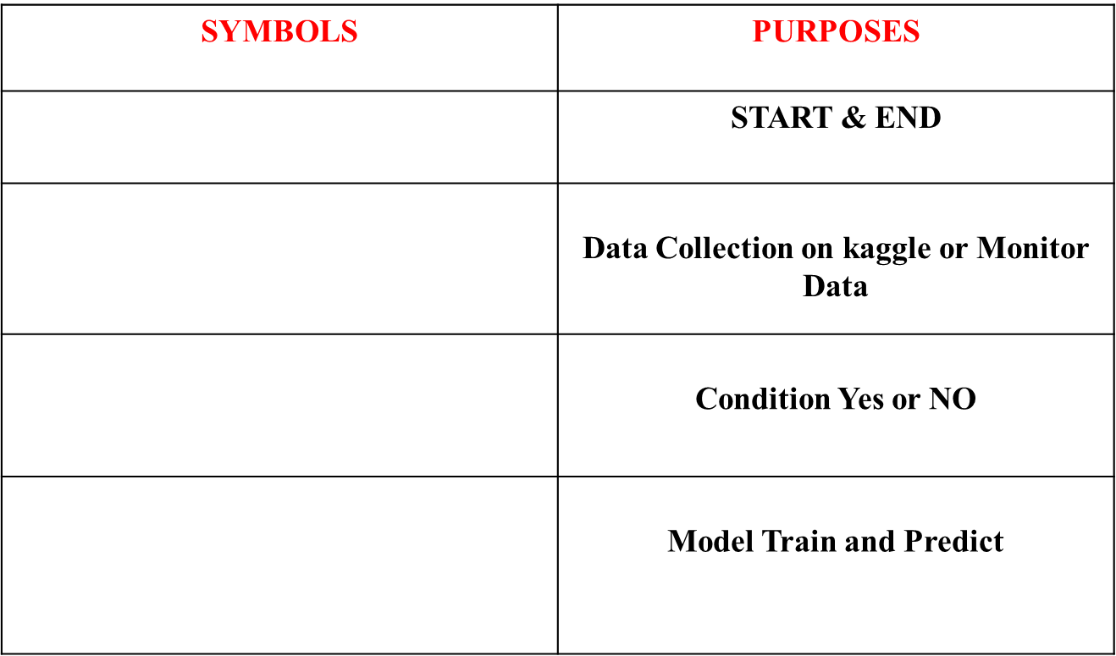

SYSTEM DIAGRAM

3.1 ARCHITECTURE DIAGRAM

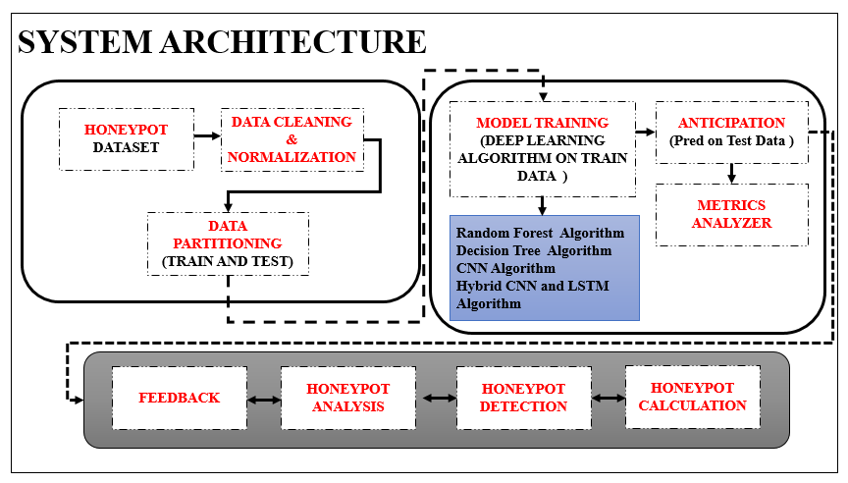

3.2 FLOW DIAGRAM

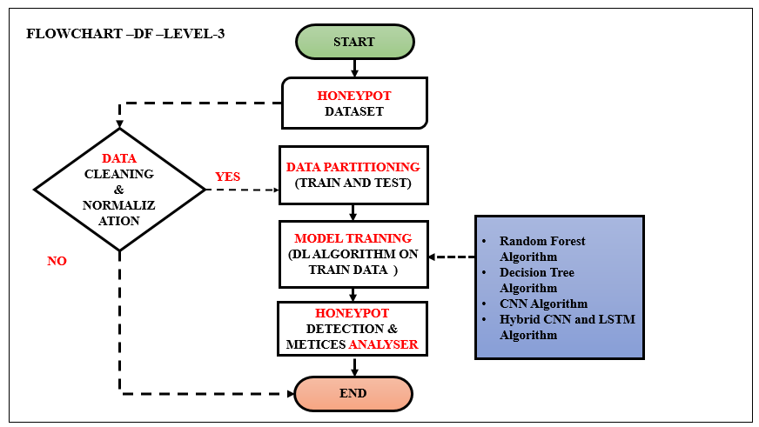

3.3 USE CASE DIAGRAM
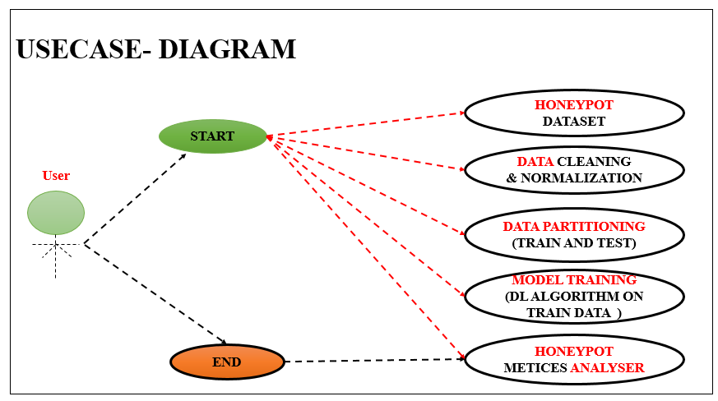

3.4 ER DIAGRAM

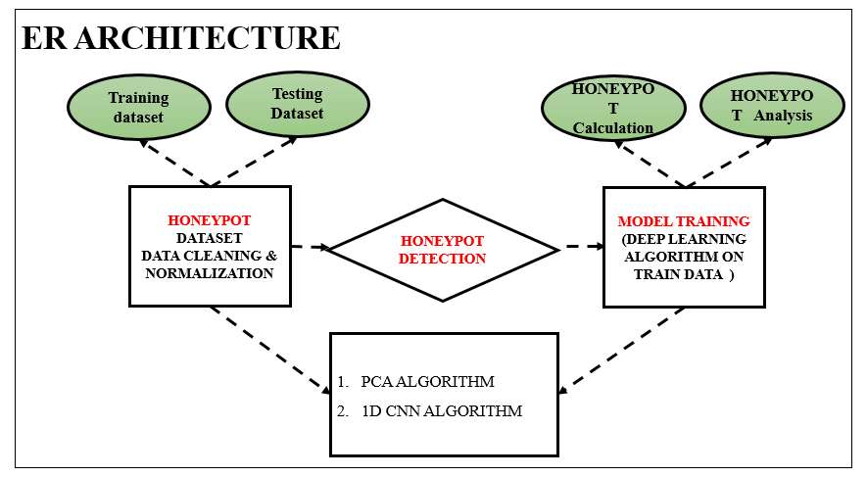

3.5 SEQUENCE DIAGRAM

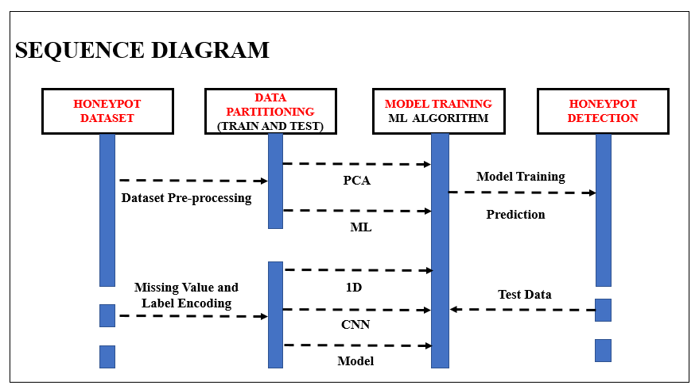

3.6 ACTIVITY DIAGRAM
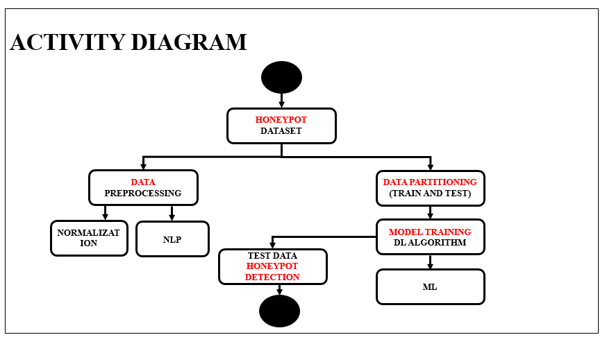

CHAPTER 4
IMPLEMENTATION

4.1 MODULES
- Data Insight Gatherer and Refiner
- Feature Extraction
- Data Partitioning(Train and Test)
- Model Training
- Anticipation (pred)
- Metrics Analyzer

4.2 MODULES DESCRIPTION
1. Data Collection and Selection Module
This module is responsible for gathering raw network traffic and attack data, which forms the foundation of the detection model. It collects logs from the honeypot environment, simulates attack scenarios, and captures data across different layers of the network protocol stack. Sources include firewall logs, server responses, system calls, and port interaction records. Additionally, datasets such as NSL-KDD or custom-captured honeypot logs may be integrated for broader coverage.

Data preprocessing begins at this stage, involving cleaning, filtering, and normalizing the data. The system removes missing values, handles inconsistent entries, and standardizes features to bring all data into a consistent format suitable for machine learning models. The module also categorizes types of attacks such as DoS, Probe, R2L, and U2R to assist in label encoding for supervised learning.

Proper selection of features is crucial for reducing complexity and improving the performance of downstream models. The system evaluates which attributes (e.g., duration, protocol type, service, flag) are most informative for classifying attack behaviors. The final output of this module is a clean, structured dataset ready for analysis and modeling.

2. Data Preprocessing and Label Encoding Module
This module focuses on transforming raw and cleaned data into a format suitable for machine learning. Feature scaling (e.g., using StandardScaler) is applied to numerical columns to ensure uniformity, preventing dominance of larger-valued features over smaller ones during model training. It improves the convergence rate of algorithms like neural networks.

Label encoding is used to convert categorical features such as protocol type, service, and flag into numeric form. More importantly, this module handles the critical task of converting attack labels into numeric class values (e.g., ‘normal’ → 0, ‘DoS’ → 1, etc.), which is essential for multi-class classification. One-hot encoding is then applied to target labels to make them compatible with neural networks that use categorical cross-entropy.

This module ensures that the data is not only clean but also fully compatible with various machine learning and deep learning frameworks. It serves as a bridge between raw network behavior and the learning models that will interpret it, ensuring all inputs and labels are ready for training and evaluation.

3. Exploratory Data Analysis (EDA) Module
The EDA module visualizes the statistical properties of the dataset to understand patterns, correlations, and potential data imbalances. Heatmaps are used to identify feature correlations, histograms visualize feature distributions like protocol types or flags, and count plots help analyze the distribution of attack types.

Through visualization, this module identifies trends in how attacks manifest across different ports or services. For instance, high frequency of R2L attacks on port 22 may indicate brute-force login attempts. These insights not only aid in better understanding of the dataset but also guide feature selection and model architecture.

Another key function of the EDA module is identifying data imbalance, a common issue in intrusion datasets where normal traffic far outweighs attack instances. Recognizing such imbalance early allows for informed decisions, such as using oversampling techniques or weighted loss functions in model training.

4. Autoencoder-Based Feature Extraction Module
This module applies an autoencoder—a neural network designed to compress and reconstruct input data—for dimensionality reduction and feature extraction. The input data is passed through an encoder network that reduces it to a lower-dimensional space, capturing only the most relevant features, and then through a decoder to reconstruct the original input.

By training the autoencoder on benign and malicious traffic, it learns to distinguish subtle differences in network behavior. The encoded output from the encoder serves as a compact representation of the input data, which can then be used as input for classification models like CNN or Random Forest. This helps in reducing noise and highlighting meaningful patterns.

The main advantage of this module is that it enhances the performance of downstream classifiers by feeding them richer, denoised features. It also allows the detection system to operate faster due to reduced dimensionality, making it suitable for real-time applications.

5. CNN-Based Intrusion Detection Module
Once features are extracted, they are reshaped and passed into a Convolutional Neural Network (CNN) model designed to classify the traffic into one of several categories (e.g., Normal, DoS, Probe, R2L, U2R). The CNN leverages filters and pooling layers to automatically learn spatial hierarchies from the extracted features.

The model is trained using a categorical cross-entropy loss function and validated using accuracy and loss metrics. Epoch-wise accuracy and loss are plotted to monitor overfitting or underfitting, and the final model is saved for deployment. CNNs are particularly effective at detecting spatial and sequential anomalies in network traffic patterns.

This module ensures robust classification with high accuracy, leveraging deep learning's capability to extract non-linear and complex patterns. Its output is a trained model capable of classifying new network events into appropriate attack categories or as normal behavior.

6. Performance Evaluation and Visualization Module
This module evaluates the trained CNN model and other classifiers like Random Forest and Decision Trees using standard performance metrics such as accuracy, precision, recall, F1-score, and confusion matrix. These metrics are vital for assessing the real-world applicability of the intrusion detection system.

Visual representations such as confusion matrices and bar charts for performance metrics help developers and security analysts quickly interpret how well the model performs, where it fails, and which attack types are most or least accurately detected. This feedback loop is essential for iteratively improving the model.

In addition to evaluation, this module includes resource usage estimation like memory requirements and CCU (Correct Classification Units), providing insight into the computational demands of the model. This helps in making decisions regarding deployment in constrained environments.

7. Classical ML Model Comparison Module
This module compares the performance of deep learning models with traditional machine learning classifiers like Decision Trees and Random Forests. These models are trained on the same feature set (extracted from the autoencoder) and evaluated using the same metrics to ensure a fair comparison.

By doing so, the system highlights the advantages of deep learning (such as generalization and feature learning) versus traditional approaches (which may be faster but less accurate for complex patterns). It also helps choose the right model based on application requirements such as speed, interpretability, or computational resource constraints.

This comparison provides insights into hybrid deployment strategies where simpler models can be used for real-time alerting, and deeper models can be applied during post-event analysis. It increases the flexibility and practicality of the proposed security solution.

8. Honeypot Simulator and Attack Generation Module
This module is a simulated attack generator that mimics real-world intrusion attempts, such as port scans, brute force attacks, malware uploads, and DDoS floods. It sends crafted packets to target ports/services and logs attacker behavior, simulating threats in a controlled testbed.

The simulator provides realistic training and testing data to hone the detection system. It also includes a blocking mechanism that halts attack attempts once a threshold is crossed, mimicking real-world network defense responses.

By automating attack simulations, this module ensures that the detection system is not only evaluated on historical datasets but also tested against dynamic, evolving threats. It closes the loop in a continuous training and evaluation environment for AI-based defense systems.

- METRICES ANALYSER

- The Final Result will get generated based on the overall classification and prediction. The performance of this proposed approach is evaluated using some measures like,
  - Accuracy
- Accuracy of classifier refers to the ability of classifier. It predicts the class label correctly and the accuracy of the predictor refers to how well a given predictor can guess the value of predicted attribute for a new data.
- $AC= (TP+TN)/(TP+TN+FP+FN)$
  - Precision
- Precision is defined as the number of true positives divided by the number of true positives plus the number of false positives.
- $Precision=TP/(TP+FP)$
  - Recall
  - Recall is the number of correct results divided by the number of results that should have been returned. In binary classification, recall is called sensitivity. It can be viewed as the probability that a relevant document is retrieved by the query.
  - ROC
  - ROC curves are frequently used to show in a graphical way the connection/trade-off between clinical sensitivity and specificity for every possible cut-off for a test or a combination of tests. In addition the area under the ROC curve gives an idea about the benefit of using the test(s) in question.
  - Confusion matrix
      - A confusion matrix is a table that is often used to describe the performance of a classification model (or "classifier") on a set of test data for which the true values are known. The confusion matrix itself is relatively simple to understand, but the related terminology can be confusing.

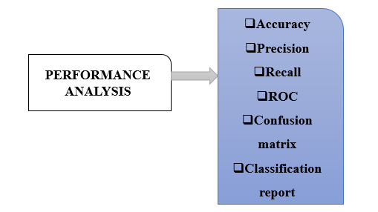

CHAPTER 5
SYSTEM REQUIREMENTS
Software Requirements
- O/S : Windows 10
- Language : Python
- Front End : Spyder
Hardware Requirements
- System : Pentium IV 2.4 GHz
- Hard Disk : 800 GB
- Mouse : Logitech.
- Keyboard : 110 keys enhanced
- Ram : 8GB

Testing of Product
System testing is the stage of implementation, which aimed at ensuring that system works accurately and efficiently before the live operation commence. Testing is the process of executing a program with the intent of finding an error. A good test case is one that has a high probability of finding an error. A successful test is one that answers a yet undiscovered error.
Testing is vital to the success of the system. System testing makes a logical assumption that if all parts of the system are correct, the goal will be successfully achieved. The candidate system is subject to variety of tests-on-line response, Volume Street, recovery and security and usability test. A series of tests are performed before the system is ready for the user acceptance testing. Any engineered product can be tested in one of the following ways. Knowing the specified function that a product has been designed to from, test can be conducted to demonstrate each function is fully operational. Knowing the internal working of a product, tests can be conducted to ensure that “al gears mesh”, that is the internal operation of the product performs according to the specification and all internal components have been adequately exercised.

UNIT TESTING
Unit testing is the testing of each module and the integration of the overall system is done. Unit testing becomes verification efforts on the smallest unit of software design in the module. This is also known as ‘module testing’. The modules of the system are tested separately. This testing is carried out during the programming itself. In this testing step, each model is found to be working satisfactorily as regard to the expected output from the module. There are some validation checks for the fields. For example, the validation check is done for verifying the data given by the user where both format and validity of the data entered is included. It is very easy to find error and debug the system.
INTEGRATION TESTING
Data can be lost across an interface, one module can have an adverse effect on the other sub function, when combined, may not produce the desired major function. Integrated testing is systematic testing that can be done with sample data. The need for the integrated test is to find the overall system performance. There are two types of integration testing. They are:
i) Top-down integration testing.
ii) Bottom-up integration testing.
WHITE BOX TESTING
White Box testing is a test case design method that uses the control structure of the procedural design to drive cases. Using the white box testing methods, we derived test cases that guarantee that all independent paths within a module have been exercised at least once.
BLACK BOX TESTING
- Black box testing is done to find incorrect or missing function
- Interface error
- Errors in external database access
- Performance errors
- Initialization and termination errors
In ‘functional testing’, is performed to validate an application conforms to its specifications of correctly performs all its required functions. So this testing is also called ‘black box testing’. It tests the external behaviour of the system. Here the engineered product can be tested knowing the specified function that a product has been designed to perform, tests can be conducted to demonstrate that each function is fully operational.
VALIDATION TESTING
After the culmination of black box testing, software is completed assembly as a package, interfacing errors have been uncovered and corrected and final series of software validation tests begin validation testing can be defined as many, but a single definition is that validation succeeds when the software functions in a manner that can be reasonably expected by the customer.
USER ACCEPTANCE TESTING
User acceptance of the system is the key factor for the success of the system. The system under consideration is tested for user acceptance by constantly keeping in touch with prospective system at the time of developing changes whenever required.
OUTPUT TESTING
After performing the validation testing, the next step is output asking the user about the format required testing of the proposed system, since no system could be useful if it does not produce the required output in the specific format. The output displayed or generated by the system under consideration. Here the output format is considered in two ways. One is screen and the other is printed format. The output format on the screen is found to be correct as the format was designed in the system phase according to the user needs. For the hard copy also output comes out as the specified requirements by the user. Hence the output testing does not result in any connection in the system.
System Implementation
Implementation of software refers to the final installation of the package in its real environment, to the satisfaction of the intended users and the operation of the system. The people are not sure that the software is meant to make their job easier.
- The active user must be aware of the benefits of using the system
- Their confidence in the software built up
- Proper guidance is impaired to the user so that he is comfortable in using the application
Before going ahead and viewing the system, the user must know that for viewing the result, the server program should be running in the server. If the server object is not running on the server, the actual processes will not take place.

User Training
To achieve the objectives and benefits expected from the proposed system it is essential for the people who will be involved to be confident of their role in the new system. As system becomes more complex, the need for education and training is more and more important. Education is complementary to training. It brings life to formal training by explaining the background to the resources for them. Education involves creating the right atmosphere and motivating user staff. Education information can make training more interesting and more understandable.
Training on the Application Software
After providing the necessary basic training on the computer awareness, the users will have to be trained on the new application software. This will give the underlying philosophy of the use of the new system such as the screen flow, screen design, type of help on the screen, type of errors while entering the data, the corresponding validation check at each entry and the ways to correct the data entered. This training may be different across different user groups and across different levels of hierarchy.
Operational Documentation
Once the implementation plan is decided, it is essential that the user of the system is made familiar and comfortable with the environment. A documentation providing the whole operations of the system is being developed. Useful tips and guidance is given inside the application itself to the user. The system is developed user friendly so that the user can work the system from the tips given in the application itself.

System Maintenance
The maintenance phase of the software cycle is the time in which software performs useful work. After a system is successfully implemented, it should be maintained in a proper manner. System maintenance is an important aspect in the software development life cycle. The need for system maintenance is to make adaptable to the changes in the system environment. There may be social, technical and other environmental changes, which affect a system which is being implemented. Software product enhancements may involve providing new functional capabilities, improving user displays and mode of interaction, upgrading the performance characteristics of the system. So only thru proper system maintenance procedures, the system can be adapted to cope up with these changes. Software maintenance is of course, far more than “finding mistakes”.
Corrective Maintenance
The first maintenance activity occurs because it is unreasonable to assume that software testing will uncover all latent errors in a large software system. During the use of any large program, errors will occur and be reported to the developer. The process that includes the diagnosis and correction of one or more errors is called Corrective Maintenance.

Adaptive Maintenance
The second activity that contributes to a definition of maintenance occurs because of the rapid change that is encountered in every aspect of computing. Therefore Adaptive maintenance termed as an activity that modifies software properly with a changing environment is both necessary & common place.
Perceptive Maintenance
The third activity that may be applied to a definition of maintenance occurs when a software package is successful. As the software is used, recommendations for new capabilities, modifications to existing functions, and general enhancement are received from users. To satisfy requests in this category, Perceptive maintenance is performed. This activity accounts for the majority of all efforts expended on software maintenance.
Preventive Maintenance
The fourth maintenance activity occurs when software is changed to improve future maintainability or reliability, or to provide a better basis for future enhancements. Often called preventive maintenance, this activity is characterized by reverse engineering and re-engineering techniques.
Types of Software Testing
Ad-hoc testing
This type of software testing is very informal and unstructured and can be performed by any stakeholder with no reference to any test case or test design documents. The person performing Ad-hoc testing has a good understanding of the domain and workflows of the application to try to find defects and break the software. Ad-hoc testing is intended to find defects that were not found by existing test cases.
Acceptance Testing
Acceptance testing is a formal type of software testing that is performed by end user when the features have been delivered by developers. The aim of this testing is to check if the software confirms to their business needs and to the requirements provided earlier. Acceptance tests are normally documented at the beginning of the sprint (in agile) and is a means for testers and developers to work towards a common understanding and shared business domain knowledge.
Accessibility Testing
In accessibility testing, the aim of the testing is to determine if the contents of the website can be easily accessed by disable people. Various checks such as colour and contrast (for colour blind people), font size for visually impaired, clear and concise text that is easy to read and understand.
Agile Testing
Agile Testing is a type of software testing that accommodates agile software development approach and practices. In an Agile development environment, testing is an integral part of software development and is done along with coding. Agile testing allows incremental and iterative coding and testing.
API Testing
API testing is a type of testing that is similar to unit testing. Each of the Software APIs are tested as per API specification. API testing is mostly done by testing team unless APIs to be tested or complex and needs extensive coding. API testing requires understanding both API functionality and possessing good coding skills.
Automated testing
This is a testing approach that makes use of testing tools and/or programming to run the test cases using software or custom developed test utilities. Most of the automated tools provided capture and playback facility, however there are tools that require writing extensive scripting or programming to automate test cases.
All Pairs testing
Also known as Pair wise testing, is a black box testing approach and a testing method where in for each input is tested in pairs of inputs, which helps to test software works as expected with all possible input combinations.
Beta Testing
This is a formal type of software testing that is carried out by end customers before releasing or handing over software to end users. Successful completion of Beta testing means customer acceptance of the software.
Black Box testing
Black box testing is a software testing method where in testers are not required to know coding or internal structure of the software. Black box testing method relies on testing software with various inputs and validating results against expected output.
Backward Compatibility Testing
Type of software testing performed to check newer version of the software can work successfully installed over previous version of the software and newer version of the software works as fine with table structure, data structures, files that were created by previous version of the software.
Boundary Value Testing (BVT)
Boundary Value Testing is a testing technique that is based on concept “error aggregates at boundaries”. In this testing technique, testing is done extensively to check for defects at boundary conditions. If a field accepts value 1 to 100 then testing is done for values 0, 1, 2, 99, 100 and 101.
Big Bang Integration testing
This is one of the integration testing approaches, in Big Bang integration testing all or all most all of the modules are developed and then coupled together.
Bottom up Integration testing
Bottom up integration testing is an integration testing approach where in testing starts with smaller pieces or sub systems of the software till all the way up covering entire software system. Bottom up integration testing begins with smaller portion of the software and eventually scale up in terms of size, complexity and completeness.
Branch Testing
Is a white box testing method for designing test cases to test code for every branching condition? Branch testing method is applied during unit testing.
Browser compatibility Testing
It is one of the sub types of testing of compatibility testing performed by testing team. Browser compatibility testing is performed for web applications with combination of different browsers and operating systems.
Compatibility testing
Compatibility testing is one of the test types performed by testing team. Compatibility testing checks if the software can be run on different hardware, operating system, bandwidth, databases, web servers, application servers, hardware peripherals, emulators, different configuration, processor, different browsers and different versions of the browsers etc.
Component Testing
This type of software testing is performed by developers. Component testing is carried out after completing unit testing. Component testing involves testing a group of units as code together as a whole rather than testing individual functions, methods.
Condition Coverage Testing
Condition coverage testing is a testing technique used during unit testing, where in developer tests for all the condition statements like if, if else, case etc., in the code being unit tested.
Dynamic Testing
Testing can be performed as Static Testing and Dynamic testing, Dynamic testing is a testing approach where-in testing can be done only by executing code or software are classified as Dynamic Testing. Unit testing, Functional testing, regression testing, performance testing etc.
Decision Coverage Testing
Is a testing technique that is used in Unit testing, objective of decision coverage testing is to expertise and validate each and every decisions made in the code e.g. if, if else, case statements.
End-to-end Testing
End to end testing is performed by testing team, focus of end to end testing is to test end to end flows e.g. right from order creation till reporting or order creation till item return etc. and checking. End to end testing is usually focused mimicking real life scenarios and usage. End to end testing involves testing information flow across applications.
Exploratory Testing
Exploratory testing is an informal type of testing conducted to learn the software at the same time looking for errors or application behaviour that seems non-obvious. Exploratory testing is usually done by testers but can be done by other stake holders as well like Business Analysts, developers, end users etc. who are interested in learning functions of the software and at the same time looking for errors or behaviour is seems non-obvious.
Equivalence Partitioning
Equivalence partitioning is also known as Equivalence Class Partitioning is a software testing technique and not a type of testing by itself. Equivalence partitioning technique is used in black box and grey box testing types. Equivalence partitioning classifies test data into Equivalence classes as positive Equivalence classes and negative Equivalence classes, such classification ensures both positive and negative conditions are tested.
Functional Testing
Functional testing is a formal type of testing performed by testers. Functional testing focuses on testing software against design document, Use cases and requirements document. Functional testing is a black box type of testing and does not require internal working of the software unlike white box testing.
Fuzz Testing
Fuzz testing or fuzzing is a software testing technique that involves testing with unexpected or random inputs. Software is monitored for failures or error messages that are presented due to the input errors.
GUI (Graphical User Interface) testing
This type of software testing is aimed at testing the software GUI (Graphical User Interface) of the software meets the requirements as mentioned in the GUI mock-ups and Detailed designed documents. For e.g. checking the length and capacity of the input fields provided on the form, type of input field provided, e.g. some of the form fields can be displayed as dropdown box or a set of radio buttons. So GUI testing ensures GUI elements of the software are as per approved GUI mock-ups, detailed design documents and functional requirements. Most of the functional test automation tools work on GUI capture and playback capabilities. This makes script recording faster at the same time increases the effort on script maintenance.
Glass box Testing
Glass box testing is another name for White box testing. Glass box testing is a testing method that involves testing individual statements, functions etc., Unit testing is one of the Glass box testing methods.
Gorilla Testing
This type of software testing is done by software testing team, has a scary name though? Objective of Gorilla Testing is to exercise one or few functionality thoroughly or exhaustively by having multiple people test the same functionality.
Happy Path Testing
Also known as Golden path testing, this type of testing focuses on selective execution of tests that do not exercise the software for negative or error conditions.
Integration Testing
Integration testing also known as met in short, in one of the important types of software testing. Once the individual units or components are tested by developers as working then testing team will run tests that will test the connectivity among these units/component or multiple units/components. There are different approaches for Integration testing namely, Top-down integration testing, Bottom-up integration testing and a combination of these two known as Sand witch testing.
Interface Testing
Software provides support for one or more interfaces like “Graphical user interface”, “Command Line Interface” or “Application programming interface” to interact with its users or other software. Interfaces serves as medium for software to accept input from user and provide result. Approach for interface testing depends on the type of the interface being testing like GUI or API or CLI.
Internationalization Testing
Internationalization testing is a type of testing that is performed by software testing team to check the extent to which software can support Internationalization i.e., usage of different languages, different character sets, double byte characters etc., For e.g.: Gmail, is a web application that is used by people all over work with different languages, single by or multi byte character sets.
Keyword-driven Testing
Keyword driver testing is more of an automated software testing approach than a type of testing itself. Keyword driven testing is known as action driven testing or table driven testing.
Load Testing
Load testing is a type of non-functional testing; load testing is done to check the behaviour of the software under normal and over peak load conditions. Load testing is usually performed using automated testing tools. Load testing intends to find bottlenecks or issues that prevent software from performing as intended at its peak workloads.
Localization Testing
Localization testing a type of software testing performed by software testers, in this type of testing, software is expected to adapt to a particular locale, it should support a particular locale/language in terms of display, accepting input in that particular locale, display, font, date time, currency etc., related to a particular locale. For e.g. many web applications allow choice of locale like English, French, German or Japanese. So once locale is defined or set in the configuration of software, software is expected to work as expected with a set language/locale.
Negative Testing
This type of software testing approach, which calls out the “attitude to break”, these are functional and non-functional tests that are intended to break the software by entering incorrect data like incorrect date, time or string or upload binary file when text files supposed to be upload or enter huge text string for input fields etc. It is also a positive test for an error condition.
Non-functional testing
Software are built to fulfil functional and non-functional requirements, non-functional requirements like performance, usability, localization etc., There are many types of testing like compatibility testing, compliance testing, localization testing, usability testing, volume testing etc., that are carried out for checking non-functional requirements.
Pair Testing
It is a software testing technique that can be done by software testers, developers or Business analysts (BA). As the name suggests, two people are paired together, one to test and other to monitor and record test results. Pair testing can also be performed in combination of tester-developer, tester-business analyst or developer-business analyst combination. Combining testers and developers in pair testing helps to detect defects faster, identify root cause, fix and test the fix.

Performance Testing
It is a type of software testing and part of performance engineering that is performed to check some of the quality attributes of software like Stability, reliability, availability. Performance testing is carried out by performance engineering team. Unlike Functional testing, Performance testing is done to check non-functional requirements. Performance testing checks how well software works in anticipated and peak workloads. There are different variations or sub types of performance like load testing, stress testing, volume testing, soak testing and configuration testing.
Penetration Testing
It is a type of security testing, also known as pen test in short. Penetration testing is done to tests how secure software and its environments (Hardware, Operating system and network) are when subject to attack by an external or internal intruder. Intruder can be a human/hacker or malicious programs. Pen test uses methods to forcibly intrude (by brute force attack) or by using a weakness (vulnerability) to gain access to a software or data or hardware with an intent to expose ways to steal, manipulate or corrupt data, software files or configuration. Penetration Testing is a way of ethical hacking, an experienced Penetration tester will use the same methods and tools that a hacker would use but the intention of Penetration tester is to identify vulnerability and get them fixed before a real hacker or malicious program exploits it.
Regression Testing
It is a type of software testing that is carried out by software testers as functional regression tests and developers as Unit regression tests. Objective of regression tests are to find defects that got introduced to defect fix (is) or introduction of new feature(s). Regression tests are ideal candidate for automation.
Retesting
It is a type of retesting that is carried out by software testers as a part of defect fix verification. For e.g. a tester is verifying a defect fix and let us say that there are 3 test cases failed due to this defect. Once tester verifies defect fix as resolved, test will retest or test the same functionality again by executing the test cases that were failed earlier.
Risk based Testing
It is a type of software testing and a different approach towards testing a software. In Risk based testing, requirements and functionality of software to be tested are prioritized as Critical, High, Medium and low. In this approach, all critical and high priority tests are tested and them followed by Medium. Low priority or low risk functionality are tested at the end or may not base on the time available for testing.
Smoke testing
It is a type of testing that is carried out by software testers to check if the new build provided by development team is stable enough i.e., major functionality is working as expected in order to carry out further or detailed testing. Smoke testing is intended to find “show stopper” defects that can prevent testers from testing the application in detail. Smoke testing carried out for a build is also known as build verification test.
Security Testing
It is a type of software testing carried out by specialized team of software testers. Objective of security testing is to secure the software is to external or internal threats from humans and malicious programs. Security testing basically checks, how good is software’s authorization mechanism, how strong is authentication, how software maintains confidentiality of the data, how does the software maintain integrity of the data, what is the availability of the software in an event of an attack on the software by hackers and malicious programs is for Security testing requires good knowledge of application, technology, networking, security testing tools. With increasing number of web applications necessarily of security testing has increased to a greater extent.
Sanity Testing
It is a type of testing that is carried out mostly by testers and in some projects by developers as well. Sanity testing is a quick evaluation of the software, environment, network, external systems are up & running, software environment as a whole is stable enough to proceed with extensive testing. Sanity tests are narrow and most of the time sanity tests are not documented.
Scalability Testing
It is a non-functional test intended to test one of the software quality attributes i.e. “Scalability”. Scalability test is not focused on just one or few functionality of the software instead performance of software as a whole. Scalability testing is usually done by performance engineering team. Objective of scalability testing is to test the ability of the software to scale up with increased users, increased transactions, increase in database size etc., It is not necessary that software’s performance increases with increase in hardware configuration, scalability tests helps to find out how much more workload the software can support with expanding user base, transactions, data storage etc.,
Stability Testing
It is a non-functional test intended to test one of the software quality attributes i.e. “Stability”. Stability testing focuses on testing how stable software is when it is subject to loads at acceptable levels, peak loads, loads generated in spikes, with more volumes of data to be processed. Scalability testing will involve performing different types of performance tests like load testing, stress testing, spike testing, soak testing, spike testing etc…
Static Testing is a form of testing where in approaches like reviews, walkthroughs are employed to evaluate the correctness of the deliverable. In static testing software code is not executed instead it is reviewed for syntax, commenting, naming convention, size of the functions and methods etc. Static testing usually has check lists against which deliverables are evaluated. Static testing can be applied for requirements, designs, and test cases by using approaches like reviews or walkthroughs.
Stress Testing is a type of performance testing, in which software is subjected to peak loads and even to a break point to observe how the software would behave at breakpoint. Stress testing also tests the behaviour of the software with insufficient resources like CPU, Memory, Network bandwidth, Disk space etc.

CHAPTER 6
CONCLUSION
The AI-powered honeypot system for advanced threat detection and analysis presents an innovative and robust solution for improving network security. By leveraging machine learning algorithms, particularly deep learning techniques like Convolutional Neural Networks (CNN), the system is capable of detecting and classifying various network intrusions with high accuracy. The integration of simulation modules that mimic real-world attacks, such as port scanning and brute force attempts, provides a realistic training ground for the detection system, ensuring that the model is well-equipped to handle live attack scenarios. Moreover, the use of autoencoders for feature extraction reduces the data dimensionality, thereby increasing processing efficiency and reducing noise in the dataset.

However, the effectiveness of the honeypot system also depends on continuous monitoring and updating, especially given the ever-evolving nature of cyber threats. The system has shown significant promise in detecting known and novel attacks, but there is always room for improvement in terms of real-time detection and response time. By continuously adapting the model to emerging threats, the system can evolve to provide an even higher level of security for networks, ultimately contributing to a safer digital ecosystem.

CHAPTER 7
FUTURE ENCHANCEMENT
In the future, one key enhancement for the AI-powered honeypot system would be to implement adaptive learning capabilities. This would allow the system to adjust its detection parameters dynamically based on the evolving nature of cyber-attacks. By integrating reinforcement learning techniques, the system could continuously refine its detection models by learning from real-world attack data, thus becoming more effective over time. Furthermore, integrating the system with other security tools such as Intrusion Prevention Systems (IPS) and Security Information and Event Management (SIEM) platforms could improve its overall threat response time and provide a more comprehensive security framework.

Additionally, enhancing the system's scalability and deployment capabilities is crucial for handling larger, more complex networks. Future versions of the system could incorporate cloud-based architectures and distributed honeypots to scale horizontally, allowing the system to monitor more extensive networks in real-time. Furthermore, improving the system's ability to detect advanced persistent threats (APTs) and zero-day attacks, which often use novel methods to bypass traditional detection systems, will be a critical step in strengthening the overall security posture of the system.

CHAPTER 8
SAMPLE CODE

# honeypot_simulator.py

import socket
import time
import random
from concurrent.futures import ThreadPoolExecutor
import argparse
import logging

# Setup logging
logging.basicConfig(
filename='attack_log.txt',
level=logging.INFO,
format='%(asctime)s - %(levelname)s - %(message)s'
)

class HoneypotSimulator:
def __init__(self, target_ip="127.0.0.1", intensity="medium"):
self.target_ip = target_ip
self.intensity = intensity

self.target_ports = [21, 22, 23, 25, 80, 443, 3306, 5432]

self.intensity_settings = {
"low": {"max_threads": 2, "delay_range": (1, 3)},
"medium": {"max_threads": 5, "delay_range": (0.5, 1.5)},
"high": {"max_threads": 10, "delay_range": (0.1, 0.5)}
}

self.attack_counter = {}
self.blocked_ips = set()
self.BLOCK_THRESHOLD = 10

def log_attack(self, attack_type, port, details=""):
msg = f"[{attack_type}] Attack on port {port}. Details: {details}"
logging.info(msg)
print(msg)

if self.target_ip not in self.attack_counter:
self.attack_counter[self.target_ip] = 0

self.attack_counter[self.target_ip] += 1

if self.attack_counter[self.target_ip] >= self.BLOCK_THRESHOLD:
if self.target_ip not in self.blocked_ips:
self.blocked_ips.add(self.target_ip)
block_msg = f"[BLOCKED] IP {self.target_ip} blocked after excessive activity."
logging.warning(block_msg)
print(block_msg)

def is_blocked(self):
return self.target_ip in self.blocked_ips

def simulate_port_scan(self):
if self.is_blocked():
return
print(f"\n[*] Starting PORT SCAN on {self.target_ip}")
for port in self.target_ports:
self.log_attack("PORT_SCAN", port, "Scanning port")
try:
with socket.socket(socket.AF_INET, socket.SOCK_STREAM) as sock:
sock.settimeout(0.5)
sock.connect((self.target_ip, port))
except:
pass
time.sleep(0.1)

def simulate_brute_force(self, port):
if self.is_blocked():
return
print(f"\n[*] Starting R2L brute force on port {port}")
users = ["admin", "root"]
pwds = ["123456", "password", "toor"]
for u in users:
for p in pwds:
try:
with socket.socket(socket.AF_INET, socket.SOCK_STREAM) as sock:
sock.settimeout(2)
sock.connect((self.target_ip, port))
creds = f"{u}:{p}"
sock.send(creds.encode())
self.log_attack("R2L_ATTACK", port, f"Attempted {creds}")
time.sleep(0.2)
except:
pass

def simulate_url_scan(self):
if self.is_blocked():
return
print(f"\n[*] Simulating URL Scan on port 80")
urls = ["/admin", "/phpmyadmin", "/wp-login.php", "/login", "/.env"]
try:
with socket.socket(socket.AF_INET, socket.SOCK_STREAM) as sock:
sock.settimeout(3)
sock.connect((self.target_ip, 80))
for path in urls:
req = f"GET {path} HTTP/1.1\r\nHost: {self.target_ip}\r\n\r\n"
sock.send(req.encode())
self.log_attack("URL_SCAN", 80, f"Scanned {path}")
time.sleep(0.2)
except:
pass

def simulate_ddos_attack(self):
if self.is_blocked():
return
print(f"\n[*] Simulating DDoS on port 80")
try:
for _ in range(50): # simulate burst
with socket.socket(socket.AF_INET, socket.SOCK_STREAM) as sock:
sock.settimeout(0.2)
sock.connect((self.target_ip, 80))
sock.send(b"GET / HTTP/1.1\r\nHost: test\r\n\r\n")
self.log_attack("DDOS", 80, "Rapid request flood")
except:
pass

def simulate_malware_probe(self):
if self.is_blocked():
return
print(f"\n[*] Simulating Malware Probe on port 21")
try:
with socket.socket(socket.AF_INET, socket.SOCK_STREAM) as sock:
sock.settimeout(2)
sock.connect((self.target_ip, 21))
sock.send(b"USER anonymous\r\n")
sock.recv(1024)
sock.send(b"STOR evil.exe\r\n")
self.log_attack("MALWARE_PROBE", 21, "Attempted to upload malware")
except:
pass

def run_continuous_simulation(self, duration=300):
print(f"\n[*] Running simulation for {duration} seconds at intensity '{self.intensity}'")
end_time = time.time() + duration
max_threads = self.intensity_settings[self.intensity]["max_threads"]
delay_range = self.intensity_settings[self.intensity]["delay_range"]

attack_pool = [
("PORT_SCAN", lambda: self.simulate_port_scan()),
("R2L", lambda: self.simulate_brute_force(22)),
("URL_SCAN", lambda: self.simulate_url_scan()),
("DDOS", lambda: self.simulate_ddos_attack()),
("MALWARE_PROBE", lambda: self.simulate_malware_probe())
]

with ThreadPoolExecutor(max_workers=max_threads) as executor:
while time.time() < end_time:
if self.is_blocked():
print(f"[!] IP {self.target_ip} blocked. Stopping simulation.")
break
_, attack_func = random.choice(attack_pool)
executor.submit(attack_func)
time.sleep(random.uniform(*delay_range))

def main():
parser = argparse.ArgumentParser(description="Honeypot Attack Simulator")
parser.add_argument("--target", default="127.0.0.1", help="Target IP address")
parser.add_argument("--intensity", choices=["low", "medium", "high"], default="medium", help="Intensity")
parser.add_argument("--duration", type=int, default=60, help="Duration in seconds")
args = parser.parse_args()

simulator = HoneypotSimulator(args.target, args.intensity)
try:
simulator.run_continuous_simulation(args.duration)
except KeyboardInterrupt:
print("\n[*] Interrupted by user.")
finally:
print("[*] Simulation complete.")

if __name__ == "__main__":
main()

CHAPTER 9
SAMPLE SCREENSHOT

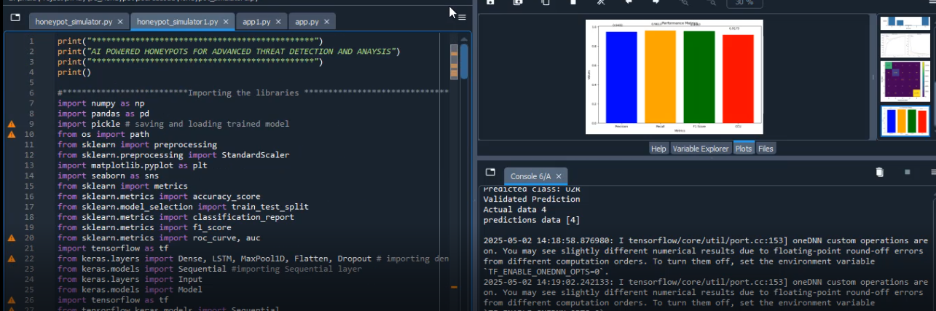

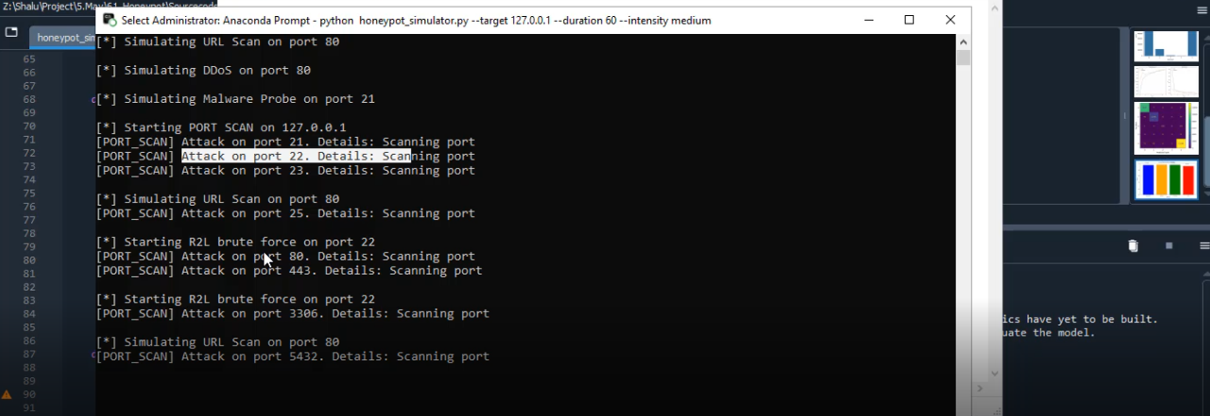

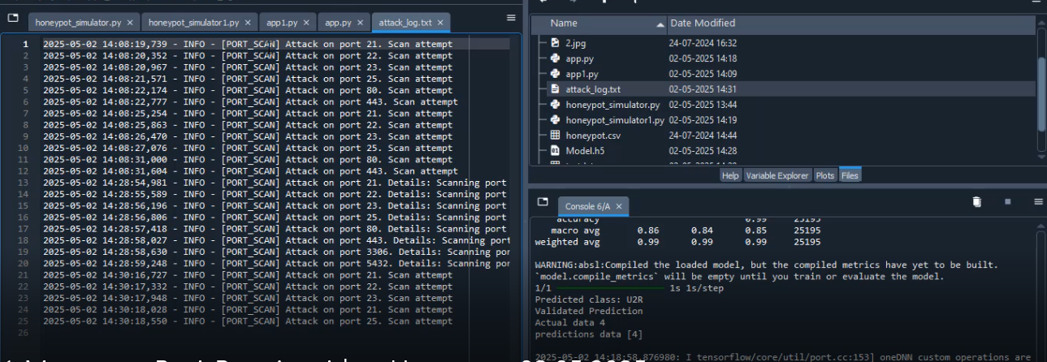

CHAPTER 10
REFERENCE PAPER
- "AI-Driven Intrusion Detection Systems: An Overview and Comparative Study" - 2024
- "Convolutional Neural Networks for Cybersecurity: A Review" - 2024
- "Machine Learning in Honeypot Systems for Intrusion Detection" - 2023
- "A Comprehensive Survey on Honeypots and Security Monitoring" - 2023
- "Deep Learning Techniques for Anomaly Detection in Network Traffic" - 2024
- "Comparative Analysis of Machine Learning Algorithms in Cybersecurity" - 2023
- "Enhanced Cybersecurity with AI-Powered Threat Detection" - 2023
- "Application of Autoencoders for Network Intrusion Detection" - 2023
- "Next-Generation Honeypot Systems for Advanced Threat Detection" - 2023
- "Real-time Network Intrusion Detection Using Deep Learning" - 2024
- "A Survey on Hybrid Models for Intrusion Detection Systems" - 2023
- "Honeypot Systems: Architecture and Future Trends" - 2024
- "Reinforcement Learning for Intrusion Detection and Prevention" - 2023
- "Cloud-based Honeypot Systems for Distributed Intrusion Detection" - 2023
- "A Review of Machine Learning Applications in Intrusion Detection" - 2024
- "AI and Machine Learning for Real-time Threat Detection" - 2023
- "Honeypot Simulation: Creating Realistic Attack Scenarios for Network Defense" - 2023
- "Cybersecurity Attacks and AI-Based Detection: A Comprehensive Overview" - 2024
- "Using CNN for Intrusion Detection in Network Security" - 2023
- "Feature Engineering for Intrusion Detection Using AI" - 2024
- "Machine Learning Approaches for Detection of DDoS Attacks" - 2023
- "A Comparative Study of Supervised and Unsupervised Machine Learning in Intrusion Detection" - 2023
- "AI-based Solutions for Detection of Malware and Zero-Day Attacks" - 2024
- "Dynamic Threat Detection in Honeypot Systems Using Deep Learning" - 2023
- "Hybrid Intrusion Detection Systems Combining Honeypots and Machine Learning" - 2024
- "Security Systems for Emerging Networks: From Honeypots to AI-based Detection" - 2023
- "Deep Reinforcement Learning for Real-Time Intrusion Detection Systems" - 2024
- "Advanced Persistent Threat Detection Using AI-Based Security Systems" - 2024
- "Machine Learning in IoT Security: Intrusion Detection and Prevention" - 2024
- "Artificial Intelligence in Threat Intelligence and Detection Systems" - 2023
- "A New Approach to Intrusion Detection with Deep Neural Networks" - 2024
- "Cybersecurity and Machine Learning: Techniques for Attack Detection" - 2023
- "The Role of Honeypots in Detecting Novel Cyber Threats" - 2023
- "Evaluating the Performance of Honeypots in Modern Network Environments" - 2024
- "AI and Machine Learning for Network Traffic Anomaly Detection" - 2023
- "Edge Computing for Network Security: Honeypots and Real-time Detection" - 2024
- "Exploring the Effectiveness of Autoencoders for Attack Classification" - 2023
- "Leveraging Neural Networks for Cyberattack Detection in Real-Time" - 2024
- "Honeypot Integration with SIEM for Advanced Threat Detection" - 2024
- "Advanced Machine Learning Algorithms for Detection of R2L Attacks" - 2023
- "Cyberattack Classification Using AI-based Network Security Systems" - 2023
- "A Survey on Artificial Intelligence and Its Role in Intrusion Detection" - 2024
- "Securing the Cloud: Honeypots and AI in Distributed Systems" - 2023
- "Leveraging Deep Learning for Enhanced Cybersecurity Solutions" - 2024
- "AI-Enhanced Honeypot Systems for Early Detection of Cyberattacks" - 2023
- "Real-Time Intrusion Detection Using CNNs in Network Security" - 2024
- "An Overview of Hybrid Detection Systems in Network Security" - 2024
- "Improving Intrusion Detection Systems with Transfer Learning" - 2023
- "Cyber Threat Intelligence with AI: Integrating Honeypots and Machine Learning" - 2024
- "Implementing AI Models for Real-time Attack Detection in Honeypots" - 2023

