**SunSaver: Smart Solar Energy Optimization System**

**Abstract :**

**Problem Statement:** The Solar Efficient System aims to overcome the decline in energy production from solar panels due to inadequate maintenance. To achieve this, an automatic system has been designed to optimize solar energy utilization, ensuring sustainability and reliability.

**Idea:** Sunsaver revolutionizes solar energy optimization by ingeniously harnessing the untapped potential of sunlight. The innovative approach centres around strategically deploying Light Dependent Resistors (LDRs) to intricately analyse the sun's direction and intensity. This real-time data is then processed through a cutting-edge algorithm, allowing precise adjustments to the orientation of solar panels for optimal energy absorption. The dynamic responsiveness of Sunsaver is facilitated by a sophisticated servo motor system that seamlessly tracks the sun's movement throughout the day. The output from the solar panel is fed to the battery which gives constant 5V supply that will power the entire tracking system.

**Uniqueness:** Decline energy in solar system is a very familiar and rooted problem over the decades from the beginning of the implementation of the solar system. In most of the cases it is sorted out by single axis tracker but for better effectiveness we introduce dual axis tracker in order to increased efficiency. For the small scale integration the cost will also be very less for implementing the tracker system. This tracking solar panels are mounted in a floating type PVC material which can be installed in Stagnant Water areas ,which also stops evaporation of water bodies and also provide better cooling system which leads to maintain optimum temperature in the solar panel it also increases efficiency .In our prototype we tried to implement a rechargeble lithium ion battery which is charged by the solar panel itself. the 5 volt regulated supply from the battery powers the tracking system

**PROTOTYPE IMAGE:**

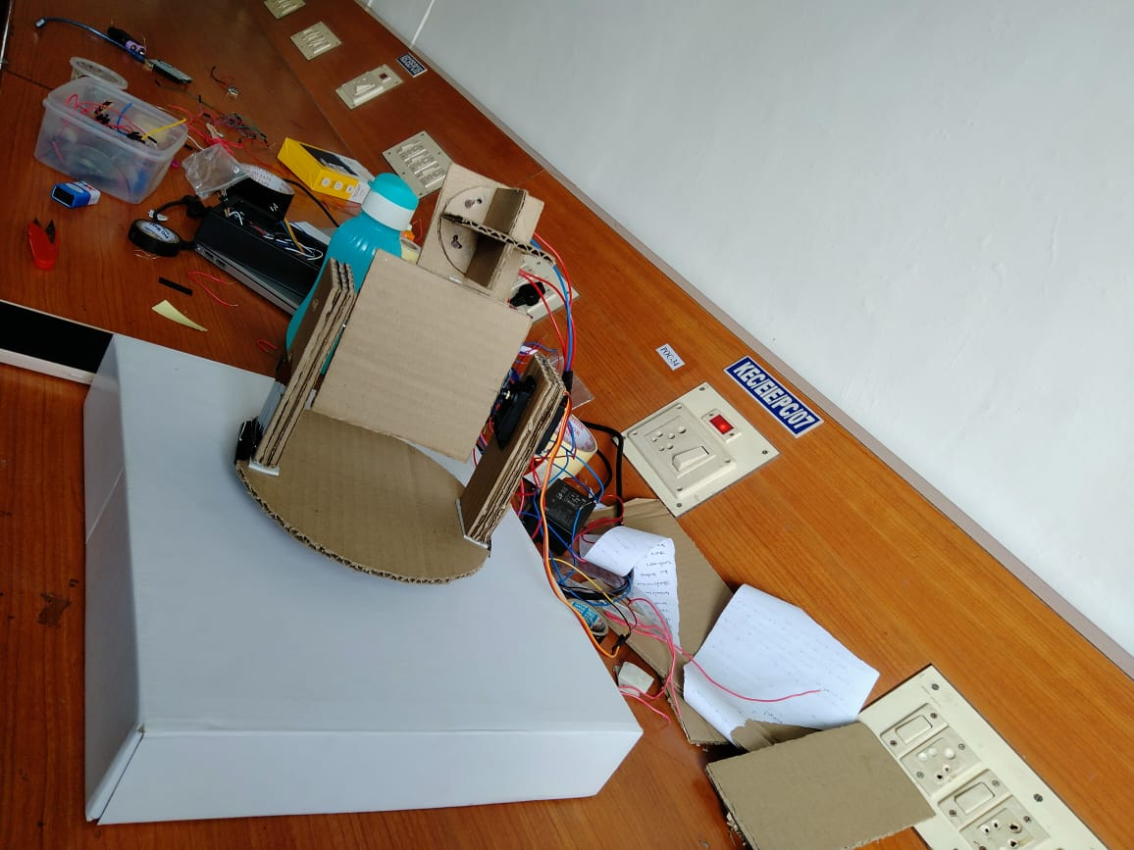

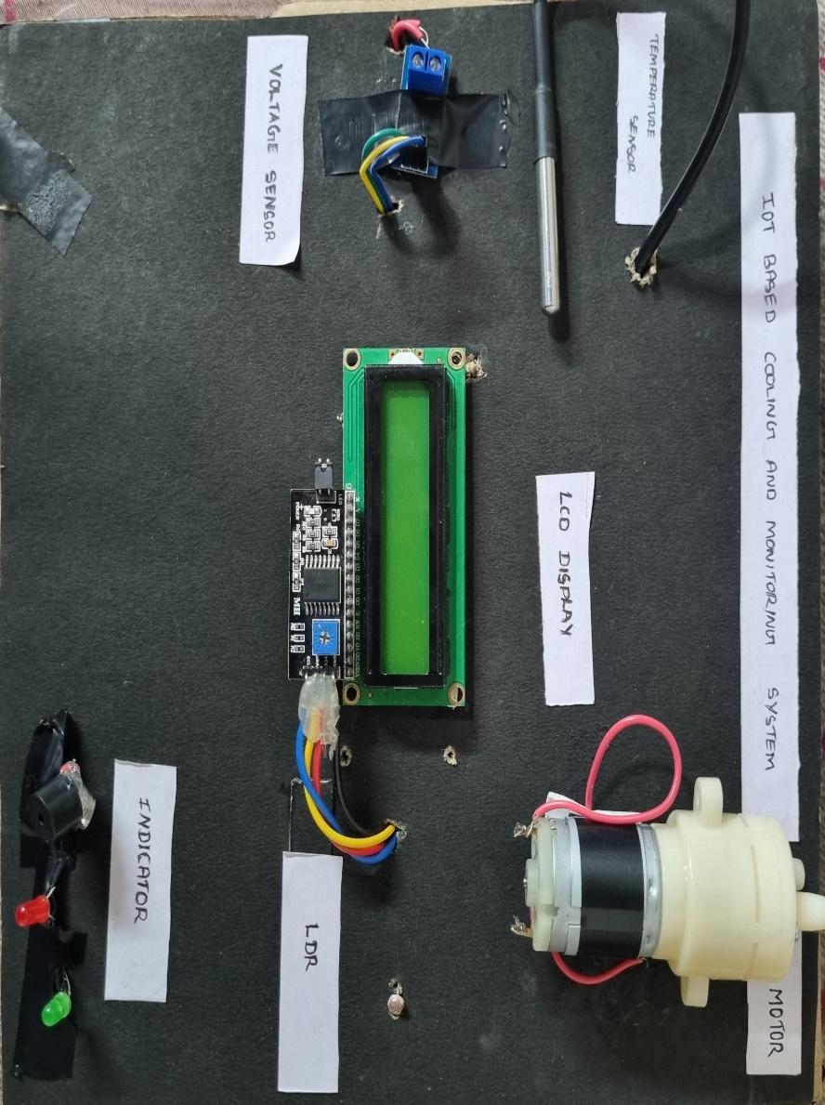

**A PROJECT IDEA SUBMITTED BY**

1. SIVASURIYA K
2. SRUTHI R
3. VISHNUPRIYA B