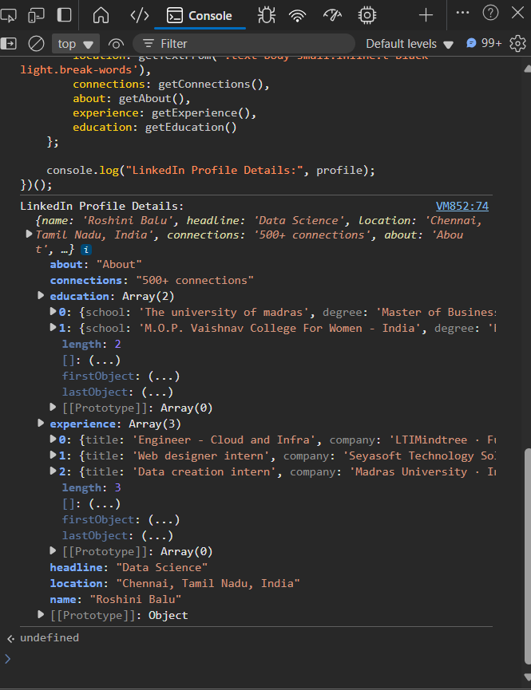

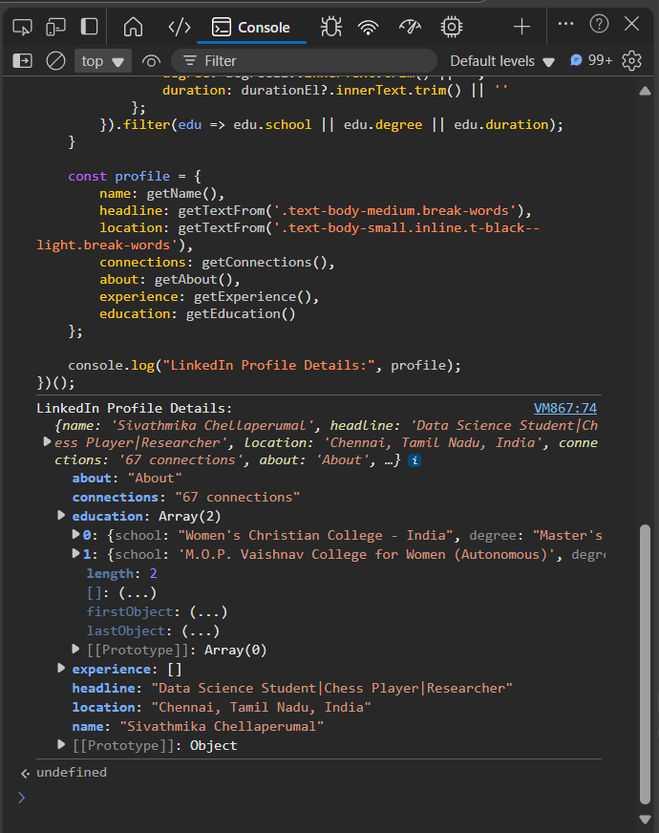

I learned to extract structured data from a LinkedIn profile using JavaScript by targeting specific DOM elements with querySelector. I wrote functions to get details like name, headline, location, about, experience, and education. I handled missing elements gracefully, cleaned the extracted text, and organized the results into a readable object format. This helped me understand real-world web scraping and improved my DOM manipulation and JavaScript logic skills.