**SIVIC Atlas Based MR Spectroscopy Auto Prescription**

**User’s Guide**

1. **License:**

Copyright © 2009-2017 The Regents of the University of California.

All Rights Reserved.

Redistribution and use in source and binary forms, with or without modification, are permitted provided that the following conditions are met:

• Redistributions of source code must retain the above copyright notice, this list of conditions and the following disclaimer.

• Redistributions in binary form must reproduce the above copyright notice, this list of conditions and the following disclaimer in the documentation and/or other materials provided with the distribution.

• None of the names of any campus of the University of California, the name "The Regents of the University of California," or the names of any of its contributors may be used to endorse or promote products derived from this software without specific prior written permission.

THIS SOFTWARE IS PROVIDED BY THE COPYRIGHT HOLDERS AND CONTRIBUTORS "AS IS" AND ANY EXPRESS OR IMPLIED WARRANTIES, INCLUDING, BUT NOT LIMITED TO, THE IMPLIED WARRANTIES OF MERCHANTABILITY AND FITNESS FOR A PARTICULAR PURPOSE ARE DISCLAIMED. IN NO EVENT SHALL THE COPYRIGHT HOLDERS OR CONTRIBUTORS BE LIABLE FOR ANY DIRECT, INDIRECT, INCIDENTAL, SPECIAL, EXEMPLARY, OR CONSEQUENTIAL DAMAGES (INCLUDING, BUT NOT LIMITED TO, PROCUREMENT OF SUBSTITUTE GOODS OR SERVICES; LOSS OF USE, DATA, OR PROFITS; OR BUSINESS INTERRUPTION) HOWEVER CAUSED AND ON ANY THEORY OF LIABILITY, WHETHER IN CONTRACT, STRICT LIABILITY, OR TORT (INCLUDING NEGLIGENCE OR OTHERWISE) ARISING IN ANY WAY OUT OF THE USE OF THIS SOFTWARE, EVEN IF ADVISED OF THE POSSIBILITY OF SUCH DAMAGE.

1. **Contacts:**

[**yan.li@ucsf.edu**](mailto:yan.li@ucsf.edu)

[**jason.crane@ucsf.edu**](mailto:Jason.crane@ucsf.edu)

[**sarah.nelson@ucsf.edu**](mailto:sarah.nelson@ucsf.edu)

1. **Installation:**

* Verify that there is at least 3GB of space in /export/home, e.g:

df -h /export/home

Filesystem Size Used Avail Use% Mounted on

/dev/sda10 147G 38G 102G 27% /export/home

* Download the latest distribution of SIVIC for the GE scanner console, (sivic_GE_console_version_Linux_x86_64.tar.gz) from sourceforge:

<https://sourceforge.net/projects/sivic/files/0.9.55/sivic_GE_console_0.9.55_Linux_x86_64.tar.gz/download>

* Copy the tar file (e.g., sivic_GE_console_0.9.55_Linux_x86_64.tar.gz) to the sdc home directory (/export/home/sdc) on the console
* Untar the contents and create a link

cd /export/home/sdc

tar -xf sivic_GE_console_0.9.55_Linux_x86_64.tar.gz

ln -s sivic_GE_console_0.9.55_Linux_x86_64 svk

* Download the auto prescription package (svk_auto_rx.tar.gz) from sourceforge and copy it to the sdc home directory (/export/home/sdc) on the console
* Untar the package:

cd /export/home/sdc

tar -xf svk_auto_rx.tar.gz

* Add button on console (optional):

Add the following xml element to this file (Note that the button may not appear in the console until scanner gets rebooted):

/export/home/sdc/nuevo/resources/browser/Applications.xml

<application allPatients="false" comments="Post processing application" executable="/export/home/sdc/svk/console/packages/Atlas_Based_Auto_MRSI_Prescription/svk_atlas_auto_mrsi_start" height="-1" icon="default" instances="1" managed_window_desc="default" mode="1" name="SVK Auto MRS RX" order="16" selection="1" tool="n" unmanaged_window_desc="default" width="-1"/>

* Note, the user will need to download FSL and dcm2nii (TODO)

1. **Running the auto Rx package**

* Start the SVK Auto Rx GUI by one of the following two methods:
  + If a button was added to the console, click on that (“SVK Auto MRS RX”)
  + If no button was added, open a terminal window and start from the command line:

cd /export/home/sdc/svk/console/packages/Atlas_Based_Auto_MRSI_Prescription

./svk_atlas_auto_mrsi_start

* When the GUI pops up select a T1 series from the console’s data browser. This is the series the prescription will be aligned to:

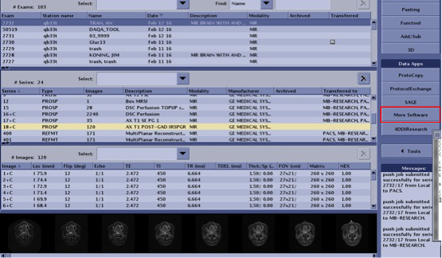

* After the series is highlighted in the console, click on the “OK” button, verify the selected series and click on the “Run” button.

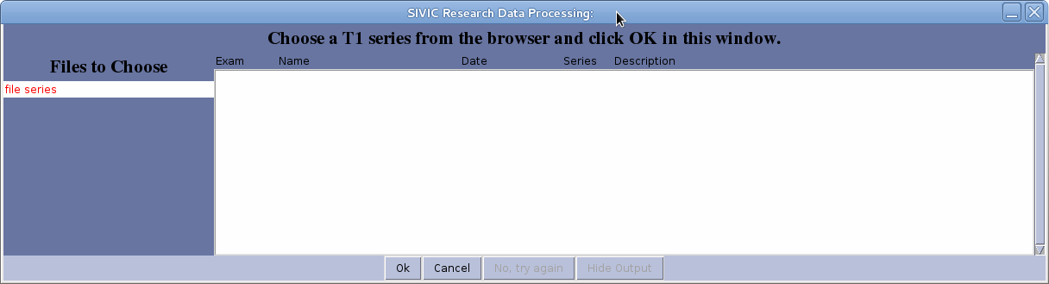

* Select an atlas prescription from the left “Atlas Directory” browser and click “Add”

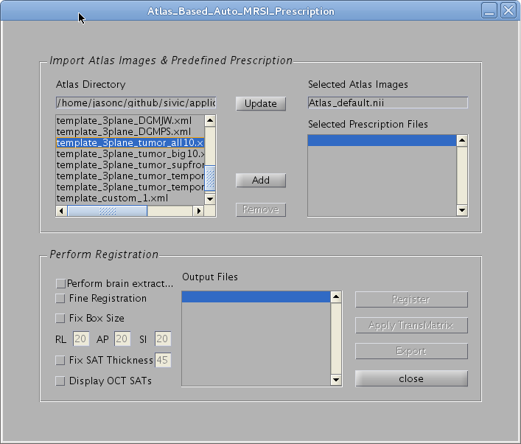

* Click on Register to align the atlas prescription to the patient’s T1.

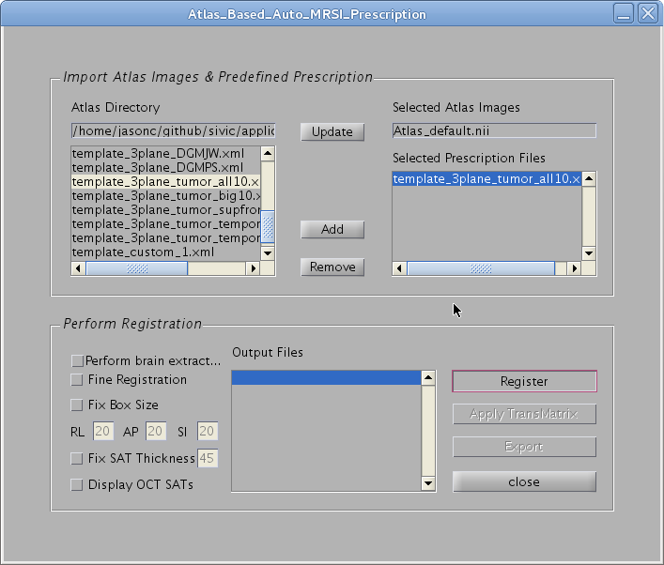

* The patient aligned prescription will be displayed in 3 pop-up windows:

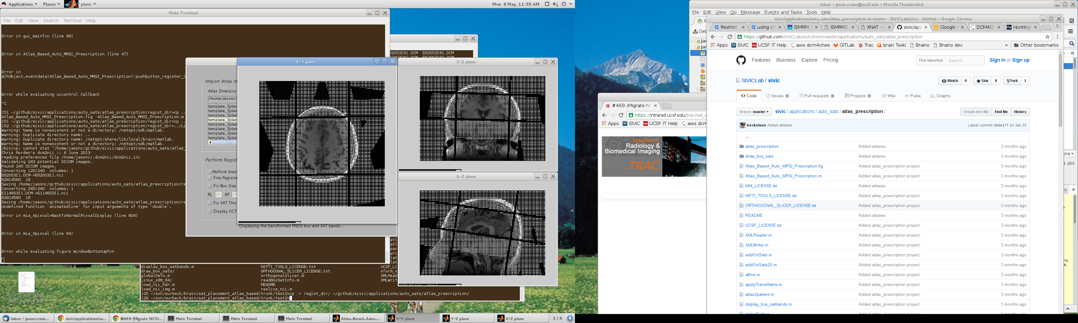

* Output Files:
  + Intermediate processing files are written to a temporary directory:
    - /export/home/sdc/svk/console/data/SCANNER_NAME/
  + Final results are written to /usr/g/research/mrs/
    - transMatrix.dat
    - box_satbands_atlasbased.dat
    - sat_bands.dat
    - press_box.dat

1. **References and Resources:**

Bian, W., Li, Y., Crane, J. C. and Nelson, S. J. (2017), Fully automated atlas-based method for prescribing 3D PRESS MR spectroscopic imaging: Toward robust and reproducible metabolite measurements in human brain. Magn. Reson. Med. doi:10.1002/mrm.26718

Source: <https://github.com/SIVICLab/sivic/tree/master/applications/auto_sats/atlas_prescription>

Sample Prescriptions: <https://github.com/SIVICLab/sivic/tree/master/applications/auto_sats/atlas_prescription/atlas_prescription>