**AK28 ANDROID SMART CONTROLLER USER MANUAL**

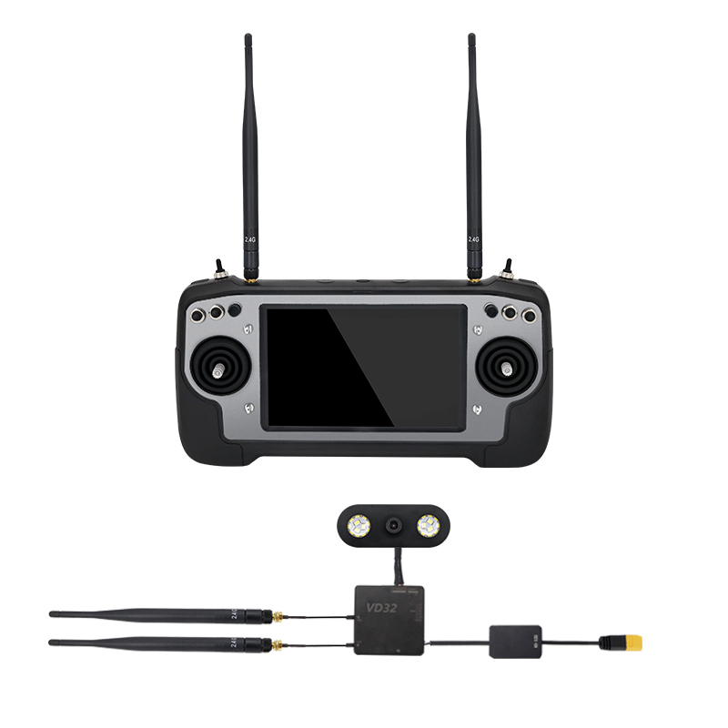

**V1.0**

**Sep 2019**

Thank you for purchasing SIYI Technology’s product.

With iUAV OS, a customized drone operating system powered by Android, AK28 is born to promote UAV application to an easier, more efficient and more stable level. The new controller integrated with long-distance datalink and videolink comes with an HD FPV camera. And it is designed and manufactured with the waterproof and dustproof ability on the industrial level for drone operations in extreme circumstances.

Through digital video transmission, AK28 receives from the drone the real-time FPV and has a capability to deal with the information in the screen display using its powerful operating system, which finally helps pilots control and understand their drones in a good way. AK28 makes itself a perfect combination of UAV remote control and communicating technology on both hardware and software. Moreover, by providing an opening SDK to global users, we believe that AK28's potential can be infinite as their ideas are accomplished on the exciting platform!

To maintain a safe and orderly public space and to ensure you a good using experience of AK28 transmitter, please read this manual carefully. If you have any issue using the product, please consult the manual or check online pages of AK28 on SIYI Technology’s official website (http://www.siyi.biz). You can also inquire our after-sale service coordinator (support@siyi.biz).

**CONTENT**

1 READ TIPS 1

1.1 Icon Definition 1

1.2 Flight Safety 1

1.3 Precautions on Charging AK28 3

1.4 Precautions on Using SD Card 4

1.5 SIM Card Using Manual 5

1.6 Precautions on Storage/Carrying/Recycling 5

2 PRODUCT INTRODUCTION 7

2.1 Product Features 7

2.2 Parts 9

2.2.1 At a Glance 9

2.2.2 Button/Switch Types and the Default Channel Definitions 10

2.3 Technical Specification 12

2.4 Packing List 14

2.5 AK28 Common Diagram 16

2.6 Transmitter LED Indicator Definitions 17

3 GET READY TO USE AK28 18

3.1 How to Place Transmitter Antennas Right 18

3.1.1 Good Antenna Angle of Transmitter 20

3.1.2 Good Antenna Angle of Sky Station 21

3.2 How to Charge AK28 Transmitter 22

3.3 How to Link/Bind AK28 Transmitter to VD32 Sky Station 24

3.4 Throttle Joystick Type 26

4 OPERATING SYSTEM 27

4.1 Tips 27

4.2 Download System Application 27

4.3 How to Import Files and Install System Application 27

5 SIYI TX 29

5.1 Channel Settings 29

5.1.1 End Point 29

5.1.2 Middle Point 30

5.1.3 Channel Reverse 31

5.1.4 Channel Mapping 32

5.2 Datalink Settings 33

5.3 System Settings 34

5.4 Model Settings (One Move to Do Agricultural Drone Settings)* 35

5.5 Fail-safe 36

6 VD32 SKY STATION 38

6.1 At a Glance 38

6.2 Datalink Connection with FC 39

6.3 Datalink Connection with Ground Station 39

6.4 Videolink Module 40

7 Firmware and Voice Upgrading 41

8 After-sale Service 42

10.1 To-be-repair Procedure 42

10.2 After-sale Policy 42

10.1.1 7-Day Return & Refund 42

10.1.2 15-Day Replacement 44

10.1.3 1-Year Warranty Repair 45

# 1 READ TIPS

## 1.1 Icon Definition

Please pay more attention to content indicated with the following marks:

**DANGER** Dangerous manipulation probably leads to human injuries.

**WARNING** Warnings on manipulation possibly leads to human injuries.

**CAUTION** Cautions on what manipulation may lead to property loss.

**C:\Users\drake\Desktop\说明书\警示2.jpgC:\Users\drake\Desktop\说明书\警示3.jpgProhibited Mandatory Mark**

## 1.2 Flight Safety

AK28 Android Smart Controller is designed for professional application in specific industries, users who a.pproaches to the device should have at least the basic ability to manipulate it. Any irregular or irresponsible manipulations of the device may cause damages and lead to property loss or human injuries. Non-adult users must follow their trainer’s guidance or the supervision of any adult. Disassembling or modification on the AK28 transmitter is prohibited without the permission from SIYI Technology.

To maintain a safe and orderly public space and to ensure you a good using experience of SIYI’s products, please read the prohibited and mandatory terms carefully:

**C:\Users\drake\Desktop\说明书\警示2.jpg** Do not use AK28 transmitter to control an aircraft in places of intensive crowd (squares, parks), places of many obstructions (streets, parking lots), fields of strong magnetic or interference (power/radar stations, railways) or any other fields that may cause property loss or human injuries.

**C:\Users\drake\Desktop\说明书\警示2.jpg**Do not hold or cover transmitter antenna or obstruct transmission by any mean in a flight.

**C:\Users\drake\Desktop\说明书\警示2.jpg** Do not point directly to your aircraft with the sky station antennas’ upper end in a flight.

**C:\Users\drake\Desktop\说明书\警示2.jpg** Do not fly an aircraft when you are tired, drunk, sickness or in any occasion without a good feeling.

**C:\Users\drake\Desktop\说明书\警示2.jpg** Do not fly an aircraft when it is rainy, windy or at night.

**C:\Users\drake\Desktop\说明书\警示2.jpg**Do not power off the transmitter in a flight while the aircraft engine and motors are still working.

**C:\Users\drake\Desktop\说明书\警示3.jpg** Keep the aircraft within sight range in a flight.

**C:\Users\drake\Desktop\说明书\警示3.jpg**Make sure AK28 transmitter’s screen menu is back to system menu before taking off a flight, in case of any accident caused by mistouching to system settings.

**C:\Users\drake\Desktop\说明书\警示3.jpg**Do not forget to check both battery levels of the transmitter and the sky station before flying an aircraft.

B**C:\Users\drake\Desktop\说明书\警示3.jpg**efore finishing flight, power off the aircraft first, then the transmitter.

**C:\Users\drake\Desktop\说明书\警示3.jpg**Before doing any setting or adjustment to the transmitter, make sure the aircraft engine is powered off and motor wires are off connection, in case of an accidental power-on.

**C:\Users\drake\Desktop\说明书\警示3.jpg**Before fly an aircraft for the first time, make sure that the fail-safe function in your AK28 transmitter is activated.

**C:\Users\drake\Desktop\说明书\警示3.jpg**Before fly an aircraft for the first time, power on the transmitter first and hold the throttle joystick at its bottom position, then power on the aircraft.

## 1.3 Precautions on Charging AK28

AK28 transmitter is equipped with a replaceable and chargeable LiPo battery and a standard 5V/2A output charger adapter in market.

**C:\Users\drake\Desktop\说明书\警示2.jpg** Do not use any USB chargers over 5V output to charge AK28 transmitter.

**C:\Users\drake\Desktop\说明书\警示2.jpg** For the best charging experience, please make sure AK28 transmitter is powered off before charging. And the charging current should not exceed 2A.

**C:\Users\drake\Desktop\说明书\警示2.jpg** Stop charging if you find the charger is damaged, broken or overheat.

**C:\Users\drake\Desktop\说明书\警示2.jpg** Stop charging if there was a peculiar smell, some smoke or leaks. In such cases you shall sent the transmitter back to SIYI Tech for detection and testing.

**C:\Users\drake\Desktop\说明书\警示2.jpg**Do not charge AK28 transmitter when the environment temperature or the battery temperature is over 60℃.

**DANGER**

Keep AK28 transmitter away from any places that a baby or a kid may reach while you are charging it, and it could be better to have supervision from an adult in case of accidents.

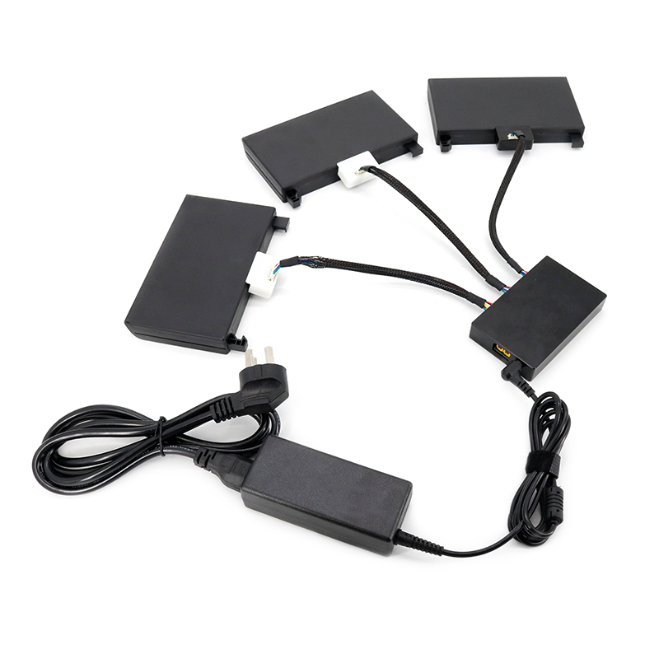

You can also have spare batteries for AK28 transmitter and charge up to three AK28 batteries through a professional battery charging hub designed and manufactured by SIYI.

The spare batteries and the battery charging hub are sold separately.

## 1.4 Precautions on Using SD Card

**C:\Users\drake\Desktop\说明书\警示2.jpg**Do not disassemble, bend, press, abandon or damage SD card by any means.

**C:\Users\drake\Desktop\说明书\警示2.jpg** Stop using the SD card if you find it soaked by water, oil or any other chemical liquid.

**CAUTION**

A SD card is also an electronic product, keep it away from static electricity.

Keep the Micro-SD card slot clean in case of blocking by sand or dirt.

Keep the SD card in slot while you are downloading or uploading data; taking out it mistakenly, hitting it or shattering it may cause damage or data loss.

Keep the SD card away from places that a baby or a kid may reach in case that it was swallowed mistakenly by the baby/kid.

## 1.5 How to Use SIM Card on AK28

Coming soon

## 1.6 Precautions on Storage/Carrying/Recycling

**CAUTION**

For storage, please keep AK28 transmitter away from any places that babies or kids may reach.

**DANGER**

For storage, please keep AK28 transmitter away from such places below:

Places are extremely hot (above 60℃) or cold (under -20℃);

Places under direct sunshine or too dusty or wet;

Places with an unstable supporting structure or may cause vibration;

Places near steam or other heat sources.

# 2 PRODUCT INTRODUCTION

## 2.1 Product Features

**iUAV OS Customized Operating System**

Powered by Android, iUAV OS is an improved operating system with deep learning to drone users' requirement and habits, which provides a stable, convenient and efficient user experience. AK28 will share its SDK secondary development, and it has many hardware extending ports for infinite possibilities to explore more features in new application scenes

**Digital Video Transmission**

Integrated with digital video transmission system, AK28 can display real-time video information in front of your drone in order to ensure your drone flight with more efficiency and security.

*Compatible with all flight controllers on the market

*The FPV display floating window can be zoomed in or out

*Effective videolink range for agricultural drones: 2 km (height at 3 meters)

**Industry-level Protection**

Considering the complicated working conditions of agricultural drones outdoors, the completely waterproof and dustproof process has been done to key connectors on AK28 operating panel, such as the shell, the switches, external ports, etc. With this process, the controller and its system can still work in smooth and stable performance despite how bad the environment could be.

**Dual Navigation Lights**

Drone operations at night are safer than ever with VD32’s navigation lights of 8W consumption and 120-degree searching angle.

**High Brightness LCD Screen**

Under direct sunlight, you can still have a clear view of real-time information display due to AK28's 7" high brightness and high definition LCD screen.

**Replaceable High Capacity LiPo Battery**

AK28 uses the same high capacity lipo battery for top-class smartphone brands. The battery features low internal resistance, long working time for 10 hours, and an excellent power curve for the operating system. These are the exactly cool features which most drone flight requires, especially the long flights.

**The Pursuit of Perfect Industrial Design**

**A Product with Quality and Dignity**

AK28 is not only hardware with an open system, but also a carrier of various tastes and free branding. Metallic operating panel with various choices of color can be perfectly compatible with your drone design, and laser logo helps you market your own brand easily.

## 2.2 Parts

### 2.2.1 At a Glance

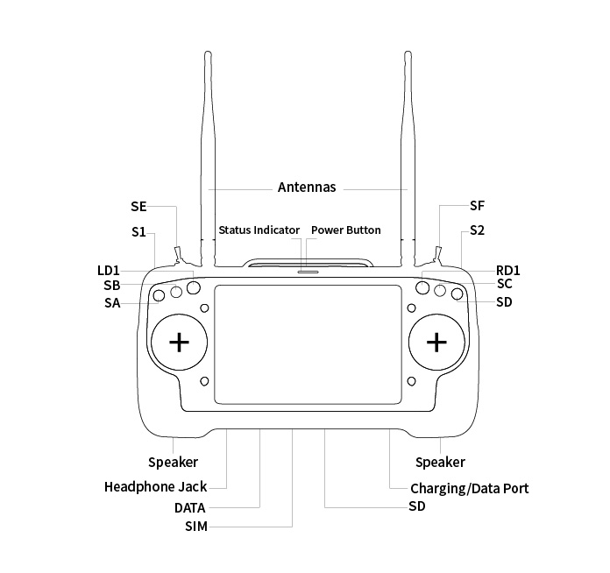

Mark: Press and hold the power button three seconds to power on AK28 transmitter.

### 2.2.2 Button/Switch Types and the Default Channel Definitions

AK28 transmitter has 14 channels in total. Each channel is controlled by an independent switch or button. Please refer to the form below for the default channel definitions from channel 1 to 14.

|  |  |  |  |
| --- | --- | --- | --- |
| **Channel No.** | **Joysticks / Buttons / Switches** | **Default Definition:**  **Mode 2**  **JIYI FC** | **Default Definition:**  **Mode 2**  **BOYING FC** |
| 1 | Joystick J1 | Aileron | Aileron |
| 2 | Joystick J2 | Elevator (Reversed) | Elevator (Reversed) |
| 3 | Joystick J3 | Throttle | Throttle |
| 4 | Joystick J4 | Rudder | Rudder |
| 5 | 3-stage Switch SA | Flight Mode  High: Attitude  Middle: GPS  Low: Execute AB  (Reversed) | Flight Mode  High: Hold Altitude  Middle: GPS  Low: Auto Flight  (Reversed) |
| 6 | Self-Locking Button S2 | Return to Home, Break Point  High: Off  Middle: Break Spraying  Low: Return to Home  (Reversed) | Pump  Press: On/Off  (Reversed) |
| 7 | Self-Locking Button S1 | Pump  High: Off  Middle: Linkage  Low: Manual  (Reversed) | Return to Home  Press: On/Off |
| 8 | 3-stage Switch SB | A/B Point  High: Off  Middle: Record A  Low: Record B  (Reversed) | A/B Point, Break Point  High: Record B  Middle: Break / Clear A/B  Low: Record A  (Reversed) |

Mark: Self-locking button stays in the position you press them to; Self-resetting button rebound to original position after a press.

Mark: AK28 transmitter supports customize channel definitions as well. Please refer to the chapter “SIYI TX APP” in this manual for detail.

### 2.2.3 Ports on AK28

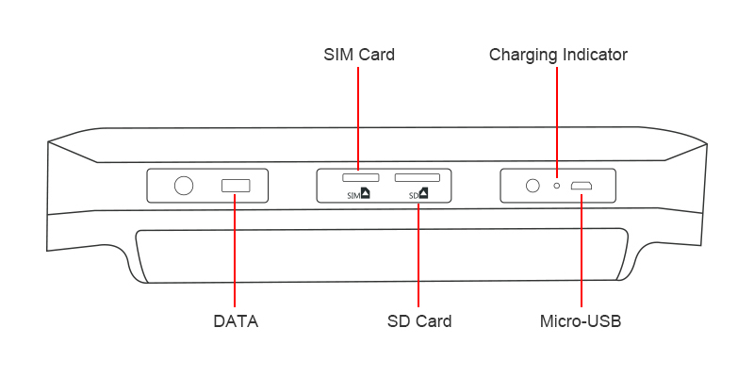

**Port Funciton**

DATA: Upgrading transmitter firmware.

SIM Card: Insert your SIM card to use cellular network.

SD Card: Insert your SD card to read and storage files.

Charging Indicator: Check charging status of your transmitter.

Micro-USB: Charging, file transferring, upgrade Android system.

## 2.3 Technical Specification

**Overall**

|  |  |
| --- | --- |
| **Channels** | 14 Channels |
| **Applicable Model** | Planes / Helicopters / Gliders / Quadcopters / Multi-rotors / Vehicles / Boats / Robots |
| **Compatible FC** | Open Source Flight Controllers: PIX/APM, etc.  BOYING PALADIN V2  TOPXGUN T1-A  WOOZOOM THEONE-A  EFY FINIX200M  JIYI K3A/K++  CFUAS C1-A |
| **Joystick Resolution** | 4096 grades |
| **Frequency Band** | 2400 MHz – 2483 MHz |
| **Transmitting Power** | 100 mW (20 dBm) E.I.R.P |
| **Spreading Method** | FHSS |
| **Receiving Sensibility** | -101 dBm |
| **Control Range** | 4 km / 2.5 miles (unobstructed, free of interference)  2 km (ground to ground) |
| **Video Resolution** | 480p @ 25fps |
| **PC Software** | SIYI Assistant v1.2.0 |
| **Battery Type & Watt Hour** | Replaceable and Chargeable 3.7V 12690mAh Li-Po 1S Battery  47 Wh |
| **Duration** | 10 hours |
| **Working Current** | Transmitter: 200 mA  Receiver: 80 mA  Idle: 60 mA |
| **Charging Port Type** | Micro-USB |
| **Wireless Type & Function** | 2.4G ISM (radiolink/datalink/videolink)  Bluetooth (datalink communication)  WIFI (internet) |
| **Packing Size** | 37x27x18 cm |
| **Packing Weight** | 2.7 kg (3.5kg by volume) |

**Ground Station (Transmitter)**

|  |  |
| --- | --- |
| **Operating System** | Android 7.0  2G RAM & 16G ROM |
| **Screen Display & Resolution** | 7 inch High Brightness LCD Screen  Display Resolution: 1280x800 |
| **Battery Type**  **& Watt Hour** | Replaceable & Chargeable 3.7V 12690mAh Li-Po 1S Battery; 47 Wh |
| **Duration** | 10 hours |
| **Battery Working Temperature** | 0 ~ 55 (℃) |
| **Charging Port Type** | Micro-USB; 5V/2A |
| **Charging Time** | About 9 hours (through Micro-USB)  5 hours (3 batteries through charging hub) |
| **Dimensions** | 308 x 148 x 72 mm (antennas folded) |
| **Net Weight** | 1100 g |

**Sky Station (Receiver)**

|  |  |
| --- | --- |
| **Signal Output** | 14 channels of SBUS, 5 channels of PWM |
| **Datalink Ports (to FC)** | UART, CAN (optional) |
| **Antenna Gain** | 5 dBi |
| **Working Voltage** | 15 – 50V |
| **Telemetry Voltage** | 15 – 50V |
| **Operating Temperature** | -10 to 55 (℃) |
| **Dimensions** | 59 x 59 x 16 mm (without antenna) |
| **Net Weight** | 50g (without antenna) |

**FPV Camera & Navigation Lights**

|  |  |
| --- | --- |
| **Camera Angle** | FOV 120° |
| **Power Consumption (Navigation Lights)** | 8 W |
| **Luminous Flux** | 120-140 lm/W |
| **LED Type** | Translucent |
| **LED Searching Angle** | 120° |
| **Operating Temperature** | -10 to 55 (℃) |
| **Dimensions** | 106 x 25 x 41 mm |
| **Net Weight** | 108 g |

## 2.4 Packing List

1 x AK28 Transmitter

1 x VD32 Sky Station

1 x FPV Camera with Dual Navigation Lights

1 x 4-pin Data Cable / Flight Controller Cable

1 x OTG Micro-USB Cable

1 x USB Charger (5V/2A)

1 x Anti-vibration Kit

1 x Upgrading Tool

1 x Strap Belt

1 x Storage Case

## 2.5 AK28 Common Diagram

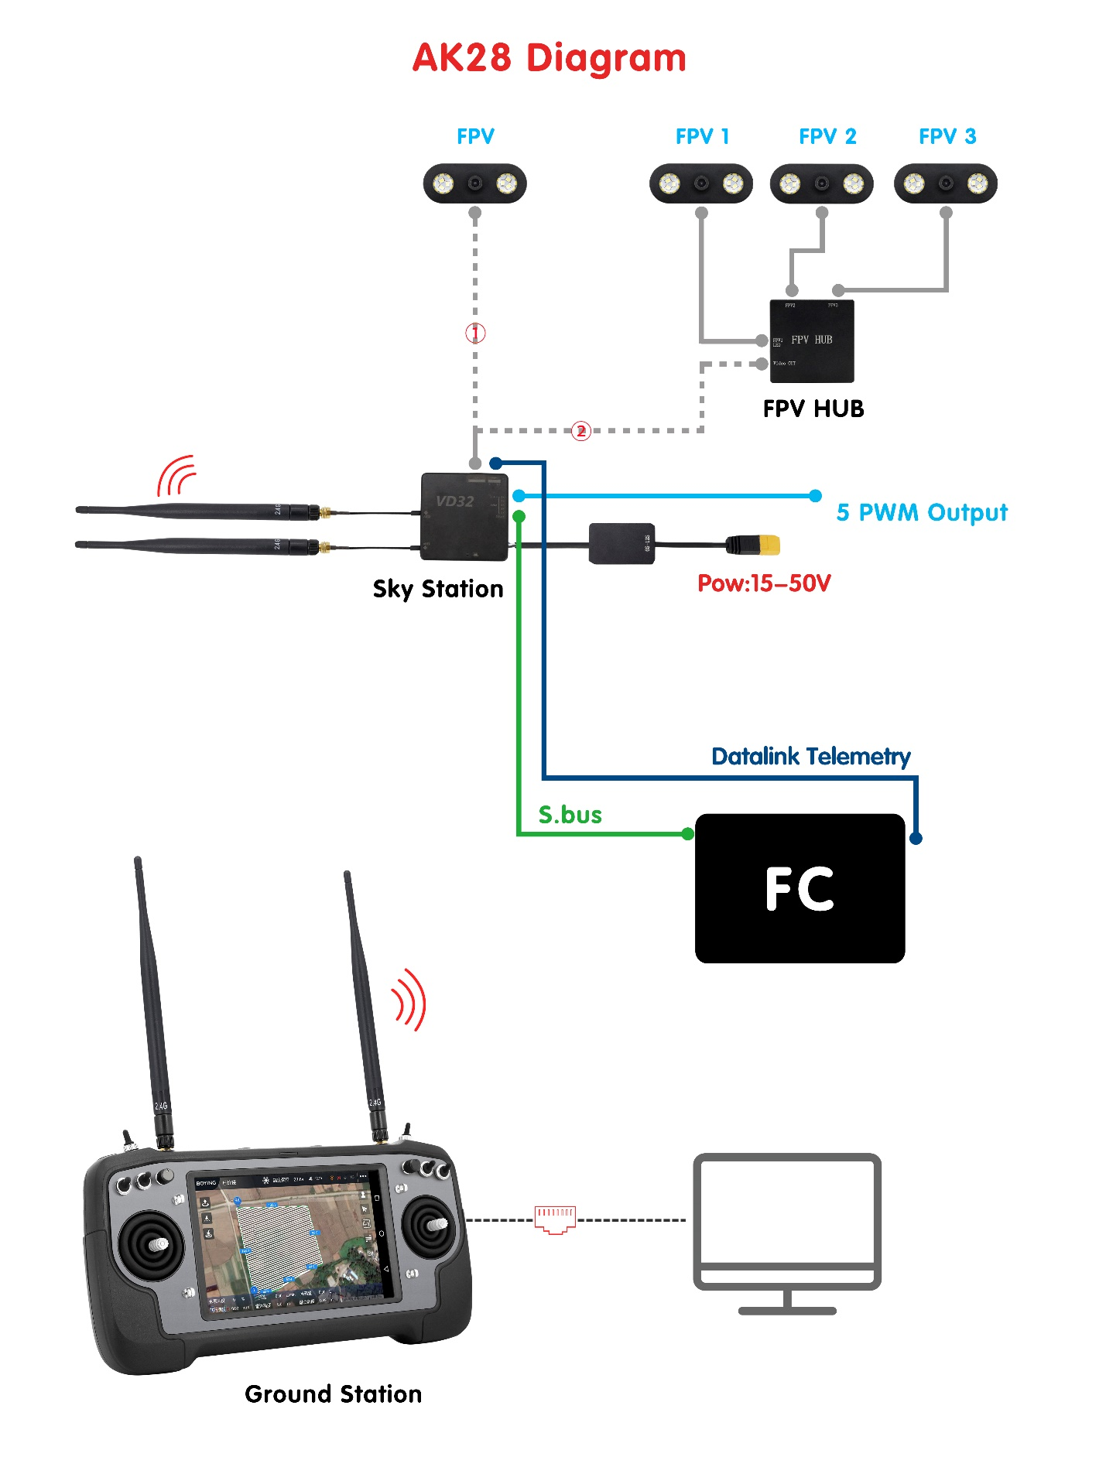

## 2.6 Transmitter LED Indicator Definitions

The LED indicator on top of the touchscreen has three colors and different frequencies to indicate AK28 transmitter’s different working status.

 Solid Green: Good communication.

 Green Blinks: Blinking frequency indicates AK28 transmitter’s RF signal strength. The faster it blinks, the worse the signal is.

 Slow Red Blinks: Transmitter firmware does not match.

 Fast Red Blinks: Transmitter is linking/binding with receiver.

 Triple Red Blinks: RF initialization failed.

 Four Red Blinks: Joysticks require calibration.

 Solid Yellow: No communication between transmitter and receiver.

 Triple Yellow Blinks: Video transmission abnormal.

 Yellow Blinks: System voltage abnormal.

   Fast Red-Green-Yellow Blinks: Upgrading mode.

   Red-Green-Yellow Blinks in every 5 seconds: Receiver under wireless upgrading.

# 3 GET READY TO USE AK28

## 3.1 How to Place Transmitter Antennas Right

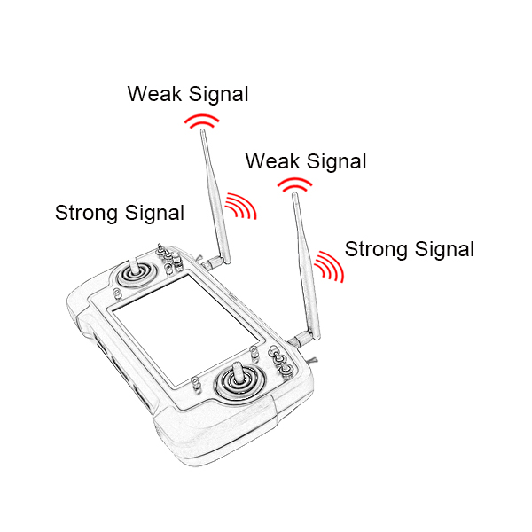

**A**

Mark: AK28 transmitter has the best signal strength when the antennas are placed horizontally (A, B). Thus, please avoid pointing antennas’ upper end straightly to your aircraft and do not fold the antennas (C).

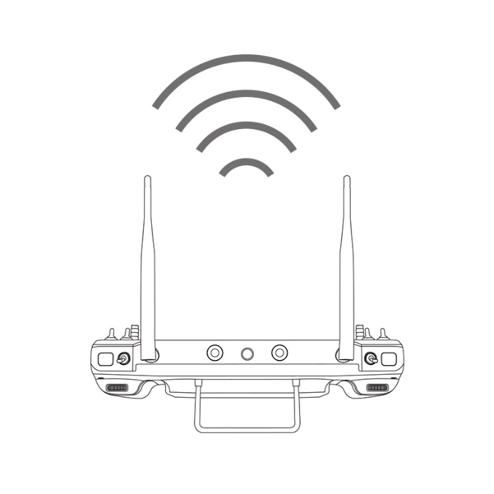

**B**

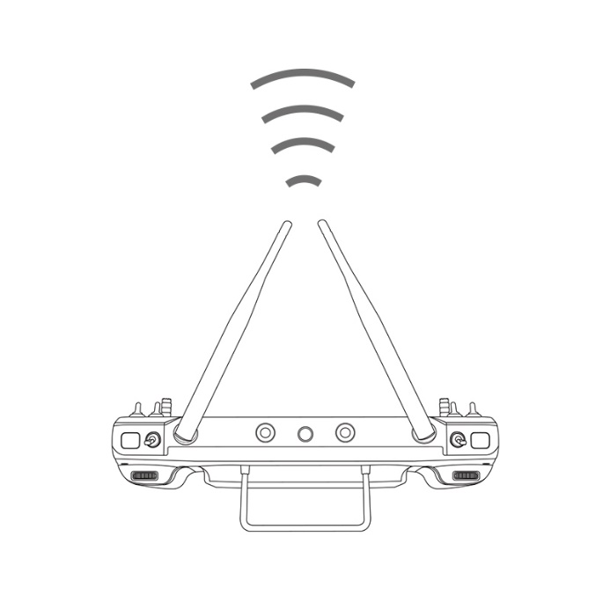

**C**

### 3.1.1 Good Antenna Angle of Transmitter

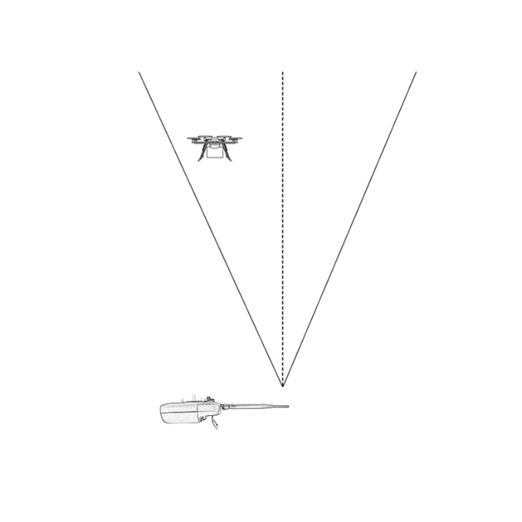

**Aircraft in front of the transmitter**

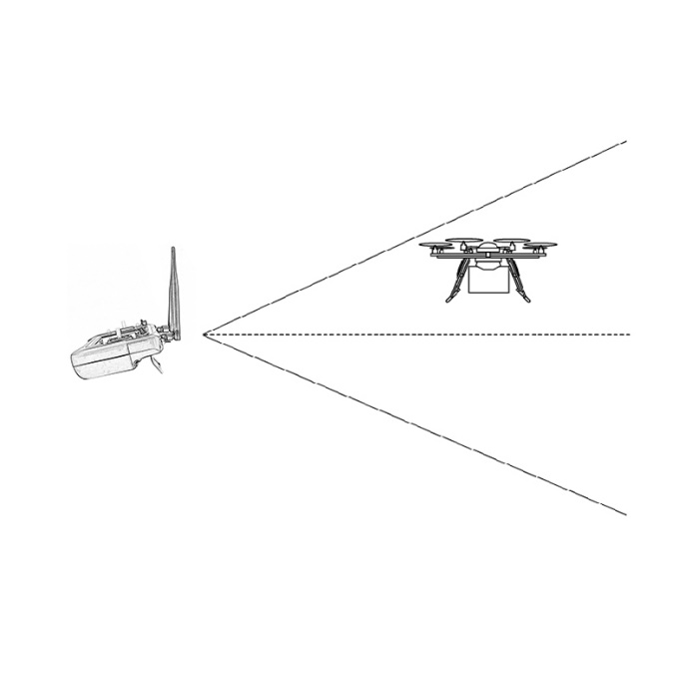

**Aircraft up from the transmitter**

### 3.1.2 Good Antenna Angle of Sky Station

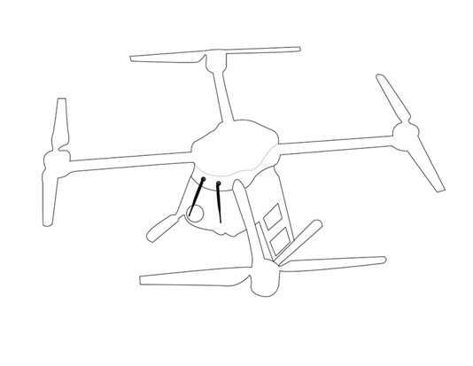

**Flying high**

(Altitude higher than 10 meters, antennas should be placed downwards)

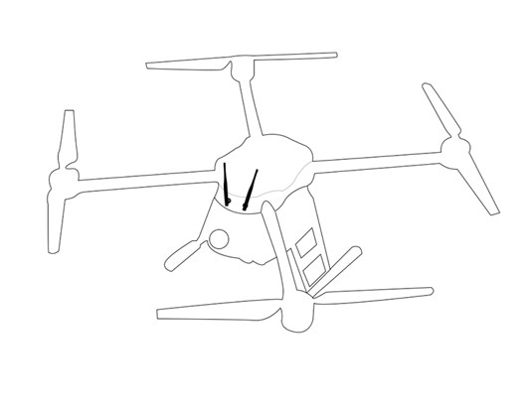

**Flying low**

(Altitude lower than 10 meters, antennas should be placed upwards)

**WARNING**

Do not fold or cover antennas and avoid any obstruction between the transmitter and the aircraft in flight, otherwise there will be an obvious decrease to transmission signal quality.

## 3.2 How to Charge AK28 Transmitter

Before charging your AK28 transmitter, please read the part “1 READ TIPS - 1.3 Precautions on Charging AK28 Transmitter” carefully.

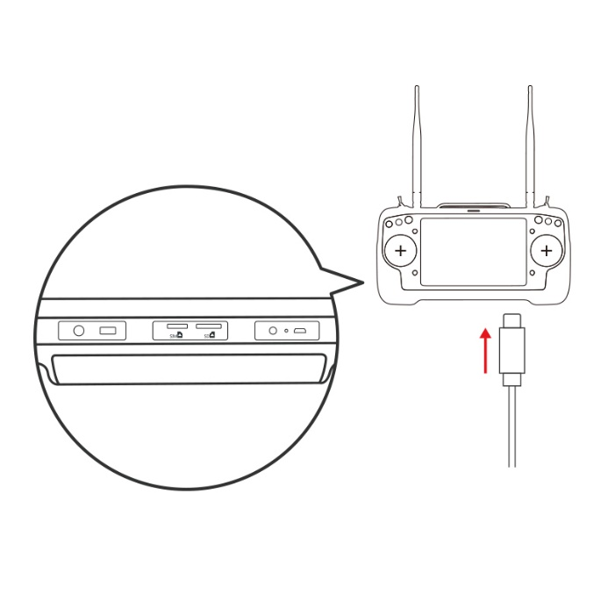

**Transmitter Power Off Charging**

Please use the original OTG Micro-USB cable coming in AK28 packing list for connecting the Micro-USB port on bottom transmitter to the USB port on the charger adapter. When the charging indicator is solid red, transmitter is under charging. When the charging indicator turns to solid green, charging is finished.

**Transmitter Power On Charging**

AK28 system pops “USB inserted, please confirm before disconnecting datalink/videolink function and switching to charging or file transferring function”. Then click “Yes”.

Mark: Please make sure that the charging current is less than 2A or it may cause damage to battery.

Mark: AK28 transmitter is equipped with a replaceable 12690mAh LiPo 1S battery. Charging time is about 10 hours using a standard 5V/2A charger adapter. Charging time may change according to chargers with different standard, please also pay an attention to the transmitter charging indicator when you are charging AK28 transmitter.

**Charging Indicator Definition**

**Power Off Charging**

 Solid Red: Transmitter is under charging.

 Solid Green: Charging is finished.

**Power on Charging**

 Solid Yellow: Transmitter is under charging.

 Solid Green: Charging is finished.

## 3.3 How to Link/Bind AK28 Transmitter to VD32 Sky Station

Each unit of AK28 transmitter is assigned with a unique ID code. Before linking VD32 sky station to AK28 transmitter, the sky station identifies transmitter ID (***Linking/Binding***) first. When the first linking process between AK28 transmitter and VD32 sky station is done, the transmitter ID code will be memorized by the sky station so that you don’t have to repeat the process before next fight (except when your transmitter has to be linked with a different sky station).

**Linking/Binding Steps**

1. Please keep your AK28 transmitter about one meter away from your VD32 sky station and power on the transmitter;
2. In AK28 screen menu, open “SIYI TX” and tap on “System Settings”;

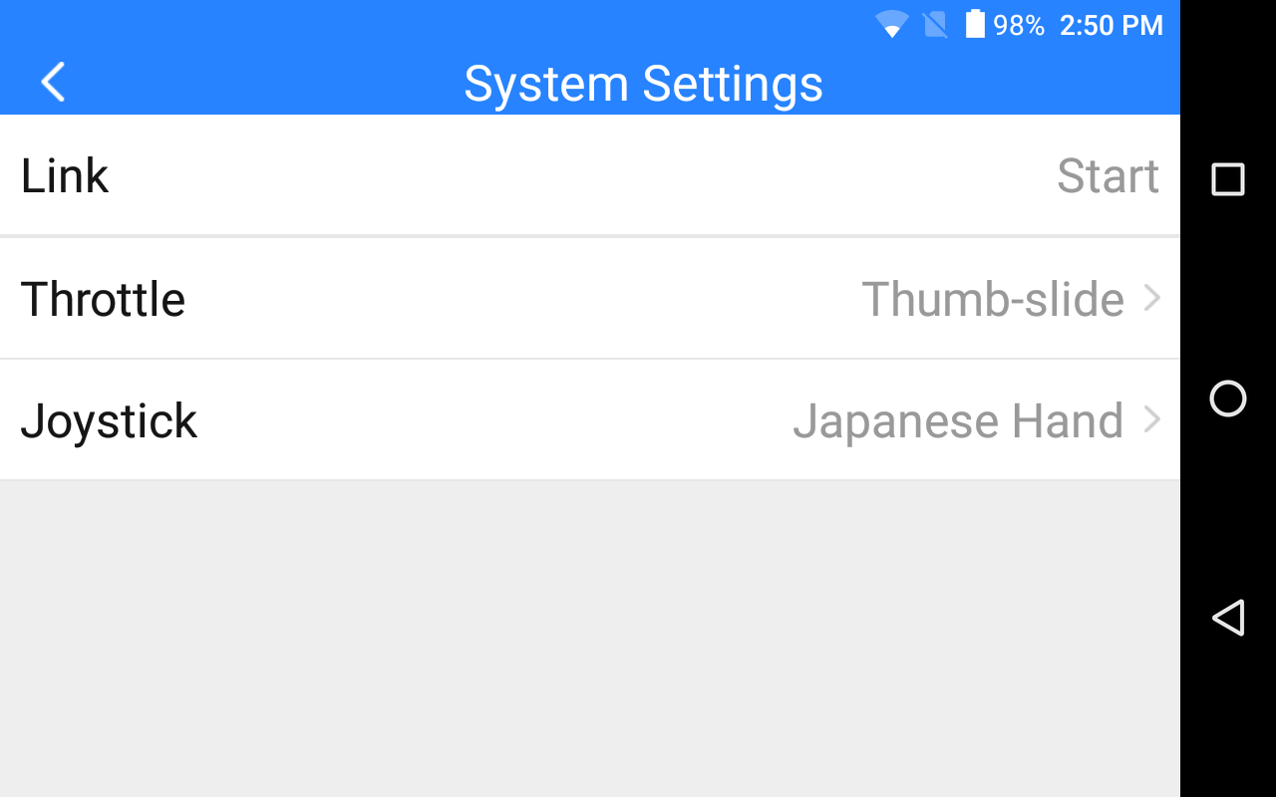

1. On your VD32 sky station, stick a pin or needle to the linking button inside the linking hole, press and hold the button for 3 seconds till the status indicator blinks red which means sky station is ready for linking;

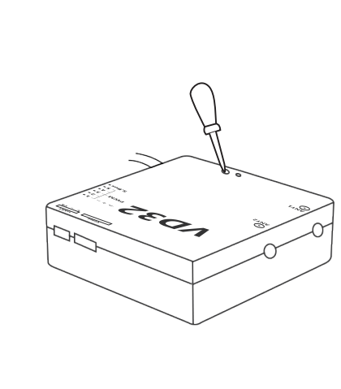

1. Tap on “Link - Start” and wait for a second, if transmitter indicator and sky station indicator both blinks green, linking is finished.

**WARNING**

Before linking AK28 transmitter to VD32 sky station, please make sure your aircraft motors have no power connected (E.S.C are off connection).

Reboot the sky station when linking steps are finished, and try to manipulate on the transmitter to confirm if it is a successful linking.

## 3.4 Throttle Joystick Type

AK28 transmitter supports both “Thumb-slide” and “Self-centering” throttle joysticks. Users decide which type to use according to their preference. Generally, if your AK28 transmitter has been set up as “Thumb-slide” throttle joystick, then the throttle type in “System Settings” should be “Thumb-slide” as well.

**Steps**

Open “SIYI TX”, tap on “System Settings – Throttle – Self-centering/Thumb-slide” to choose your favorite throttle type.

# 4 OPERATING SYSTEM

## 4.1 Tips

**Screenshot**

Users can tap on the screenshot button in the Android system notification menu or double click transmitter power button to make screenshots.

## 4.2 Download System Application

The very necessary applications, “SIYI TX” and “SIYI FPV”, have been pre-installed in AK28 transmitter before delivery. Users can visit SIYI Tech’s official website (<http://en.siyi.biz/en/ak28/downloads/>) or contact SIYI Tech’s technical support email ([support@siyi.biz](mailto:support@siyi.biz)) to download and update the same applications if they were not in your system when you have got it.

4.3 How to Import Files and Install System Application

**Method 1**

Copy the APK from PC to a TF card and insert the TF card to the slot on AK28 transmitter. Then you can read and install the file through the “File Manager” application in AK28 system.

**Method 2**

Connect AK28 transmitter to your PC through an OTG Micro-USB cable and in AK28 system screen it will pop up “USB inserted, please confirm before disconnecting datalink/videolink function and switching to charging or file transferring function”. Tap on “Yes”, then open “Computer” file in your PC system and find the new file driver detected. Copy the APK into the driver and you can read and install the file through the “File Manager” application in AK28 system.

**WARNING**

AK28 is a professional handheld ground station for UAV which requires a stable system. Please do not install any application which does work for your UAV system in case of any danger to flight safety.

# 5 SIYI TX

Users can set up AK28 transmitter through the system application “SIYI TX”.

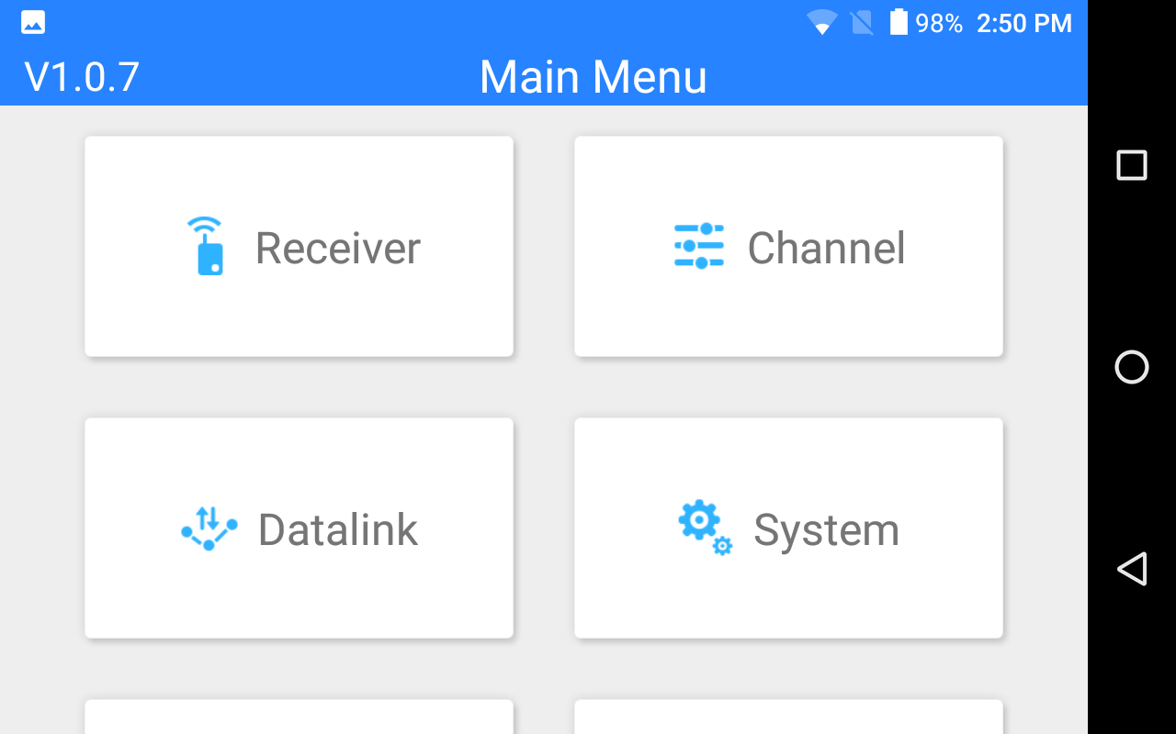

## 5.1 Channel Settings

Users can set the output value and middle point value and switch output direction (normal/reversed) and change mapping definition for each channel of AK28 transmitter.

### 5.1.1 End Point

Users can set the output value of a channel and its maximum/minimum limit.

**Steps**

1. Please refer to the picture below. Slide the blue bar in your target channel to the target output value. When the channel output is normal, tap on the left/right box to input value of the minimum/maximum limit, the range is between -150 and 150.
2. After setting, output value of the channel will not exceed the limit even under “Program Mix*” function in order to protect the servo and some other external device.

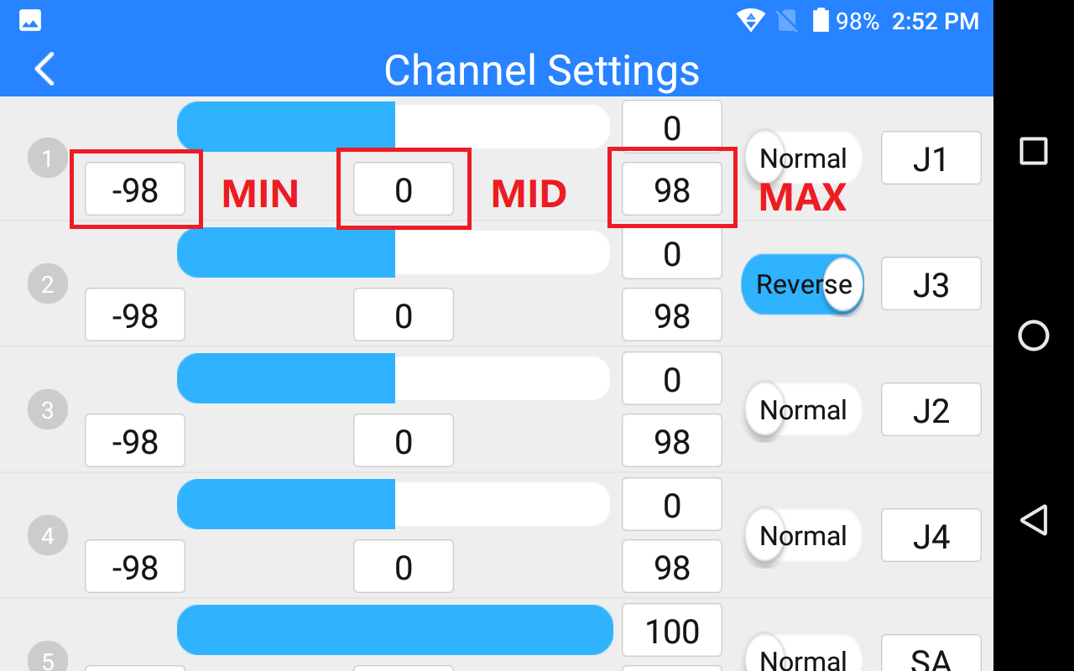

### 5.1.2 Middle Point

Please refer to the picture above. Tap on the box below the middle of your target channel to input value of the middle point.

### 5.1.3 Channel Reverse

Users can reverse a channel’s output direction through “Channel Reverse”.

**Steps**

1. When your AK28 transmitter is linked to a new model, please confirm if all the servos, buttons, and switches have been mapped to right channels as you need.
2. Try to manipulate the joysticks, switches, buttons, and dials on your AK28 transmitter to confirm if the output direction of each channel is normal or reversed.
3. Please refer to the picture below. Tap on the “Normal/Reversed” box to switch the channel direction and the box will show if the channel is normal or reversed.

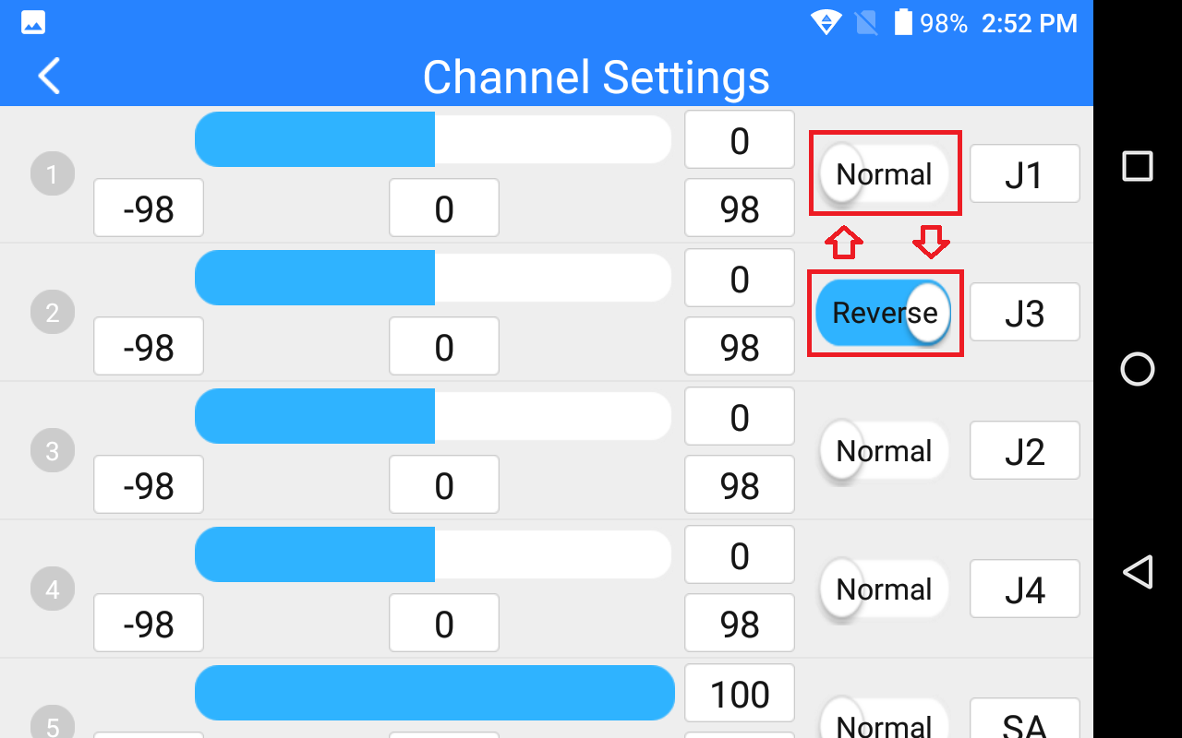

### 5.1.4 Channel Mapping

All 14 channels of AK28 transmitter can be mapped freely as you need to the joysticks, switches, buttons, and dials.

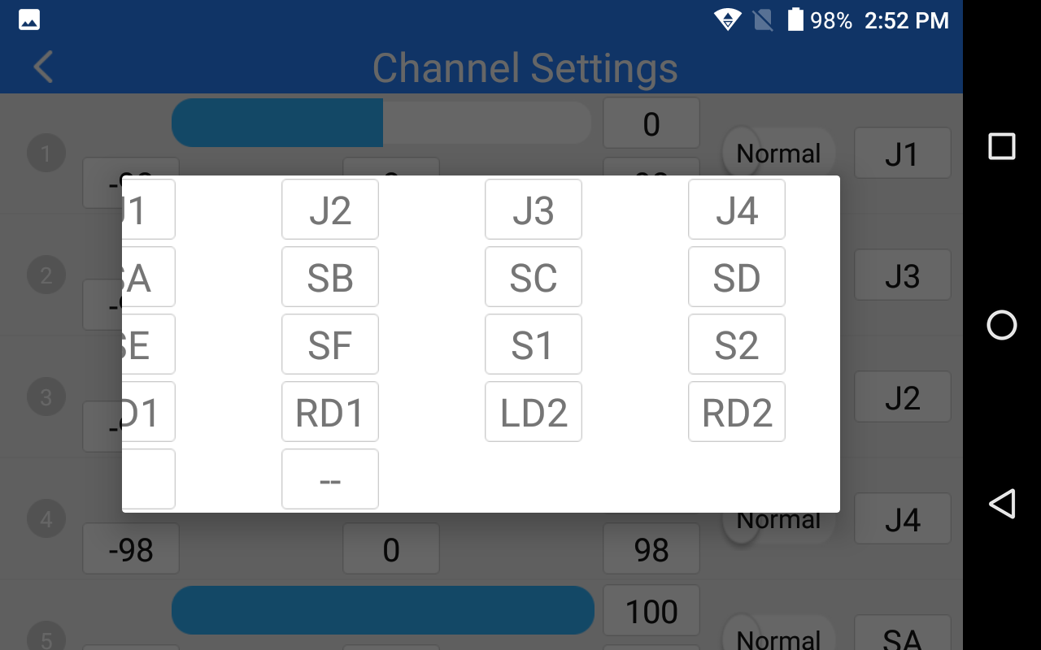

**Steps**

1. Please refer to the picture above. Tap on the last box on right of your target channel to open the list of all joysticks, switches, buttons, and dials.
2. In AK28 transmitter system, channel 1-4 is default to be Aileron, Elevator, Throttle, and Rudder.
3. Let’s take example of Channel 1 (Aileron). Tap on the “J1” box on right of Channel 1 and select a joystick/switch/button/dial in the list. In the box it will show the selected joystick/switch/button/dial.

## 5.2 Datalink Settings

Users can set datalink output mode, flight controller type, and baud rate through datalink settings function.

**Datalink Output Mode**

AK28 transmitter supports two datalink output modes: A-USB and Bluetooth. Tap on “Connect” to switch output mode.

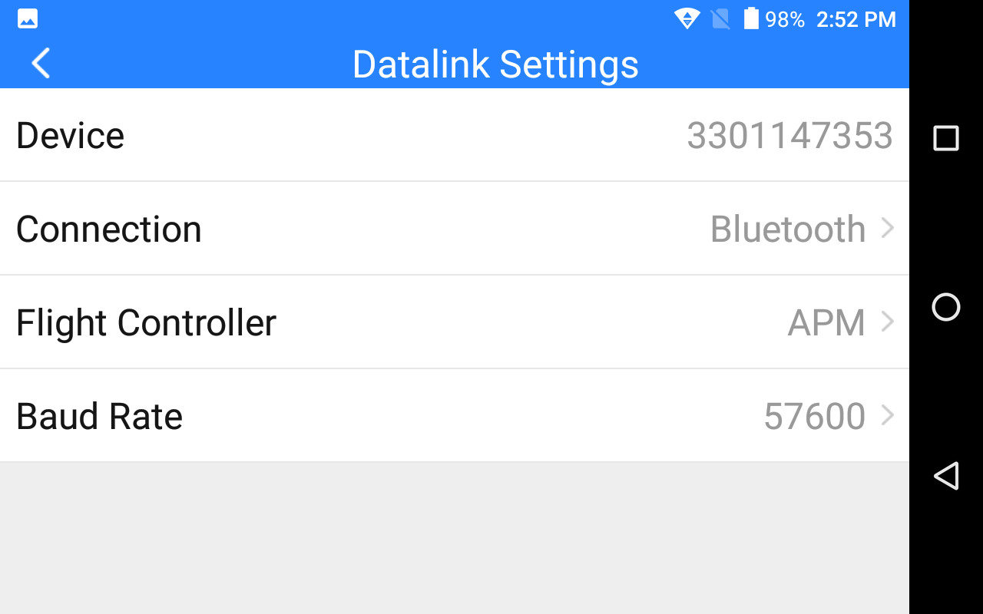

Mark: The Bluetooth module can only support one pair of device. So while you are using Bluetooth as your datalink output mode, please do not shut down the Bluetooth function in AK28 system or use the system Bluetooth to pair with any other device.

**Flight Controller Types**

AK28 transmitter can support most of the popular flight controllers on market, such as open source flight controllers under Mavlink protocol (PIX/APM/etc.), BOYING PALADIN V2, TOPXGUN T1-A, WOOZOOM THEONE-A, EFY FINIX200M, JIYI K3A/K++, CFUAS C1-A, etc.

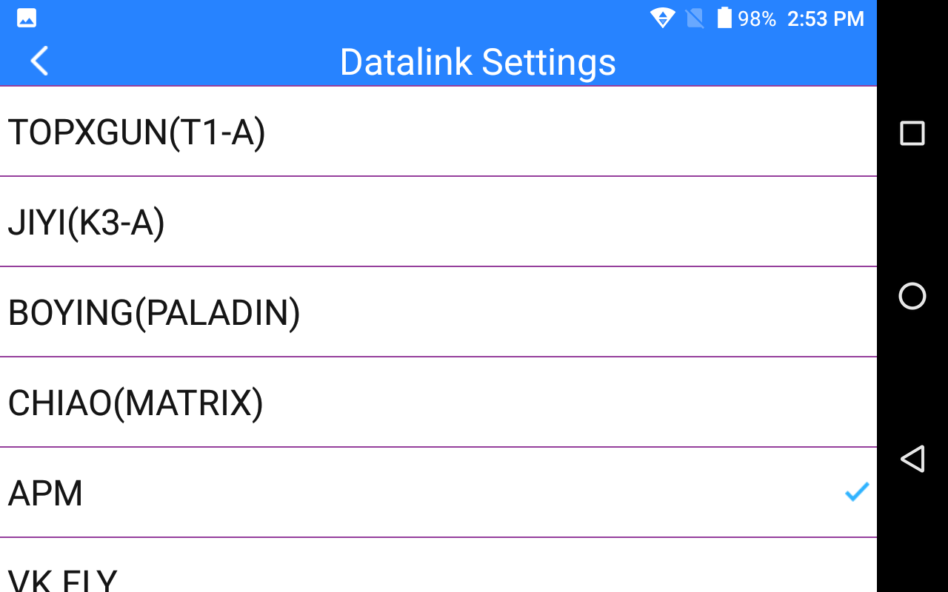

**Baud Rate**

If your flight controller type was not listed here, you can still set a baud rate accordingly to yours to match.

## 5.3 System Settings

Under “System Settings”, users can link AK28 transmitter with VD32 sky station, switch throttle type and joystick type.

**Link/Bind**

Tap on “Link” to make linkage between AK28 transmitter and VD32 sky station.

**Throttle Type**

Tap on “Throttle” to switch throttle joystick type between Self-centering and Thumb-slide.

**Joystick Type**

Tap on “Joystick” to select a joystick control type (Mode 1/Mode 2/Custom).

## 5.4 Model Settings (One Move to Do Agricultural Drone Settings)*

AK28 transmitter will support the function “One Move to Do Agricultural Drone Settings”. Users can select and match the FC(Flight Controller) and ESC(Electronic Speed Controller) type according to what they have bought. Then the joystick/switch/button/dial definition and datalink settings will be done automatically. So you will be ready for flight immediately.

** CAUTION**

Please make sure your AK28 transmitter and VD32 sky station are linked before doing agricultural drone settings.

When the settings are done, please do not forget to re-calibrate your AK28 transmitter joysticks before unlocking motors and taking a flight.

**Steps**

1. Open “SIYI TX” and enter “Model Type” menu.
2. Select the right FC and ESC type according to what you have bought. Please select “FOC” for ESC which is free of calibration. And select “Standard” for ESC which requires calibrating output value, then your AK28 transmitter will generate the channel value automatically according to your requirement.
3. Calibrate your AK28 transmitter joysticks in your flight controller’s ground control software.
4. Unlock motors and take off your drone.

## 5.5 Fail-safe

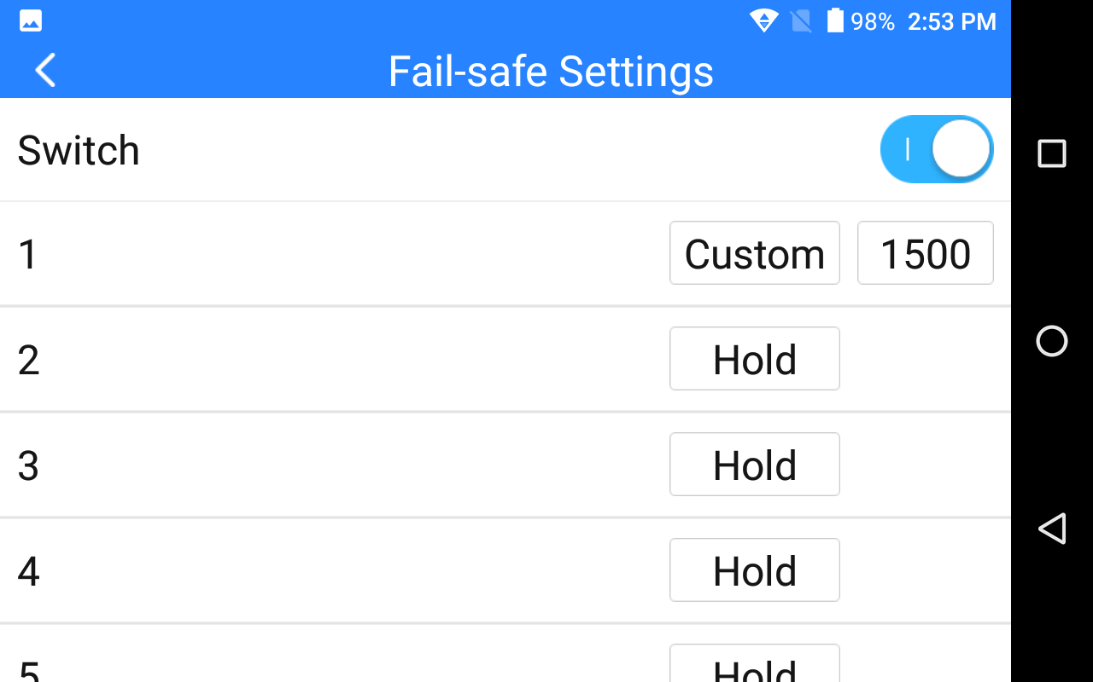

Before linking AK28 transmitter to VD32 sky station, do not forget to do fail-safe settings and turn on the function. Thus if your transmitter lost linkage with sky station, fail-safe function will run automatically and immediately to protect your model from a potential crash.

**Steps**

1. Make sure the transmitter is linked to sky station.
2. Open “SIYI TX” and enter fail-safe menu.
3. Please refer to the picture above. Under fail-safe menu, the function is default to be off and it displays “HOLD” in each channel. In this circumstances, if your transmitter lost linkage with sky station, the sky station will output the last channel value received from your transmitter.
4. Turn on the switch up-right in the screen to activate fail-safe function.
5. When the function is activated, please tap on your target channel box to switch it from “HOLD” to “CUSTOM: 1500”. Then tap on the value box to input the channel value according to your requirement.
6. The value box will show your fail-safe value.

# 6 VD32 SKY STATION

## 6.1 At a Glance

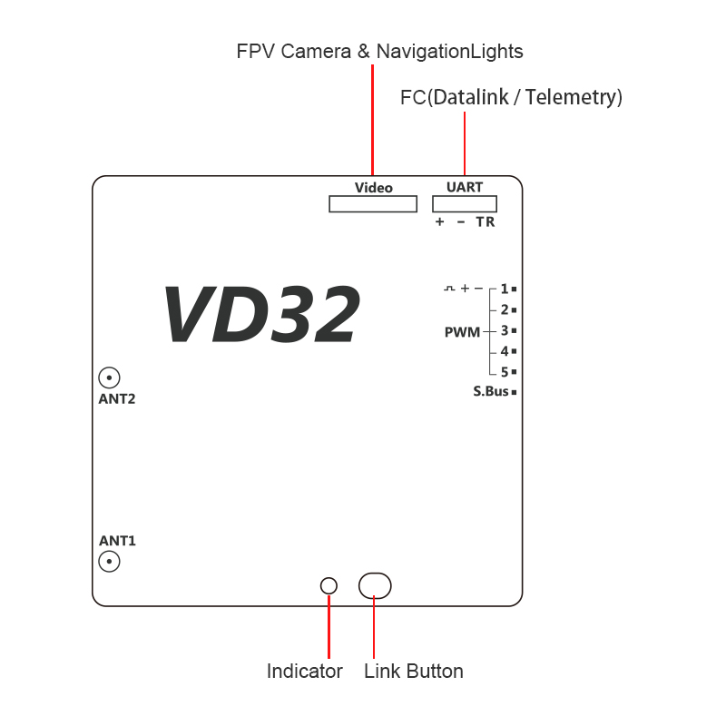

**Port Definition**

Video: Signal and power output for FPV camera and navigation lights.

UART: Datalink port for telemetry output/input.

S.Bus: S.Bus signal output.

PWM1-5: Signal output from PWM channel 1 to 5.

## 6.2 Datalink Connection with FC

The UART port is for telemetry signal output/input. Please refer to the prints around the port for making connection.

The “+” and “-” port on VD32 sky station should be connected to the positive and negative end on your flight controller. And the “T” and the “R” port should be crossing connected to the “R” and the “T” serial port.

## 6.3 Datalink Connection with Ground Station

**USB Connection**

Enter “Datalink Settings” in “SIYI TX” and change the connection method to “A-USB”. Open your ground control station and select USB connection accordingly. If your GCS may pop up “Please confirm to authorize USB”, please tap on “Yes”.

**Bluetooth Connection**

Enter “Datalink Settings” in “SIYI TX” and change the connection method to “Bluetooth”. Then activate Bluetooth function in the Android system settings and search for Bluetooth device name as “33********”. Connect to the device and input password “1234” to match. Go to your ground control station and connect to the matched Bluetooth device.

## 6.4 Videolink Module

Please make sure that the antennas, the camera and the power cable are all connected to the ports on VD32 sky station. Then power on AK28 transmitter.

**Navigation Lights**

Switch “SF” is default to turn on/off the navigation lights. You can change to another switch or button in channel settings.

**FPV Video Feeds**

Open VD FPV application to check real-time video feeds in the system. If your GCS may pop up “Please confirm to authorize USB”, please tap on “Yes”.

When you switch back to your ground control station, the VD FPV application will stay on your screen as a floating window which can be zoomed in and out freely.

# 7 Firmware and Voice Upgrading

AK28 transmitter and VD32 sky station support firmware upgrading through PC.

Before upgrading AK28 transmitter, it is necessary to download the software “SIYI Assistant v1.2.0” and connect AK28 transmitter to your PC using the original OTG USB cable with the upgrading tool.

**Steps**

1. Please visit the AK28 download page on SIYI Tech’s official website to download all necessary software, application and firmware one by one.

Link: http://en.siyi.biz/en/ak28/downloads/

1. Release the .zip files and install “SIYI Assistant v1.2.0” on your PC.
2. Then use the original OTG USB cable with the upgrading tool to connect AK28 transmitter to your computer.
3. Run “SIYI Assistant v1.2.0” to check AK28 transmitter’s current firmware version. If they are not the latest version, then tap on “Upgrade” to enter firmware upgrading menu.
4. Load the latest firmware files and tap on “Upgrade” and wait till the process is finished.

To upgrade firmware for VD32 sky station, please using the original OTG Micro-USB cable to connect VD32 sky station to your PC and repeat the step 4-5 above.

# 8 After-sale Service

## 10.1 To-be-repair Procedure

If you meet any difficulties using SIYI Technology’s product, please send your email to [support@siyi.biz](mailto:support@siyi.biz) or consult your sales manager directly.

If it was a confirmed product defect or damage which requires returning or replacement or repairing, SIYI engineers will guide you for the process.

## 10.2 After-sale Policy

SIYI Technology guarantees that, subject to the following conditions, Return & Refund Service, Replacement Service and Warranty Repair Service can be requested. Please contact SIYI directly ([support@siyi.biz](mailto:support@siyi.biz) or your sales manager) or your authorized SIYI dealer for more detail.

### 10.1.1 7-Day Return & Refund

You can request Return & Refund Service:

Within seven (7) days of receiving a product if the product has no manufacturing defect, has not been activated and is still in new or like-new condition.

Within seven (7) days of receiving a product if the product has a manufacturing defect.

Return & Refund Service will not be provided where:

It is requested beyond seven (7) calendar days of receiving a product.

A product sent to SIYI for Return & Refund Service does not include all original accessories, attachments or packaging, or any item is not in new or like-new condition, i.e. with cracks, dents or scratches.

A legal proof of purchase, receipt or invoice is not provided or is reasonably believed to have been forged or tampered with.

Any fault or damage of the product is caused by unauthorized use or modification of the product, including exposure to moisture, entry of foreign bodies (water, oil, sand, etc.) or improper installation or operation.

Product labels, serial numbers, waterproof marks, etc. show signs of tampering or alteration.

Damage is caused to the product by uncontrollable external factors, including fire, floods, high winds or lightning strikes.

A product is not delivered to SIYI within seven (7) calendar days after Return & Refund Service confirmation is sent from SIYI.

Other circumstances stated in this policy.

### 10.1.2 15-Day Replacement

You can request Replacement Service:

Within fifteen (15) calendar days of receiving the product if the product has sustained a substantial damage in transit, provided always that the damage proof issued by the carrier can be provided to SIYI.

Within fifteen (15) calendar days of receiving the product if the product does not match the original description of the product in one or more significant respects.

Within fifteen (15) calendar days of receiving the product if the product suffers performance failure.

Replacement Service will not be provided where:

Service is requested more than fifteen (15) calendars days after receiving a product.

Legal proof-of-purchase, receipts, or invoices are not provided, or are reasonably believed to have been forged or tampered with.

A product sent to SIYI for replacement does not include all original accessories, attachments and packaging, or contains items damaged by user error.

A product is found to have no defects after all appropriate tests are conducted by SIYI.

Any fault or damage of the product is caused by unauthorized use or modification of the product, including exposure to moisture, entry of foreign bodies (water, oil, sand, etc.) or improper installation or operation.

Damage is caused by uncontrollable external factors, including fires, floods, high winds, or lightning strikes.

Received product has not been sent back to DJI seven (7) calendar days after replacement confirmation from DJI.

Proof of damage during transit issued by the carrier cannot be provided.

Other circumstances stated in this policy.

### 10.1.3 1-Year Warranty Repair

You can request warranty repair service:

If a product does not function as warranted during the warranty period, you may obtain after-sales service by contacting SIYI’s service center. You will need to provide a valid proof-of-purchase, receipt or order number for the warranty service.

Charges may apply for services not covered by this Limited Warranty. Please contact SIYI for information specific to your location.

Please note that the warranty service is only available in the respective SIYI service regions where you purchased your SIYI product.

Warranty Repair service will not be provided where:

Crashes or fire damage caused by non-manufacturing factors, including but not limited to pilot errors.

Damage caused by unauthorized modification, disassembly, or shell opening not in accordance with official instructions or manuals.

Damage caused by improper installation, in correct use, or operation not in accordance with official instructions or manuals.

Damage caused by non-authorized service provider.

Damage caused by unauthorized modification of circuits and mismatch or misuse of the battery and charger.

Damage caused by operation in bad weather (i.e. strong winds, rain, sand/dust storms, etc.)

Damage caused by operating the product in an environment with electromagnetic interference (i.e. in mining areas or close to radio transmission towers, high-voltage wires, substations, etc.)

Damage caused by operating the product in an environment suffering from interference from other wireless devices (i.e. transmitter, video-downlink, Wi-Fi signals, etc.)

Damage caused by reliability or compatibility issues when using unauthorized third-party parts.

Damage caused by operating the unit with a low-charged or defective battery.

Products or parts with an altered identification label or from which the identification label has been removed.

SIYI Technology (Shenzhen) Co., Ltd.

+86 400 838 2918

support@siyi.biz