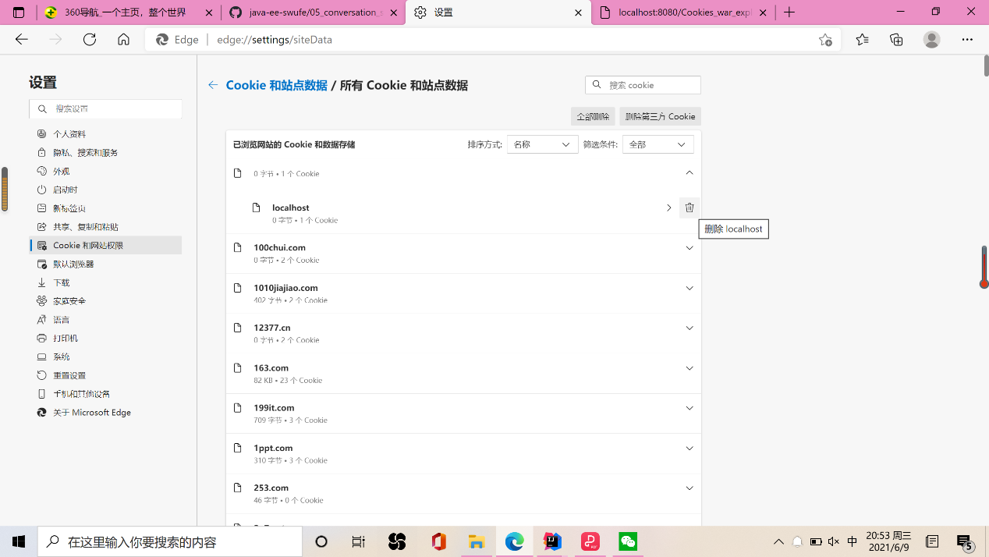

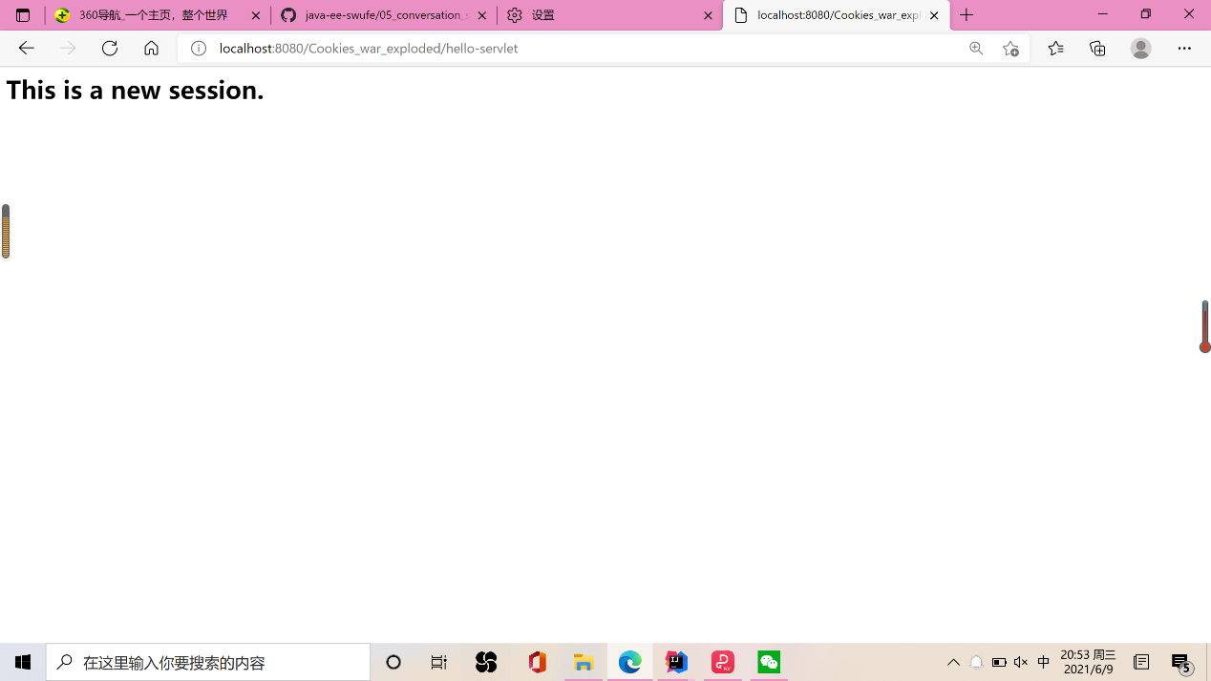

Cookie1:

Delete the data of cookie in setting

Return to visit the hello-servlet again.

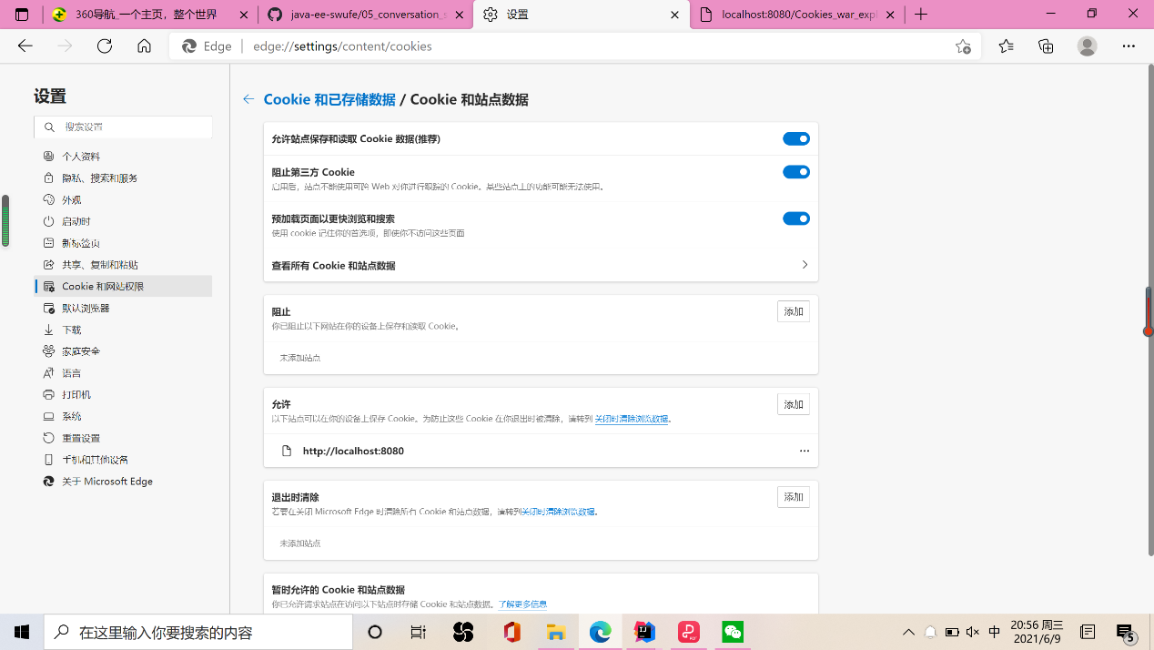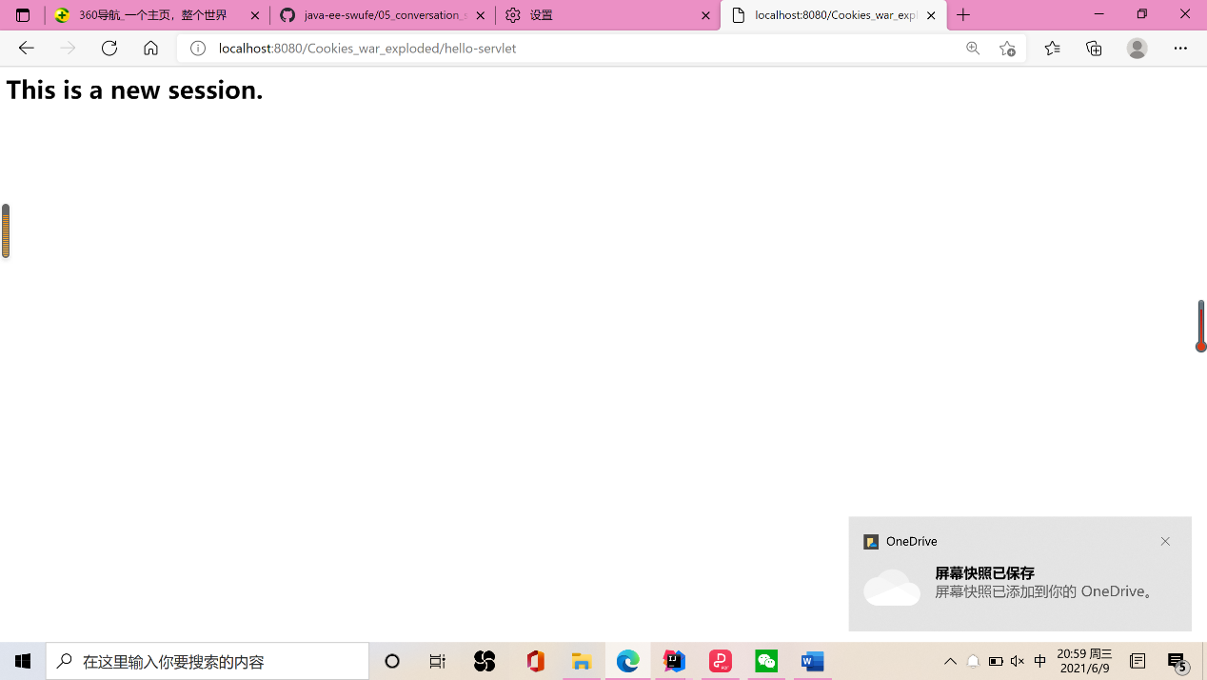

Cookie2:

Stop the third one to track cookie, and also delete the data of cookie in setting, the click click me to see “this is a new session”