**Insertion Sort**

Insertion sort is a simple sorting algorithm that allows for efficient, in-place sorting of the array, one element at a time.

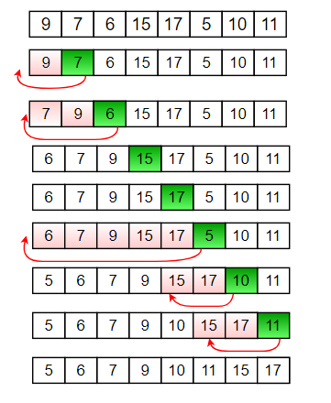

**Insertion Java Code:**

public class Insertion {

public static void insertionSort(int[] Arr) {

for (int i = 1; i < Arr.length; ++i) {

int j = i;

while (j > 0 && Arr[j - 1] > Arr[j]) {

int key = Arr[j];

Arr[j] = Arr[j - 1];

Arr[j - 1] = key;

j = j - 1;

}

}

}

public static void main(String args[]) {

int[] arr = {9, 2, 6, 4, 10, 8};

insertionSort(arr);

for (int i = 0; i < arr.length; ++i) {

System.out.print(arr[i] + " ");

}

System.out.println();

}

}