title: "Wine Quality Analysis"
author: "Siyuan Zhang"
date: "2025-12-19"
---
###DATA CHECK AND EDA
##Initialize environment and load data
#nitialize environment and organize data, tidy up data formats for subsequent
library("readxl")
library("dplyr")
library("data.table")
winequality<- fread("winequality-red.csv", sep = ";")
library("tidyverse")
glimpse(df)
Result：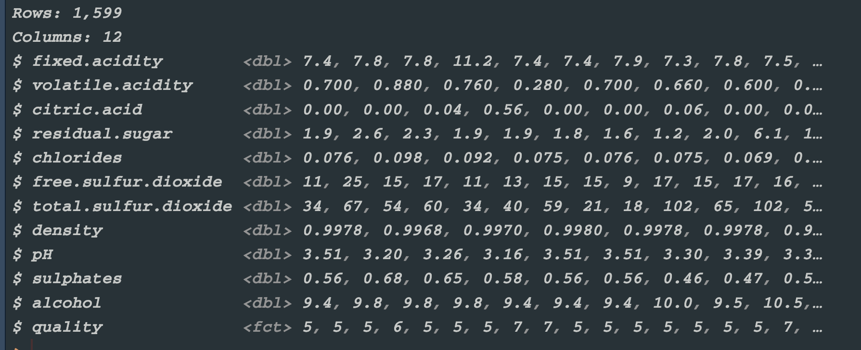
## Data preprocessing
#Obtain summaries of numeric variables and missing value situations
names(df) <- gsub("\\.", " ", names(df))
library(tidyverse)
library(skimr)
library(patchwork)
cat("========Data Type========")
summary(df)
Result：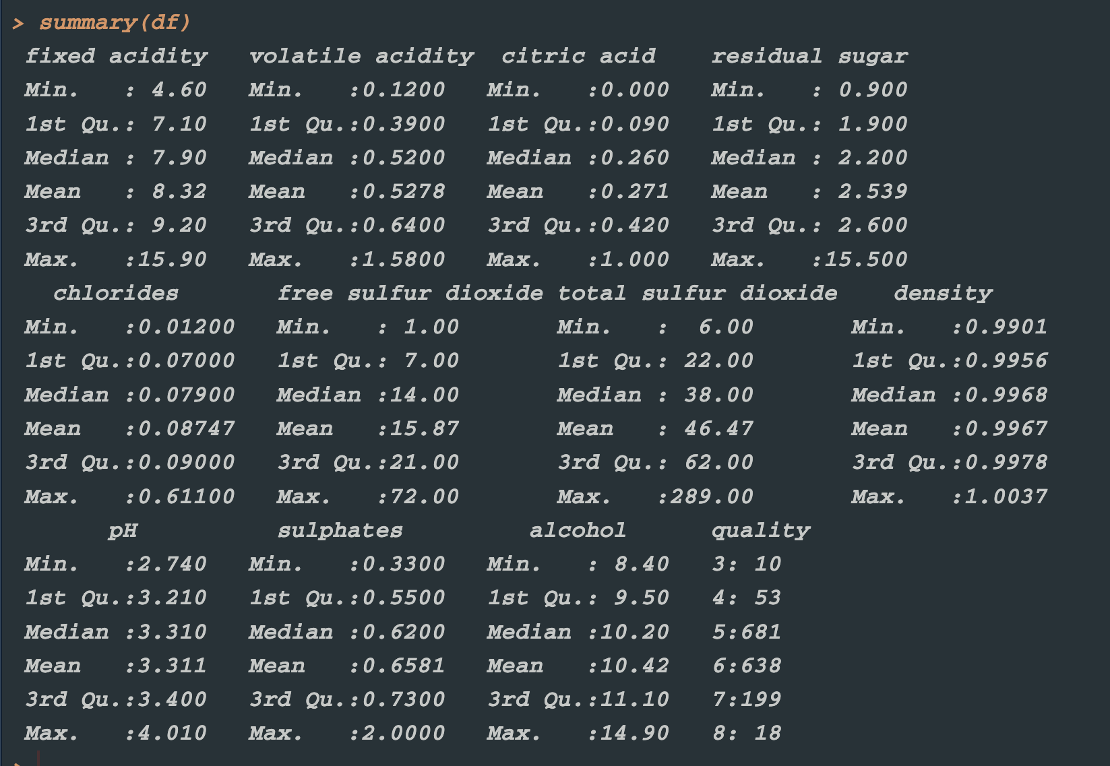
## Missing value inspection
#Count the number of missing values in each column to ensure data integrity
```{r}
cat("======== Missing Value Inspection ========")
print(colSums(is.na(df)))
Result：
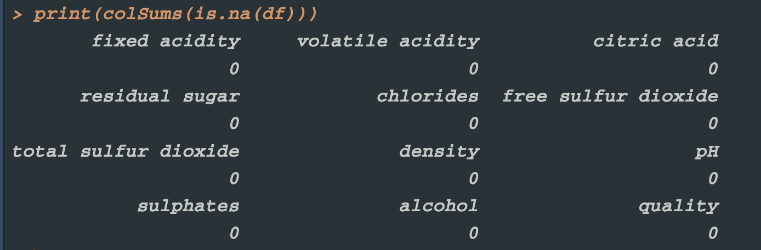
*There are no missing values in the entire data frame df. This wine-quality dataset is complete and intact in its current dimensions; no imputation or deletion of missing values is needed downstream.
skimr::skim(df)
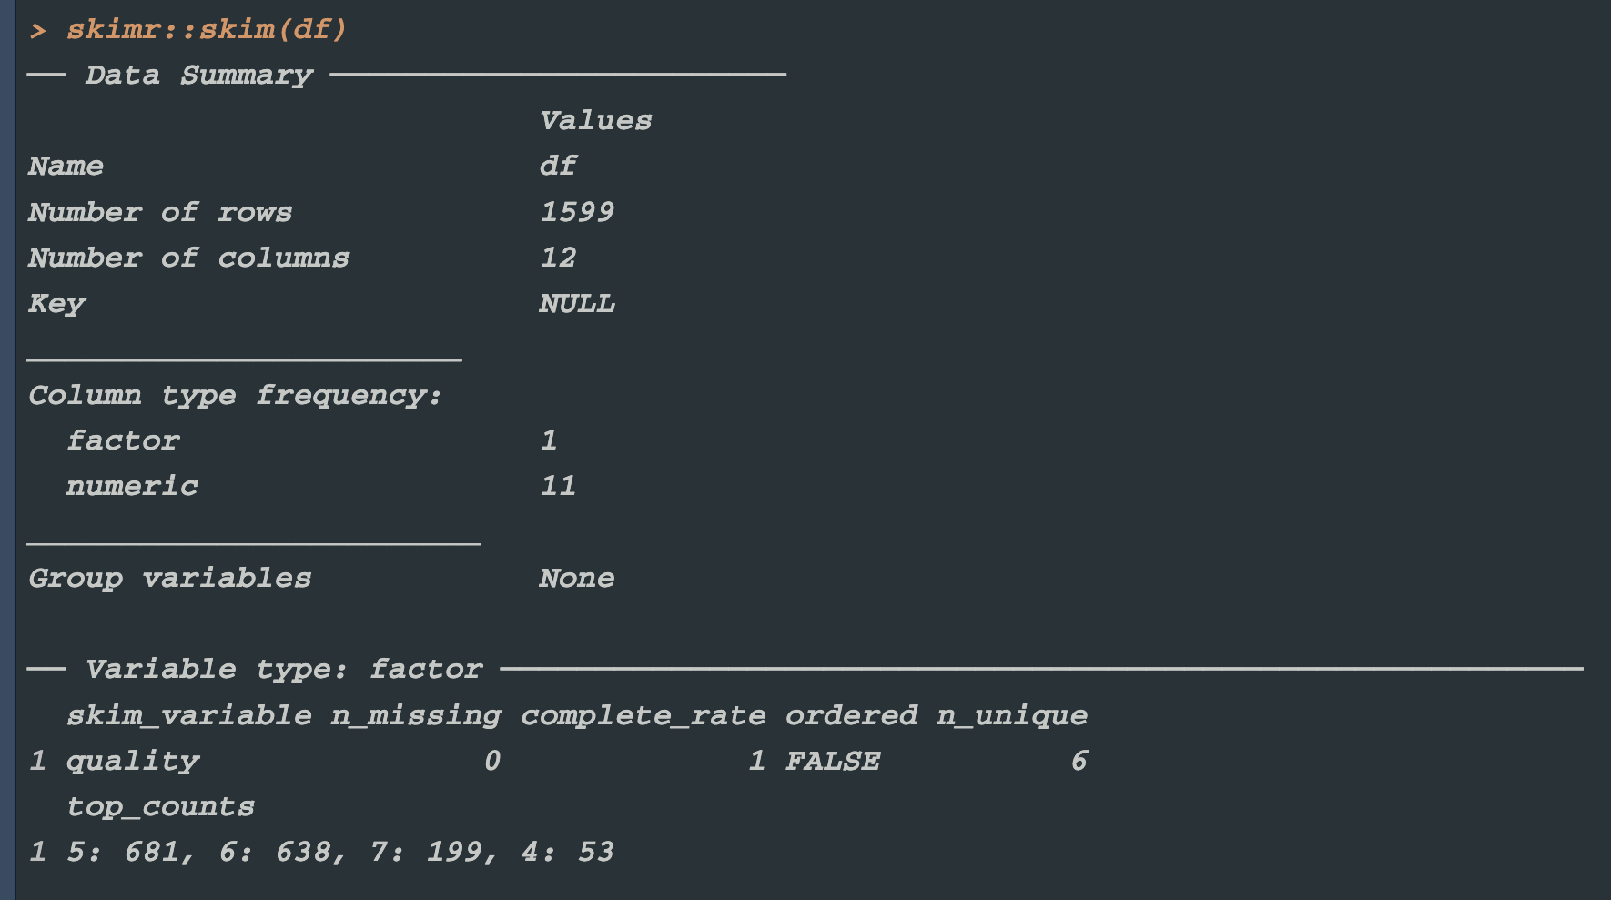
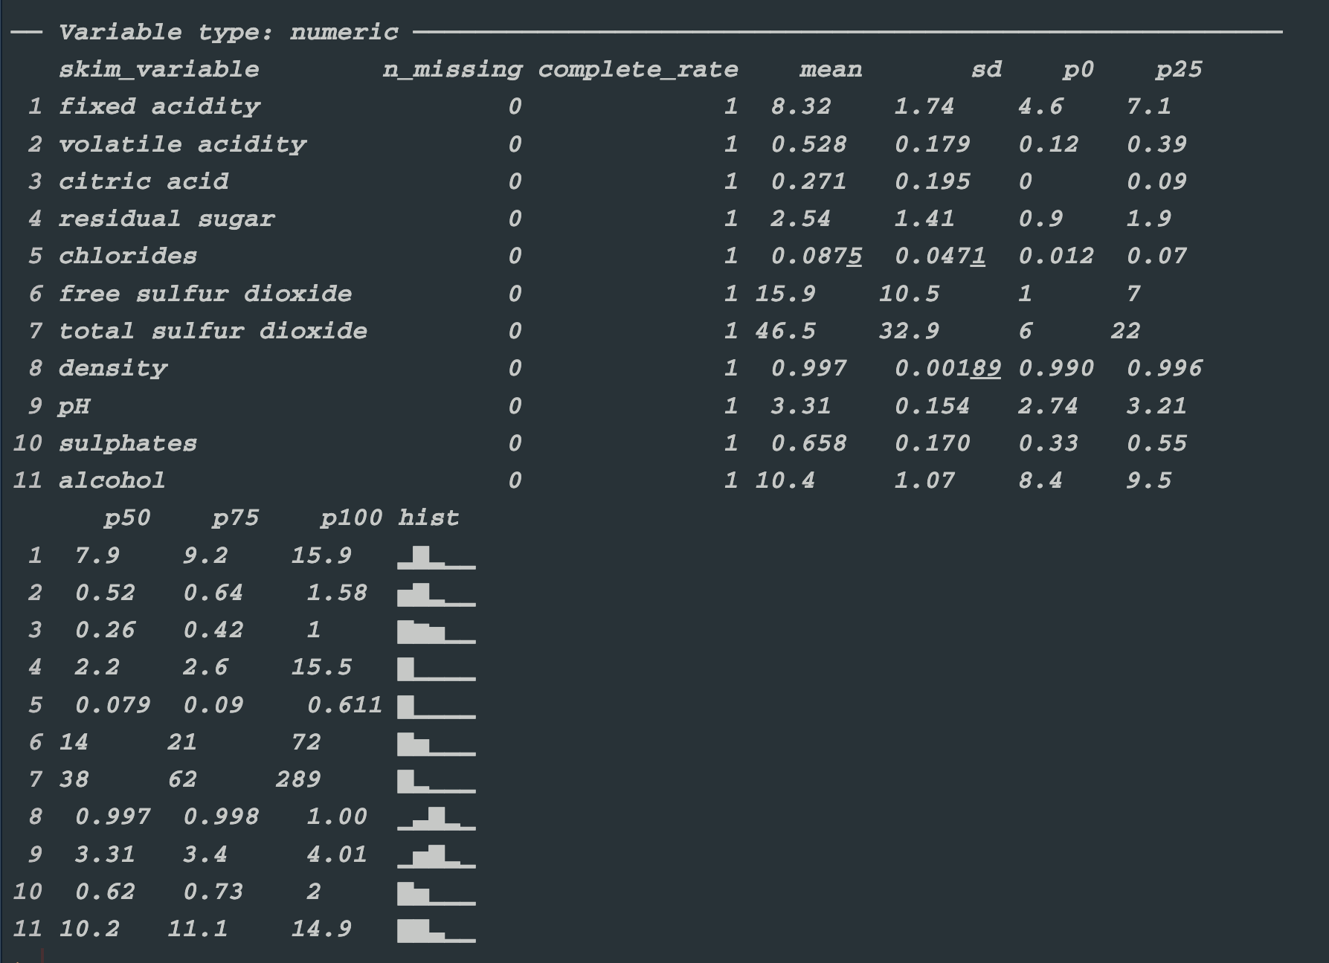
*The data are complete with no missing values and contain a moderate sample size (n = 1,599).
Quality ratings cluster around 5 and 6, indicating that the majority of the wines are of medium quality.
The distributions of several chemical components reveal potential outliers and skewness that should be addressed during preprocessing.
Alcohol content, volatile acidity, and residual sugar are likely to be key features influencing quality.
## Response variable analysis
#Analyze the distribution of the target variable (wine quality)
cat("==================EDA==================")
cat("==========Response Variable==========")
df$quality <- as.numeric(as.character(df$quality))
p_hist_q <- ggplot(df, aes(quality)) +
geom_bar(fill = "orange", width = 0.7) +
scale_x_continuous(breaks = min(df$quality):max(df$quality)) +
labs(title = "Quality ", subtitle = " Output variable based on sensory data ") +
theme_minimal(base_size = 14)
p_box_q <- ggplot(df, aes(y = quality)) +
geom_boxplot(fill = "orange", alpha = 0.6, outlier.color = "red", width = 0.25) +
labs(title = "Quality ", subtitle = " Outliers ") +
theme_minimal(base_size = 14)

print(p_hist_q)
print(p_box_q)
#Most quality ratings fall between 5 and 7,#
#accounting for roughly 70–80 % of the scores, #
#which aligns with the typical pattern of wine sensory evaluation.#

## Explanatory variable distribution analysis
#Identify outliers and the natural distribution of the data to provide a basis for subsequent processing
#(Since most regions have strict regulations defining wine mainly in terms of acidity and alcohol content, while other variables serve primarily as references for wine taste and quality, the following analysis separately examines the distributions of acidity and alcohol.)
cat("==========Explanatory Variable==========")
p_alcohol <- ggplot(df, aes(x = alcohol)) +
geom_histogram(aes(y = ..density..), bins = 20, fill = "orange", alpha = 0.5) +
geom_density(color = "darkorange", linewidth = 1) +
geom_vline(xintercept = c(8, 22), linetype = "dashed", color = "red") +
labs(title = "Alcohol content distribution
(extreme values marked: <8 % and >22 %)", x = "Alcohol content %", y = "Density") +
theme_minimal(base_size = 14)
print(p_alcohol)
p_volatile_acidity <-ggplot(df, aes(x = `volatile acidity`))+
geom_histogram(aes(y = after_stat(density)),bins = 20,fill = "orange",alpha = 0.5)+
geom_density(color = "darkorange", linewidth = 1)+
geom_vline(xintercept = c(0, 2), linetype = "dashed", color = "red")+
labs(title = "Distribution of volatile acidity",x = "Volatile acidity",y = "Density")+
theme_minimal(base_size = 14)
print(p_volatile_acidity )
p_fixed_acidity <-ggplot(df, aes(x = `fixed acidity`))+
geom_histogram(aes(y = after_stat(density)),bins = 20,fill = "orange",alpha = 0.5)+
geom_density(color = "darkorange", linewidth = 1)+
geom_vline(xintercept = c(0, 20), linetype = "dashed", color = "red")+
labs(title = "Distribution of fixed acidity",x = "Fixed acidity",y = "Density")+
theme_minimal(base_size = 14)
print(p_fixed_acidity)
p_citric_acid <-ggplot(df, aes(x = `citric acid`))+
geom_histogram(aes(y = after_stat(density)),bins = 20,fill = "orange",alpha = 0.5)+
geom_density(color = "darkorange", linewidth = 1)+geom_vline(xintercept = c(0, 1), linetype = "dashed", color = "red")+
labs(title = "Distribution of citric acid",x = "Citric acid",y = "Density")+
theme_minimal(base_size = 14)
print(p_citric_acid)
library("gridExtra")
grid.arrange(p_alcohol, p_volatile_acidity,p_fixed_acidity,p_citric_acid ,ncol = 4,top = "Univariate Analysis of Key Physicochemical Indicators")
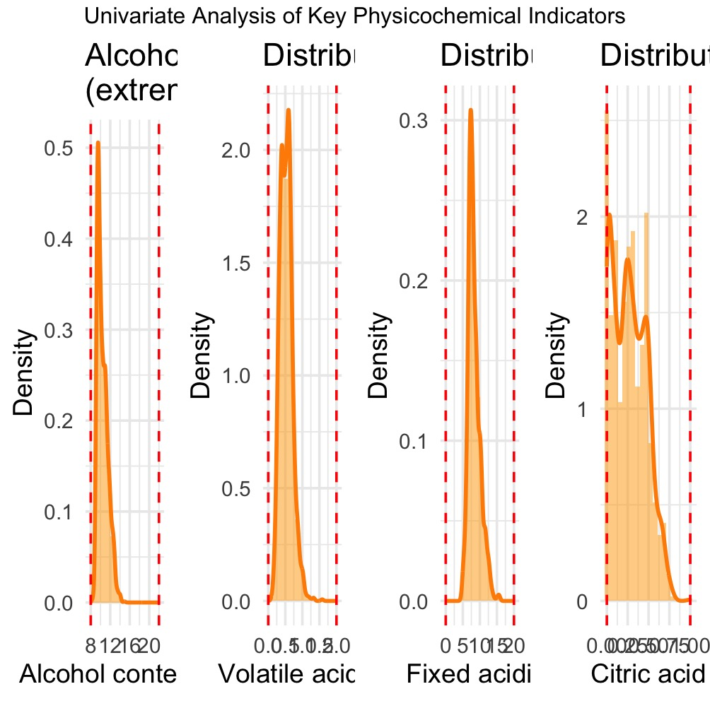
*This univariate analysis plot is intended to illustrate the distribution characteristics of four key physicochemical indicators in the wine dataset. It helps us understand, for each indicator:
1.Central tendency: the location of the peak, reflecting where the data are concentrated (e.g., alcohol content centers around 12%).
2.Dispersion: the range and shape of the distribution, showing how spread out the values are (e.g., citric acid is more dispersed, whereas volatile acidity is more concentrated).
3.Distribution shape: whether the distribution is unimodal or multimodal and whether it is symmetric, revealing the underlying structure of the data (e.g., the multimodality of citric acid may suggest the presence of distinct sub-groups).
## Multivariate correlation analysis
#Visualize correlations among variables
library("RColorBrewer")
library("corrplot")
library("ggcorrplot")
corrplot(cor_matrix,method = "color", type = "full",
col = rev(brewer.pal(11, "YlOrRd")),
tl.cex = 0.8,
tl.srt = 90,
tl.col="darkorange",
addCoef.col = "black",
number.cex = 0.6,
title = "Heatmap of Input Variable Correlation Matrix",
mar = c(0, 0, 2, 0))
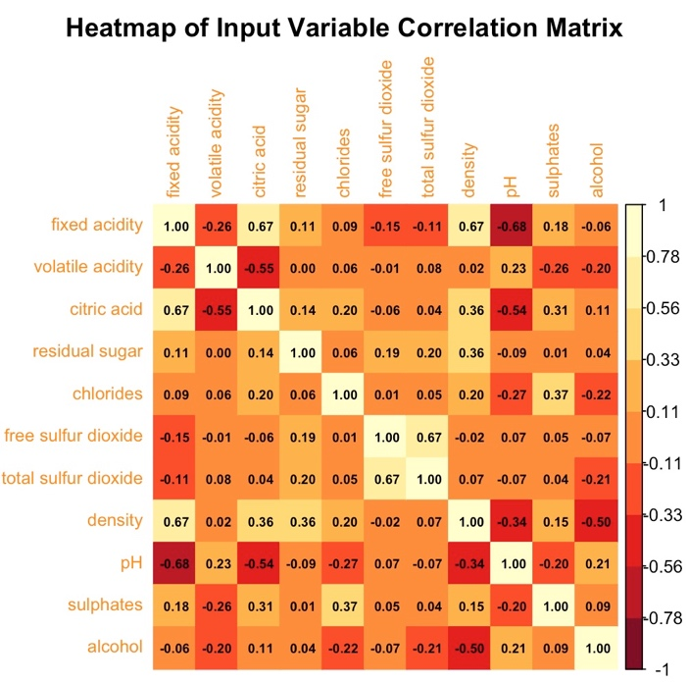
Strong positive correlations
citric acid ↔ fixed acidity: 0.67
density ↔ fixed acidity: 0.67
citric acid ↔ density: 0.36
free sulfur dioxide ↔ total sulfur dioxide: 0.67
Strong negative correlations
fixed acidity ↔ pH: –0.68 (higher acidity → lower pH)
pH ↔ citric acid: –0.54
pH ↔ density: –0.34
alcohol ↔ density: –0.50
p_corr <- ggcorrplot(cor_matrix, hc.order = TRUE,
type = "lower",
lab = TRUE,
lab_size = 3,
colors = c("YlOrRd"),
title = " Input Variable Correlation Matrix ",
ggtheme = theme_minimal(base_size = 12))
theme(plot.title = element_text(hjust = 0.5, face = "bold"))
print(p_corr)
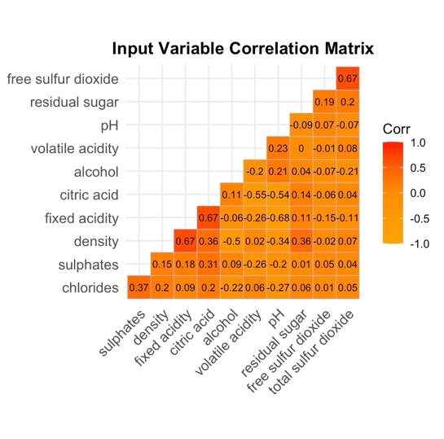
## Pairwise scatterplot matrix
#In-depth analysis of relationships among variables and quality grouping patterns
library(GGally)
library(ggplot2)
cont_var <- c(1:11)
df11 <- df[ , ..cont_var]
var_lab <- c("fixed acidity","volatile acidity","citric acid","residual sugar","chlorides","free sulfur dioxide","total sulfur dioxide","density","pH","sulphates","alcohol")
my_upper <- wrap("cor",
size = 2.2,
colour = "orange")
my_lower <- wrap("points",
size= 0.35,
alpha = 0.25,
colour = "darkorange")
my_diag <- wrap("densityDiag",
colour = "red",
size = 0.25)
pairs <- ggpairs(
df11,
columnLabels = var_lab,
aes(color = factor(df$quality), alpha = 0.55),
upper = list(continuous = my_upper),
lower = list(continuous = my_lower),
diag = list(continuous = my_diag)
) +
theme_bw(base_size = 7) +
theme(
axis.text.x = element_text(size = 5.5, angle = 45, hjust = 1),
axis.text.y = element_text(size = 5.5),
panel.grid.major = element_blank(),
panel.grid.minor = element_blank(),
legend.position = "bottom")
print(pairs)
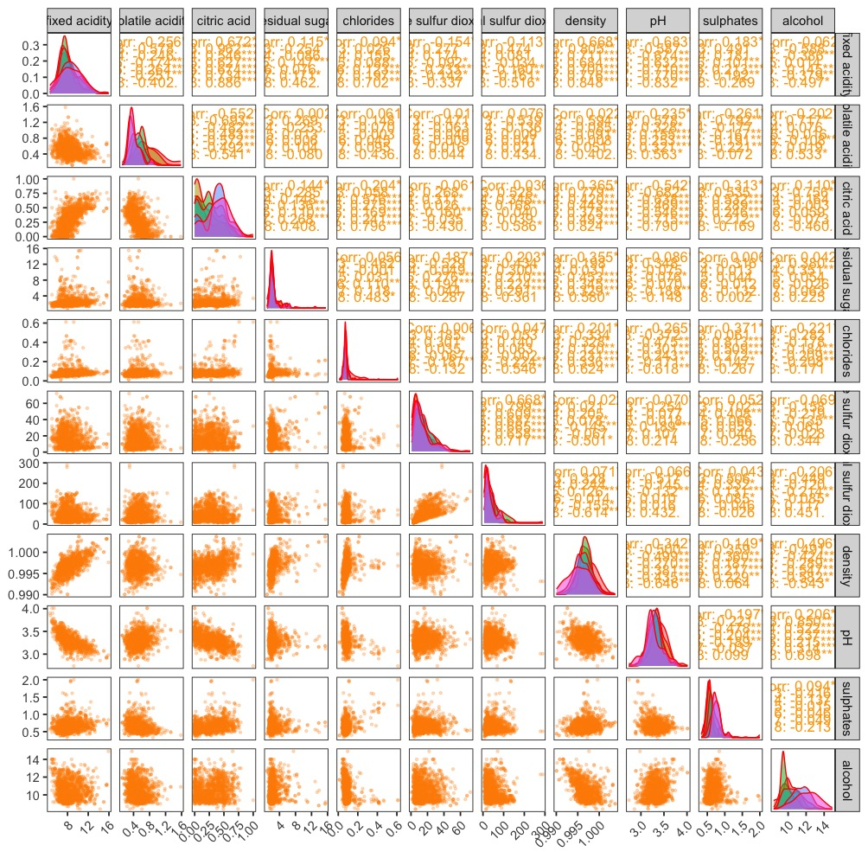

library(ggplot2)
library(gridExtra)
library(grid)
plot_list <- lapply(names(input_vars), function(var) {
ggplot(df, aes(y = .data[[var]])) +
geom_boxplot(fill = "orange", alpha = 0.6, outlier.color = "darkorange", width = 0.5,outlier.size = 0.3) +
labs(title = paste(var), y = var) +
theme_minimal(base_size = 7)})
grid.arrange(grobs = plot_list, ncol = 3, top = " Input Variable Outlier Detection (Red Dots Indicate Outliers)")
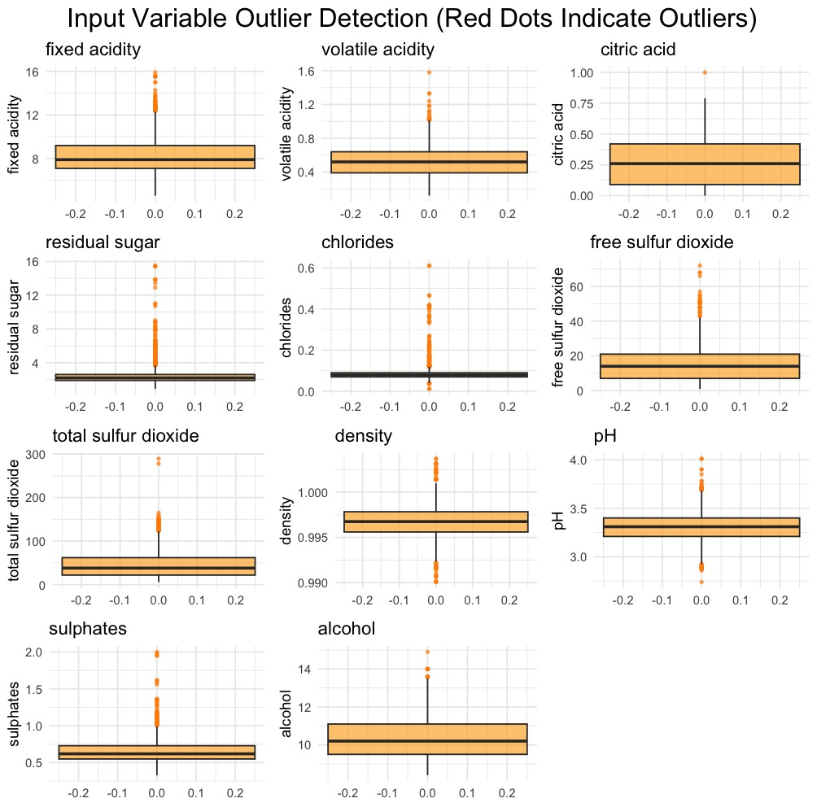
Several variables contain outliers:
1.Almost every variable shows red-flagged outliers, indicating that the dataset contains extreme or anomalous observations along multiple dimensions.
Outlier patterns differ across variables:
2.For some variables (e.g., citric acid, total sulfur dioxide, residual sugar, alcohol) the outlying values are extremely high, far beyond the normal range.
3.For others (e.g., fixed acidity, volatile acidity) the outliers are less extreme but still noticeably higher than the bulk of the data.
4. A few variables exhibit outliers whose visual “prominence” varies—some barely stand out, others are clear extremes.
Data dispersion varies by variable:
5.Different box lengths and whisker spans reflect differing within-variable variability.
6.Citric acid’s tiny box shows highly concentrated values.
7.Fixed acidity’s longer box indicates greater dispersion.
## Outlier detection
#Use the Z-score method (|Z| > 3) to identify outliers
z_scores <- as.data.frame(lapply(input_vars, function(x) (x - mean(x))/sd(x)))
outliers_z <- sapply(z_scores, function(x) sum(abs(x) > 3))
cat("======= Number of outliers by the Z-score method=======")
print(outliers_z)
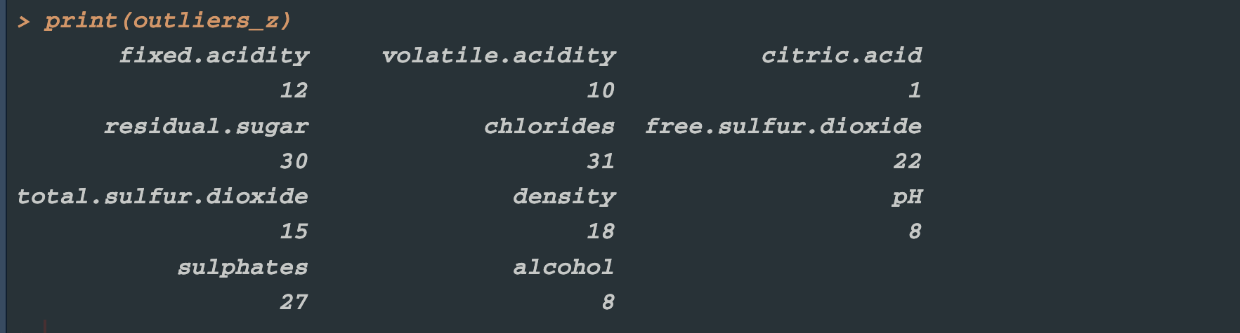
library(dplyr)
quality_summary <- df %>%count(quality) %>%mutate(percentage = n / sum(n) * 100)
cat("=======Distribution of quality scores=======")
print(quality_summary)
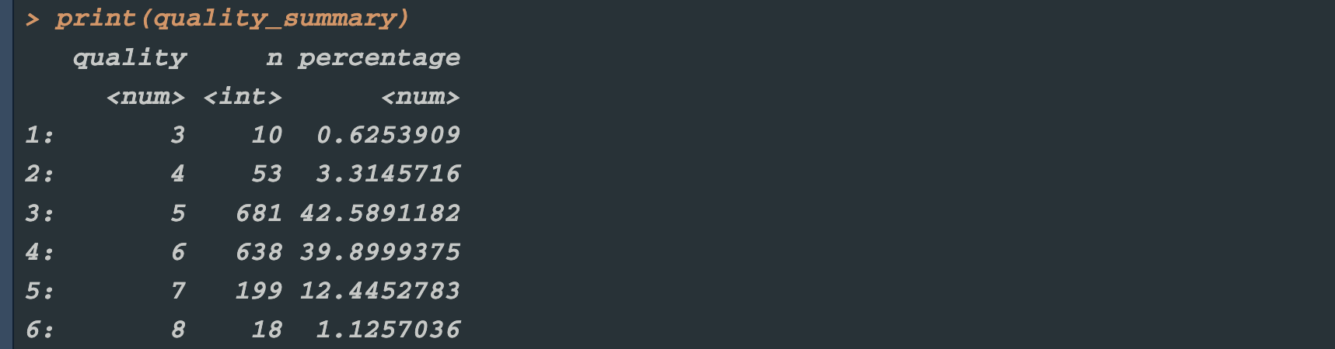
cor_with_quality <- cor(df[, 1:11], df$quality) %>%
as.data.frame() %>%tibble::rownames_to_column("variable") %>%
arrange(desc(abs(V1))) %>%head(3)
## Variables strongly related to quality
cat("======= Variables strongly related to quality =======")
print(cor_with_quality)
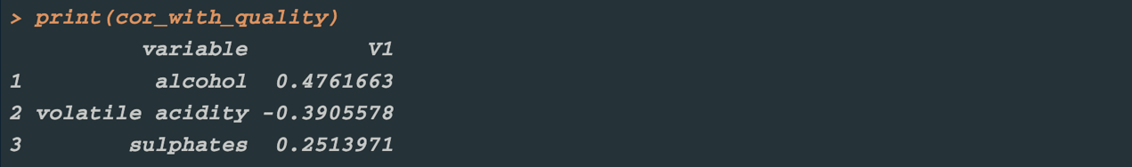
strong_cor_pairs <- which(abs(cor_matrix) > 0.6 & abs(cor_matrix) < 1, arr.ind = TRUE)
strong_cor_df <- data.frame(
var1 = rownames(cor_matrix)[strong_cor_pairs[, 1]],
var2 = colnames(cor_matrix)[strong_cor_pairs[, 2]],
cor = cor_matrix[strong_cor_pairs])
cat("======= Strongly correlated input variable pairs=======")
print(strong_cor_df)
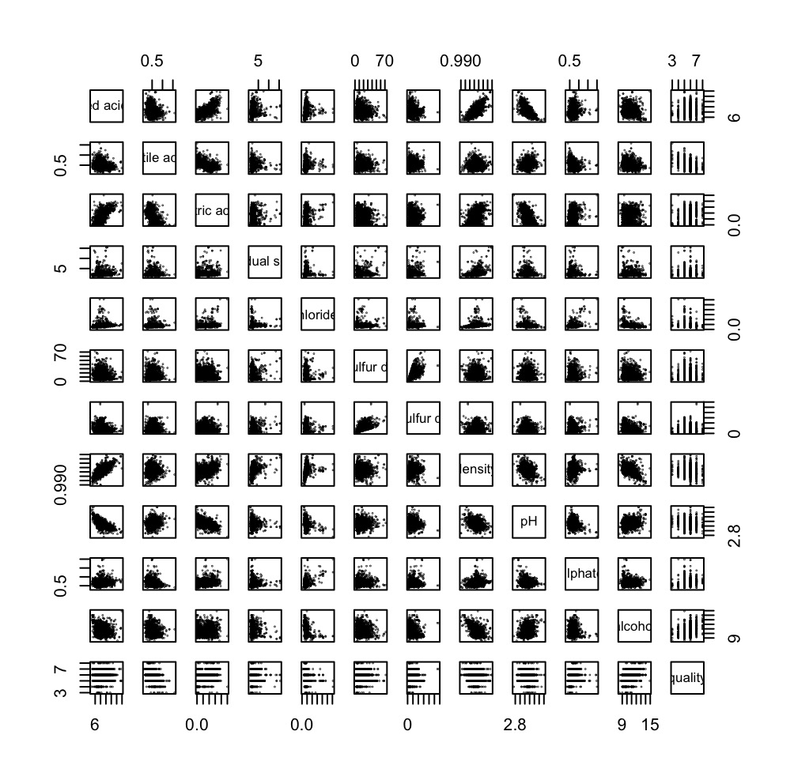
###GLM
library(tidyverse)
library(car)
library(MASS)
##Data Exploration and Visualization
#Create a scatterplot matrix of variables to initially explore relationships between them
#Display all variable names in the dataset
pairs(df[, c(1:11, 12)], pch = 20,cex=0.1)
cat("Variable"); print(names(df))
df_clean <- df %>%filter(`alcohol` >= 8 & `alcohol` <= 22,`volatile acidity` <= 1.5,
`residual sugar` <= 65)
##Filtering Outliers: Limit reasonable ranges for alcohol content, volatile acidity, and residual sugar level
df_clean <- df_clean %>%mutate(
log_residual_sugar = log(`residual sugar` + 1),
log_chlorides = log(`chlorides` + 0.001))
##Building a GLM Model
#Define the generalized linear model formula, using wine quality as the dependent variable and multiple chemical indicators as independent variables.
glm_formula <- quality ~
`fixed acidity` + `volatile acidity` + `citric acid` + log_residual_sugar +
log_chlorides + `free sulfur dioxide` + `total sulfur dioxide` +
density + pH + sulphates + alcohol
glm_model <- glm(formula = glm_formula,data = df_clean,
family = gaussian(link = "identity"), na.action = na.exclude )

cat("======= GLM model summary=======")
summary(glm_model)
##Model Diagnosis and Testing
qq_plot <- ggplot(data.frame(residuals = residuals(glm_model)), aes(sample = residuals)) +
stat_qq() +
stat_qq(size = 1)+
stat_qq_line(color = "orange") +
labs(title = " GLM Residual QQ Plot", x = " Quantiles ", y = " Residuals ") +
theme_minimal()
print(qq_plot)
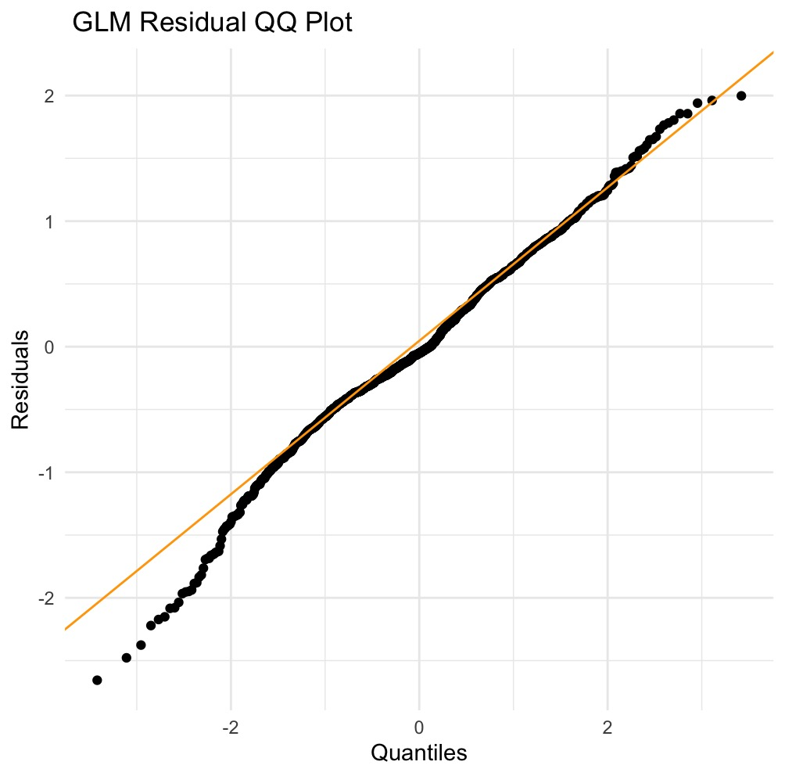
shapiro_test <- shapiro.test(residuals(glm_model))
cat("======= Normality Test for Residuals=======")
print(shapiro_test)
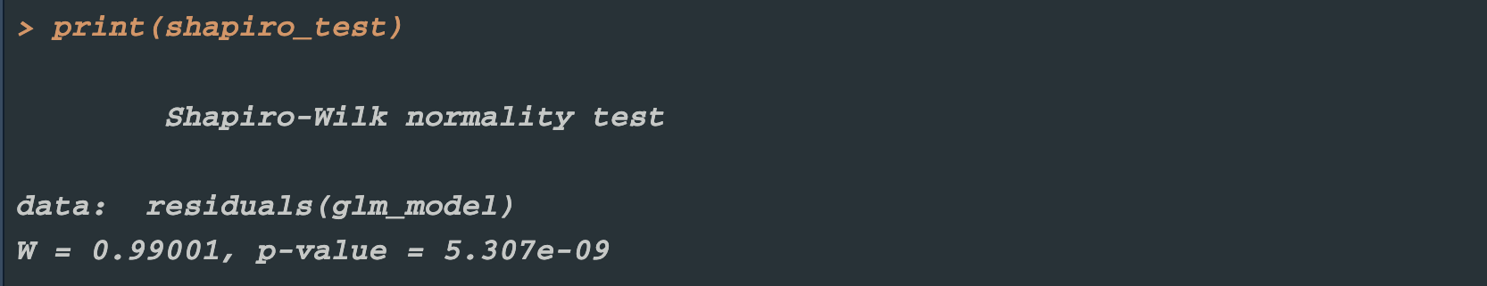
resid_fit_plot <- ggplot(data.frame(fitted = fitted(glm_model),
resid = residuals(glm_model)), aes(x = fitted, y = resid)) +
geom_point(alpha = 0.5) + geom_hline(yintercept = 0, linetype = "dashed") +
labs(title = " Residuals vs Fitted Values", x = " Fitted Values ", y = " Residuals ") +
theme_minimal()
print(resid_fit_plot)
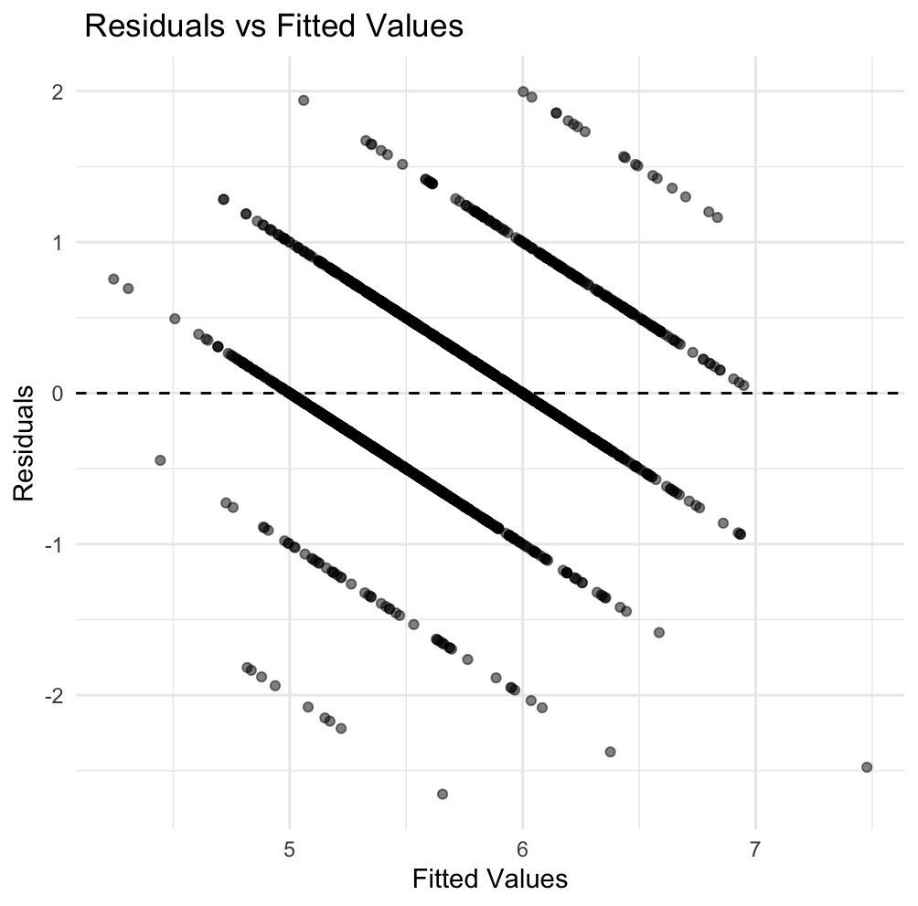
*Wine quality scores are not continuous but integer-valued from 1 to 10.Consequently, the model’s fitted values are also effectively integers, creating the distinct banded regions visible in the plot.
library(lmtest)
bp_test <- bptest(glm_model)
cat("======= Breusch-Pagan =======")
print(bp_test)
vif_values <- car::vif(glm_model)
cat("======= VIF values for each variable =======")
print(vif_values)
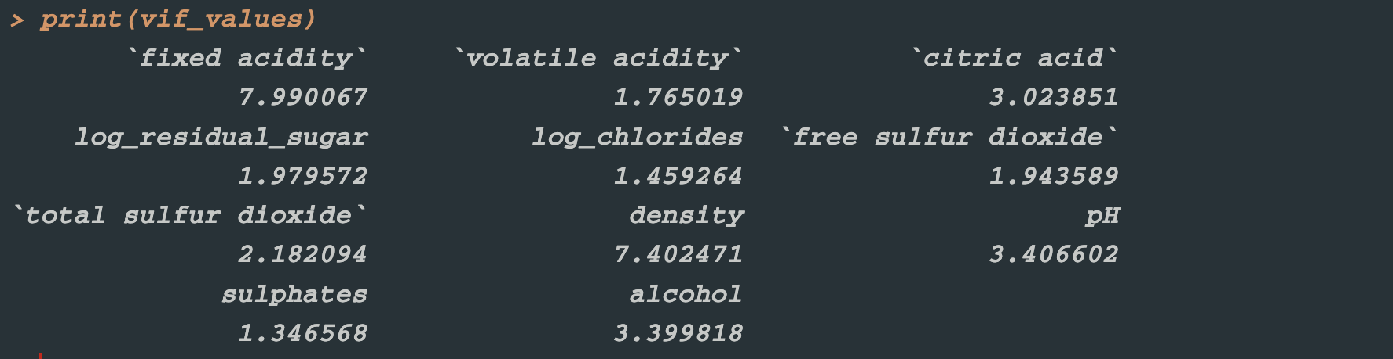
```
##Use AIC criterion for stepwise regression to automatically select the optimal combination of variables and avoid overfitting.
#combination of variables and avoid overfitting.
glm_step <- MASS::stepAIC(glm_model,direction = "both", trace = FALSE )
cat("======= Optimized model results after stepwise regression=======")
summary(glm_step)
##Results Interpretation
#Extract significant variables (p < 0.05), rank them by the magnitude of their effects, indicate the direction of positive or negative impact, and identify the key factors that have a significant influence on wine quality.
sig_vars <- summary(glm_step)$coefficients %>%as.data.frame() %>%
rownames_to_column("variable") %>%
filter(`Pr(>|t|)` < 0.05) %>%
mutate(effect = ifelse(Estimate > 0, " positive effect ", " negative effect "),
magnitude = abs(Estimate)) %>%
arrange(desc(magnitude))
cat("======= Variables that have a significant impact on quality =======")
print(sig_vars[, c("variable", "effect", "Estimate", "Pr(>|t|)")])
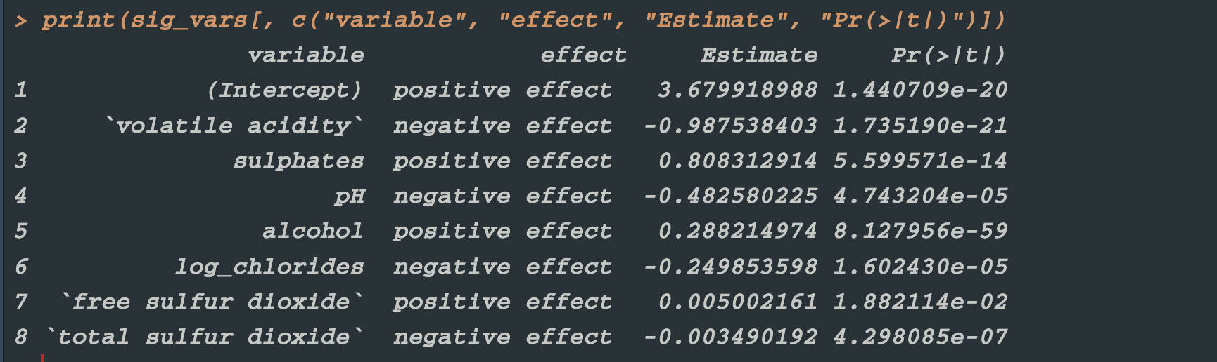

###DEEP LEARNING
cat("===================Deep Learning===================")
library(keras)
library(tidyverse)
library(caret)
library(readr)
library(tensorflow)
##Data Preparation and Preprocessing
#Set a random seed to ensure reproducibility, and split the data into training and testing sets with an 80/20 ratio.
set.seed(123)
X <- df[, 1:11]
y <- df$quality
preprocess_params <- preProcess(X, method = c("center", "scale"))
X_scaled <- predict(preprocess_params, X)
X_matrix <- as.matrix(X_scaled)
y_vector <- as.numeric(y)
train_index <- createDataPartition(y_vector, p = 0.8, list = FALSE)

```
##Neural Network Architecture Design
cat("======= Build a neural network model =======")
model <- keras_model_sequential() %>%
layer_dense(units = 128, activation = "relu", input_shape = ncol(x_train)) %>%
layer_batch_normalization() %>%
layer_dropout(rate = 0.3) %>%

layer_dense(units = 64, activation = "relu") %>%
layer_batch_normalization() %>%
layer_dropout(rate = 0.3) %>%

layer_dense(units = 32, activation = "relu") %>%
layer_dropout(rate = 0.2) %>%

layer_dense(units = 16, activation = "relu") %>%
layer_dense(units = 1, activation = "linear")
##Model Compilation and Configuration
#Track both MAE and MSE simultaneously
model %>% compile(optimizer = optimizer_adam(learning_rate = 0.001),loss = "mse",
metrics = c("mae", "mse"))
cat("=======Model architecture=======")
summary(model)
##Callback Settings
callbacks_list <- list(callback_early_stopping(monitor = "val_loss",
patience = 15,restore_best_weights = TRUE),
callback_reduce_lr_on_plateau(monitor = "val_loss",factor = 0.5,patience = 8,
min_lr = 0.0001),
callback_model_checkpoint(filepath = "best_wine_model.h5",save_best_only = TRUE,
monitor = "val_loss"))
```
##Model Training and Monitoring
#Train for 200 epochs: maximum number of iterations
#Batch size 64: balance memory usage and training efficiency
```{r}
cat("======= Start training the model =======")
history <- model %>% fit(x_train, y_train,epochs = 200,batch_size = 64,
validation_split = 0.2,verbose = 1,callbacks = callbacks_list)

cat("======= Plot training history =======")
plot(history)
##Model Evaluation and Prediction
#Quantitative evaluation: Compute metrics such as MSE and MAE on the test set
```{r}
cat("======= Model Evaluation =======")
test_evaluation <- model %>% evaluate(x_test, y_test, verbose = 0)
cat("Test loss (MSE)", test_evaluation[[1]], "\n")
cat("est Mean Absolute Error (MAE", test_evaluation[[2]], "\n")
cat("Test Mean Squared Error ", test_evaluation[[3]], "\n")
at("=======Prediction=======")
predictions <- model %>% predict(x_test)
predictions <- as.numeric(predictions)

cat("Root Mean Squared Error (RMSE)", rmse, "\n")
cat("Mean Absolute Error (MAE)", mae, "\n")
cat("Coefficient of Determination (R²)", r_squared, "\n")
```
##Performance Analysis and Result Interpretation
```{r}
results_df <- data.frame(ActualQuality = y_test,
PredictedQuality = round(predictions, 2),
AbsoluteError = abs(y_test - predictions),
RelativeError = abs(y_test - predictions) / y_test * 100)

cat("=======Predicted results=======")
print(head(results_df, 10))

quality_performance <- results_df %>%
mutate(QualityGrade = as.factor(ActualQuality)) %>%
group_by(QualityGrade) %>%
summarise(SampleCount = n(),
MeanAbsoluteError = mean(AbsoluteError),
Accuracy = sum(round(PredictedQuality) == ActualQuality) / n() * 100) %>%arrange(QualityGrade)

cat("\nPerformance Analysis by Quality Grade:\n")
print(quality_performance)

###RANDOM FOREST
cat("===================Random Forest===================")
library(randomForest)
library(caret)
library(ggplot2)
library(dplyr)
##Data Preprocessing
names(df) <- make.names(names(df))
df$quality <- as.factor(df$quality)
table(df$quality)
##Data Splitting
#70/30 split: 70% for training, 30% for testing, while maintaining
randomnessset.seed(123)
train_index <- createDataPartition(df$quality, p = 0.7, list = FALSE)
train_data <- df[train_index, ]
test_data <- df[-train_index, ]
train_data$quality <- factor(train_data$quality)
test_data$quality <- factor(test_data$quality, levels = levels(train_data$quality))
##Basic Random Forest Model Construction
#500 trees: A sufficient number of trees to ensure stability
set.seed(123)
rf_model <- randomForest(quality ~ .,
data = train_data,
ntree = 500,
mtry = sqrt(ncol(train_data)-1),
importance = TRUE,
na.action = na.omit)
print(rf_model)
##Basic Model Prediction and Evaluation
#Generate predictions: Perform classification predictions on the test set
#Confusion matrix: Comprehensively evaluate classification performance (accuracy, recall, F1 score, etc.)
predictions <- predict(rf_model, test_data)
conf_matrix <- confusionMatrix(predictions, test_data$quality)
print(conf_matrix)
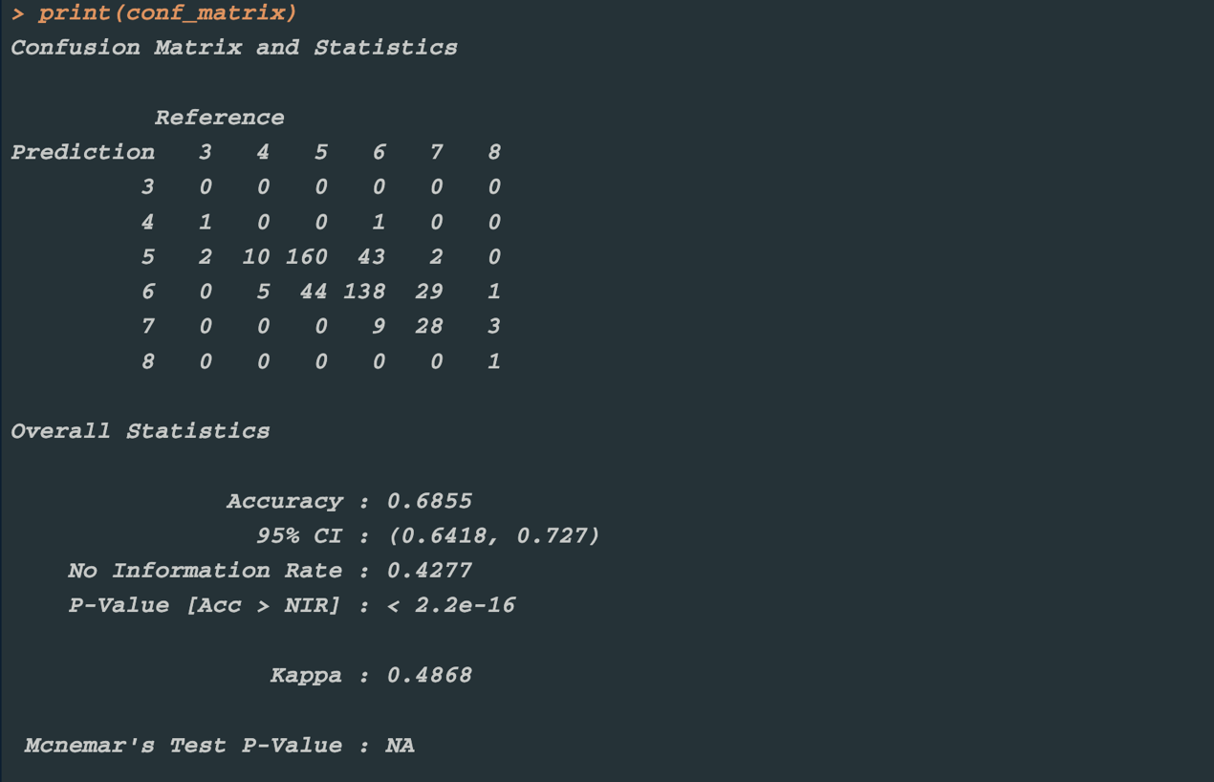
##Variable Importance Analysis
#Visualize variable importance to identify the features that contribute most to wine quality classification, providing a basis for feature selection and model interpretation.
importance_plot <- varImpPlot(rf_model, main = " Variable Importance Plot")
print(importance_plot)
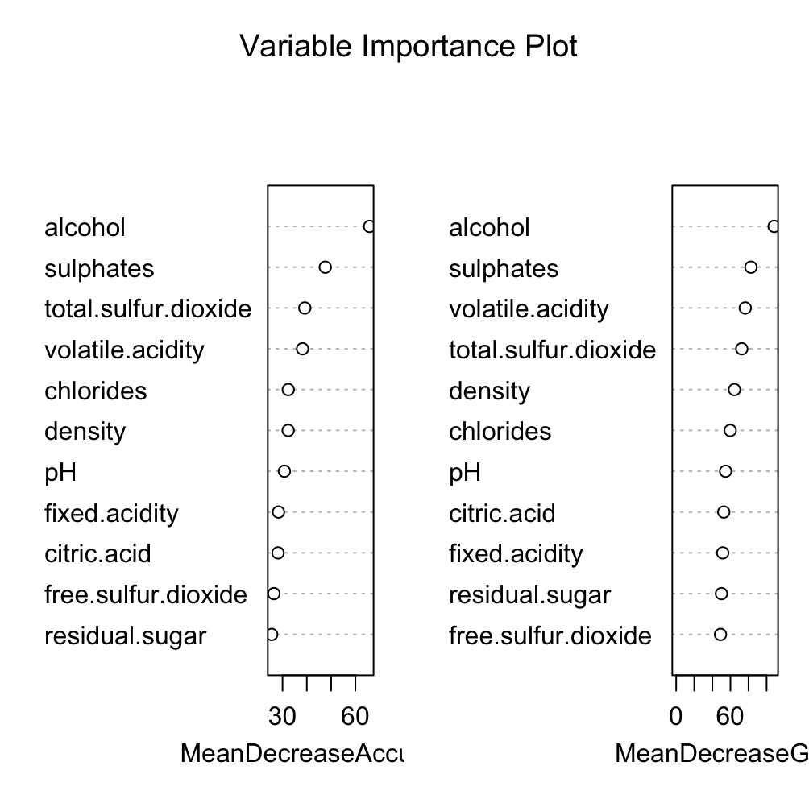
##Hyperparameter Tuning
#More robust performance evaluation
#Multiple parameter combinations: adjust mtry (number of features considered at each split) and minimum node sample size
control <- trainControl(method = "cv", number = 5, verboseIter = TRUE)
tune_grid <- expand.grid(mtry = c(2, 4, 6, 8, 10),
splitrule = "gini",min.node.size = c(1, 5, 10))
rf_tune <- train(quality ~ .,data = train_data,method = "ranger",trControl = control,
tuneGrid = tune_grid,importance = "impurity")
print(rf_tune)
##Final Model Evaluation
#Re-predict: Ensure consistency of factor levels
final_predictions <- predict(rf_model, test_data)
final_predictions <- factor(final_predictions, levels = levels(test_data$quality))
final_conf_matrix <- confusionMatrix(final_predictions, test_data$quality)
print(final_conf_matrix)
accuracy <- final_conf_matrix$overall['Accuracy']
cat("model accuracy:", round(accuracy, 3), "\n")
print(final_conf_matrix$byClass[, c("Precision", "Recall", "F1")])

