Personas

# Mark Magas – IT Consultant Manager

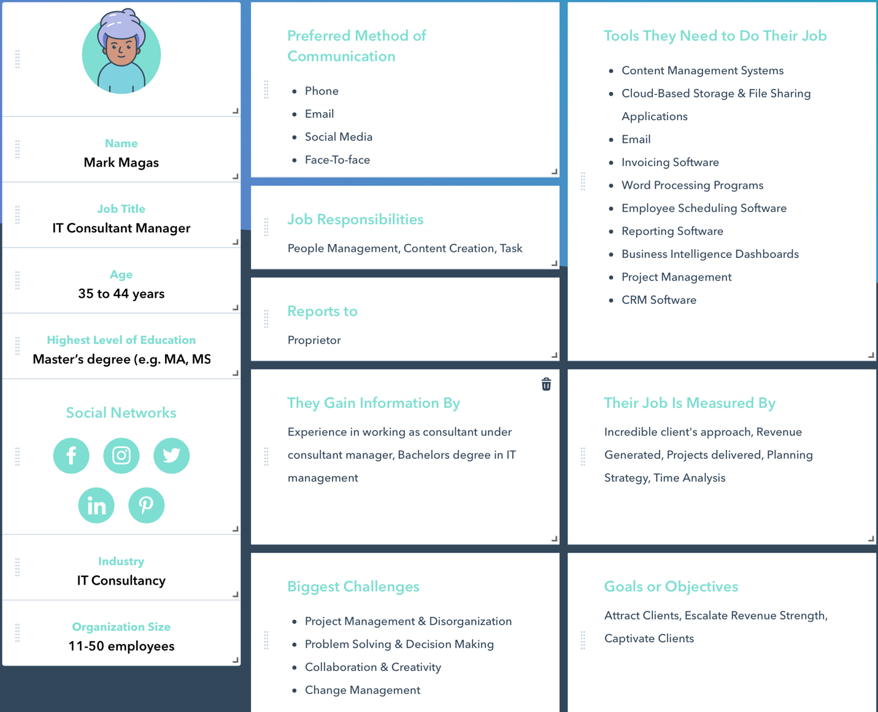

# Jennifer Zayn – IT Consultant Rep

# Rajeev Aidan – IT Consultant Rep

# Jeremy Jessica – Customer

