Capstone Project I

Sprint 4

# Mockup

1. Welcome page – Shows options

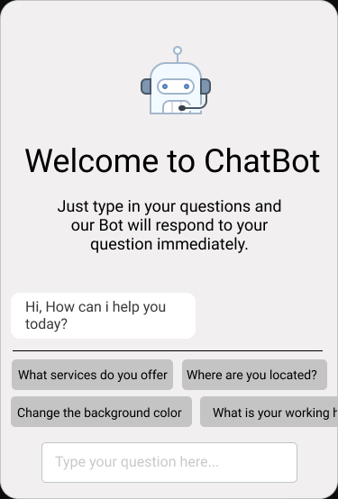

1. Shows options and answers

1. Gives options and asks to select from it

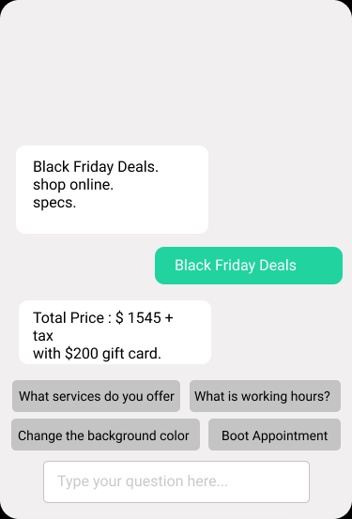

1. Forward to real customer service agent

1. Waiting page for customer service agent

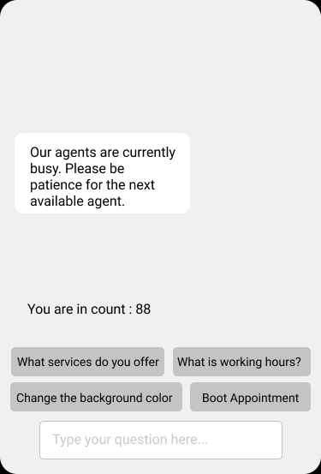

1. Waiting page that gives additional resources

1. Giving current answers to questions from suggestions

