A Minor Project Final Report on

Futsal Arena - A Futsal Booking System

Submitted in Partial Fulfillment of the
Requirements for the Degree of COMPUTER
ENGINEERING under
Pokhara University



Submitted By: -
Suprim Joshi
Suprav Bajracharya
Sarad Kafle
Mission Adhikari

Under the Supervision of
Er. Simanta Kasaju

Date
26 February ,2026

Acknowledgement
We would like to express our sincere gratitude to everyone who contributed to the successful
completion of this project.
First and foremost, we extend our heartfelt thanks to our project supervisor, Er. Simanta
Kasaju, for his invaluable guidance, continuous support, and encouragement throughout this
journey. His insights, expertise, and constructive feedback played a vital role in shaping and
improving our project.
We are also deeply thankful to NCIT (Nepal College of Information Technology) for
providing us with the necessary resources, facilities, and academic environment that made
this project possible. Our sincere appreciation goes to the Head of the Computer
Department, Er. Amit Srivastava, for his motivation, leadership, and support throughout
the course of this project.
Lastly, we extend our appreciation to our team members for their unwavering support,
insightful discussions, and helpful suggestions in resolving challenges throughout the project.

With Regards,
Suprim Joshi
Suprav Bajracharya
Sarad Kafle
Mission Adhikari

Abstract
The increasing demand for organized sports facilities and the growing popularity of futsal have highlighted the need for an efficient system to manage court bookings and related records. Traditional manual methods of handling futsal reservations often result in issues such as double booking, data inconsistency, and difficulty in maintaining customer and payment information. To address these challenges, this project presents a Futsal Management System based on Database Management System (DBMS) concepts.
The proposed system provides a computerized and centralized platform for managing futsal court reservations, user details, and booking schedules. Users can view available courts and time slots and make reservations accordingly, while administrators can manage courts, user records, and booking information through a structured interface.
The system emphasizes data integrity, accuracy, and security by reducing redundancy and enforcing proper constraints within the database. By validating booking requests and updating availability in real time, the system prevents double booking of courts and ensures reliable record keeping. The DBMS enables efficient storage, retrieval, and management of large volumes of data, making the system scalable and dependable.
Overall, the Futsal Management System demonstrates the practical application of DBMS in solving real-world reservation and management problems. It reduces manual workload, improves operational efficiency, and enhances user satisfaction by providing a reliable and user-friendly booking solution. The system can be further extended with features such as online payment integration, automated notifications, and mobile application support in future developments.

Keywords: Futsal Management System, Database Management System (DBMS), Court Booking, Slot Reservation, User Management, Relational Database, Data Integrity, Booking System, Admin Module, Sports Facility Management
TABLE OF CONTENTS
Acknowledgement ii
Abstract iii
List of Tables vi
List of Figures vii
1. Introduction 1
1.1 Background 1
1.2 Statement of the Problem 3
1.3 Objectives 3
1.4 Scope 3
2. Literature Review 5
2.1 Overview of Futsal Management System 5
2.2 Similar Platforms 5
2.3 Key Insights for Futsal Management System 5
3. System Analysis and Methodology 7
3.1 System Analysis 7
3.1.1 Requirement Analysis 7
3.1.2 Feasibility Study 8
3.1.3 Gantt Chart and Task Division 11
3.2 Methodology 12
3.2.1 Iterative Model 13
3.2.2 Software Specification 14
3.3 System Design 16
3.3.1 Sequence Diagram 16
3.3.2 Context Diagram 19
3.3.3 Process Flow Diagram 19
3.3.4 Activity Diagram 20
3.3.5 Schema Diagram 21
4. Implementation and Testing 23
4.1 Module Description 23
4.1.1 User Module 23
4.1.2 Admin Module 23
4.2 Testing 23
4.2.1 Purpose of Testing 23
4.2.2 Unit Testing Test Cases 24
5. Conclusion 26
6. Future Works 27
7. References 28
8. Appendix 29

List of Tables

Table 1 System Requirements 9
Table 2 Task Schedule 10
Table 3 Gantt Chart for Iteration 1 11
Table 4 Gantt Chart for Iteration 2 11
Table 5 Gantt Chart for Iteration 3 12
Table 6 Project Task Division 12
Table 7 Tools Used 16
Table 8 Unit Testing Test Cases 24

List of Figures
Figure 1 Iterative Model of Software Development Life Cycle 13
Figure 2 Sequence Diagram for User Login/Court Booking 17
Figure 3 Sequence Diagram for Admin Login/Court Management 18
Figure 4 Context Diagram 19
Figure 5 Process Flow Diagram 20
Figure 6 Activity Diagram 21
Figure 7 Schema Diagram 22

Introduction

Background
In recent years, sports and recreational activities have gained great importance in promoting a healthy lifestyle. Among indoor sports, futsal has become increasingly popular due to its fast-paced nature and suitability for players of different age groups. As the number of futsal courts and players continues to grow, managing court reservations and customer records using traditional manual methods has become inefficient and unreliable. Most futsal centers still rely on paper-based registers or phone calls for booking courts, which often leads to problems such as double booking, data loss, and poor coordination between customers and administrators.
With the rapid development of information technology, organizations are moving toward computerized systems to manage their operations effectively. A Database Management System (DBMS) plays a crucial role in storing, organizing, and retrieving data in a structured and secure manner. In the context of futsal management, a DBMS can be used to handle information related to users, courts, booking schedules, and payments. A computerized Futsal Management System provides a centralized platform where all reservation activities can be managed systematically, reducing human errors and improving service efficiency.
The Futsal Management System is designed to simplify the court booking process by providing real-time access to court availability and booking schedules. Users can easily view available time slots and reserve courts according to their preferences, while administrators can manage court details, user information, and booking records through a single interface. By using a relational database, the system ensures organized storage of data with minimal redundancy and improved consistency.
One of the major challenges in manual booking systems is the problem of double booking, where the same court and time slot may be reserved by more than one user. This leads to confusion and dissatisfaction among customers. The proposed system addresses this issue by validating each booking request against the database before confirmation. Once a booking is completed, the database is immediately updated to reflect the current status, ensuring accurate and up-to-date information for all users.
Security and data integrity are essential aspects of any management system. The Futsal Management System applies DBMS concepts such as access control, data validation, and constraint enforcement to protect user information and prevent unauthorized modifications. User details, booking history, and transaction records are securely stored and can be retrieved whenever required. This improves transparency and helps futsal owners maintain proper operational and financial records.
Overall, the Futsal Management System demonstrates the practical application of Database Management System principles in solving real-world reservation and management problems. By replacing the traditional manual approach with an automated database-driven system, the project aims to improve accuracy, efficiency, and reliability in futsal court management. The system also provides a strong foundation for future enhancements such as online payment integration, mobile application support, and automated notifications, making it a scalable and modern solution for futsal facilities.

Statement of the Problem
The current futsal court booking and management systems face several challenges that hinder both players and administrators from achieving a smooth and efficient experience. These challenges include:
- Inefficient court scheduling: Manual booking processes and lack of real-time availability updates often lead to double bookings, scheduling conflicts, and underutilization of futsal courts.
- Limited user accessibility: Players frequently struggle to check court availability, view time slots, and make reservations through a single, user-friendly platform.
- Insecure payment handling: Many existing systems lack secure and reliable online payment integration, causing inconvenience and reducing user trust.
- Poor administrative control: Administrators face difficulties in managing bookings, tracking payments, maintaining schedules, and generating reports efficiently.
- Lack of scalability: Traditional systems are often unable to handle increased demand during peak hours, tournaments, or special events, resulting in operational inefficiencies.
There is a need for a centralized and scalable futsal management system that enables players to easily book courts, make secure payments, and manage reservations, while providing administrators with powerful tools to handle scheduling, customer management, and financial tracking efficiently. The proposed Futsal Management System aims to deliver a secure, reliable, and user-centric platform supported by a robust backend infrastructure.

Objectives
Traditional futsal booking systems mostly rely on manual methods such as paper records and phone calls, which are inefficient and prone to errors. Due to the absence of a centralized database system, managing court reservations and customer information becomes difficult and unreliable.So the main objectives of our project is to,
- To develop an online Futsal Management System for viewing availability and booking courts efficiently.
- To ensure real-time booking with accurate data handling and no double reservations.
- To provide an admin panel for managing courts, schedules, bookings, and users.
- To create a secure, reliable, and scalable backend system for future enhancements.

Scope
The scope of the Futsal Management System includes the key functional and database aspects required to manage futsal court reservations efficiently:
- User Authentication and Management:
  - Implement user registration and login functionality.
  - Securely store and manage user credentials in the database.
  - Maintain user sessions for controlled access to system features.

- Court and Schedule Management:
  - Allow administrators to add, edit, and remove futsal courts.
  - Manage available time slots for each court using the database.
  - Provide real-time updates to ensure accurate and visible court schedules.

- Court Booking and Reservation System:
  - Enable users to reserve courts for specific dates and time periods.
  - Prevent double booking by validating reservations against existing records.

- Database Management:
  - Use a relational database to store and manage user information, court details, and booking records.
  - Ensure organized and consistent data handling across the system.
  - Security and Data Handling:
  - Apply input validation and access control measures.
  - Protect user and booking data from unauthorized access.

- Admin Dashboard:
  - Provide a centralized interface for administrators to manage courts, booking schedules, and user records effectively.
  - Development and Testing:
  - Use standard development tools for system implementation.
  - Perform testing to verify functionality and reliability of the system.

- Development and Testing:
  - Use standard development tools for system implementation.
  - Perform testing to verify functionality and reliability of the system.

Literature Review
The literature review explores existing research and systems related to Futsal Management Systems, focusing on the technologies, methodologies, and challenges associated with such platforms. The objective of this review is to analyze related work and identify the mechanisms used in previous studies to build efficient and scalable futsal reservation systems.

Overview of Futsal Management System
The sports and recreation industry has increasingly adopted digital platforms for futsal court booking, driven by the need for convenience and real-time access. Research highlights the importance of scalable backend systems, real-time court availability updates, and secure payment processing in enhancing user experience and operational efficiency. Studies also emphasize the role of user-friendly interfaces and automated booking notifications in increasing user engagement and satisfaction.
However, many existing futsal reservation systems face challenges such as:
- Inefficient court management: Overbooking and lack of real-time updates lead to user dissatisfaction and operational inefficiencies.
- Limited backend scalability: Systems often struggle to handle high traffic during peak hours, resulting in slow performance or crashes.
- Insecure payment processing: Many platforms lack robust payment gateways, leading to trust issues among users.
These challenges highlight the need for a centralized and scalable futsal reservation system that provides users with a seamless booking experience while enabling administrators to manage court schedules, time slots, and reservations efficiently.

Similar Platforms
Several existing platforms, such as Playtomic and Futsal Booking, have successfully implemented futsal reservation systems. These platforms utilize scalable backend architectures and real-time databases to handle high traffic and ensure accurate court availability. However, they often rely on proprietary technologies, making it difficult for smaller futsal centers or independent developers to replicate their success.
Research also highlights the use of Node.js and Express.js in building scalable backend systems for sports reservation and e-commerce platforms. These technologies are known for their flexibility, performance, and ability to handle real-time updates, making them ideal for futsal reservation systems. Additionally, MySQL is widely used for its reliability and efficiency in managing large datasets, such as court details, user information, and booking records.

Key Insights for Futsal Management System
Based on the literature review, the Futsal Management System will leverage the following insights:
- Scalable backend architecture: Use Node.js and Express.js to build a high-performance backend capable of handling real-time updates and peak traffic.
- Real-time court management: Implement a real-time booking system to prevent double booking and ensure accurate court availability.
- Secure payment processing: Integrate a reliable payment gateway to ensure secure and seamless transactions.
- Efficient database management: Use MySQL to store and manage court details, user information, and booking records efficiently.
By addressing these key areas, the Futsal Management System aims to provide a user-friendly platform that meets the needs of both users and administrators.

System Analysis and Methodology

System Analysis
System analysis is the process of observing a system for troubleshooting or development purposes. It is applied to information technology, where computer-based systems require defined analysis according to their makeup and design. For the Futsal Management System, this process involves evaluating the backend infrastructure to ensure it supports real-time court reservations, efficient data management, and secure operations.

Requirement Analysis
Requirement analysis involves identifying the essential needs and conditions required for developing or modifying a system. This process ensures that the expectations of stakeholders, including users and administrators, are carefully considered. As a fundamental phase of requirement engineering, it includes gathering, analyzing, documenting, validating, and managing system requirements to ensure successful project execution.
Before initiating the development process, it is crucial to collect all necessary requirements. The core requirements define the foundation of the Futsal Management System, shaping its functionalities and objectives, with a strong emphasis on backend capabilities.

- Functional Requirements
The system must provide the following backend functionalities:
- Keeping records of users and administrators.
- Keeping records of available futsal courts and their schedules.
- Ensuring that each court can be booked only once per time slot to prevent double booking.
- Keeping details of whether a booking has been paid and confirmed.
- Allowing administrators to add, update, or remove courts and time slots.
- Non-Functional Requirements
- User Interface:
The backend should support a simple and efficient API structure to enable a user-friendly frontend experience.
- Scalability:
The system should handle multiple users and concurrent booking requests efficiently.
The server should process and respond to requests effectively under high traffic.
- Portability:
The platform should be accessible via web browsers on various operating systems.
- Maintainability:
The system should be easy to update and maintain.
There should be a clear separation between frontend and backend logic.
- Security:
The system must be protected from unauthorized access to user and admin data.
The database must be secured against attacks such as SQL injection.
Secure access to user and booking data must be enforced through proper validation and encrypted communication.
- Software Requirements
- Framework: Express.js with Node.js for backend development
- Database: MySQL for storing court, user, and booking data
- Server: Node.js with Express.js for handling API requests and backend logic
- Supporting Libraries:
  - body-parser for parsing incoming JSON request data
  - dotenv for managing environment variables securely
  - nodemon for automatic server restarts during development

Feasibility Study
A feasibility study is conducted to determine whether the proposed system is viable for implementation. It assesses the system’s capabilities, its impact on stakeholders, its ability to meet user requirements, and the efficient use of resources. Typically, this study is carried out by a small team with expertise in information system techniques, a thorough understanding of the relevant domain, and proficiency in system analysis and design. While any project can be feasible with unlimited resources and time, software development often faces constraints such as limited resources and tight delivery timelines. Therefore, evaluating a project’s feasibility at an early stage is both necessary and practical. The key factors considered in the feasibility study include:
- Technical Feasibility
- Operational Feasibility
- Economic Feasibility
- Schedule Feasibility

Technical Feasibility
Technically, the proposed Futsal Management System is a web-based platform designed to automate court booking, scheduling, and payment management. All technologies required for its development are open-source and freely available, making the system technically feasible. The necessary hardware and software resources for development and deployment are easily accessible.
The backend system, developed using Node.js, Express.js, and MySQL, ensures efficient data handling, secure transaction processing, and real-time court availability updates. The frontend is built using modern web technologies such as HTML, CSS, JavaScript, and responsive frameworks, providing a user-friendly and interactive interface. Integration with secure online payment gateways enhances reliability and user trust.
Additionally, cloud-based hosting and scalable architecture enable the system to handle high traffic during peak hours and tournaments. Overall, the system is technically feasible, scalable, secure, and capable of meeting both user and administrative requirements effectively.

Table 1 System Requirements
Operating System | Windows 7 or higher
Processor | 1 GHz or higher
RAM | 1 GB or higher
Disk Space | 1 GB or higher
Device | Laptop, PC, or Mobile
Browser | Recommended Firefox, Chrome
Frontend Tools | HTML, CSS, JS, React
Backend Tools | Node.js, Express.js, MySQL

Operational Feasibility
The system is straightforward to operate with basic computer knowledge and requires an internet connection to update and retrieve data from the MySQL database. The Futsal Management System meets the operational requirements of a futsal court booking platform, providing real-time court reservation, schedule management, and admin control capabilities. Hence, the system is operationally feasible.

Economic Feasibility
Economic feasibility involves a cost/benefit analysis to evaluate the effectiveness of the proposed system. The development cost for the Futsal Management System is minimal since it relies on lightweight, open-source tools like Node.js, Express.js, and MySQL. No additional hardware or proprietary software is required, and all development toolkits are freely available. The costs associated with the system are justified by its benefits, making it economically feasible.

Schedule Feasibility
The project schedule was designed based on requirements and constraints. The Futsal Management System is expected to be completed in approximately 2 months, with the majority of the time dedicated to backend development, database integration, and testing. The timeline is structured into increments to ensure steady progress and timely delivery of functional modules.
Table 2 Task Schedule
Tasks | First Increment (in days) | Second Increment (in days) | Third Increment (in days) | Approx. Duration (in days)
Requirement Analysis | 2 | 0 | 0 | 2
Planning | 2 | 4 | 3 | 9
Documentation | 12 | 11 | 12 | 35
Coding | 3 | 13 | 13 | 29
Testing | 0 | 4 | 7 | 11

Gantt Chart and Task Division

Iteration 1:
Table 3 Gantt Chart for Iteration 1
Date | 10th Nov | 12th Nov | 14th Nov | 16th Nov | 18th Nov | 20th Nov | 22nd Nov
Requirement Analysis
Planning

Documentation

Coding

Testing

Completed Task
Pending Task

Iteration 2:
Table 4 Gantt Chart for Iteration 2
Date | 6th  Dec | 8th  Dec | 10th  Dec | 12th  Dec | 14th  Dec | 16th  Dec | 18th  Dec
Requirement Analysis
Planning

Documentation

Coding

Testing

Iteration 3:
Table 5 Gantt Chart for Iteration 3
Date | 6th  Dec | 8th  Dec | 10th  Dec | 12th  Dec | 14th  Dec | 16th  Dec | 18th  Dec
Requirement Analysis
Planning

Documentation

Coding

Testing

Project Task Division:
Table 6 Project Task Division
Project Task | Done By
Frontend  (UI/UX) | Mission Adhikari  Sarad Kafle
Backend  (Database) | Suprim Joshi (Backend,Database)  Suprav Bajracharya (Database)

Methodology
We have planned to apply the following methodologies to utilize knowledge, skills, tools, and techniques across a broad range of activities to meet the requirements of our project, the Futsal Management System. This section provides detailed information about the software development process, project approach, and the tools used for developing our futsal court reservation platform, with a particular focus on backend implementation.

Iterative Model
The framework adopted for developing the Futsal Management System is the iterative model of the software development life cycle (SDLC). In this model, an initial, simplified implementation of a small set of software requirements is created first. This is followed by iterative enhancements to the initial model, progressively incorporating additional features and refining the system until all requirements are met and the software is ready for deployment.
The iterative approach ensures that the backend, which handles critical functionalities like real-time court booking, schedule management, and database operations, is developed and tested incrementally for reliability and performance.
The following subsections briefly describe the phases of the iterative SDLC model applied during the development of the Futsal Management System.
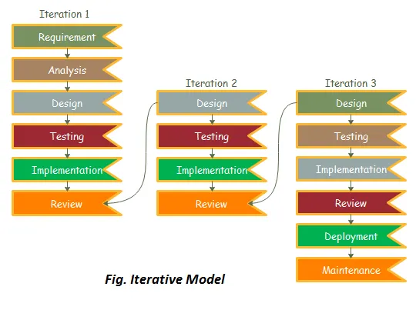
Figure 1 Iterative Model of Software Development Life Cycle
(Note: This figure would visually depict the iterative process with phases like Analysis, Design, Coding, and Testing repeating in cycles.)

Analysis
In this phase, an analysis is conducted to identify the system’s requirements. This involves gathering input from stakeholders, such as users and administrators, to define the functional and non-functional needs of the Futsal Management System. The outcome of this phase is the System Requirement Specification (SRS), which serves as the foundation for subsequent development stages.

Design
During this stage, the System Requirement Specification (SRS) is translated into the system’s design. For the Futsal Management System, this involves creating backend-focused diagrams such as:
- Context Diagram: Shows interactions between users, administrators, and the system.
- Data Flow Diagram (DFD): Illustrates how booking and court data move through the system.
- Use Case Diagram: Defines actions performed by users and administrators (e.g., booking courts, managing schedules).
- Sequence Diagram: Details backend processes such as court reservation, booking confirmation, and payment handling.

Coding
In this phase, the coding process brings the designed system to life. The backend is developed using Node.js and Express.js to handle API endpoints, business logic, and database interactions with MySQL.
Supporting tools and libraries include:
- body-parser: Processes incoming JSON requests.
- cors: Enables cross-origin requests between frontend and backend.
- dotenv: Secures environment variables.
The iterative coding approach allows for gradual implementation of features such as user management, court reservation, schedule updates, and transaction processing, culminating in a fully functional system by the project’s completion.

Testing
During this phase, the system undergoes iterative testing and refinement. Each cycle involves testing backend functionalities, such as:
- Real-time court availability updates
- Database integrity and data consistency
- API responsiveness and reliability
Modifications are made to address any identified issues. The use of nodemon facilitates rapid development by automatically restarting the server during testing, ensuring efficient debugging and validation of the system.

Software Specification
This section outlines the software tools and technologies used in the development of Futsal Management System, with a focus on backend components and their integration with the React-based frontend.

React.js
React.js, a JavaScript library, serves as the foundational technology for building Futsal Arena’s frontend. It enables the creation of dynamic, component-based user interfaces using a virtual DOM for efficient rendering. React.js structures the application into reusable components—like movie listings, seat selectors, and booking forms—enhancing interactivity and responsiveness while seamlessly interfacing with backend APIs.

CSS
CSS (Cascading Style Sheets) complements React.js by controlling the visual presentation of the frontend. It defines styles, layouts, and responsive designs, ensuring that components like court cards, booking interfaces, and schedule displays are visually appealing and adaptable across devices. CSS works alongside React.js to separate presentation from logic, delivering a polished and user-friendly experience for players and administrators.

JavaScript
JavaScript, paired with Node.js and React.js, forms a powerful ecosystem for the Futsal Management System. On the frontend, JavaScript powers dynamic features like real-time court availability updates within React components. Node.js, a JavaScript runtime, drives the backend with its event-driven architecture, handling server-side logic, API requests, and database operations. Together, these technologies enable a full-stack solution, seamlessly connecting the React frontend to the Express.js backend for a responsive and interactive futsal booking experience.

MySQL
MySQL is a relational database management system used to store the Futsal Management System’s structured data, including user records, court details, available time slots, and booking information. Its high performance, reliability, and scalability support the backends’ transactional and real-time requirements, ensuring efficient data retrieval and storage for court reservations, schedule management, and user administration.

Express.js
Express.js, a lightweight and flexible web framework for Node.js, forms the core of the Futsal Management System’s backend. It facilitates the development of RESTful APIs, manages routing, and processes HTTP requests and responses. Integrated with libraries like body-parser for parsing JSON data and cors for cross-origin support, Express.js ensures robust communication between the React frontend and the MySQL database, enabling smooth real-time court booking and schedule management.

Supporting Libraries
- body-parser: Parses incoming request bodies (e.g., JSON payloads) to handle user inputs like booking requests efficiently.
- dotenv: Manages environment variables (e.g., database credentials) securely, enhancing backend configuration.
- nodemon: Automatically restarts the Node.js server during development, streamlining coding and testing workflows
Table 7 Tools Used
Tools | Purpose
Visual Studio | Code Editor
Code | Database
MySQL | Backend
Express.js | Framework
React.js | Frontend
Node.js | Server
Git & GitHub | Version Control
Postman | API Testing

System Design
The Futsal Management System is designed to deliver an efficient and seamless court reservation experience for users and administrators, with a strong emphasis on backend functionality. Users can register, browse available futsal courts, check schedules, select time slots, and book courts. Administrators can manage court details, schedules, availability, and booking records. The backend, powered by Express.js and MySQL, ensures real-time updates, data integrity, and efficient processing of requests.
The platform includes features such as real-time court booking to prevent double reservations, secure handling of user and booking data, and an admin dashboard for operational oversight. The design prioritizes scalability, reliability, and ease of use, ensuring a smooth experience for all stakeholders while maintaining an intuitive and efficient system architecture.

Sequence Diagram
A sequence diagram is an interaction diagram that illustrates how messages flow between different system components, showing the order of events and interactions. For the Futsal Management System, sequence diagrams have been designed to represent key backend processes, such as user login, court booking, and payment handling. Below is an example focusing on the login process, highlighting the interaction between the frontend, backend, and database.

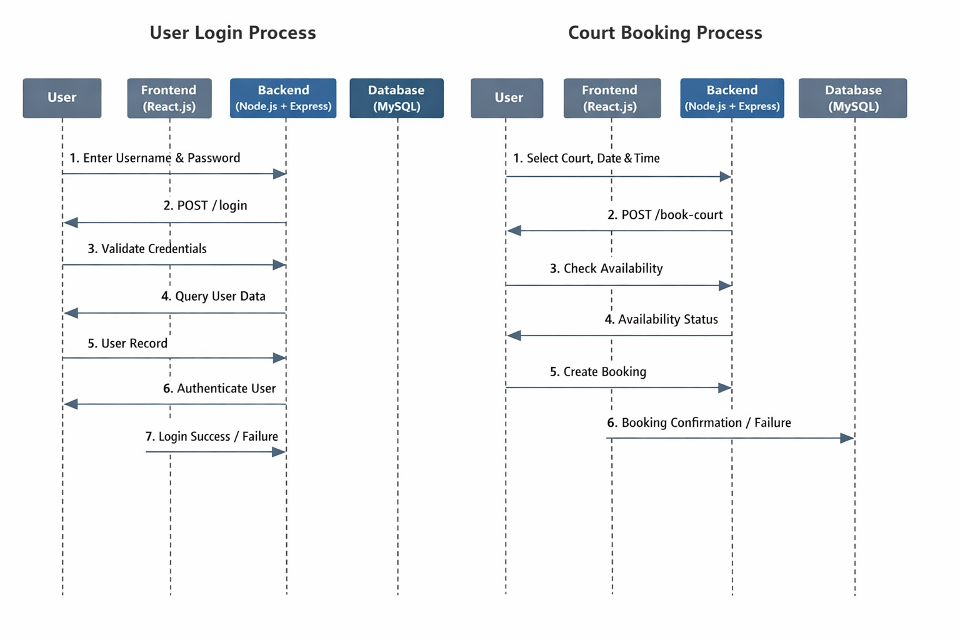
Figure 2 Sequence Diagram for User Login/Court Booking
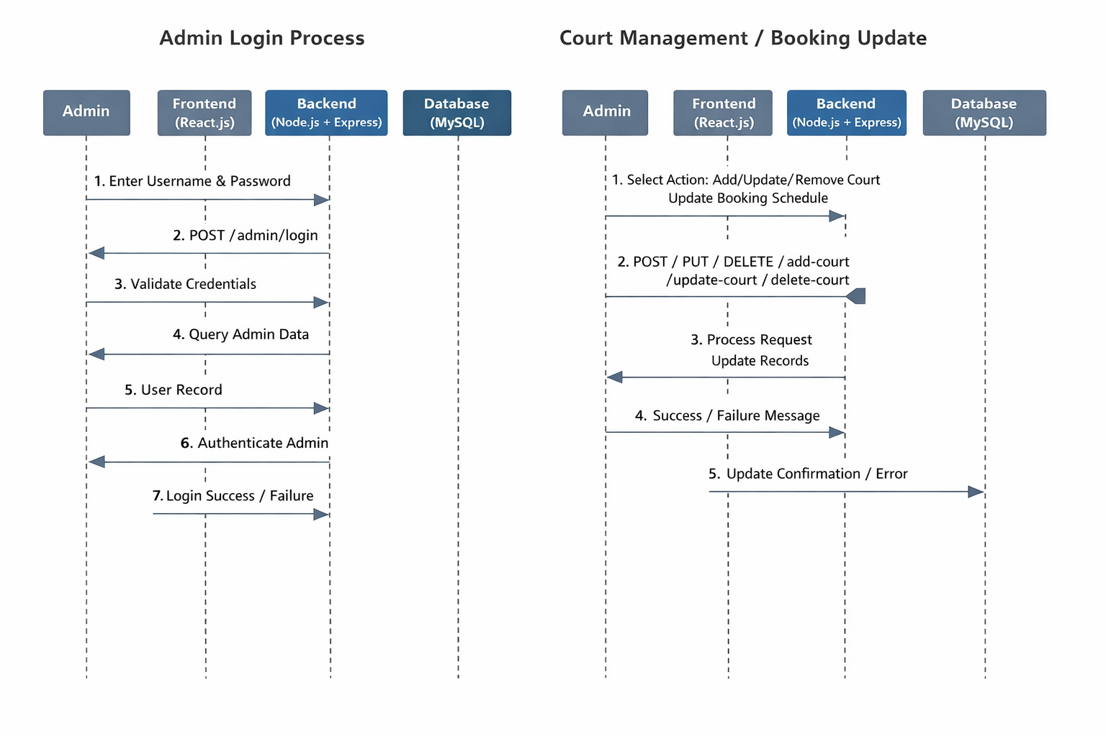
Figure 3 Sequence Diagram for Admin Login/Court Management
- The User (via the React frontend) sends a login request with credentials to the Backend (Express.js server).
- The Backend processes the request using body-parser to parse the JSON payload.
- The Backend queries the MySQL Database to verify the user’s credentials.
- The Database returns a success/failure response to the Backend.
- The Backend sends an authentication response (e.g., session confirmation) back to the Frontend.
- The Frontend updates the user interface based on the response (e.g., granting access or displaying an error).

Context Diagram
The overall explanation of a system is represented by a context diagram. Using this diagram, we define the boundary between the system, or part of a system, and its environment, showing the entities that interact with it. The diagrammatic representation of our project’s context diagram is represented below:

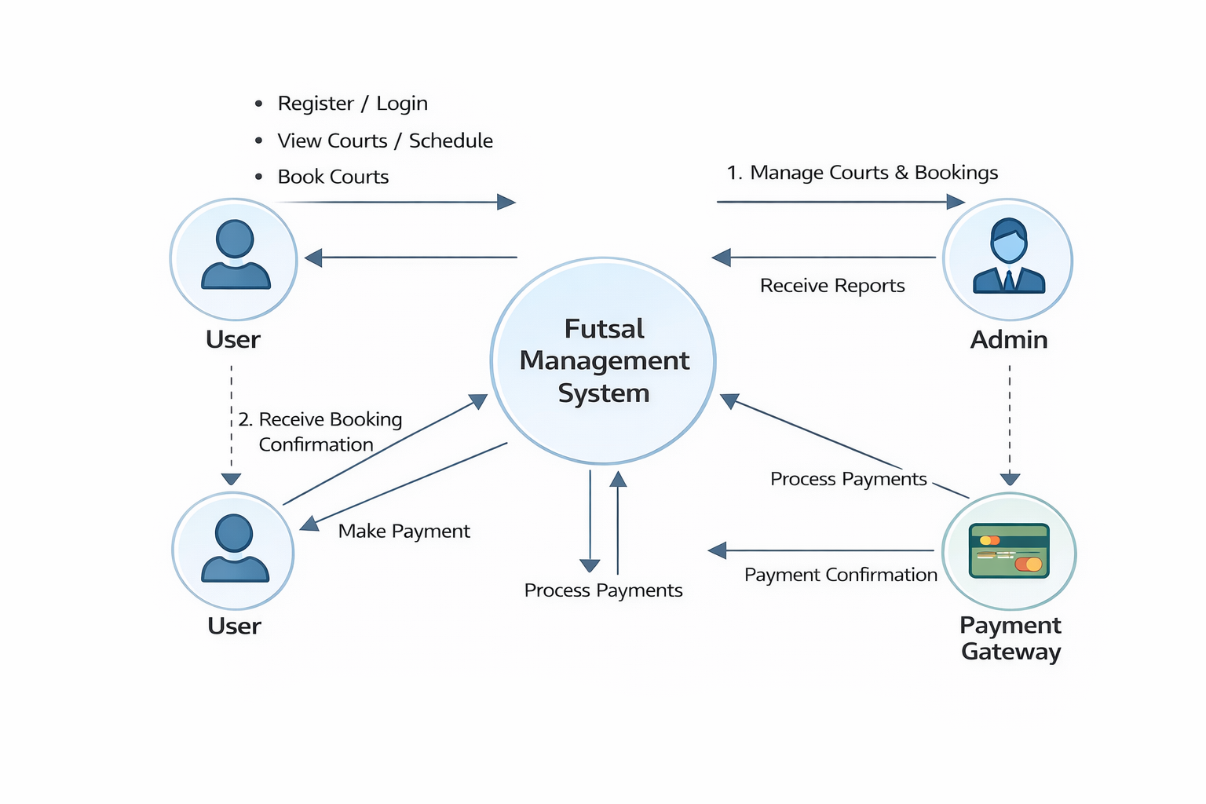
Figure 4 Context Diagram

Process Flow Diagram
A Process Flow Diagram (PFD) visually represents a process, showcasing the sequence of actions, decisions, and interactions within a system. It provides a clear understanding of how users, data, and system components work together to complete specific tasks.
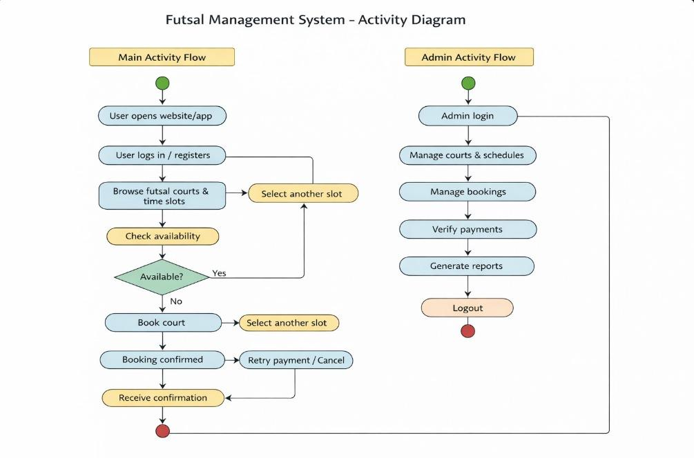
Figure 5 Process Flow Diagram

Activity Diagram
An activity diagram is a type of flowchart that illustrates the progression from one activity to another. It shows the sequence of actions, starting from the initial point and moving through to the final point, representing the workflow.

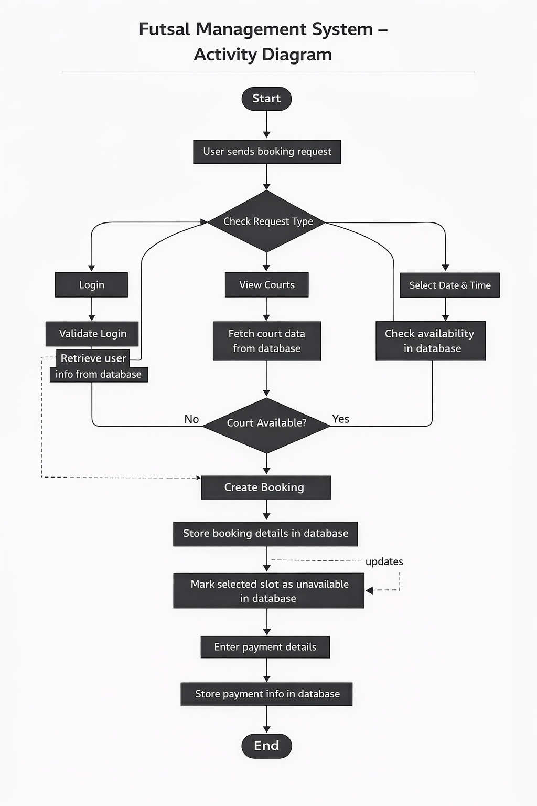
Figure 6 Activity Diagram

Schema Diagram
A Schema Diagram is a visual representation of a database structure, illustrating how data is
organized and related within a system. It helps developers and stakeholders understand the
structure, relationships, and constraints of the database.

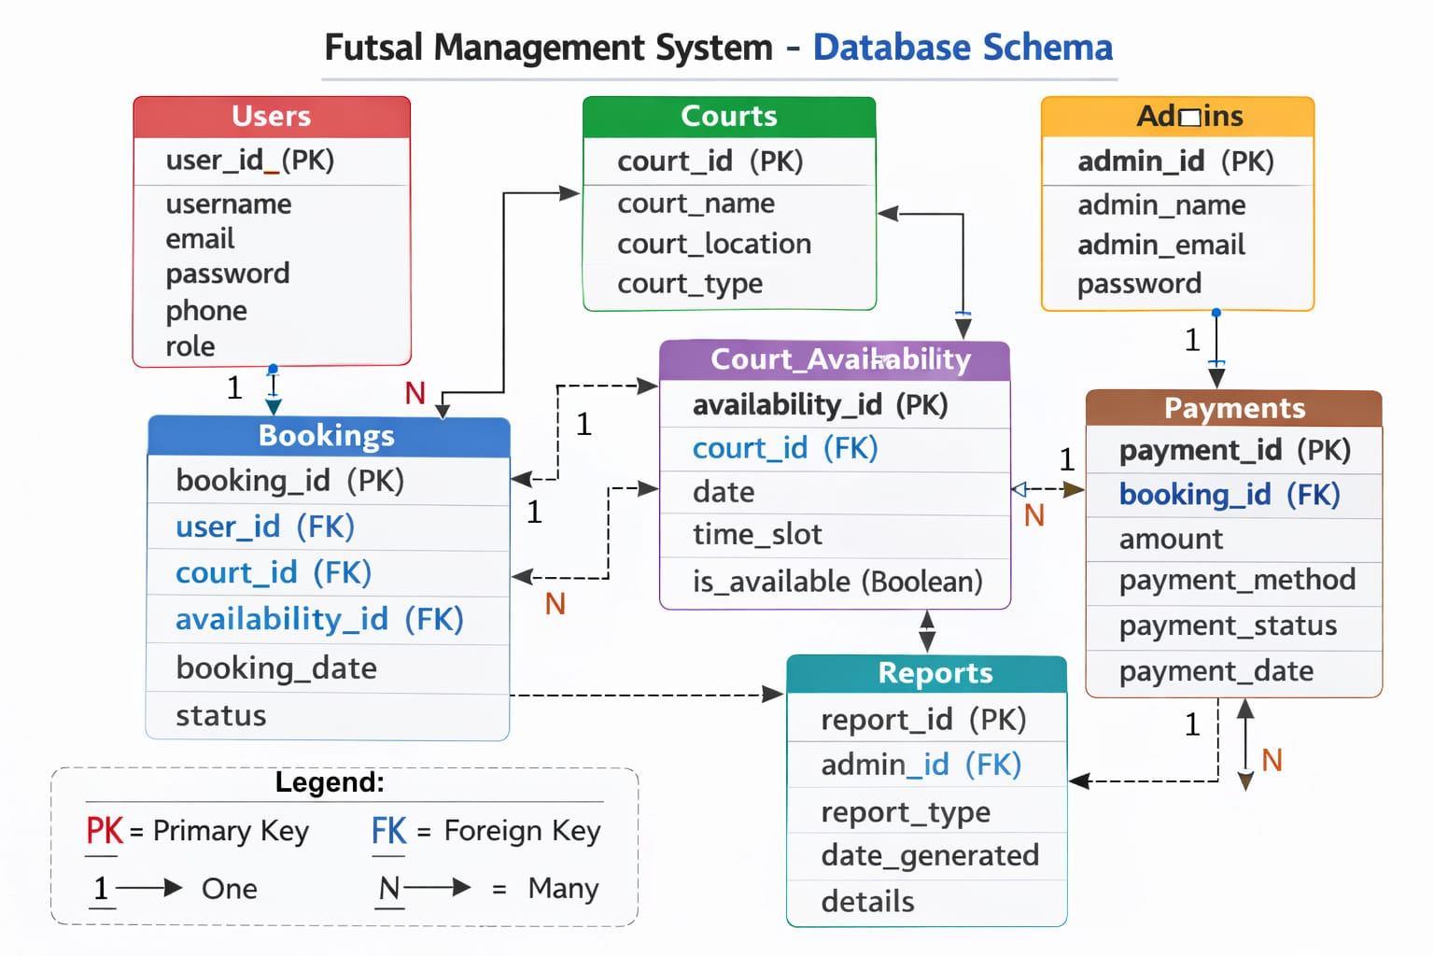
Figure 7 Schema Diagram

Implementation and Testing
The implementation phase demonstrates how the Futsal Management System is applied to ensure optimal performance, focusing on the backend infrastructure that drives its core functionalities. This chapter details the modular structure of the system and the testing processes used to validate its reliability and effectiveness.

Module Description
A well-structured design enhances maintainability and scalability. The Futsal Management System follows a modular, top-down approach, dividing the system into smaller, independent components to improve efficiency and reduce dependencies. Each module operates autonomously, ensuring that changes or issues in one do not impact others. The main modules of the Futsal Management System are:
- User Module
- Admin Module

User Module
The User Module is designed for customers who browse futsal courts, check available time slots, and book courts. Powered by the Express.js backend and MySQL database, this module handles user authentication, court browsing, time slot selection, and booking confirmations. It ensures secure access to user-specific features, such as booking history, through basic session management. The primary goal is to provide a seamless and interactive experience for reserving futsal courts.

Admin Module
The Admin Module is tailored for administrators managing the platform. It allows them to add, update, or remove movie listings and showtimes, configure seat availability, and monitor bookings. The backend ensures secure access to admin functionalities and maintains data integrity in MySQL through controlled database operations. This module supports theater staff in efficiently overseeing reservation operations.

Testing
The Admin Module is tailored for administrators managing the platform. It allows them to add, update, or remove futsal courts and time slots, configure court availability, and monitor bookings. The backend ensures secure access to admin functionalities and maintains data integrity in MySQL through controlled database operations. This module supports futsal center staff in efficiently overseeing reservation operations.

Purpose of Testing
Testing verifies that the Futsal Management System delivers what was specified, meeting functional, performance, and design requirements outlined in the system specifications. It evaluates the system’s ability to handle real-time court booking operations and maintain data consistency. The primary objectives of testing include:
- To identify defects in the project.
- To confirm the proper functioning of each module (User and Admin).

Unit Testing Test Cases
Unit Testing focuses on validating individual components of the system to ensure they perform as expected. For the Futsal Management System, this involves testing specific backend units (e.g., API endpoints, database queries, and booking logic) implemented with Express.js and MySQL. Each unit is tested independently to confirm its functionality. The table below outlines the unit tests conducted:
Table 8 Unit Testing Test Cases
Test No. | Unit | Test | Expected Result | Test Output
1 | Sign Up | Check if a new user account can be created with required details. | Account successfully created | Successful
2 | Login | Verify login with valid username and password. | User successfully logged in | Successful
3 | Add Court | Check if an admin can select a court successfully. | Court added successfully | Successful
4 | Search Court | Confirm Court data is retrieved correctly. | Courts listed successfully | Successful
5 | Select Court | Check if available Court can be selected for a specific time. | Court selected successfully | Successful
6 | Book Court | Verify that a Court is booked and is reserved. | Court booked successfully | Successful
7 | View Booking | Check if a user can access their booking details. | Booking details accessible | Successful

Conclusion
With the growing reliance on digital platforms for sports and recreation, online futsal court reservation systems have become increasingly important for both users and administrators. The Futsal Management System provides a reliable platform where users can browse courts, check schedules, and book time slots seamlessly, while administrators can efficiently manage court listings, schedules, and reservations. As online booking gains popularity, this system offers a convenient and dependable solution for accessing futsal facilities.
Research shows that user experience is crucial for the success of digital platforms, with first impressions often influencing user retention. With this in mind, the Futsal Management System is designed with a focus on backend efficiency—powered by Express.js and MySQL—to ensure real-time court availability, fast response times, and secure data management. The architecture supports a smooth booking process, delivering an intuitive experience from court selection to reservation confirmation.
This project highlights the importance of modern futsal reservation systems and demonstrates their effective implementation using Node.js, Express.js, and MySQL. The development of the system provides valuable insight into building a backend-driven web application that improves the court booking process, ensuring reliability and scalability for both users and administrators.

Future Works
The Futsal Management System, like any evolving project, has room for growth as technology and user expectations advance. While the current system is fully operational, future enhancements can make it more robust and feature-rich. Its modular backend architecture, built with Express.js and MySQL, allows for seamless integration of additional functionalities. Potential improvements include integrating a payment gateway for online transactions, adding real-time notifications for booking updates, and implementing advanced analytics for administrators to optimize court utilization and operations. As user and industry needs evolve, the system can adapt to support these enhancements, ensuring it remains a relevant and efficient tool in the futsal reservation ecosystem.

References
Smith, J. (2020). Scalable Backend Systems for E-commerce Platforms. Journal of Web Development.
Brown, A. (2019). User Experience in Online Reservation Systems. International Journal of Human-Computer Interaction.
Lee, S. (2021). Real-time Updates in Reservation Systems. Proceedings of the International Conference on Software Engineering.
Patel, R. (2018). Challenges in Movie Ticket Booking Systems. Journal of Entertainment Technology.
Kumar, V. (2022). Secure Payment Processing in Online Platforms. Journal of Cybersecurity.
Taylor, M. (2020). Case Study: BookMyShow and Fandango. International Journal of Digital Platforms.
Johnson, L. (2019). Node.js and Express.js for Scalable Backend Development. Journal of Web Technologies.
Garcia, P. (2021). MySQL for Efficient Data Management in Reservation Systems. Journal of Database Management.

Appendix

