CMPS 350 Web Development
Course Project Phase 2

Social Media Platform

Course: Web Development Fundamentals

Group Members
Sadeq Maknoon — 202206353
Abdulaziz Al-heidous — 202102762
Hamad Ashour — 202010951
Salman Janahi — 202211302

1. Data Model
1.1 Entity Relationship Schema Diagram
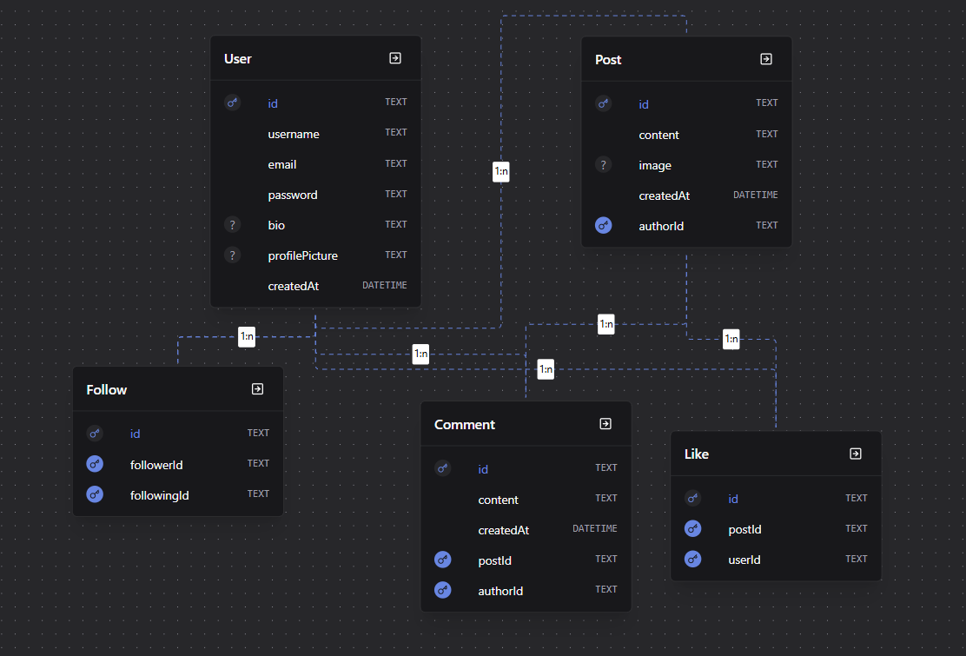

1.2 Prisma Schema
USER
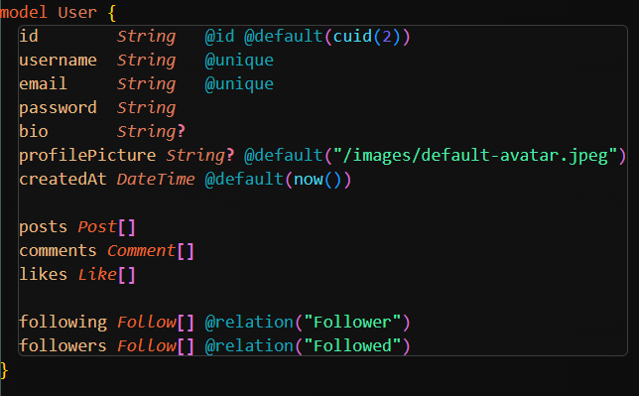

POST
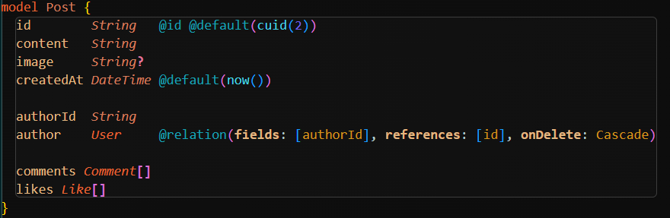

COMMENT
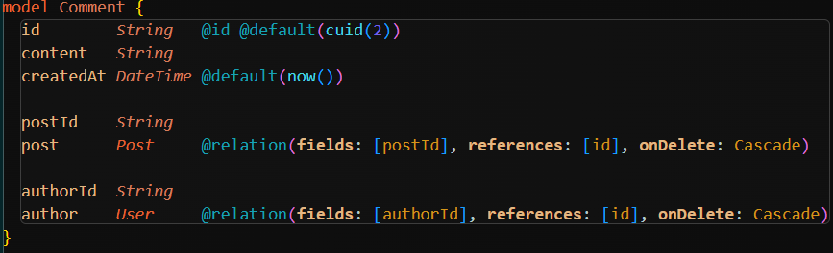

LIKE
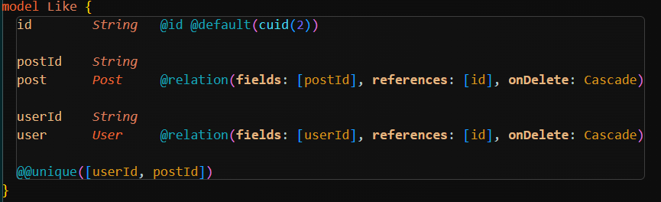

FOLLOW
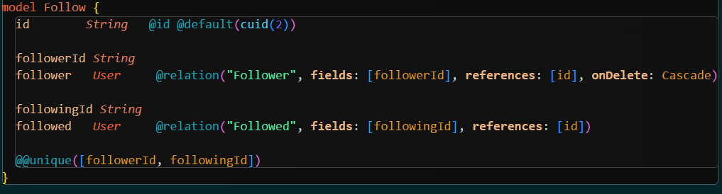

1.3 Relationships Summary
Relationship | Type | Description
User → Post | one-to-many | Each user can author many posts
User → Comment | one-to-many | Each user can write many comments
Post → Comment | one-to-many | Each post can have many comments
Post → Like | one-to-many | Each post can have many likes
User → Follow (as Follower) | one-to-many | Each user follows many users
User → Follow (as Followed) | one-to-many | Each user is followed by many users

2. Database Queries
All data access is performed via Prisma queries inside repository files (repo/). Below are the key queries used.
2.1 Authentication Queries
Get user by email (used for login):
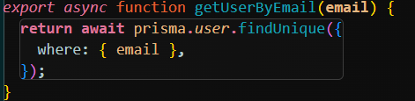

Create user (used for register):
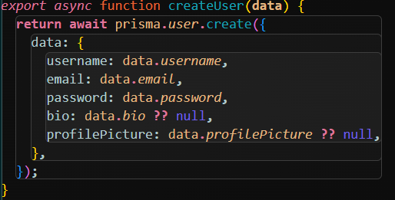

2.2 Feed Query
Retrieves posts authored by the user or by users they follow:
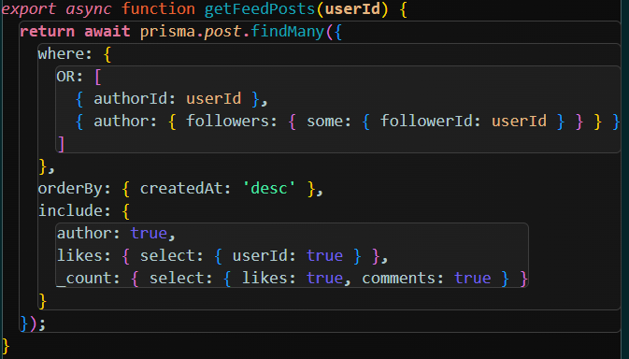

2.3 Toggle Follow Query
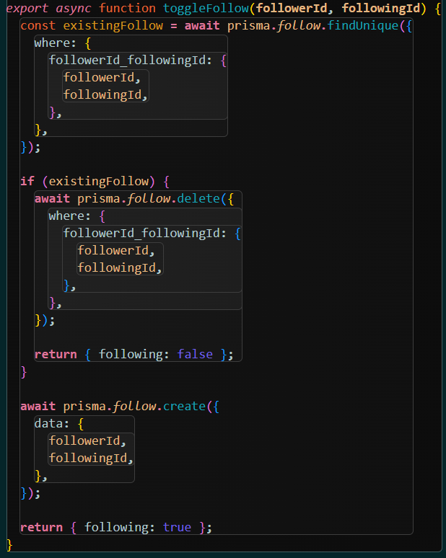

2.4 Statistics Queries
Stat 1 — Average Followers per User:
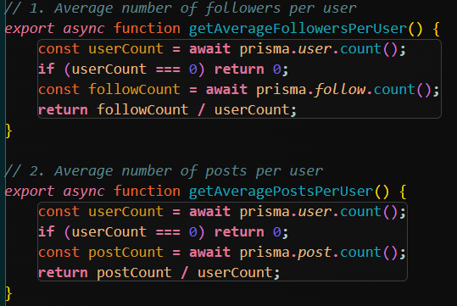
Stat 2 — Average Posts per User:


Stat 3 — Most Active User in Last 3 Months:
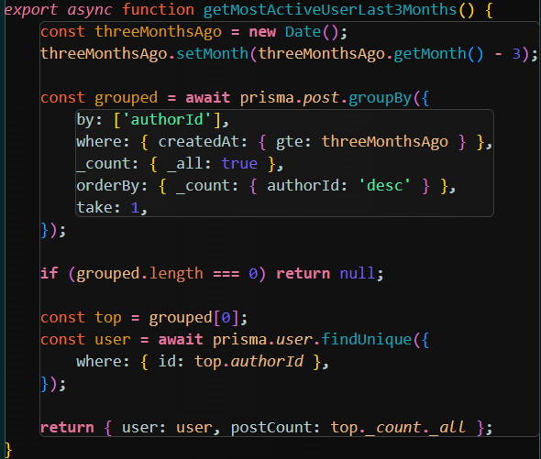

Stat 4 — Most Liked Post:
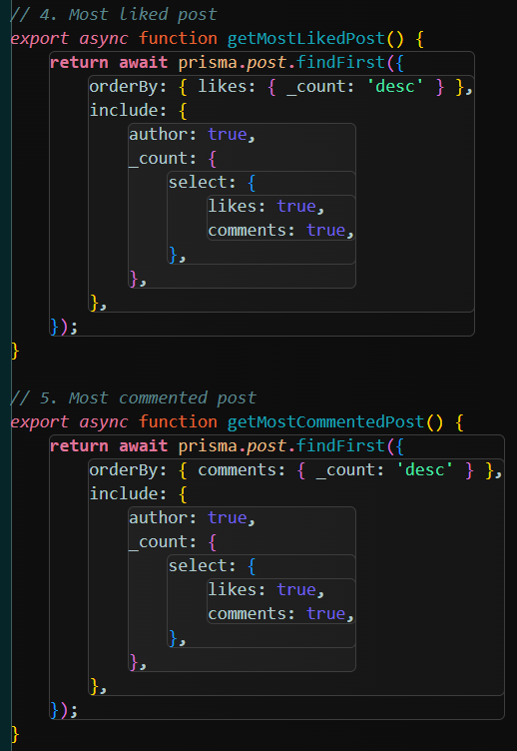

Stat 5 — Most Commented Post:


Stat 6 — Top 5 Users by Followers:
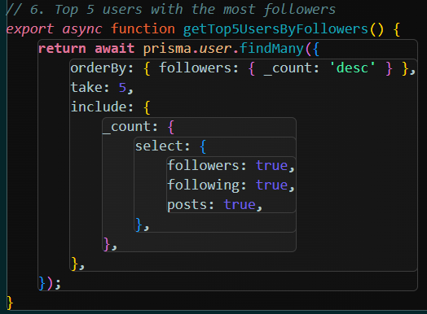

3. API Endpoints
Method | Route | Description
POST | /api/auth/register | Register a new user
POST | /api/auth/login | Authenticate a user
GET | /api/users | List all users
GET | /api/users/[id] | Get a user's profile
PUT | /api/users/[id]/profile | Update profile
POST | /api/users/[id]/follow | Toggle follow on a user
GET | /api/users/[id]/feed | Get feed for a user
GET | /api/posts | List all posts
POST | /api/posts | Create a post
GET | /api/posts/[id] | Get one post
DELETE | /api/posts/[id] | Delete a post
POST | /api/posts/[id]/like | Toggle like
GET | /api/posts/[id]/comments | List comments on a post
POST | /api/posts/[id]/comments | Create a comment
GET | /api/stats | Aggregate statistics

4. Conducted Tests
4.1 Test Cases
# | Module | Test Description | Expected Result | Actual Result | Status
1 | Register | Valid registration | User created, redirect to login | User created and redirected | Pass
2 | Register | Duplicate email | Error message shown | Error shown | Pass
3 | Register | Invalid email format | Validation error | Error shown | Pass
4 | Register | Weak password | Validation error | Error shown | Pass
5 | Login | Correct credentials | Redirect to feed | Redirected | Pass
6 | Login | Wrong password | Error message | Error shown | Pass
7 | Feed | Create post | Post appears at top | Post appeared | Pass
8 | Feed | Like a post | Count incremented | Count updated | Pass
9 | Feed | Unlike a post | Count decremented | Count updated | Pass
10 | Comments | Add comment | Comment appears in list | Comment shown | Pass
11 | Profile | Edit username | New name persists after refresh | Persisted | Pass
12 | Profile | Follow another user | Button changes to Following | Updated | Pass
13 | Feed | Followed user's posts appear | Feed includes them | Visible | Pass
14 | Stats | All 6 stats display | All visible | All shown | Pass
15 | Stats | Live update after like | Counter changes | Updated | Pass

4.2 Test Screenshots
Test 1 — Register Page
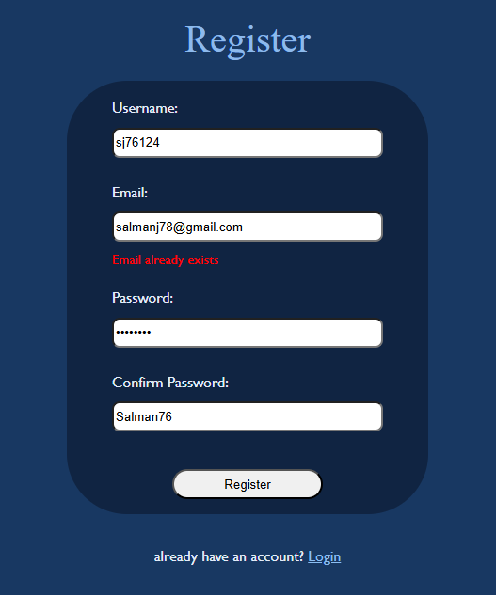
Test 5 — Login Success
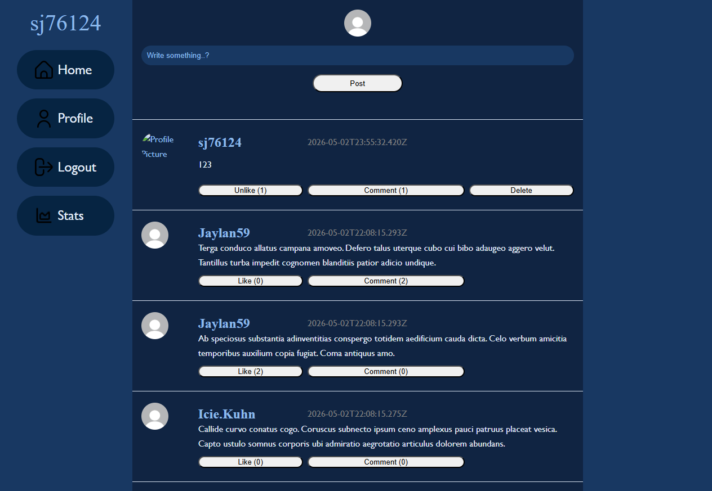

Test 7 — Create Post
Before:
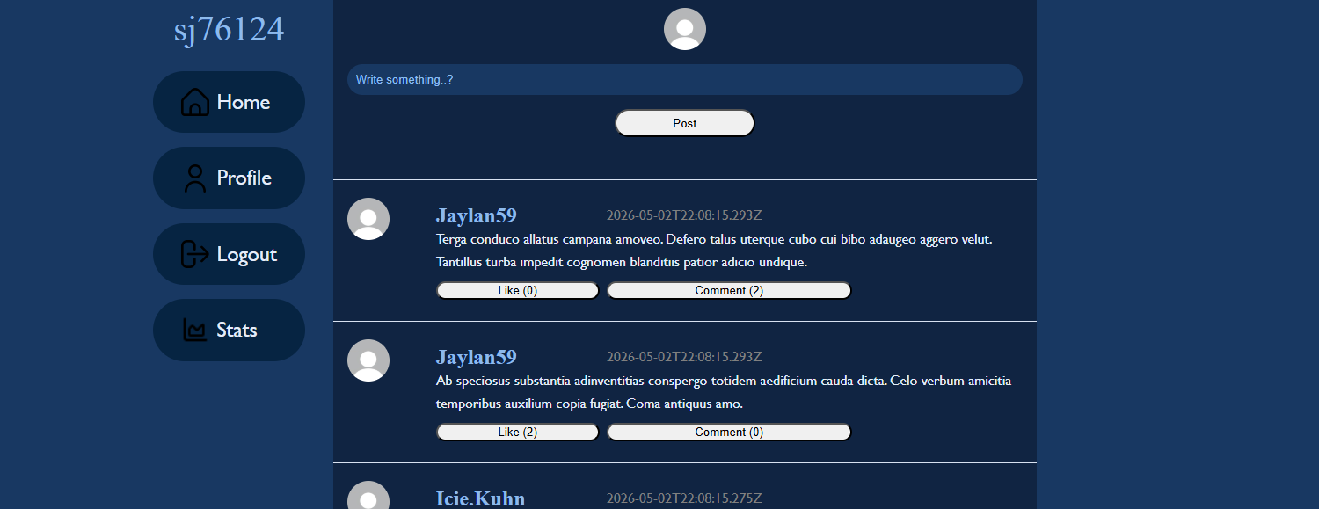
After:
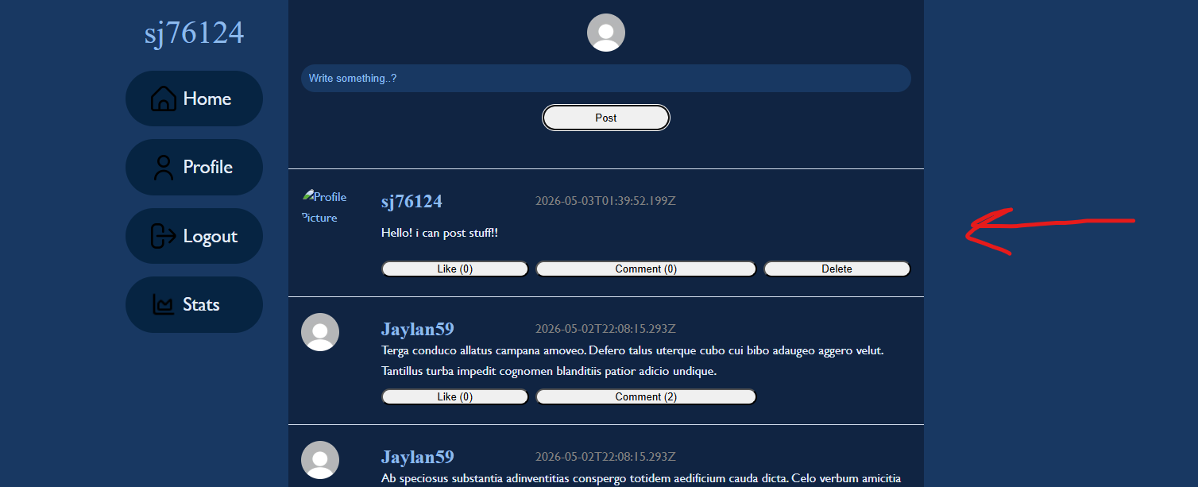

Test 14 — Statistics Page
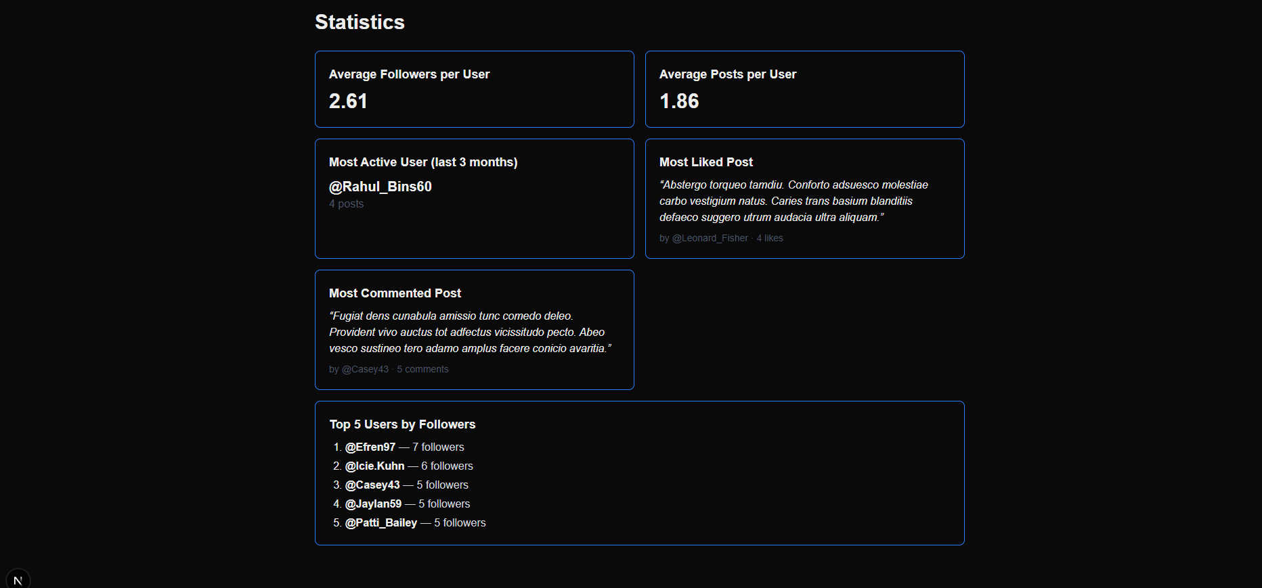

Test 15 — Live Stats Update
Before following more people:

After:
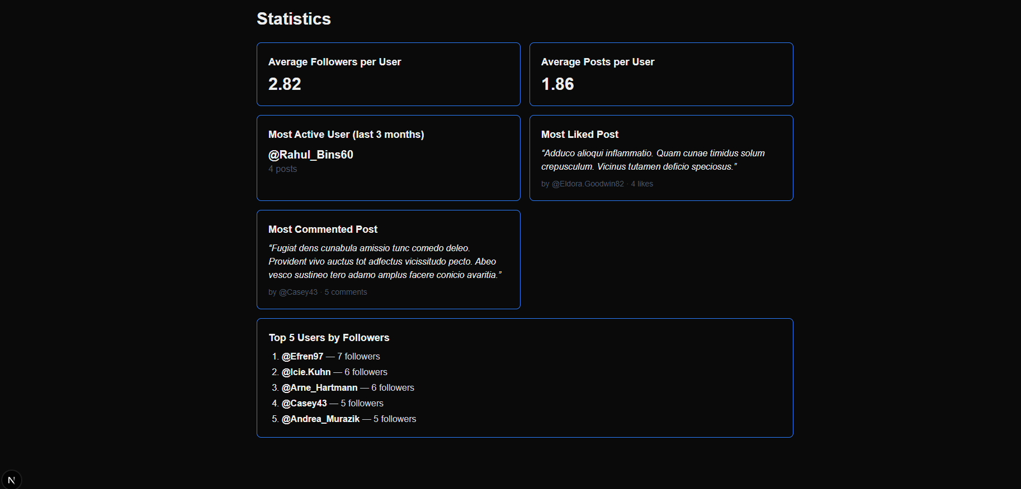

API Verification
/api/posts
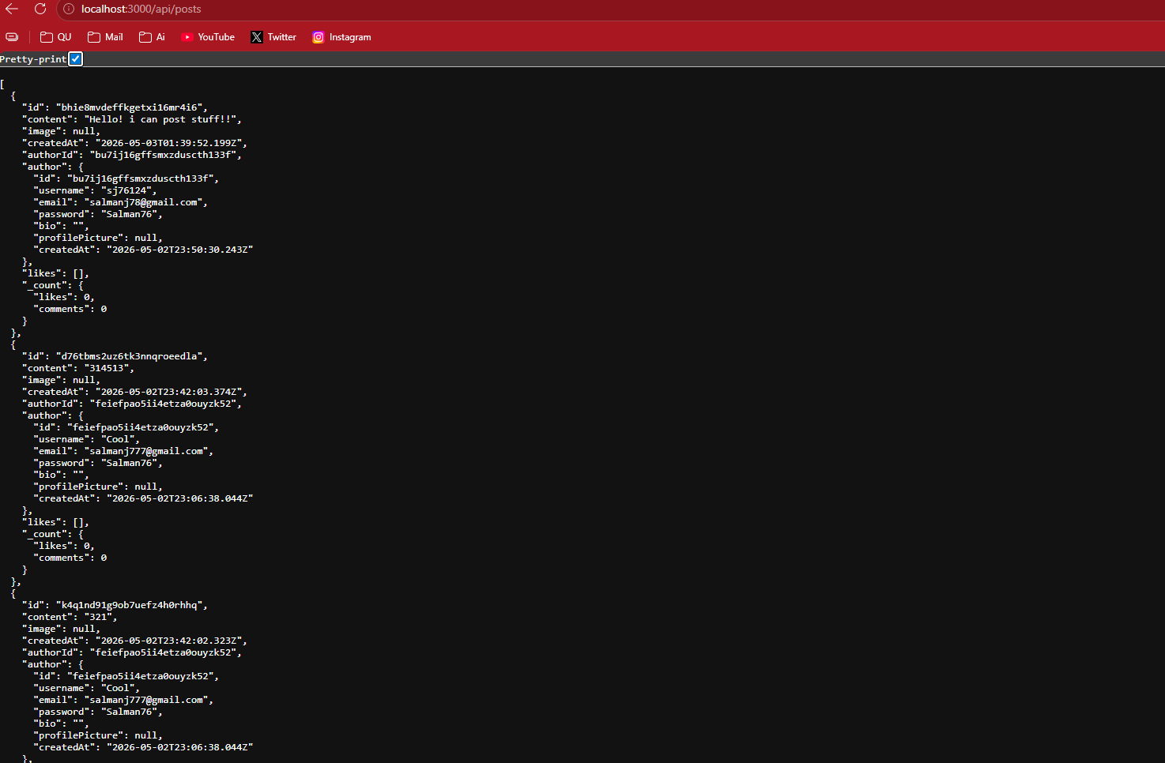
Prisma Studio Posts Table
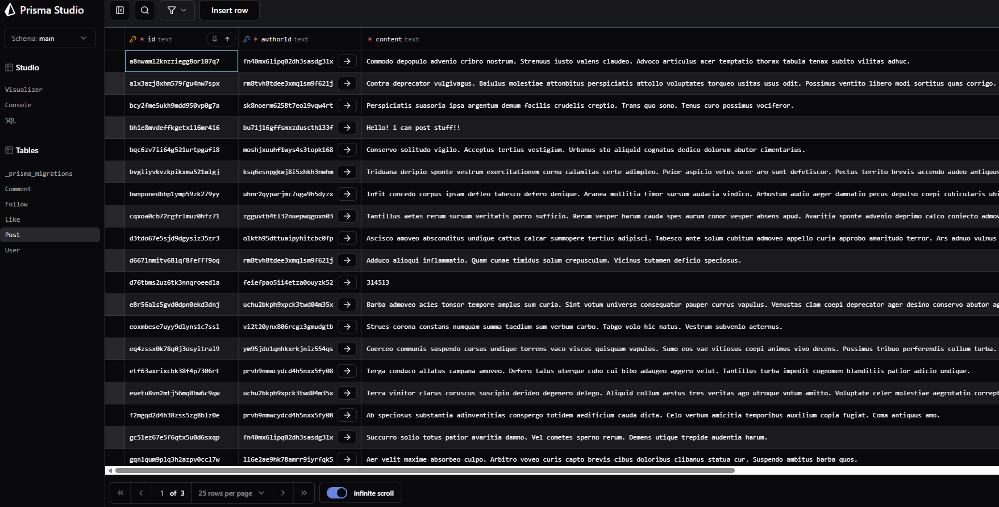
Appendix A — How to Run
cd Phase2/social-app
bun install
bun prisma migrate dev
bun prisma db seed
bun dev
Then visit:
- App: http://localhost:3000/UI/login.html
- Stats: http://localhost:3000/stats

Repository: https://github.com/SJ76x/WebDev-Course-Project/tree/main/Phase2

