SATYENDRA **JAIN**

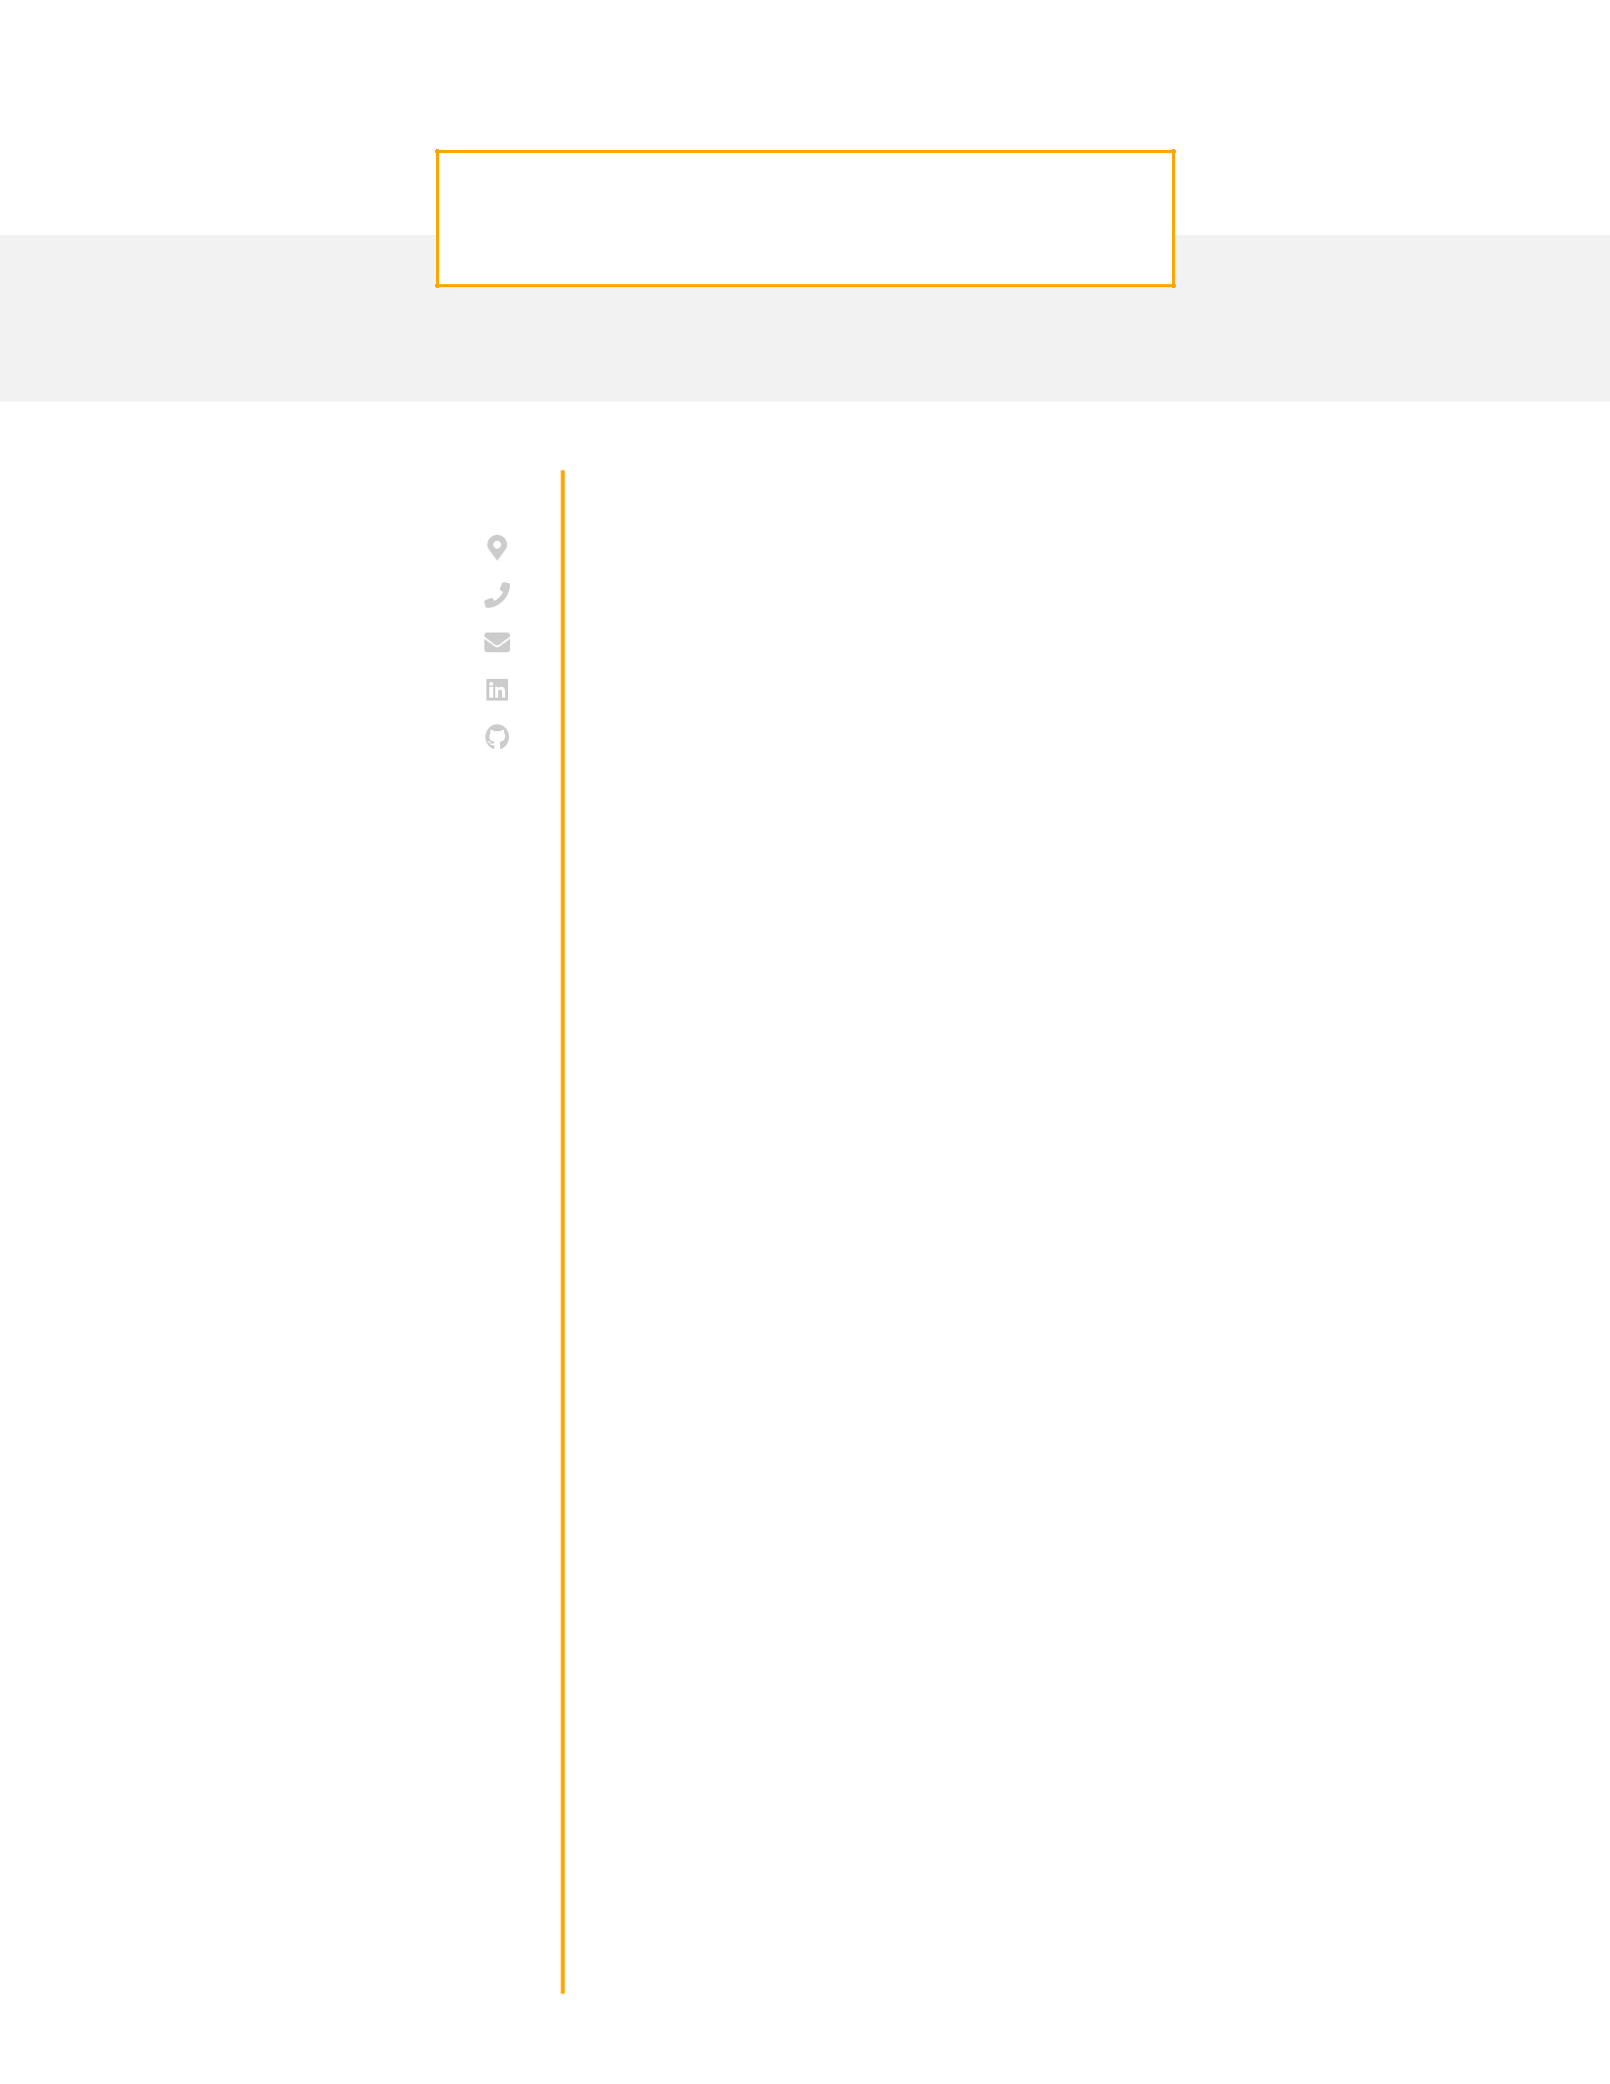

Senior Frontend Engineer

**CONTACT**

Maidenhead, UK

(+44) 7405007207

jainskumar7@gmail.com [LinkedIn](https://www.linkedin.com/in/satyendra-jain)   
[GitHub](https://github.com/SJA273/Satyendra.Jain)

**EDUCATION**

**Bachelor of Commerce**DAVV University Indore, India 2003 - 2006

**UI Design & Development Professional Certification**Arena Multimedia Indore, India 2006 - 2008

**TECHNICAL SKILLS**

**Frameworks:**

Vue JS, Angular, React JS

**State Management:**

Vuex / Pinia

**Languages / Markup:**

Typescript, JavaScript (ES6+) /

HTML5, CSS3, SASS, LESS

**Unit Testing:**

Jest / Jasmine / Karma

**UI Libraries:**

Bootstrap / Material UI

**API Integration:**

Restful API

**Version Control:**

Git / SVN

**PROPESSIONAL SUMMARY**

Role and Background

I am an experienced front-end developer with a strong focus on delivering results. I have proficiency in various front-end technologies such as **Vue.js**, **Angular**, React, **TypeScript**, and **JavaScript**. With over **15 years** of experience, I specialize in crafting dynamic and responsive user interfaces. I excel in translating complex business needs into refined, effective solutions and consistently deliver superior projects within designated timelines and budgets. I am committed to staying updated on the latest front-end development advancements and am skilled in creating and improving Rich UI web applications following usability standards. I possess comprehensive knowledge of cross-browser compatibility, front-end development concerns, Semantic HTML Coding/W3C standards, Responsive web design, user-friendly interfaces, and Google Analytics/SEO-friendly architecture (web 2.0 concept layouts). Additionally, I have demonstrated domain expertise and functional proficiency in the "**Banking and finance**", "**Retail**", "**Manufacturing**" and "**Travel, Transport, and Hospitality**" sectors.

Representative Accomplishments

* Performed Developer/Lead Developer roles for various clients like Maersk/APMT, Vanguard, Genworth, Legal & General, PruHealth, HDFC, DaVita etc.
* Responsible for Requirement Analysis, Estimation, Planning, Execution, Coordination and Product release.
* Design and develop high/low-level layouts & prototypes as per business requirements. Client communication regarding business and technical requirements based on project requirements.

**WORK EXPERIENCE**

|  |
| --- |
| Technical Lead (Senior Software Engineer) |
| Tata Consultancy Services / November 2012 – **till today** / Maidenhead, UK |

**PERSONAL DETAILS**

**Date of Birth:**

20 November 1985

**Nationality:**

Indian

**Sex:**

Male

**Marital Status:**

Married

**Languages:**

English / Hindi

**Visa Type:**

Tier 2 - ICT

**Visa Validity:**

October 2024

* Lead the frontend development team in the successful implementation of several key projects using Vue.js, Angular, and Backbone JS.
* Collaborated with UX/UI designers to create visually appealing and user-friendly interfaces.
* Developed reusable and modular components to improve code maintainability and scalability.
* Implemented responsive designs, ensuring seamless user experiences across various devices.
* Integrated third-party APIs and services to enhance the functionality of web applications.
* Conducted code reviews and provided mentorship to junior developers to foster a culture of continuous learning.
* Actively participated in the decision-making process regarding technology choices and architectural decisions.

|  |
| --- |
| Senior Software Engineer |
| Future Focus Infotech Pvt Ltd / October 2011 – October 2012 / Pune, India  Consagous Technology Pvt Ltd / August 2011 – September 2011 / Indore, India   * Played a key role in the migration of legacy systems to modern frontend frameworks, resulting in improved performance and user satisfaction. * Utilized TypeScript to enhance the robustness and maintainability of codebases. * Worked closely with cross-functional teams to gather and analyze business requirements. * Implemented and maintained unit testing processes to ensure code quality. * Developed custom themes and styles to align with branding guidelines. * Provided ongoing support and troubleshooting for existing applications. |
| Software Engineer |
| Ideavate Solutions Pvt Ltd / October 2009 – July 2011 / Indore, India  Zoom Developers Pvt Ltd / February 2008 – October 2009 / Indore, India   * Gained hands-on experience in frontend development while working on various projects using JavaScript, HTML, and CSS. * Collaborated with senior developers to implement new features and optimize existing code. * Contributed to the design and development of user interfaces for web applications. * Assisted in debugging and troubleshooting issues to ensure smooth project delivery. |