|  |
| --- |
| Cast Your Vote For Favorite Pet! |

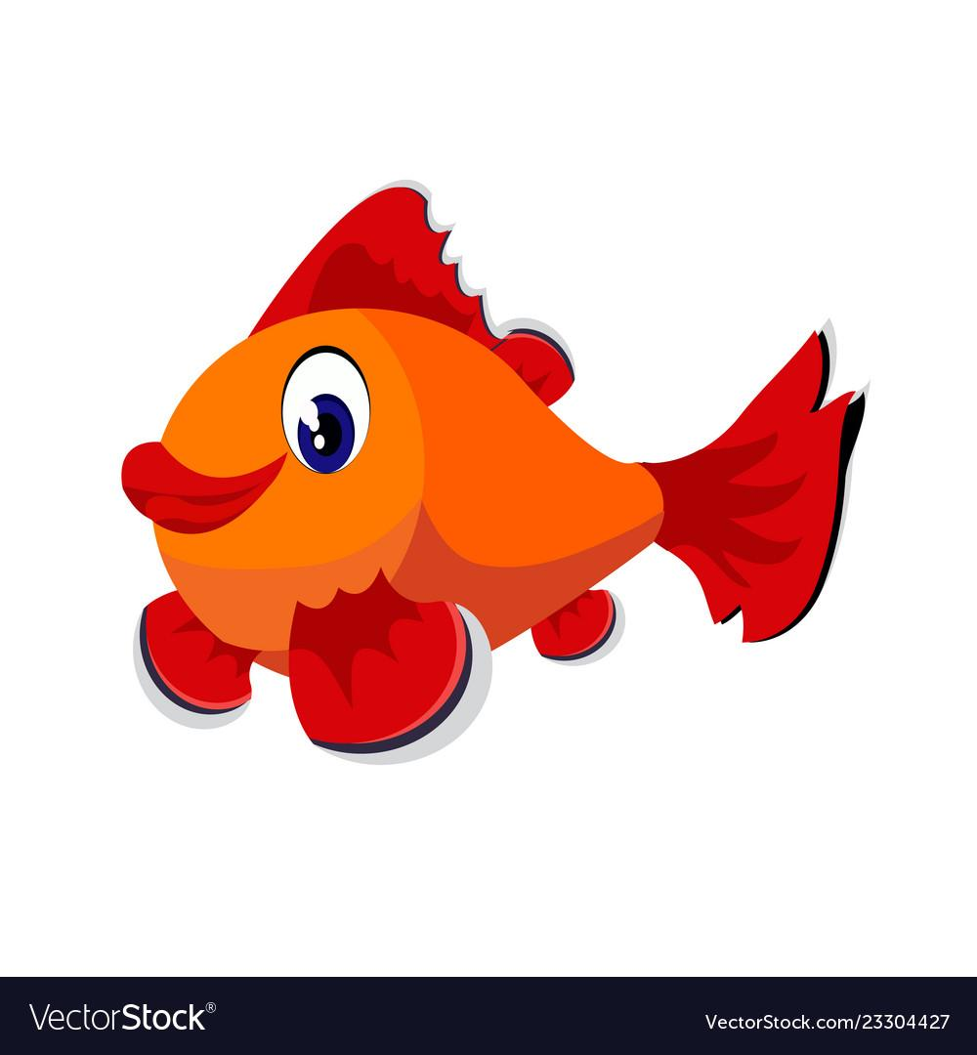

|  |
| --- |
| **Select One Choice** |

* Cat
* Dog
* Fish
* Bird

|  |
| --- |
| **Vote here!** |

1. Public Class Project 4 PetProject
2. Private Sub btnSelect_Click (sender As Object, e As EventArgs) Handles
3. btnSelect.Click
5. Sub Greetings ()
6. MessageBox.Show (“Cast Your Vote For Favorite Pet”)
7. End Sub
9. ‘declare the variables
10. lstOut.Items.Add(“Cast Your Vote For Favorite Pet”)
11. ‘initialize the pet variable
12. Pet = “Your pet choice is”
13. Select a choice
14. ‘Check for cat’
15. If (chkCat.Checked = True) Then
16. lstOut.Items.Add(“Cat + 1”)
17. Total = Vote + 1
18. End if
20. End Sub
22. ‘Check for dog’
23. If (chkDog.Checked = True) Then
24. lstOut.Items.Add(“Dog + 1”)
25. Total = Vote + 1
26. End If
28. End Sub
30. ‘Check for fish’
31. If (chkFish.Checked = True) Then
32. lstOut.Items.Add(“Fish + 1”)
33. Total = Vote + 1
34. End If
35. End Sub
37. ‘Check for bird’
38. If (chkBird.Checked = True) Then
39. lstOut.Items.Add(“Bird + 1”)
40. Total = Vote + 1
41. End If
43. End Sub
45. Private Sub btnExit_Click (sender As Object, e As EventArgs) Handles btnExit.Click
46. ‘Exit the program’
47. Beep ()
48. Application.Exit()
49. End Sub
50. End Class