Group 8

Author: Mingzhao Guo

User Manual

Elevator

Table of Contents

System Architecture 2

Inside panel Manual 2

Outside panel Manual 3

ModelUI 3

## System Architecture

The system architecture is shown below:

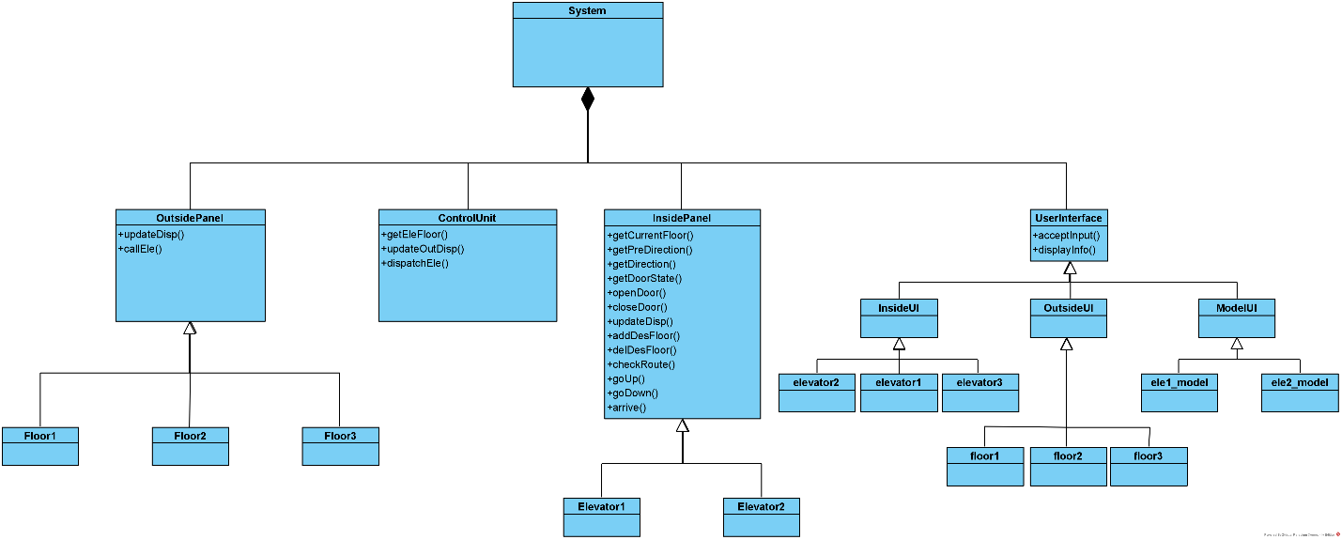

## Inside panel Manual

The inside of elevator has a UI which is shown below:

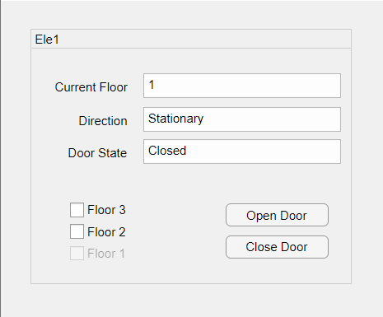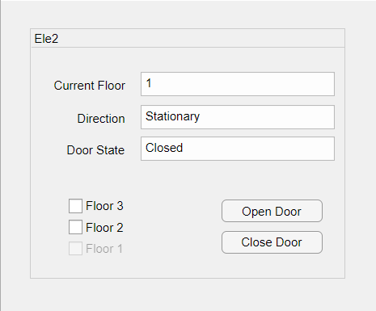

#### Select & reselect the target floor

The passenger could choose their target floors (floor 1, floor 2, floor 3). They could also cancel the target floor.

#### Open & close door

By pressing close door (open door) button, they could keep the door close (open).

## Outside panel Manual

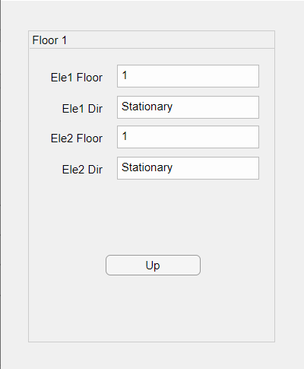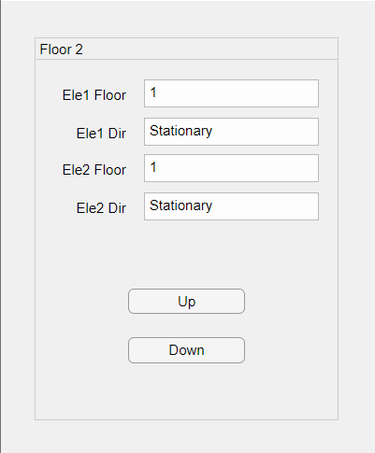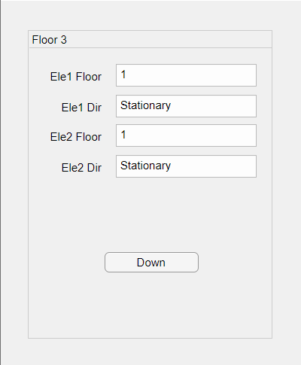

#### Call elevator

Passenger could call elevator by pressing up (or down) button.

#### Show the location of elevators

The location of two elevator is shown on the outside panel.

## ModelUI

 

#### Show elevators’ locations

It could show where the elevator is.

#### Show elevators’ door states

It could show the states(open or close) of elevators.