Group 8

Author: HeZi’an

Software Specifications

Painkiller Injector

Table of Contents

System Architecture 2

Software Specifications 2

S1: InjectorUI implementation 2

S2: Emergency Shot UI implementation 5

## System Architecture

The system architecture is shown below:

## Software Specifications

### S1: InjectorUI implementation

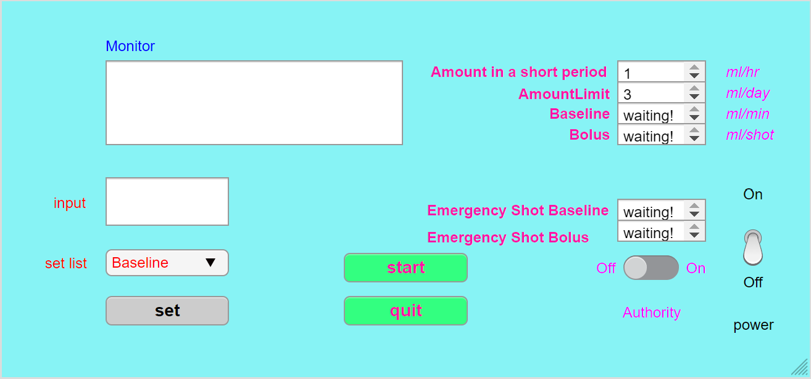

#### S1.1: Start injection

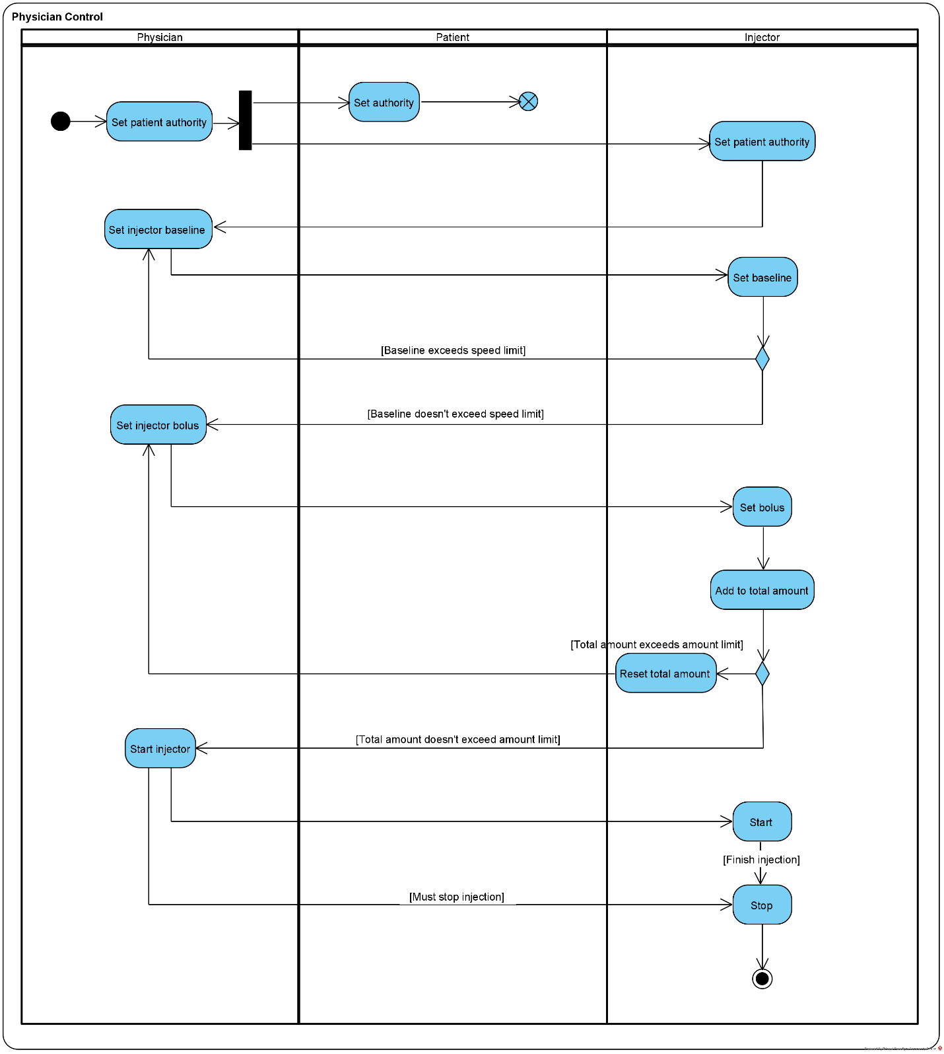s

* S1.1.1: Set patient authority

1. Authority button switched
2. Change authority value in DB

* S1.1.2: Set baseline

1. set button clicked
2. For value input
   1. If value is illegal, display warning
   2. If value is legal, display success

* S1.1.3: Set bolus

1. set button clicked
2. For value input
   1. If value is illegal, display warning
   2. If value is legal, display success

* S1.1.4: start

1. start button clicked
2. if not finish, continue

* S1.1.5: check amount limit

1. Emergency shot button switched
2. Check if the amount value exceed the Day or Hour limit, if so, pause, else continue.

#### S1.2: Stop injection

* S1.2.1: stop injection

### S2: Emergency Shot UI implementation

#### 手机屏幕的截图 描述已自动生成2.1: Emergencyshot

* S2.1.1: check authority

1. Emergency shot button switched
2. Check the authority value in DB if true then continue else return and display error