Group 8

Author: HeZi’an

User Manual

HuaRongDao

Table of Contents

System Architecture 2

Player Manual 2

*Option* 3

## System Architecture

The system architecture is shown below:

## Player Manual

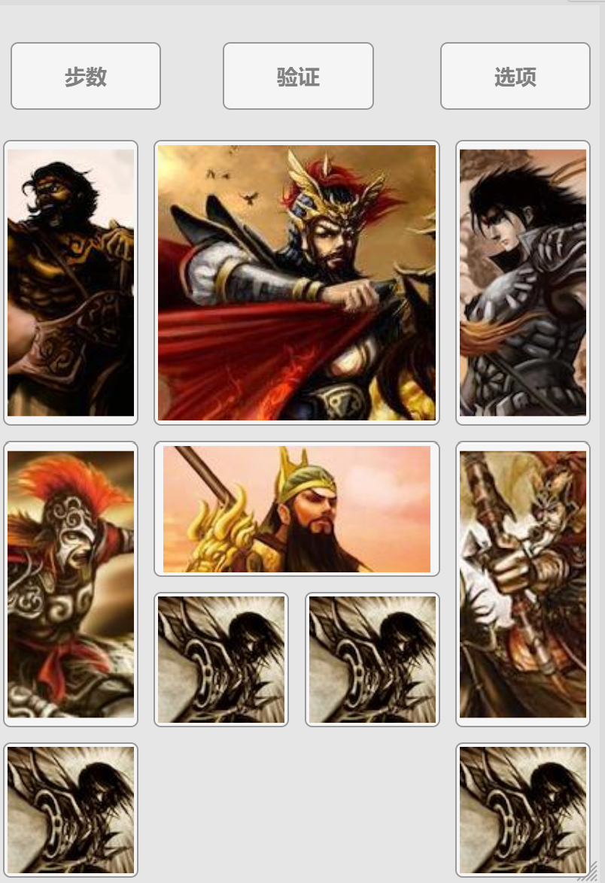The game has a UI which is shown below:

#### Step display

The button on the top left can display the steps you have consumed.

#### Verification

With this button, you can verify whether the current game can be solved.

### *Option*

After click on this button you get the option UI show as below:

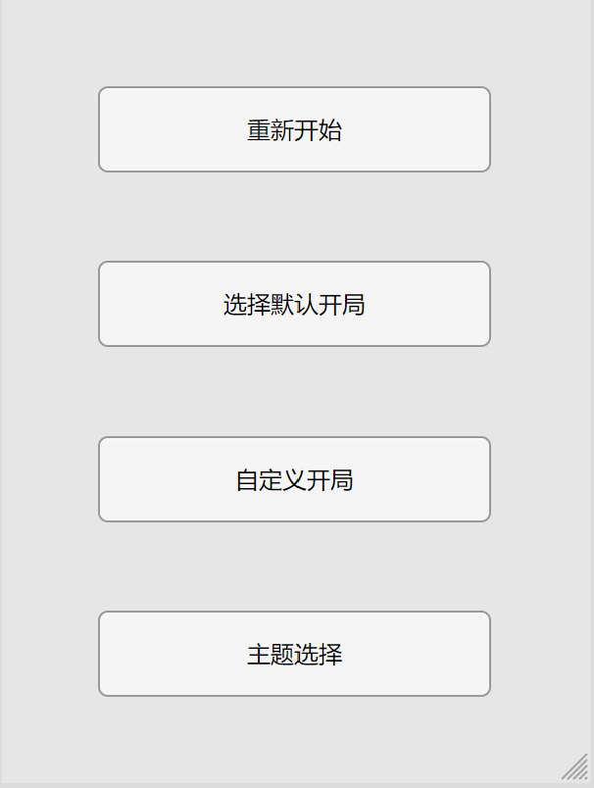with this panel, you can restart the game, select default start, customize the position of chess or choose different styles.

#### Game mechanism

Try your best to let Caocao get out of the checkerboard, every time you can move one chess towards one direction.