Group 8

Author: Mingzhao Guo

Software Requirements

Elevator System

Table of Contents

System Objective 2

Domain Analysis 2

System Architecture 4

Use Cases 5

Software Requirements 5

R1: Inside Panel 5

R2: Outside Panel 6

R3: ModelUI 6

## System Objective

In this project, we are developing a system that control the normal operation of two linked elevators for a three floors building.

## Domain Analysis

The participants of activities in an elevator system can be categorized into passengers, elevators and target floors.

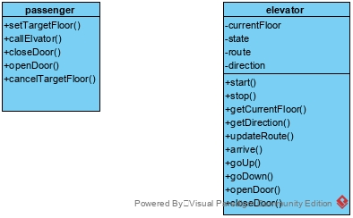

The relationships among different participants are shown as follows:

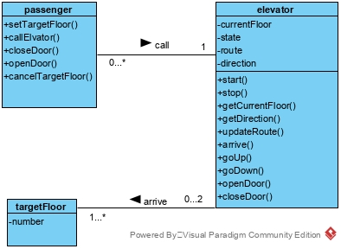

Here is the sequence of events for passengers:

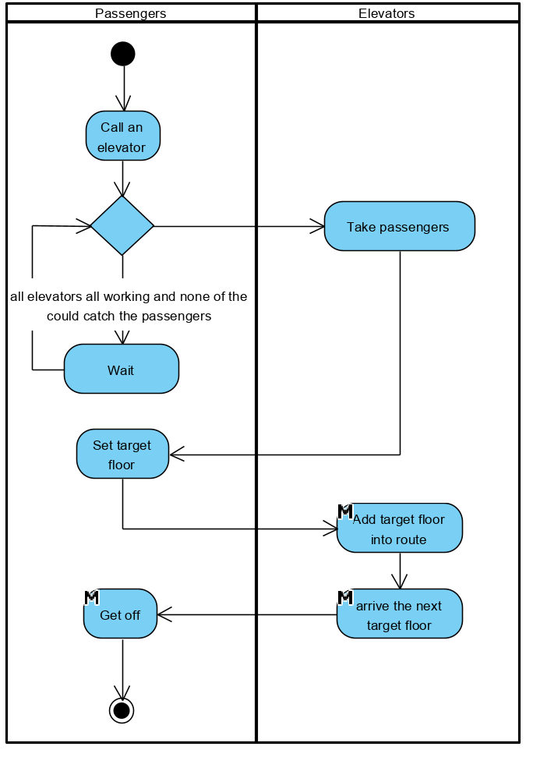

Here is the sequence of events for elevators:

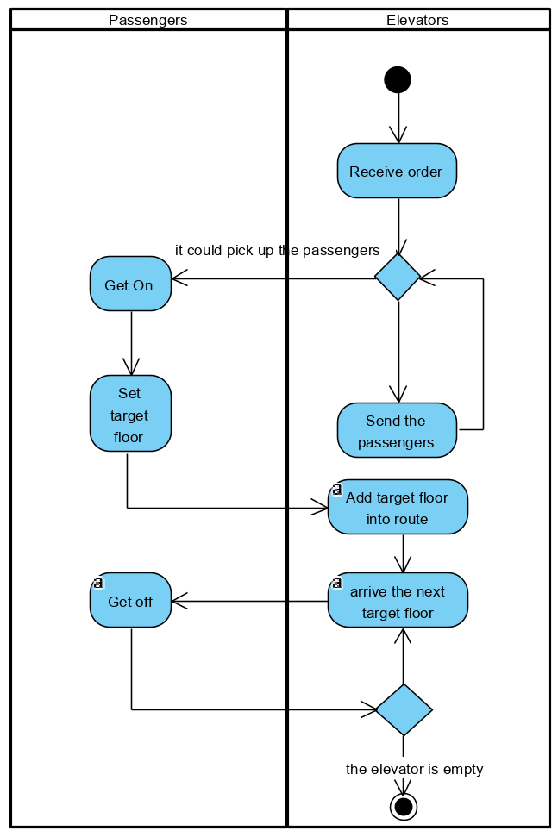

## System Architecture

From the information above, we will design a software system that allows the passengers to call for an elevator. The elevator can send passengers. The system architecture is shown below:

## Use Cases

The system can achieve the following use cases from the server’s and the chef’s perspectives:

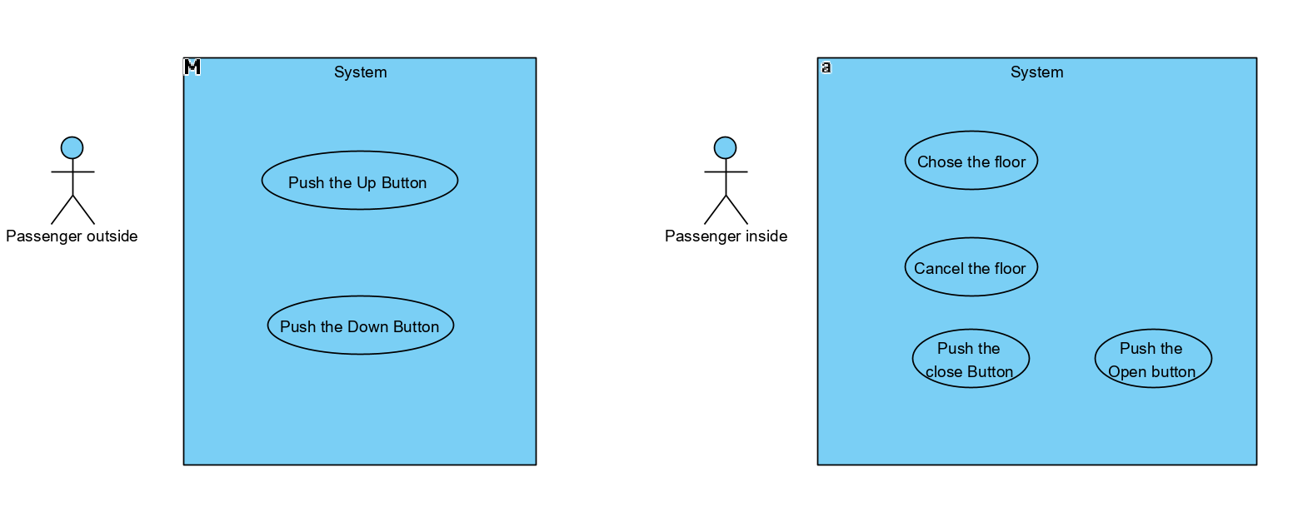

## Software Requirements

### R1: Inside Panel

* R1.1: The passenger should be able to tell elevator the target floor.
  + R1.1.1: The passenger should be able to choose a target floor
  + R1.1.2: The passenger should be able to cancel the floor has been chose
* R1.2: The passenger should be able to change the state of the door.
  + R1.2.1: The passenger should be able to keep the door opening.
  + R1.2.2: The passenger should be able to close the door.

### R2: Outside Panel

* R2.1: The passenger should be able to call an elevator
  + R2.1.1: The server should be able to push the ‘Up’ button. (except the third floor)
  + R2.1.2: The server should be able to push the ‘Down’ button. (except the first floor)

### R3: ModelUI

* R3.1: The passenger should be able to call an elevator
  + R3.1.1: Show elevators’ locations
  + R3.1.2: Show elevators’ door states