Group 8

Author: Junda Shen

Software Specifications

Elevator

Table of Contents

System Architecture 2

Software Specifications 2

S1: InsidePanel and InsideUI implementation 2

S1.1: Move to next floor 3

S1.2: Control door 4

S2: OutsidePanel and OutsideUI Implementation 5

S2.1: Call elevator 5

S3: ModelUI Implementation 6

S3.1: Show elevator status 6

# System Architecture

The system architecture is shown below:

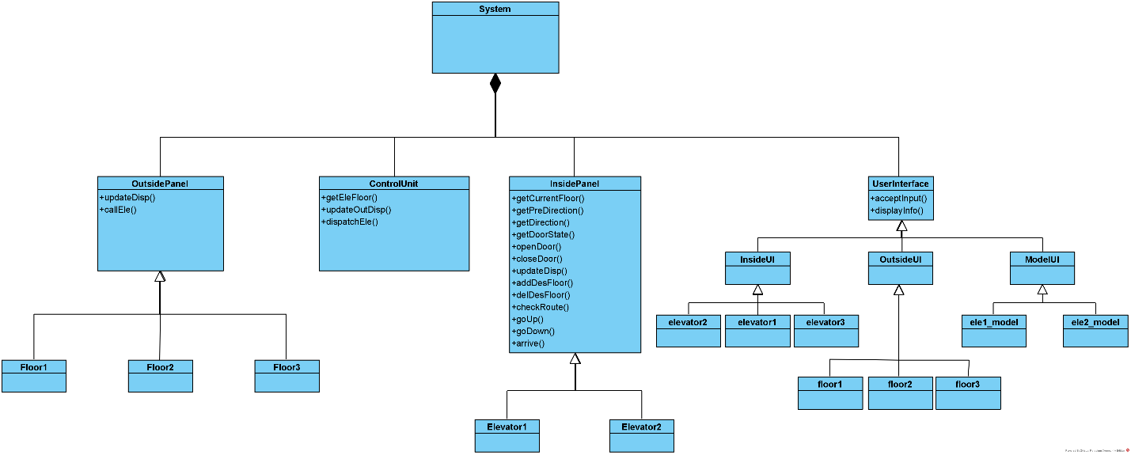

# Software Specifications

## S1: InsidePanel and InsideUI implementation

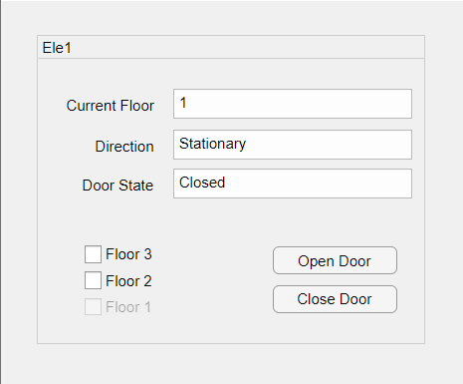 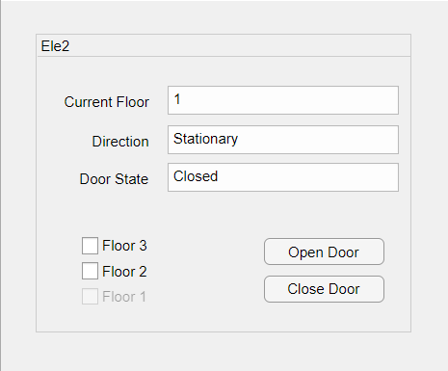

### S1.1: Move

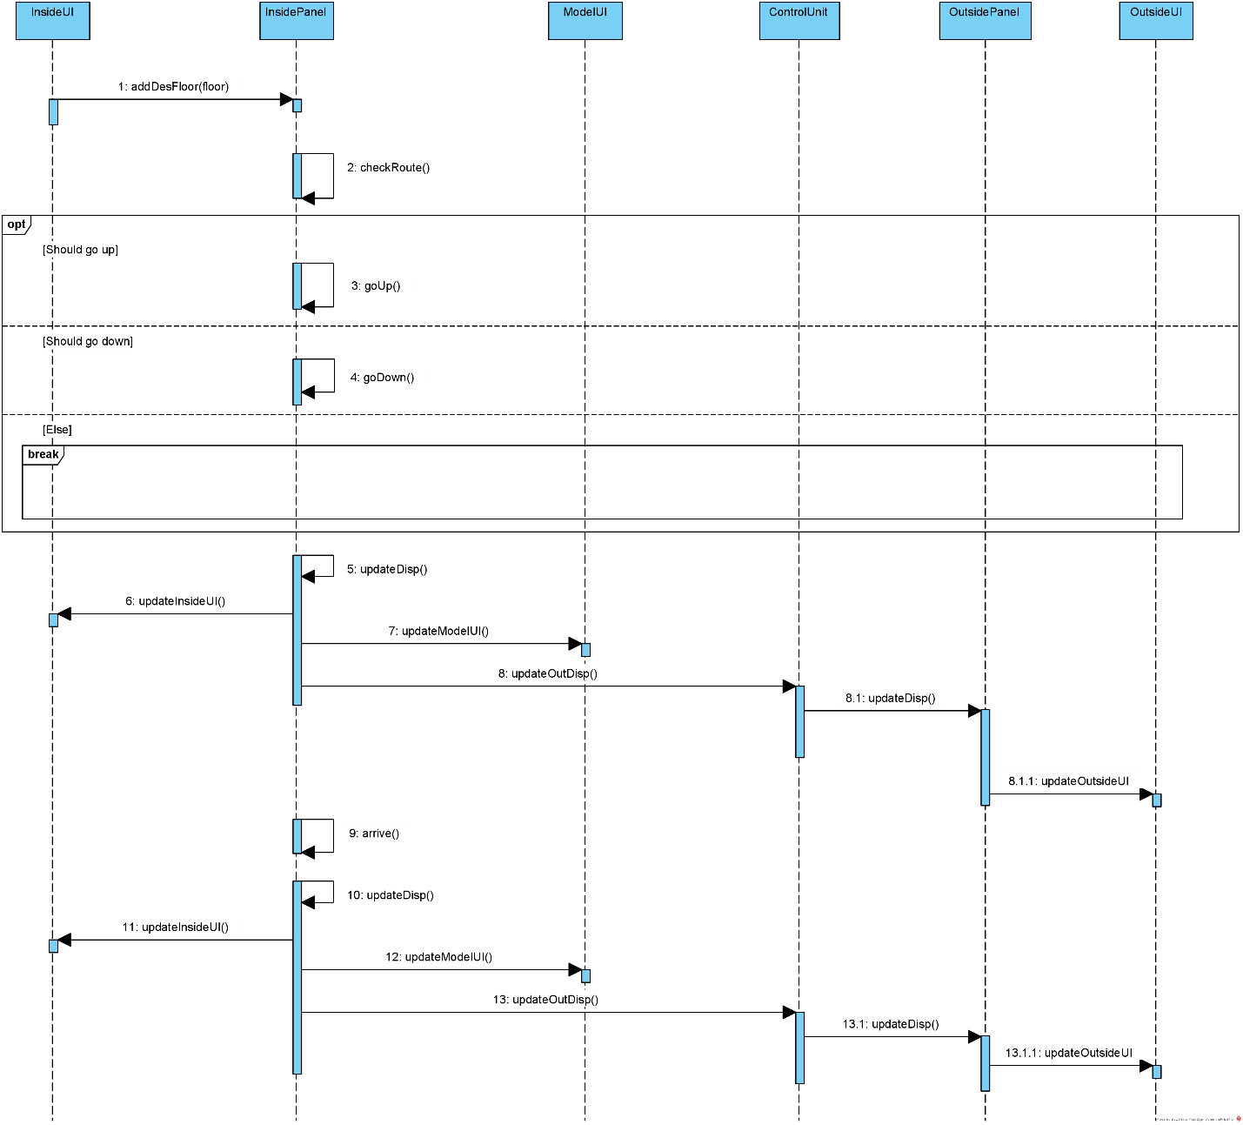

* S1.1.1: Select target floor

1. Target floor checkbox clicked
2. For all floors
   1. If the target floor was not checked, add it to the route
3. Check route, determine go up or go down or stationary
4. Update display when moving and after arriving

* S1.1.2: Deselect target floor

1. Target floor checkbox clicked
2. For all floors
   1. If the target floor was checked, delete it from the route
3. Check route, determine go up or go down or stationary
4. Update display when moving and after arriving

### S1.2: Control door

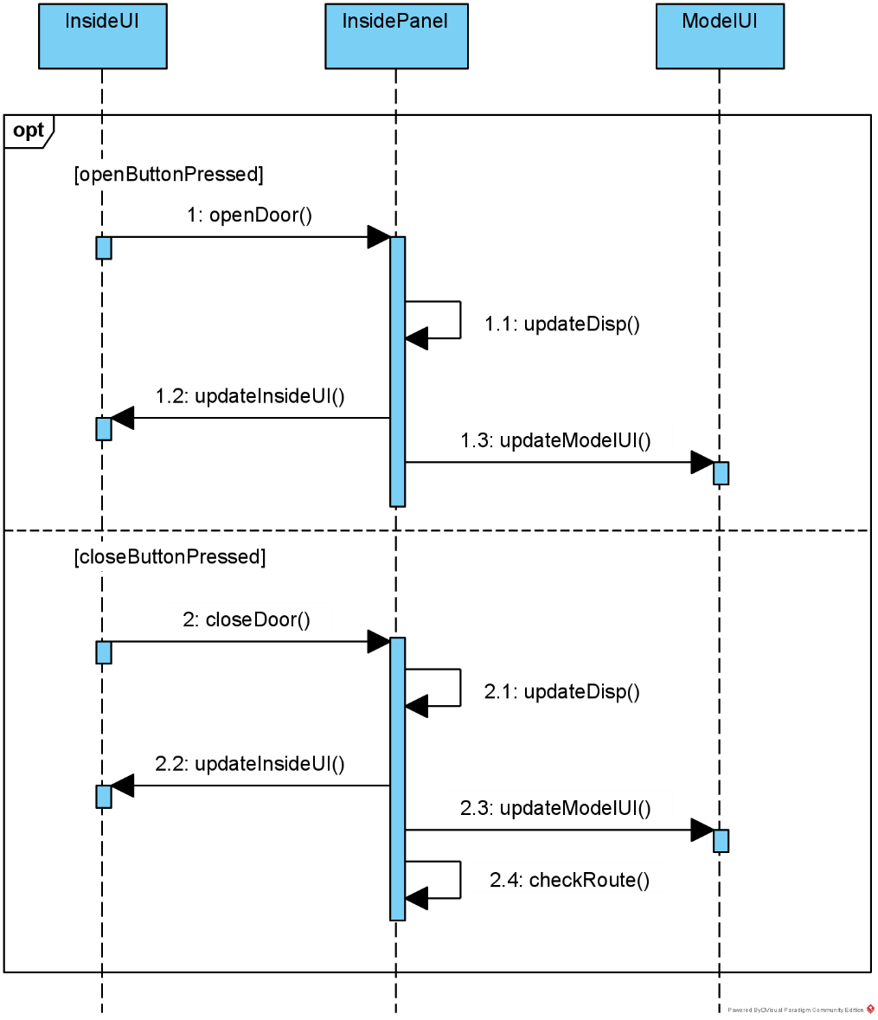

* S1.2.1: Open door

1. “Open Door” button clicked
2. Update display

* S1.2.2: Close door

1. “Close Door” button clicked
2. Update display

## S2: OutsidePanel and OutsideUI Implementation

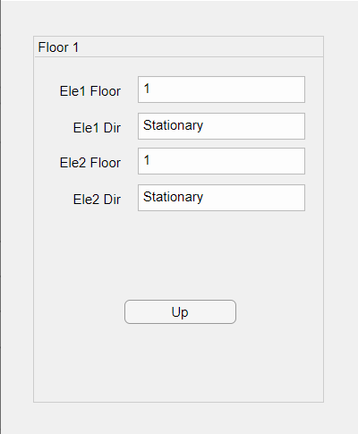 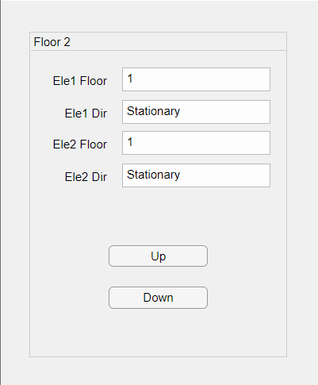 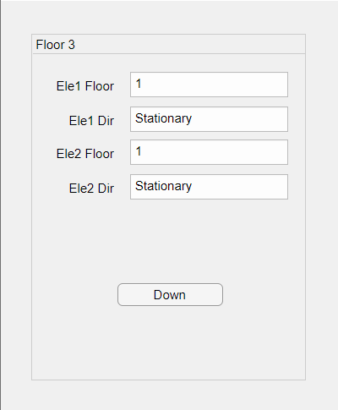

### S2.1: Call elevator

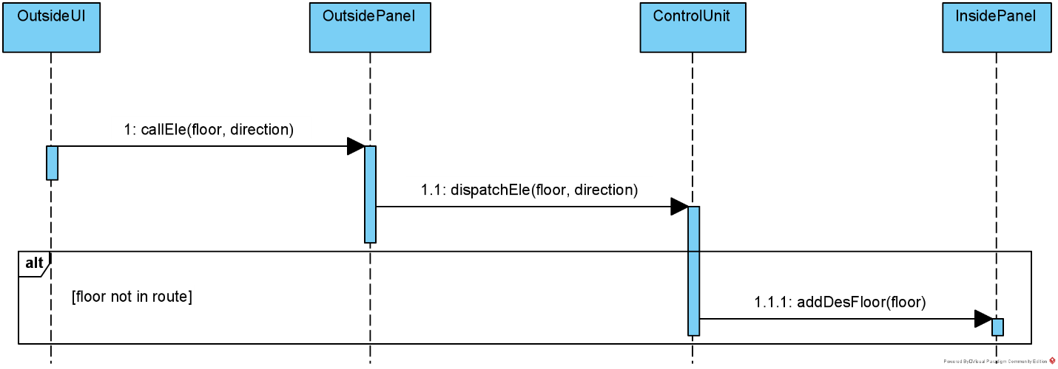

* S2.1.1: Call elevator to this floor

1. Button clicked
2. Send floor and direction information to ControlUnit
3. ControlUnit dispatched elevator
4. Add floor to the route of the dispatched elevator

## S3: ModelUI Implementation

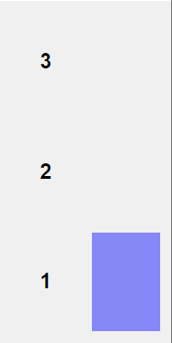 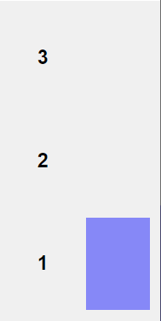

### S3.1: Show elevator status

* S3.1.1: Show elevators’ locations

1. The left model stands for elevator1, the right model stands for elevator2
2. The color blocks in two models will move with elevators: If elevator locates at floor1, then the color will be at bottom; If elevator locates at floor2, then the color will be at middle; If elevator locates at floor3 then the color will be at top

* S3.1.2 Show elevators’ door states

1. The left model stands for elevator1, the right model stands for elevator2
2. The color blocks in two models will change with door states: If elevator door is opened, then there will be white block inside the color block; If elevator door is not opened, then there will not be white block