Group 8

Author: Junda Shen

User Manual

Painkiller Injector

Table of Contents

System Architecture 2

Physician Manual 2

Turn on/off the injector 3

Set baseline for normal injection 3

Set baseline for emergency shot 3

Set bolus for normal injection 3

Set bolus for emergency shot 3

Set amount limit in 1 hour 3

Set amount limit in 24 hours 3

Set patient’s authority of emergency shot 4

Start/Stop injection 4

Patient Manual 4

Take emergency shot 4

## System Architecture

The system architecture is shown below:

## Physician Manual

The physician has a UI which is shown below:

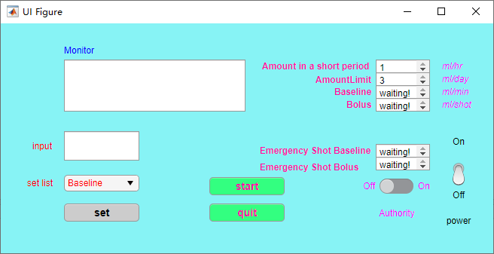

Figure 1.1

### Turn on/off the injector

* To turn on the injector, push the power switch (at the bottom-right corner in Figure 1.1) to “On”;
* To turn off the injector, push the power switch (at the bottom-right corner in Figure 1.1) to “Off”.

### Set baseline for normal injection

1. Press the “set list” (at bottom-left in Figure 1.1) and you can see a list shown in the right
2. Press the “Baseline” in the list
3. Type in the baseline in the input box (at middle-left in Figure 1.1)
4. Press “set” button (at bottom-left in Figure 1.1)
5. If your input is acceptable, you will see “Baseline set successfully!” in Monitor (at top-left in Figure 1.1); If your input is not acceptable, you will see “0.01 <= Baseline <= 0.1!!!” in the Mornitor.

Figure 1.2

### Set baseline for emergency shot

1. Press the “set list” and you can see a list shown in Figure 1.2
2. Press the “BaselineforEm” in the list
3. Type in the baseline in the input box
4. Press “set” button
5. If your input is acceptable, you will see “BaselineforEm set successfully!” in Monitor.

### Set bolus for normal injection

1. Press the “set list” and you can see a list shown in Figure 1.2
2. Press the “Bolus” in the list
3. Type in the bolus in the input box
4. Press “set” button
5. If your input is acceptable, you will see “Bolus set successfully!” in Monitor; If your input is not acceptable, you will see “Keep 0.2 <= Bolus <= 0.5” in the Mornitor.

### Set bolus for emergency shot

1. Press the “set list” and you can see a list shown in Figure 1.2
2. Press the “BolusforEm” in the list
3. Type in the bolus in the input box
4. Press “set” button
5. If your input is acceptable, you will see “BolusforEm set successfully!” in Monitor.

### Set amount limit in 1 hour

1. Press the “set list” and you can see a list shown in Figure 1.2
2. Press the “AmountInShortPeriod” in the list
3. Type in the amount in the input box
4. Press “set” button
5. If your input is acceptable, you will see the amount in value box “Amount in a short period” (Top-right in Figure 1.1).

### Set amount limit in 24 hours

1. Press the “set list” and you can see a list shown in Figure 1.2
2. Press the “AmountLimit” in the list
3. Type in the amount in the input box
4. Press “set” button
5. If your input is acceptable, you will see the amount in value box “AmountLimit” (Top-right in Figure 1.1).

### Set patient’s authority of emergency shot

* If you want to give a patient the authority of emergency shot, then push the Authority switch (at bottom-right of Figure 1.1) to “On”;
* If you want to give a patient the authority of emergency shot, then push the Authority switch to “Off”.

### Start/Stop injection

* If you want to start injection, press “start” (at bottom-middle in Figure 1.1);
* If you want to quit injection, press “quit” (at bottom-middle in Figure 1.1).

## Patient Manual

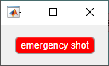The patient has a UI which is shown below:

Figure 2.1

### Take emergency shot

* If you want to take an emergency shot, then press the “emergency shot” button (at middle in Figure 2.1). Your authority of emergency shot (set by the physician) will be checked, if you have the authority, then an emergency shot will be issued (baseline and bolus are set by the physician); otherwise, no emergency shot will be issued.