CSC190 Software Engineering
Assignment 1 (Version Control: GIT Practice)
Individual Assignment
Due: Friday 02/10/2017 before Class in Blackboard

What to Turn in:
(1) This Document
(2) GIT Submission on GITHUB

Part I. Warm-up. [20pts, Estimate: 20 minutes]
Codename Cyber Missile
You, 007, a graduate of Arsfoh University, are now the best agent of the International Security Agency (ISA). You are sent to sabotage a secret project run by Dr. Evil: the Cyber Missile project that aims to destroy the privacy of all members of the Arsfoh University. Rumors are: Dr. Evil hosts his secret project on github and his project is done using Java.
To get you equipped for the mission, you have to accomplish the following tasks before infiltrating Dr. Evil’s project.
[1] Create your own account on github (you should use your real name in the account set up). Paste a screenshot which shows your account and your user name on github so that ISA can keep track of your activities. [10 minutes, 10 pts]
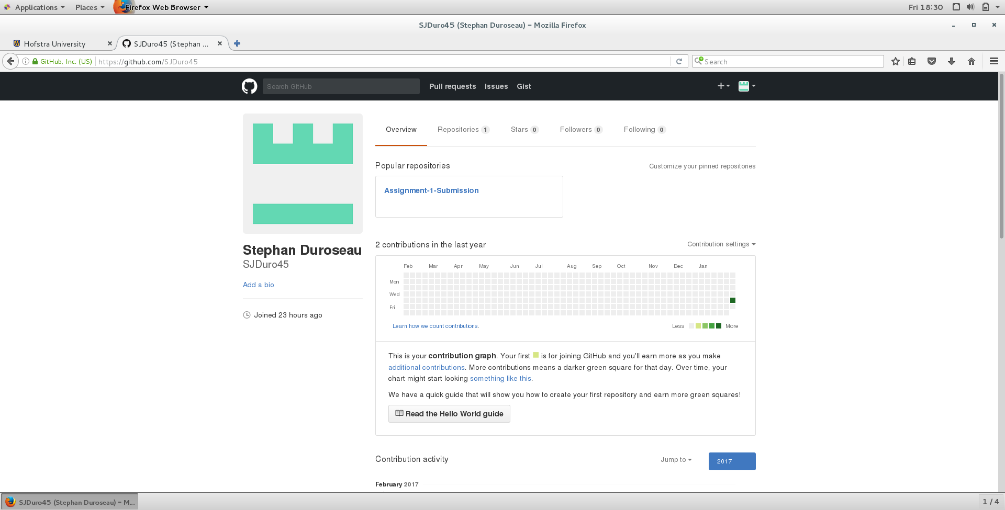
[2] Configure your GIT system globally to properly set up your name and email address in GIT. Note that they should match those of your github account. Dump the GIT configuration below (and please highlight the parts that you have configured.) [10 minutes, 10pts]
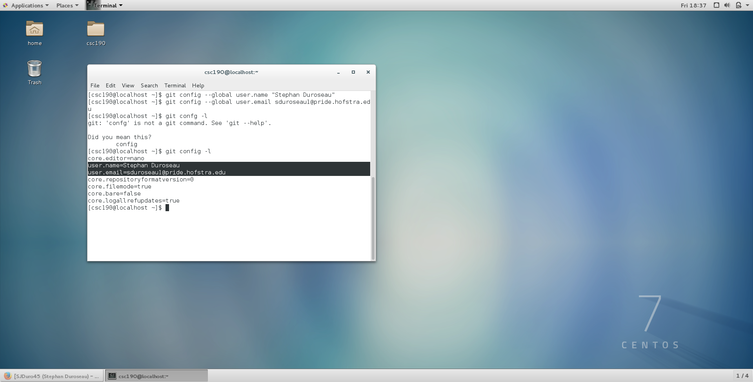
Part II. GIT Basics (Log, Stats and Diff) . [50pts, Estimate: 50 minutes]
Reconnaissance: Who Are the Bad Guys?
Dr. Evil’s project is hosted at: https://github.com/csc190Spr2017/CyberMissile.git
You should git clone a copy on your Linux image to perform the analysis. Once it is cloned, check out the FINAL branch. Your goal is to find out the details of the crimes committed by each member of Dr. Evil’s team. Later, the evidence will be used by the judge to determine the punishment received by each member. You need to address the following questions raised by the district attorney who plans to prosecute Dr. Evil.
(1) How many criminals are involved in Dr. Evil’s Cyber Missile project? List their names. Please paste a screenshot of your GIT command output. [10 min, 10pt] (hint use “git log” and pipe the result to “grep Author”)
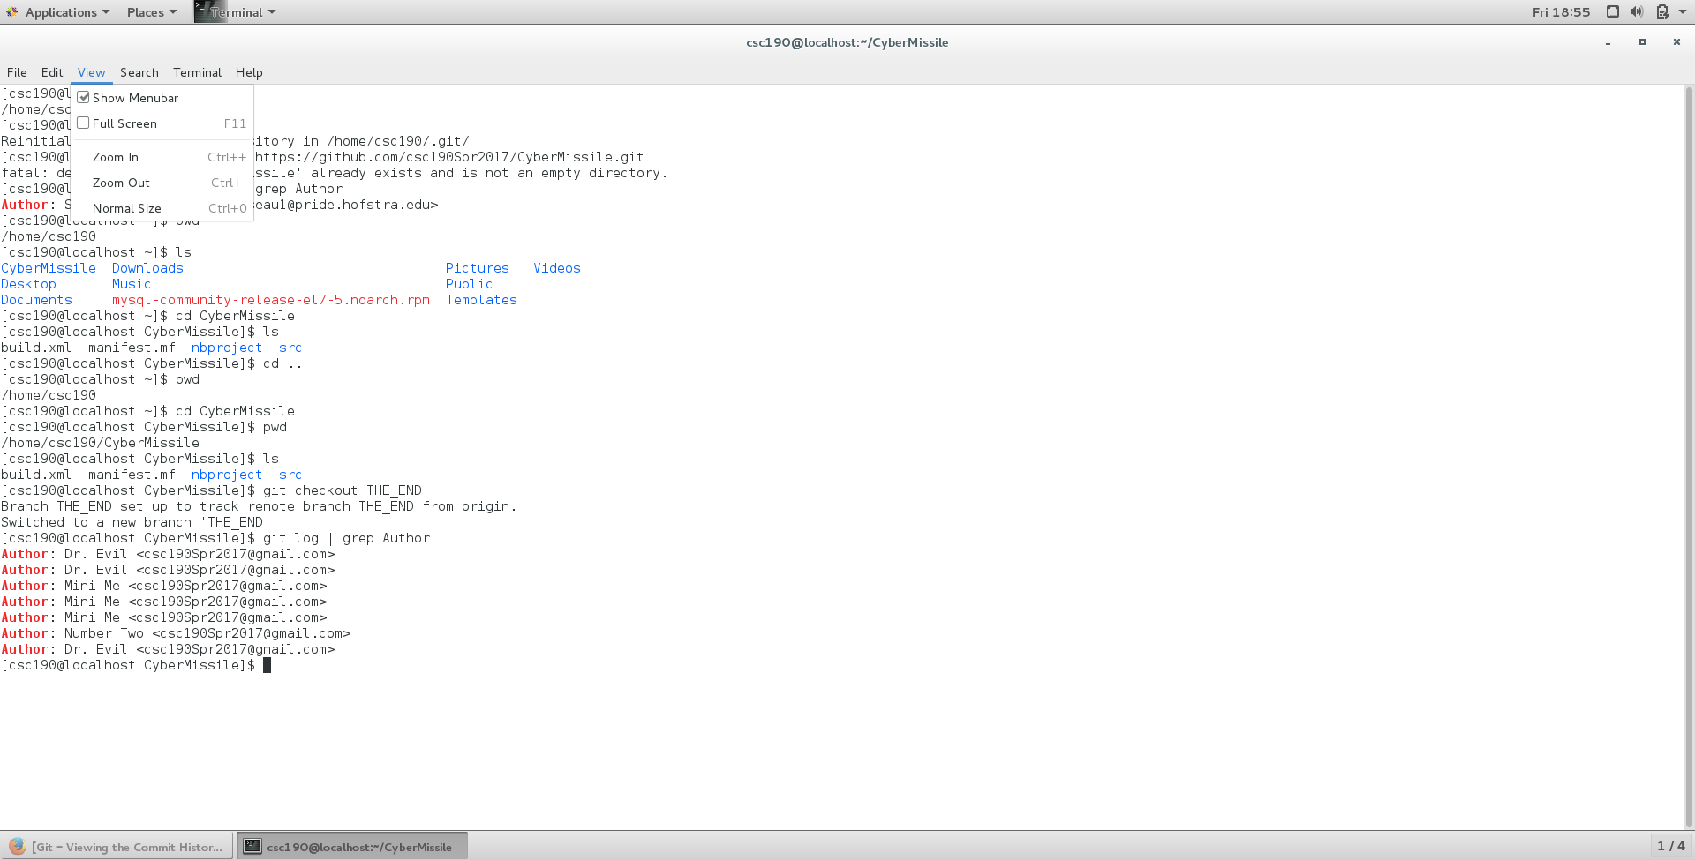

(2) If each line of Java code leads to one year in prison. How many years should Mini Me receive? Paste the screenshot to justify your conclusion. [10 min, 10 pt] (hint use “git log –author”)
He should receive two years in prison since he added two functions.
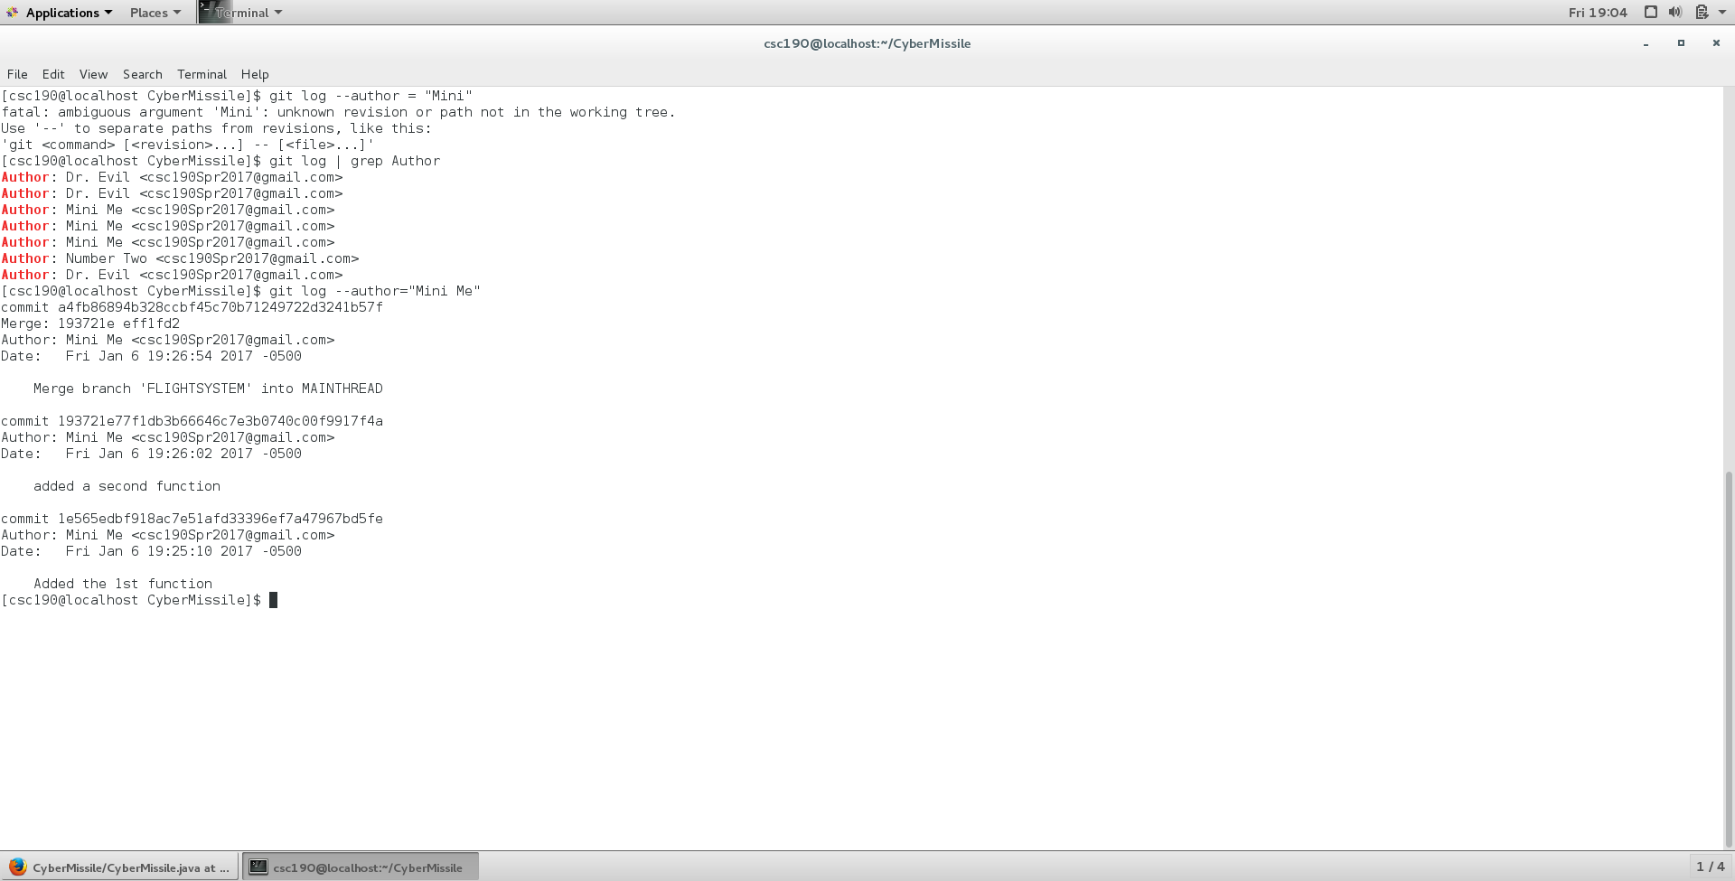
(3) Dr. Evil has two alternative plans to destroy the world (outlined in CyberMissile.java). These two plans are stored in two different branches: FINAL and THE_END. What is their difference? Please paste the screenshot to justify your conclusion. [10 min, 10pt]
The difference between the two branches is that Dr. Evil is updating his plans in the THE_END branch.
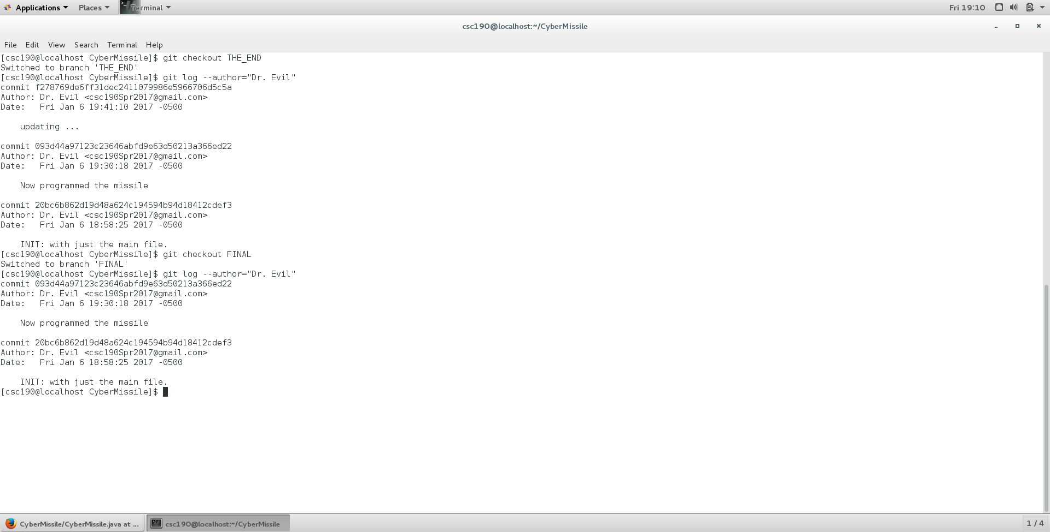
(4) How many times was CyberMissile.java modified (i.e., how many snapshots)? [5 min, 10pt]
The CyberMissile.java file was modified two times
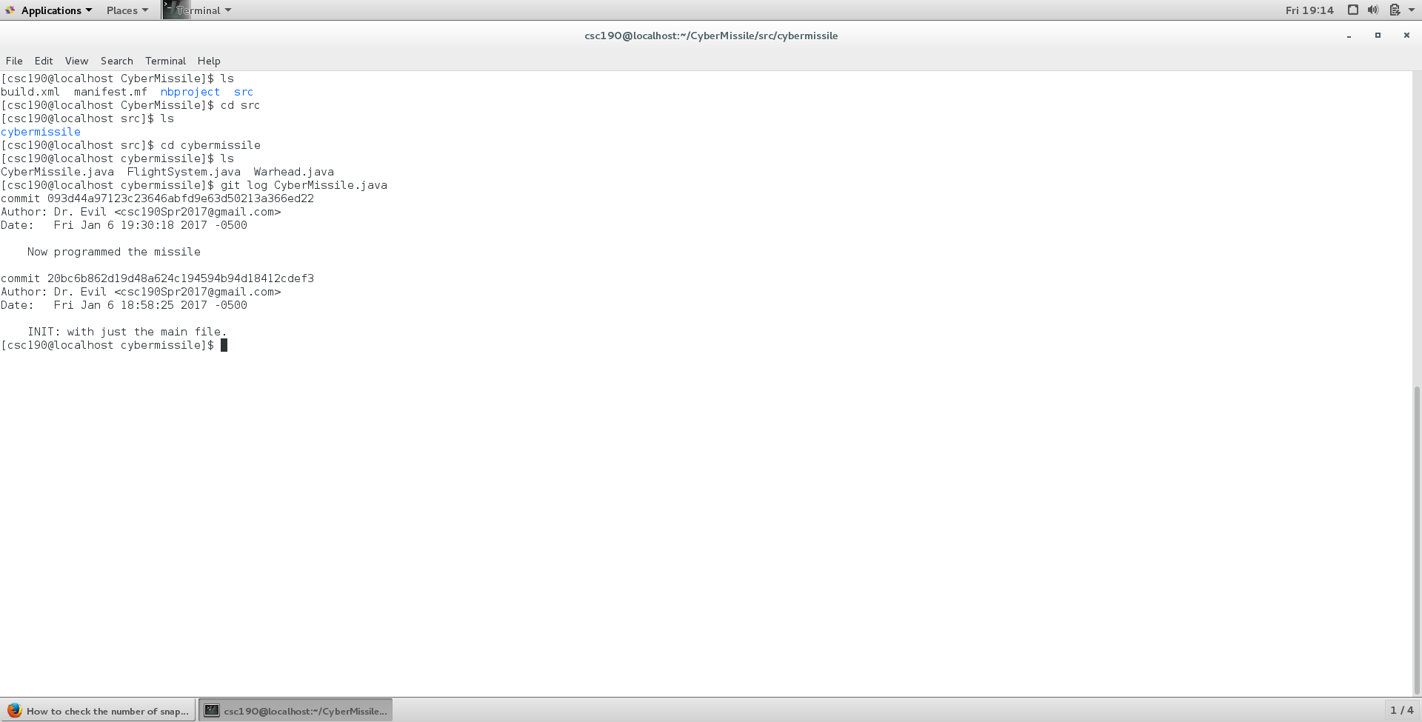

(5) Find out a GIT command to print out a tree structure of all commits. Paste the screenshot below, and answer the following question: who merged all branches? [10 min, 10pt]

Mini Me merged all of the branches
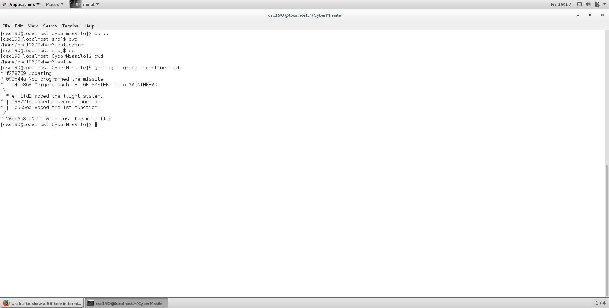
Part III. GIT Remote (30 pts, Estimate: 30 minutes)
Save the World: Defuse the Warhead
Redirect the missile to the moon and trigger the warhead to self-destruction. Commit the changes and merge them ALL into the master branch, and upload to your own github account. Paste the link below so that the instructor can git clone your project. Please note the special requirement: all changes should be merged into the master branch so that once the project is cloned at another computer, we can see the latest changes that you have made without checking out any branch.
Please paste the link below:
______________________________________________https://github.com/SJDuro45/CyberMissile.git____________________________________________

