Soreddy Jitendra Reddy

9130777631

[jitusoreddy@gmail.com](mailto:jitusoreddy@gmail.com)

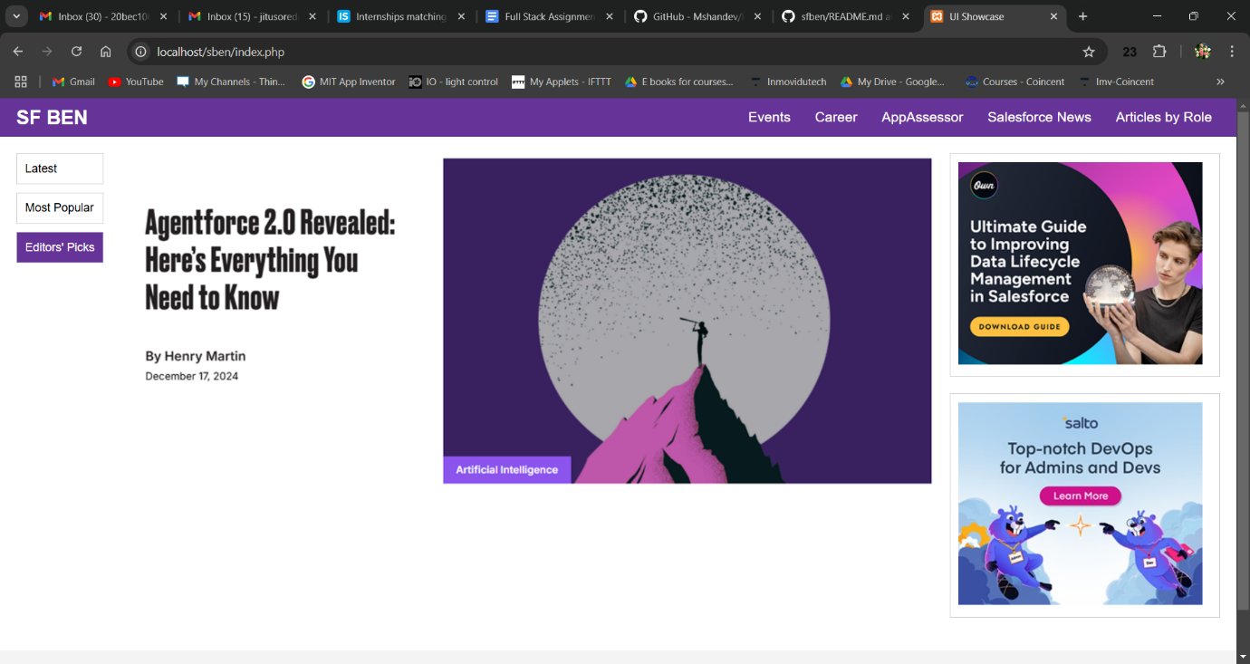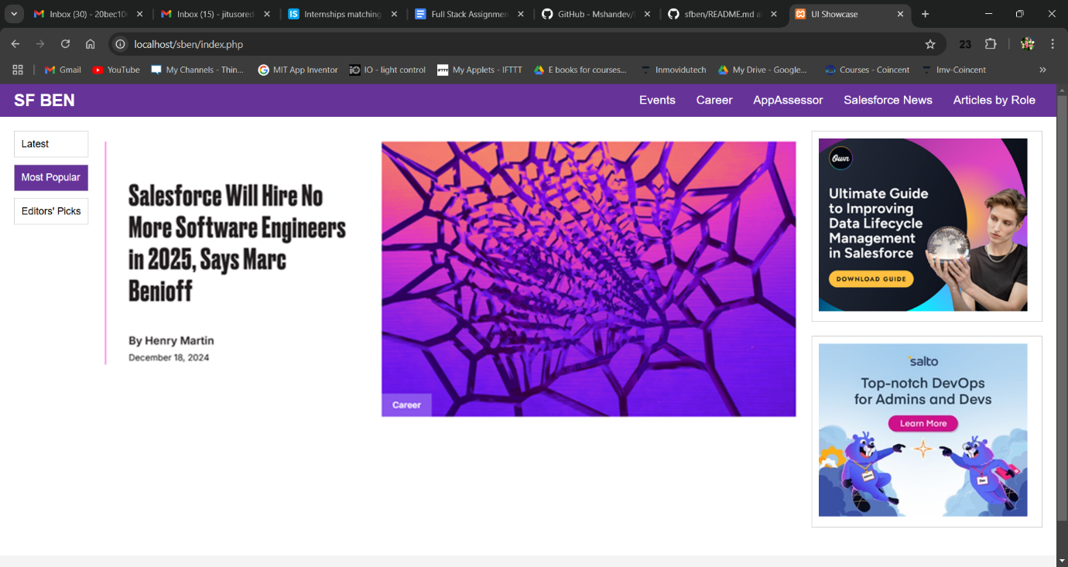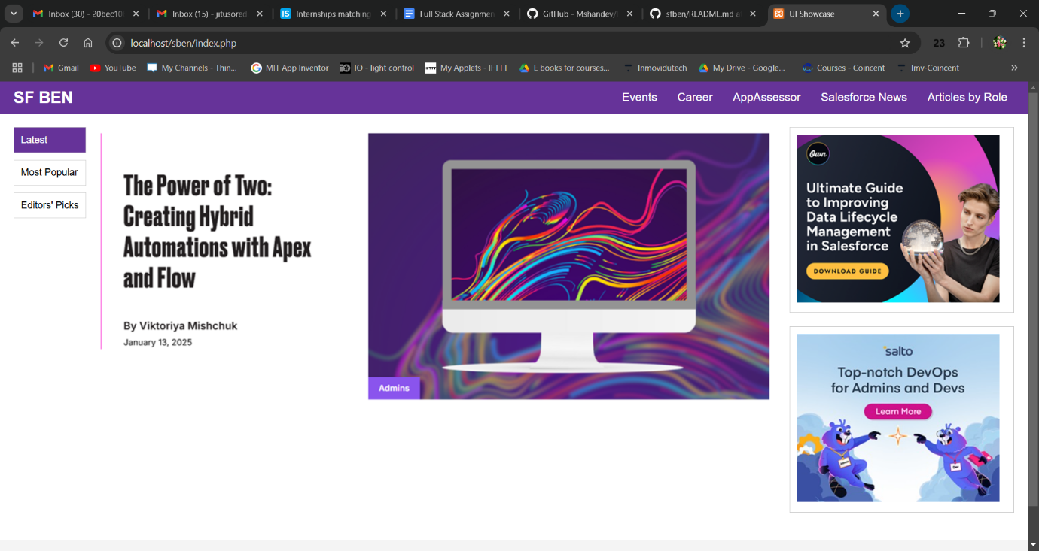

<https://github.com/SJReddy1/sfben>