**WORLD WIDE WEB**

**WWW** stands for **World Wide Web.** A technical definition of the World Wide Web is : all the resources and users on the Internet that are using the Hypertext Transfer Protocol (HTTP).

A broader definition comes from the organization that Web inventor **Tim Berners-Lee** helped found, the **World Wide Web Consortium (W3C).**

The World Wide Web is the universe of network-accessible information, an embodiment of human knowledge.

In simple terms, The World Wide Web is a way of exchanging information between computers on the Internet, tying them together into a vast collection of interactive multimedia resources.

WWW Operation

**WWW** works on client- server approach. Following steps explains how the web works:

1. User enters the URL (say, **http://www.tutorialspoint.com**) of the web page in the address bar of web browser.
2. Then browser requests the Domain Name Server for the IP address corresponding to www.tutorialspoint.com.
3. After receiving IP address, browser sends the request for web page to the web server using HTTP protocol which specifies the way the browser and web server communicates.
4. Then web server receives request using HTTP protocol and checks its search for the requested web page. If found it returns it back to the web browser and close the HTTP connection.
5. Now the web browser receives the web page, It interprets it and display the contents of web page in web browser’s window.

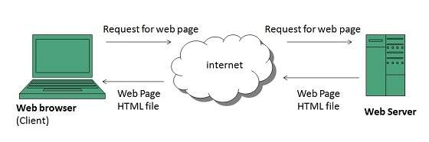

## Web Page

**web page** is a document available on world wide web. Web Pages are stored on web server and can be viewed using a web browser.

A web page can cotain huge information including text, graphics, audio, video and hyper links. These hyper links are the link to other web pages.

Collection of linked web pages on a web server is known as **website.** There is unique **Uniform Resource Locator (URL)** is associated with each web page.

### **Static Web page**

**Static web pages** are also known as flat or stationary web page. They are loaded on the client’s browser as exactly they are stored on the web server. Such web pages contain only static information. User can only read the information but can’t do any modification or interact with the information.

Static web pages are created using only HTML. Static web pages are only used when the information is no more required to be modified.

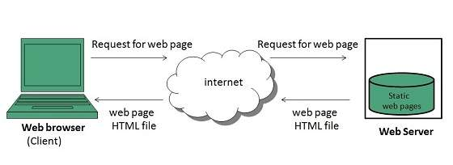

### **Dynamic Web page**

**Dynamic web page** shows different information at different point of time. It is possible to change a portaion of a web page without loading the entire web page. It has been made possible using **Ajax** technology.

#### **Server-side dynamic web page**

It is created by using server-side scripting. There are server-side scripting parameters that determine how to assemble a new web page which also include setting up of more client-side processing.

#### **Client-side dynamic web page**

It is processed using client side scripting such as JavaScript. And then passed in to **Document Object Model (DOM).**

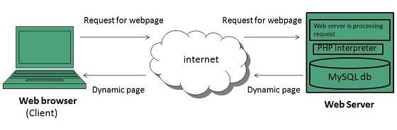

## Scripting Laguages

Scripting languages are like programming languages that allow us to write programs in form of script. These scripts are interpreted not compiled and executed line by line.

Scripting language is used to create dynamic web pages.

### **Client-side Scripting**

**Client-side scripting** refers to the programs that are executed on client-side. Client-side scripts contains the instruction for the browser to be executed in response to certain user’s action.

Client-side scripting programs can be embedded into HTML files or also can be kept as separate files.

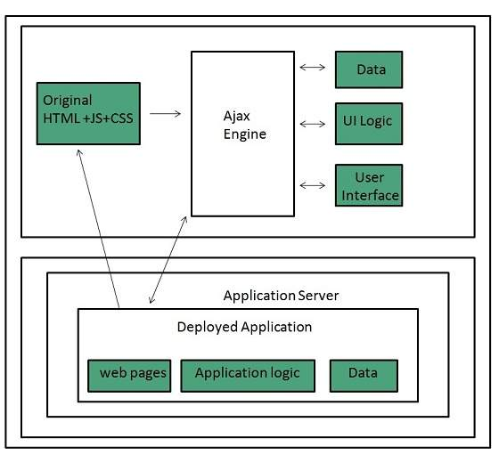

Following table describes commonly used Client-Side scripting languages:

|  |  |
| --- | --- |
| **S.N.** | **Scripting Language Description** |
| 1. | **JavaScript** It is a prototype based scripting language. It inherits its naming conventions from java. All java script files are stored in file having **.js** extension. |
| 2. | **ActionScript**It is an object oriented programming language used for the development of websites and software targeting Adobe flash player. |
| 3. | **Dart** It is an open source web programming language developed by Google. It relies on source-to-source compiler to JavaScript. |
| 4. | **VBScript** It is an open source web programming language developed by Microsoft. It is superset of JavaScript and adds optional static typing class-based object oriented programming. |

### **Server-side Scripting**

**Sever-side scripting** acts as an interface for the client and also limit the user access the resources on web server. It can also collects the user’s characteristics in order to customize response.

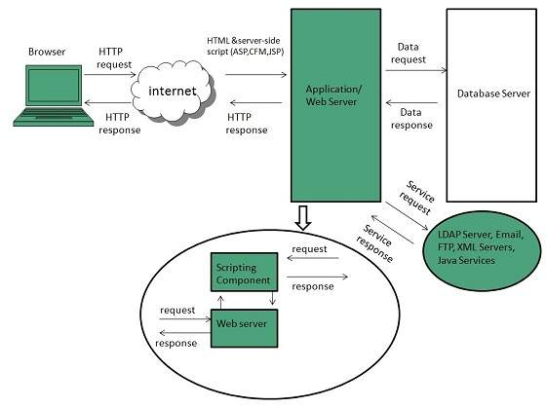

Following table describes commonly used Server-Side scripting languages:

|  |  |
| --- | --- |
| **S.N.** | **Scripting Language Description** |
| 1. | **ASP** Active Server Pages (ASP)is server-side script engine to create dynamic web pages. It supports **Component Object Model (COM)** which enables ASP web sites to access functionality of libraries such as DLL. |
| 2. | **ActiveVFP** It is similar to PHP and also used for creating dynamic web pages. It uses native **Visual Foxpro** language and database. |
| 3. | **ASP.net** It is used to develop dynamic websites, web applications, and web services. |
| 4. | **Java** Java Server Pages are used for creating dynamic web applications. The Java code is compiled into byte code and run by **Java Virtual Machine (JVM).** |
| 5. | **Python** It supports multiple programming paradigms such as object-oriented, and functional programming. It can also be used as non-scripting language using third party tools such as **Py2exe** or **Pyinstaller.** |
| 6. | **WebDNA** It is also a server-side scripting language |