YenTnbo

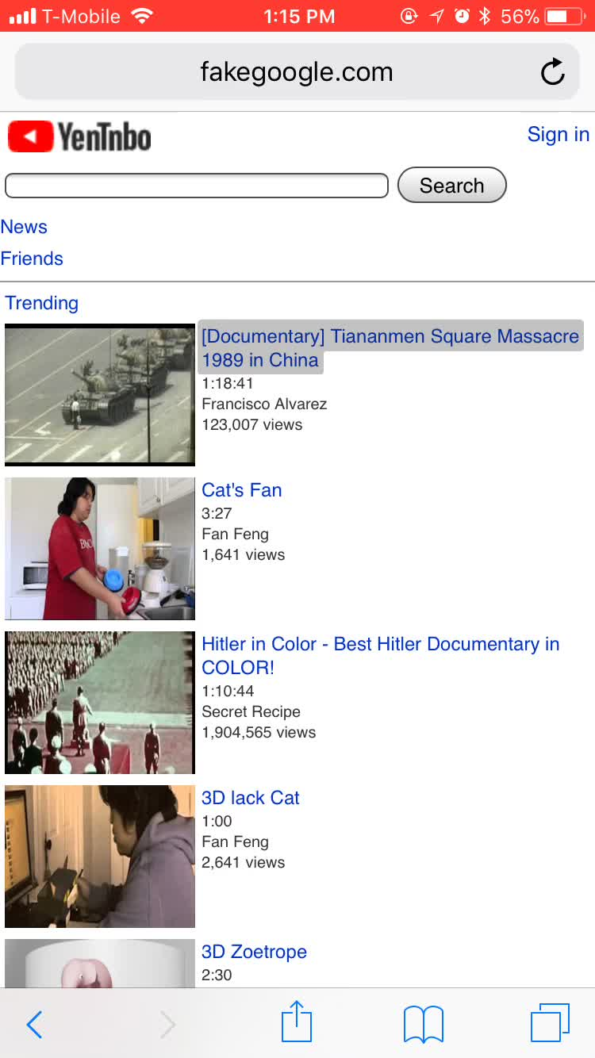Fan Feng

YenTnbo is a parody of the famous video website YouTube. YouTube is a milestone of internet censorship in my home country. Before I come to North American, YouTube is totally accessible. The mass number of videos on YouTube showed me the life in North American, and attract me to study here. Few years after, because more and more sensitive political video uploaded on YouTube, YouTube become inaccessible by IP blocking.

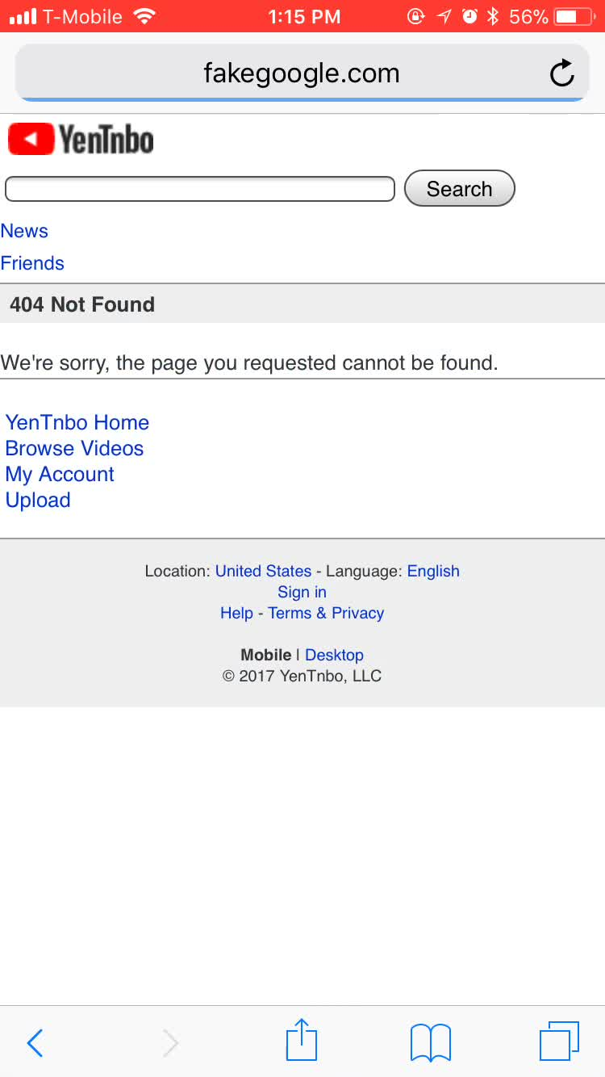YenTnbo is modified from the mobile version of YouTube website. Audiences can see different titles of the video showing on the home page, some video titles relate to different sensitive topics. Audiences are not able to access the sensitive videos, and they will navigate to a 404 page, bhe videos without sensitive contents are all accessible. YenTnbo is containing in a local mesh network, audiences will only see the contents we provide in this mesh network. Audiences will experience what a video website looks like on a censored internet.