Horo – A Unique Learning Platform for The Homeless

(*horo* means training in African language)

*Abstract -*

There are over half a million people in USA who are homeless. And There are many more families which are living below the poverty line. We believe that Lack of professional skills and dearth of employment opportunities are two major reasons for this situation. Though there are different online platforms like udemy, courseera, treehouse etc. which provide free and paid training online, most of the times, it is not accessible to the homeless people and poor families. This is majorly due to the lack of resources and money required to participate in the training courses.

Enter ‘Horo’!

‘Horo’ is a unique learning platform specially developed for homeless people and poor families to help them learn new industrial skills, get jobs and recover from their situation. We try to achieve this by connecting three types of people –

1. Homeless people / poor families
2. People who have industrial skills with experience in their fields and are willing to teach / coach other people
3. NGOs / non-profit organizations – are the organizations which are working for welfare of homeless people and poor families, are willing to provide logistics and infrastructure to conduct trainings and classes

Apart from this, every participant will be given a ‘certificate of accomplishment’ at the end of the course, which he can use to get a job. Additionally, qualified people will be introduced to different job opportunities available in the vicinity.

Main features of the platform will be –

1. Sign up as a student / trainer or coach / NGO
2. Search upcoming courses / batches
3. Rate a trainer / coach
4. Search available locations for classes
5. Search for job opportunities in the area

*Architecture Diagram:*

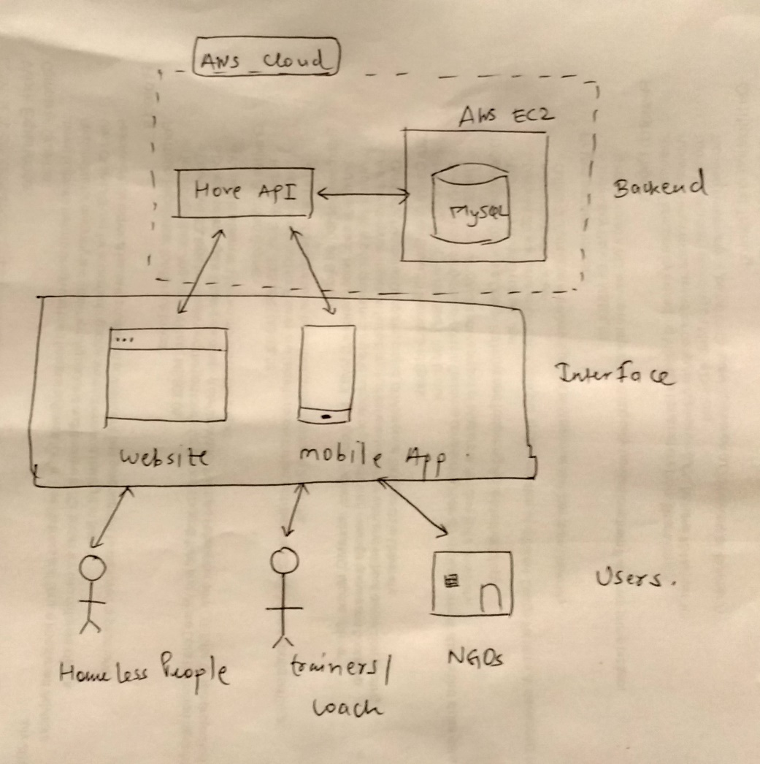

*List of personas:*

**Persona #1** – Homeless people / poor families

1. Name – XXXX XXXX
2. Age – 20 to 75+
3. Gender – Male / Female
4. Location - Address
5. Education – None or very less
6. Family – Known / Unknown
7. Primary goal – Food and Shelter
8. How they will use system –
   1. Create account on the platform
   2. Search for the course based on the location
   3. Take a course / Rate a trainer

**Persona #2** – Trainers / Coaches

1. Name – XXXXX XXXX
2. Age – 20 to 60
3. Gender – Male / Female
4. Location – Current Address
5. Education – Optional
6. Family - Known
7. Primary goal – To
8. How they will use the system –
   1. Register as a trainer
   2. Start a new batch
   3. Request for infrastructure or logistics

**Persona #3** – NGOs

1. Name – XXXX XXXX
2. Age – No of years’ active
3. Gender - None
4. Location – Their current address
5. Education – Not applicable
6. Family – Not applicable
7. Primary goal – To help homeless people
8. How they will use the system –
   1. Register as a NGO
   2. Provide trainers with infrastructure and logistics for conducting training

*List of user stories:*

User Story #1:

As a user, I should be able to search for different courses in my area, so that I can join them and develop new skills thereby getting eligible for applying for job opportunities.

User Story #2

As a user, I should be able to rate a particular coach, based on my experience, after attending a particular course, so that it I can provide my true feedback, which might help others while making a decision to join the course.

User Story #3

As a user, I should be able to register on platform as a ‘Trainer/Coach’ so that I can start helping homeless people by coaching them for a particular skill.