CraftOneLife
Kalikalyan Dash, Neha Jethani,
Rajvi Modh, Divyank Shukla
Dept. Software Engineering
San Jose State University
San Jose, USA

Abstract—This project aims to create a web application - CraftOneLife to help homeless writers in finding a way of earning money and craft their life in a better way. CraftOneLife makes earning money possible for people needing money by selling their wonderful ideas. These ideas might have been lost in them, if not sold by CraftOneLife.
- Introduction
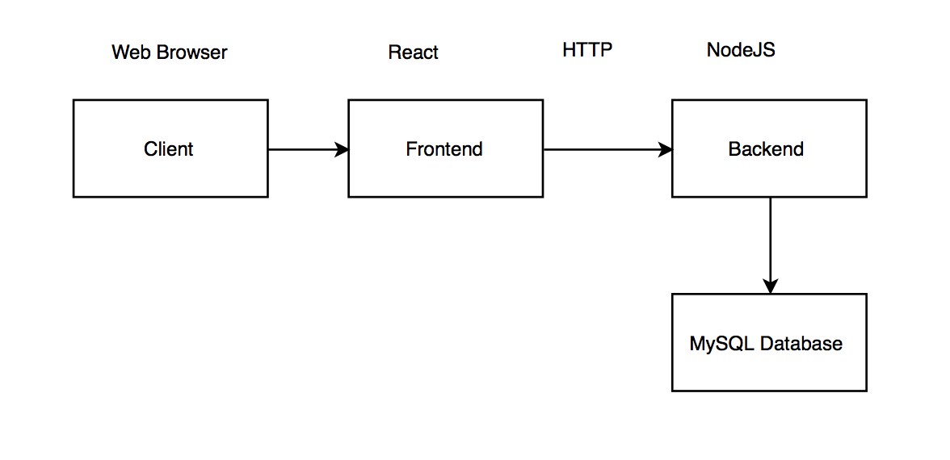
CraftOneLife is a social enterprise and benefit Non-governmental organizations(NGO). Every writer earns 80% from the profit of each sale. 1% from each sale goes toward strengthening art services for community partners that support CraftOneLife writers, which includes writing programming at social service agencies, shelters, and disability centers. CraftOneLife uses the remaining 19% to further our mission. In order to make sustainable change, company need to run a financially sustainable business. By providing a online platform to the people, who can’t afford to share their musings unless helped financially, we not only provide them the opportunity to share their stories but to get a payback for that from the readers. Below the flow of the project will be explained.

- HOW THIS WORKS
CraftOneLife works with individuals who participate in shelter or disability center art programs across the U.S. There are thousands of existing groups in shelters and disability centers. The first point of contact is most often the director who oversees the writers in these programs. This helps CraftOneLife ensure that they are helping individuals who are committed to improving their situations and finding stable employment and housing. People, who have those wonderful ideas but not financially self-sufficient, can share their stories with CraftOneLife. It can be their life experience or can be fictional that they can share with people around the globe. They share will go through a proper vetting for the originality of it. Then it will be approved by the administrator. The writer will be contacted by our team and the 80% of the total profit will be shared with him/her.

III. HOW IT AFFECTS THE SOCIETY

CraftOneLife empowers writers living with homelessness or disabilities through the celebration and sale of their work. CraftOneLife is about creating opportunity, empowerment, and validation. The writers are offered the chance to secure their own income through the sale of original writings, anecdotes, and products. By showcasing and selling works via CraftOneLife.com, our writers gain self-confidence that permeates all aspects of their lives. This, in itself, is a great giveback to the society. Writers are paid each month by check, direct deposit, or PayPal. If our writers do not have a mailing address, the payment will be sent to the shelter in whose program they participate.

IV. CRAFTONELIFE

In this project, we use a 2-tier architecture. The CraftOneLife web application front-end is created in HTML, CSS, JavaScript with React library. The back-end is implemented in JavaScript and Node.js, and the server is hosted using express modules. MySQL is used as database and it is only store useful the information..

Fig. 3. Architecture Overview

Application Scenarios
Steps:
- Writer creates a writer account and logs in
- Writer uploads his work
- Administrator logs in and checks his log
- Administrator reads the work and the shares with the team
- Team decides whether to approve the story or not and checks the authenticity of the same
- CraftOneLife puts it on the website for the users to buy
- The user logs in and buys the product
References

1.https://www.artlifting.com

