

PROJECT REPORT

CMPE-272 Enterprise Software Platform

Avadh Boriya Qiuye Kang

011487242 011487242

**Introduction**

People tends to get confused while buying online as there are unlimited options are available on various brands. It is time-consuming process to look for various brands product before purchasing that product. So, guBuys helps people to suggest brands and products, which are best, suited for them. goBuy takes data from twitter and based on their previous likes of products , it suggest based products according to their requirements . User just need to provide their twitter user id and a product they want to buy. Based on their twitter likes history It takes last 5 tweets which user liked and finds whether there is any tweets related to the product they want to buy . goBuy would suggest them few brands product, which they liked on twitter. This products are searched in amazon and it would provide link to amazon order product.

**Website Flow**

1. User input :

User is asked to provide their twitter id and product which they want to buy



2 Enter your twitter id :

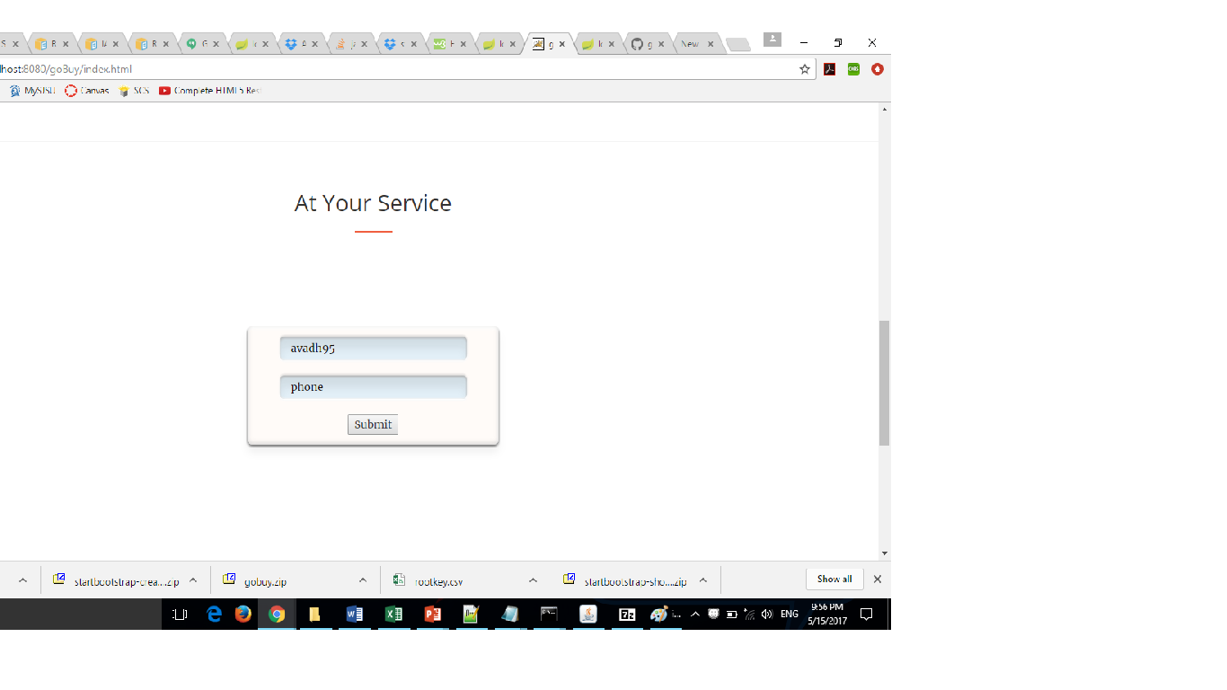

3 . results :

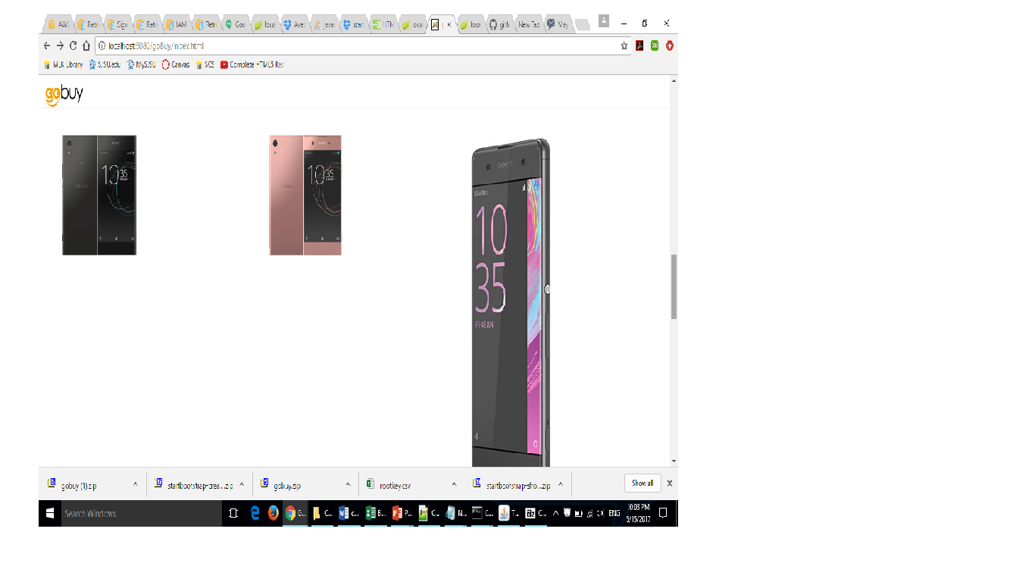

Architecture:

-Bootstrap

-Javascript

- Microservices

-TwitterApi

-Amazon Api

-Spring Framework

Future Scope :

- Your twitter followers or blog fans are like or why they follow you? It can help you to automatically discover their motivations and values. Using such knowledge, you can then better engage with your fans based on their needs and wants.

- discover why Your customers love your brand and products .For example, some customers prefer your products because your products make them stand out and achieve a sense of prestige, while others adore you because they find your products practical and consistent in quality.

It can help you analyzes your fans and automatically derive your representative fan personas. With the help of this data organization can find their unique features and why their customers prefer their brands