CMPE 272 – Project Report (Team 2)

**Online Grocery Database**

|  |  |  |  |
| --- | --- | --- | --- |
| Tin Tran | Satish Kumar Gollaprolu | Shiva Kumar Padma | Sreedeep Katragadda |

***Abstract:*** Online grocery shopping is not a new idea, but it’s not the ideal solution for groceries that are being thrown away every year, wasting billions of dollars of perfectly good food. Families who cannot afford expensive groceries should be able to buy the good food which are about to thrown away at a discounted price. We came up with a solution for this specific problem by introducing ‘Timely Grocery’. Our idea is to make our web application a platform for consumers to know about the discounted prices of groceries from various vendors. The vendors will decide how much discount to be provided for groceries considering the sell-by-date of the product.

***Keywords– grocery discount, timely grocery, near-by expiring products, online grocery database.***

1. **INTRODUCTION**

According to the USA food wastage statistics page <http://www.worldfooddayusa.org/food_waste_the_facts> , in the US alone, 30-40% of the food supply is wasted, equaling to more than 20 pounds of food per person per month. There are various reasons why grocery stores throw away huge amounts of food which are perfectly fine to consume.

* Overstocking of the products: Most grocery stores in USA are trained to operate that consumers are more likely to buy their products if it's from a fully stocked display aisle. This assumption leads to overstocking, as well as damage to items which ultimately leads to throw away of fresh goods.
* Expectations of perfection: Customers have been unknowingly trained to consume perfect, identically shaped goods. Vendors stock their products according to the users’ expectations — even if the shape, size, or the color have nothing to do with product’s quality. This preference leads farms to avoid selling the so-called “B” category goods to grocery stores.
* Marked dates on products: Most customers don’t have good idea about what expiration dates, sell-by dates, use-by dates, or best-by dates really mean. Customers (and many vendors) wrongly assume that food is no longer good to consume after these days. Most groceries are good long enough after the sell-by date.
* Damaged products and unpopular items: Typically, product packaging gets damaged during shipping to the stores, leading supermarkets to toss out the fresh goods even though the food was not compromised. The stores assume, may be correctly, that no user is going to buy a damaged box of cereals if another damaged oil can is right next to it. In addition to this, items that fail to get sold like overstocked holiday foods are often tossed.

Low income families who are on a budget should be able to buy these discounted products, since most online sites have to maintain the price for the newest and freshest products, and every store has different amount of food that they throw away. This makes it hard for consumers to find and buy the fresh quality groceries at a lower price.

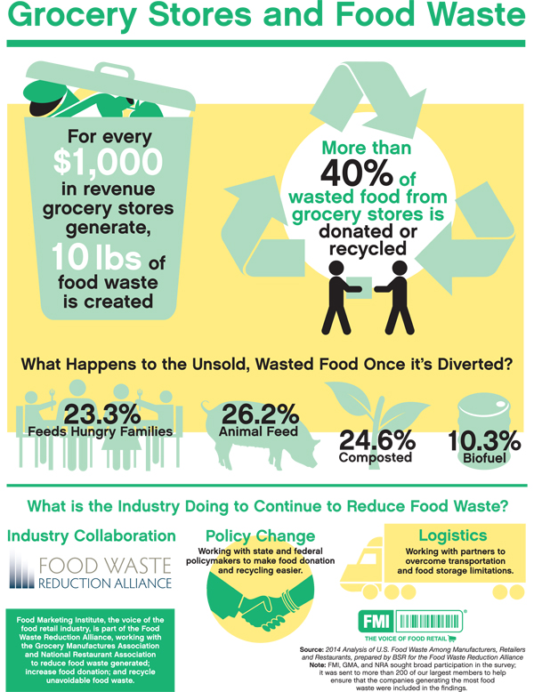

Figure 1.

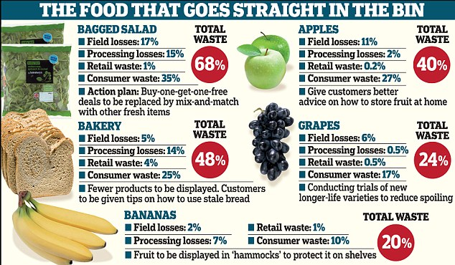

1. **SOLUTION**

We came up with a solution to provide a platform for local retailer stores to catalog and post their near sell-by date groceries, at a heavily discounted price. Local stores who have similar products and sell-by dates can compete for the lowest price. And customers can build their order and reserve it for a pickup from the retail stores. As the customer have to go and pickup these products at a local store, retailers don’t have to worry about shipping and handling, or online payment. On the other hand, budget conscious consumers who are looking to buy these discounted groceries will be able to find and buy them faster and much easier. Customers can get all the information about all the stores and their products in one central place, then make a choice for the store, saving time and money.

Figure 2.

1. **IMPLEMENTATION**

The structure of our solution resolves around Apache Server, PHP, MySQL, and a little of front end designing with HTML/CSS. As none of us had any significant experience with web design, this has proven to be a learning opportunity for us. We chose MySQL as it is a free and widely used database management system while offering almost all of the essential features. For a startup business, this will reduce the overhead and cost of buying and maintaining a more expensive DBMS such as Microsoft SQLServer or Oracle Database. We also tried experimenting with MariaDB, the successor of MySQL. For the database schema, we set up a table for vendors, and products, which contain all the information such as name, address, product names, quantity, sell-by date, prices and their discounts.

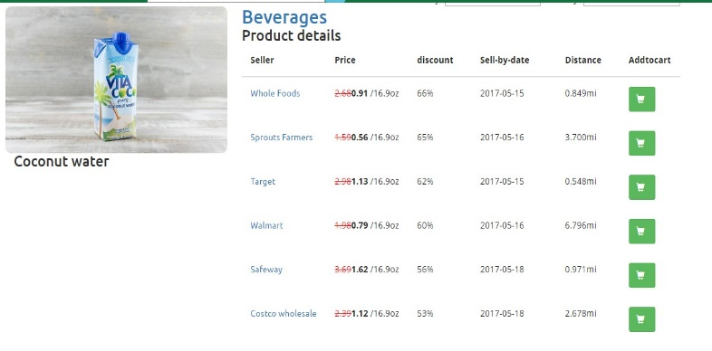

Figure 3. Displaying of different sellers and their prices.

We implemented some automation using a cronjob to check for the price and reduces it every 24 hours. The automation also purges the data that goes past the sell by date. We chose Apacher Server and PHP to test the server side code that interact with the database from the front-end page. PHP is the fastest solution to implement, compared to other web frameworks such as Python Django or NodeJS. The front-end pages contain PHP scripts to insert and retrieving data from the database. We used Bootstrap templates for the front-pages as they were quick and easy to implement.

We added a feature where the user can place an order and see which store is closer to his address for the pickup.

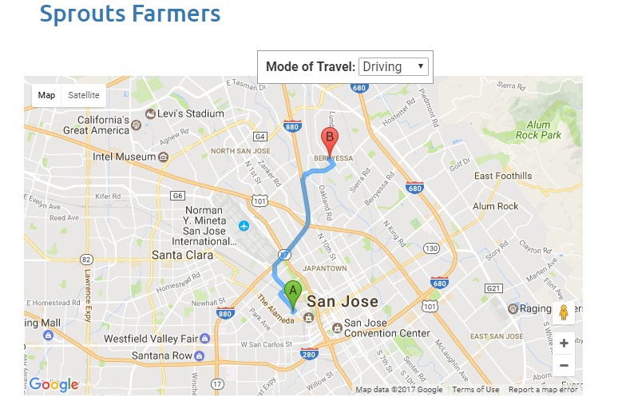

Figure 4. Sample image of the nearest store to the user.

We also had plans for other features such as data analysis on which products are most likely get thrown away, or which products get bought the most. With this information, local retailers can choose to stock more or less particular items. We also considered of adding a feature where users can negotiate with the seller if they think that the discount is not good enough for the product’s sell-by date, this idea implementation had some bugs and we will implement this in the near future. Another point to mention is that currently we don’t have a solution to handle the online payment, as customers have to go to the stores, but with delivery services such as UberEats, DoorDash and other delivery services, this can be an opportunity for expansion.

1. **CONCLUSION**

We all know how much food the stores throw away every month. The stores can offer free giveaway and feed numerous people who have trouble buying food every day. As the stores don’t go through with that much difficulty to save food. With this, many users can find better quality food at cheaper prices and they can feed themselves. While this project does not have the complexity compared to other projects, it provided us the opportunity to learn and get hands on with web development and databases. We hope to able to expand this project further to include blockchain, machine learning, and explore other areas of interests besides groceries.