SportsHub

Emma Peatfield   
Software Engineering   
San Jose State University San Jose, CA  
emma.peatfield@sjsu.edu

Sunil Lalwani  
Software Engineering  
San Jose State UniversitySan Jose, CA  
sunil.lalwani@sjsu.edu

Harshraj Rathod  
Software Engineering  
San Jose State UniversitySan Jose, CA  
harshrajsinhvijaysinh.rathod@sjsu.edu

*Abstract*—Many people enjoy playing sports in their free time. However, for a multi-player sport, someone may not have any available friends to play with at any given time. Thus, this project focuses on solving this problem to enhance the lives of those who want to be active. A player gets to pick a sport, with a level, a time, and within a location, and receives matches of another player within their vicinity that can play with them. SportsHub seeks to change the way that ‘pick-up’ sports are organized.

Keywords—mobile application, nodejs, angular, sports

# Introduction

SportsHub is a mobile application that can be used by any person that is in need of a partner for a Tennis or Badminton match. They might want to play at a time where none of their friends are available. This application focuses on a problem with ‘pick-up’ sports that exists and tries to solve it.

## Problem

Many tennis and badminton players want to practice in their free time and play ‘pick-up’ games, so they try to find friends or acquaintances to play with them. However, there is not always someone you know that it free. This makes it tough to enjoy practicing and plan out your day. Many people are all in need of a playing partner, they just need to be connected.

## Solution

SportsHub is a mobile application that can solve this problem. By matching up people with another player in their area for the same sport and same level. It will direct them to a park close by and they can decide a time to meet up. This will help everyone stay more active in their sport and get people the practice they need.

# Process

The process for creating this application began with really re-thinking our idea. We needed to figure out how to take our idea and change that into an application that works. First, we started with our database design. Then, we split up the work evenly to create a backend and a frontend for the application, so that it could be deployed onto an iPhone or Android phone.

## Database Design

The database was the first step in creating this application. We needed to decide what information we wanted each user to provide, and what information we needed to provide. For example, when a user creates an account, there needs to be a form to fill out that will transfer the data into our database. Also, when assigning the players, a location, there had to be park data that we had stored with tennis courts and location data available.

## Backend Server

Once the database was set up, the team could deploy the database to the cloud using MongoDB on Mlab, and the backend server was set up using an Amazon EC2 Instance [1]. This backend was setup so that our frontend would use APIs to query data back and forth. Thus, we did not have to deploy our mobile frontend onto the cloud.

## Frontend

The frontend of the application has a sleek design, with many interactive forms to fill out. It was coded using AngularJS, HTML, and CSS. As a team, we learned how to use Ionic Framework [2] to help us build our application. It consists of a login page, a signup page, a home page, a matches page, a winner page, and a stats page. Each page has its own functionalities and UI design. Here is a short description of each page, and their functionalities:

### Login/SignUp:

### The login and singup pages control the user authentication and creates the user form. This user form adds to the user credentials that are added to the database.

### Home Page:

The home page is the first page that users see once they login. It has a form for users to fill out when they want to play a game. It asks them 4 different things: sport, level, time, and zipcode. Once the user submits this information, they are transferred to the matches page.

### Matches Page:

This page shows all of the matches that have been retrieved from the database that have the same zipcode and similar time periods as the user. This page also displays a map of the location of the assigned park. Thus, making it easier for the user to know where to go. The user then chooses one and presses submit for the game to start.

### Winner Page:

The winner page lets the user choose the winner, and that information gets added to the stats page. It also lets the user give their opponent a rating out of 5 stars, so that future users can judge whether or not they want to play that person.

### Stats Page:

The stats page shows the number of wins and losses for each sport on the app for the user. This will also hopefully show the rating and ranking of the user, one day.

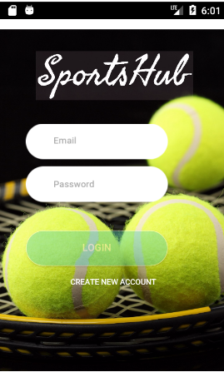

Figure 1. LogIn Page

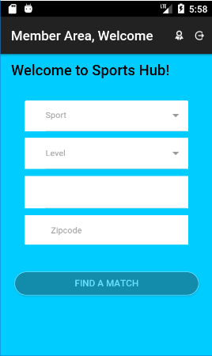

Figure 2. Home Page

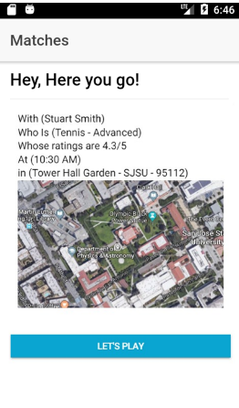

Figure 3. Matches Page

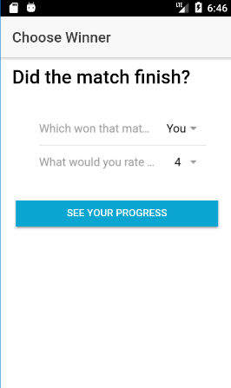

Figure 4. Winner Page

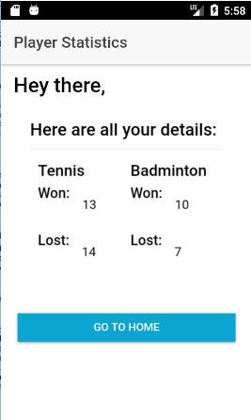

Figure 5. Stats Page

# Results

Once the separate parts of the application were built and tested individual, it came time to integrate all of the code together to build and deploy the application.

## Issues

There of course were a few issues along the way when it came to integrating the code together. This was expected, so we made the necessary changes to fix the code, so that we could get the application to work. Then, when deploying our application onto an Android Emulator from Android Studio, we had to fix a few sections of our UI code, so that it fit well in an Android environment.

## Future Implementations

A few things that we would like to add to this project vary between usability and features. There are plenty of sleek UI designs that could be implemented with our project, including adding new pages and new features. A feature that would be really nice to implement would be a multi-player option. Where a user could specify how many players they would like to play with and what sport, and the application would return results to them. Another feature would be to add more sport options for the users, especially once the multi-player update had been added.

# Conclusion

SportsHub will help revolutionize the world of ‘pick-up’ sports. It will enable people of all ages and skill levels play sports together when they have no friends or acquaintances that are free to play. Users will have freedom to choose their opponents from the matches and they will have the freedom to specify their level depending on how much of a challenge they want to face.

##### References

1. ec2-18-191-39-104.us-east-2.compute.amazonaws.com

[2] https://ionicframework.com/docs/

[3] https://github.com/SJSU272LabSP18/Project-Team-22