## BUILD -1 (05/04/2020) - ISSUES

All pages

1. Covert the ship logo in the top right corner of to a car logo. Change name of the fleets.
2. Add a logo for the fuel sense title
3. Add a tag line with the Title it just for the presentation, this is better than adding a entire about us page
4. Notification icon seems irrelevant . Either delete or show different type of updates. Graph icon next to it also shows no information.
5. User login functionality is not implemented . Can we hide the entire right side tab.
6. Remove General Analysis from the Nav

Time trending

1. Add a legend for the red dot in the time trending plot for consume Vs time
2. Refill liters value is incorrect in the right-hand side tab. Review the json file or input CSV.
3. What does box-select and lasso do ? Is it for pointing to a data?
4. Comparison period filter not required . Add functionality or remove the icon.
5. Remove message feedback and comment section.

5D Plots

1. Change the title of the graph to 5D . Instead of legends in the title move them to the legends “regular” location
2. Rename the Z Axis from RPM to the correct value I think it should be distance
3. “Save photo as a png” photo quality is poor. See if there is some easy fix for there to improve the image quality.
4. Reset camera to last saved state functionality not working . Test and verify , it seems same as reset camera to default. Remove if not implemented.
5. Filters column seems to indicate some expected functionality is not implemented. We can defend but it’s your call.

Fuel Type -Analysis

1. Change the title for the Plot - It should be ‘Scatter Plot for Fuel Type : SP 98’
2. Filters column not working. Initially, it displays the right results , correct results I hope after the first change and then it crashed and no further change in plot visibly noticeable.
3. Add legend for consistency.
4. Remove the below part from each page .

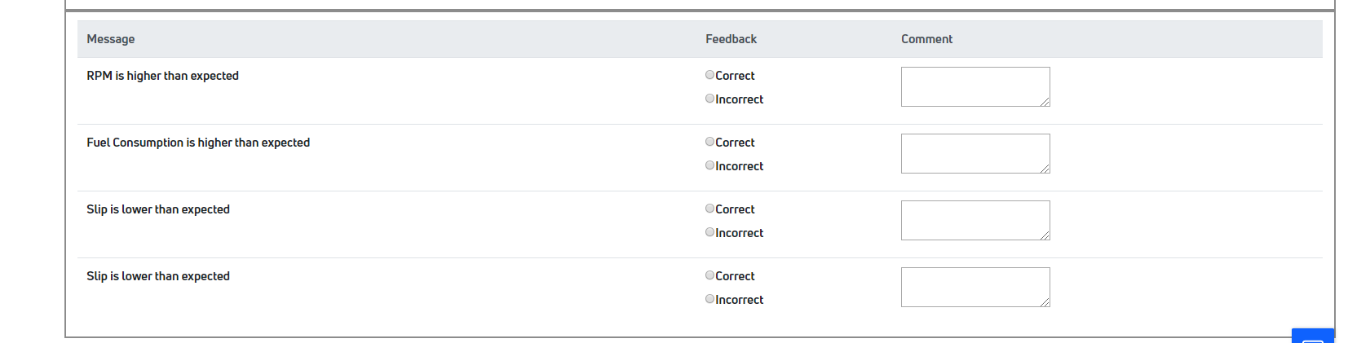

Advanced Analysis

1. Change the title for the Plot – Add “advanced analysis” to it.
2. Scatter plot functionality which is not working properly in Fuel Analysis graphs is working as expected in this graph.
3. Add legends for consistency. Tough task but need to do it .Most important page of our project
4. Incorrect model selection does not give an error message.
5. Outside Temperature, all radio buttons are not working. Implementation needs to be done ASAP.
6. Can we show our model accuracy stats in UI?